Ryan O’Connor

Computer Science Project

Dr. Cynthia Howard

February 16, 2015

Detailed Design

*Web Crawler*

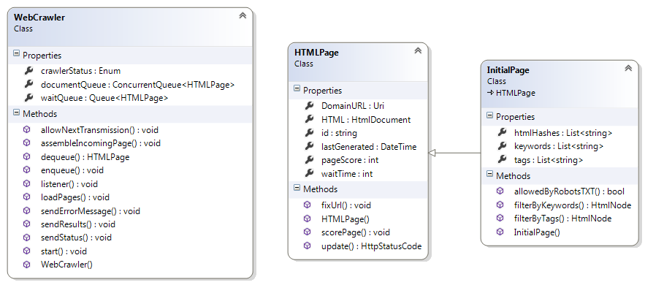



*Web Application*

