Silktide
Pros: easy to use and set up on all pages, identifies tags that are potential issues and what they affect. Potential issue elements are highlighted in red borders. Offers advice and solutions. Free without a trial. Recommended for users that want easy fast checks.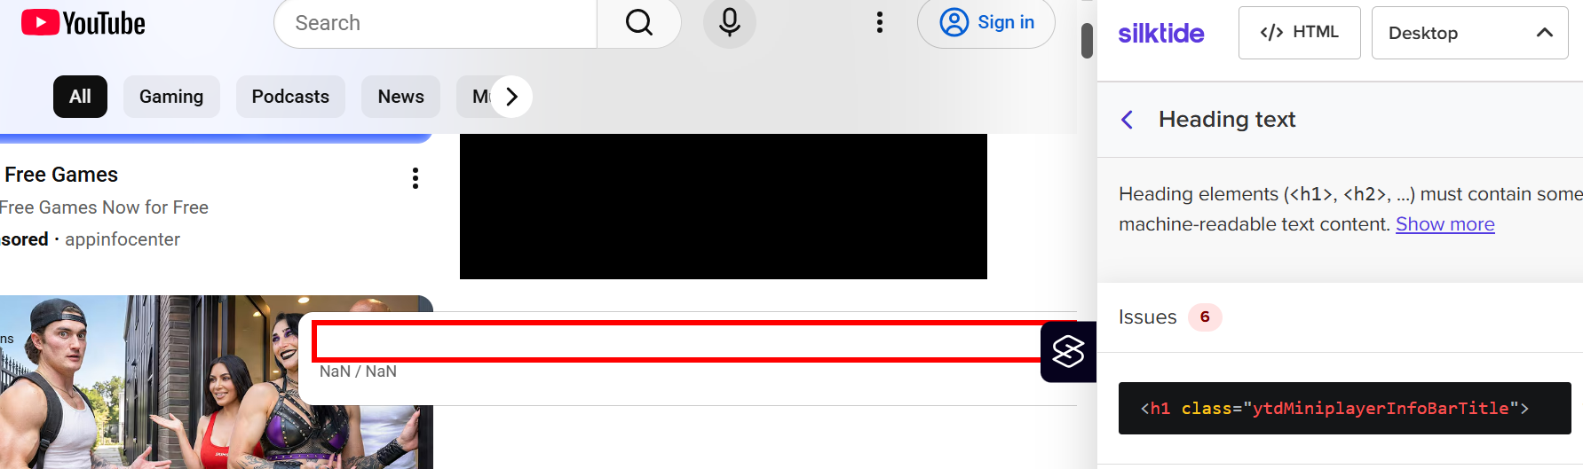
Cons: The extension can break when using it on YouTube, a popular site. When using it while video plays, the page and extension become unresponsive. While it shows specific tags, extension does not indicate their locations in code. While trying to highlight elements, it can break the structure of the page until highlight is over. Functionality is very limited. 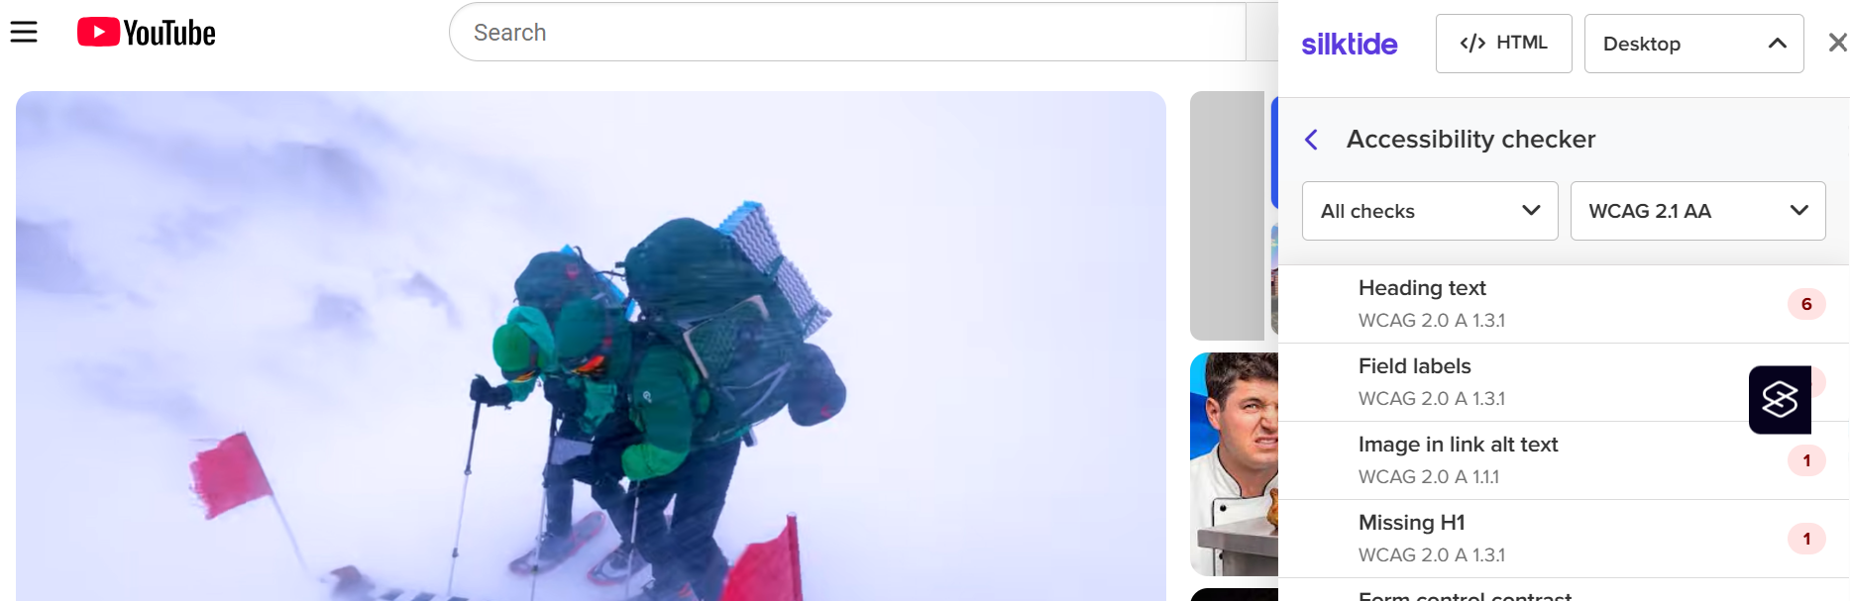
Axe
Pros: Having more options than Silktide, Axe DevTools is more comprehensive and purpose-built for accessibility. Can be used alongside Chrome dev tools. 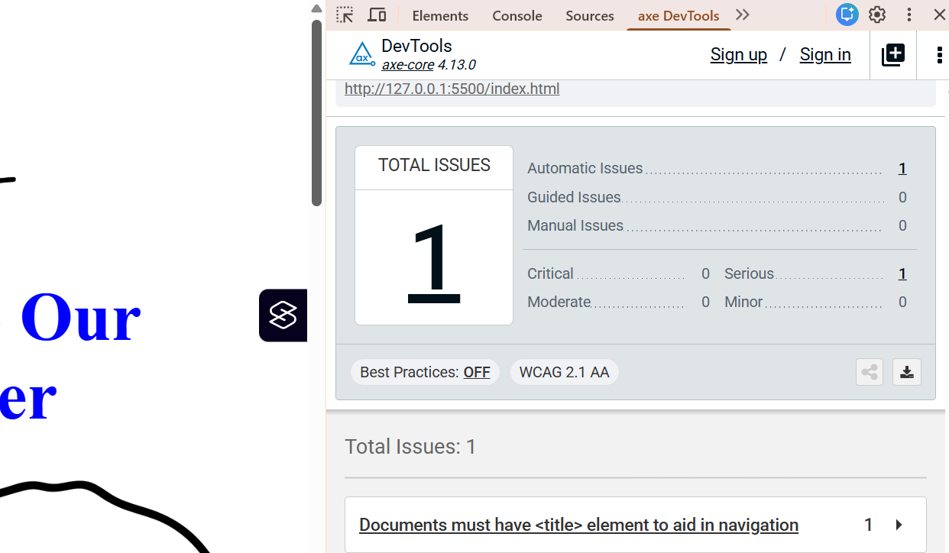
Cons: Many features cannot be used for free. In fact only page scans are available in the extension for free. Not recommended for those not willing to pay for all features.
Chrome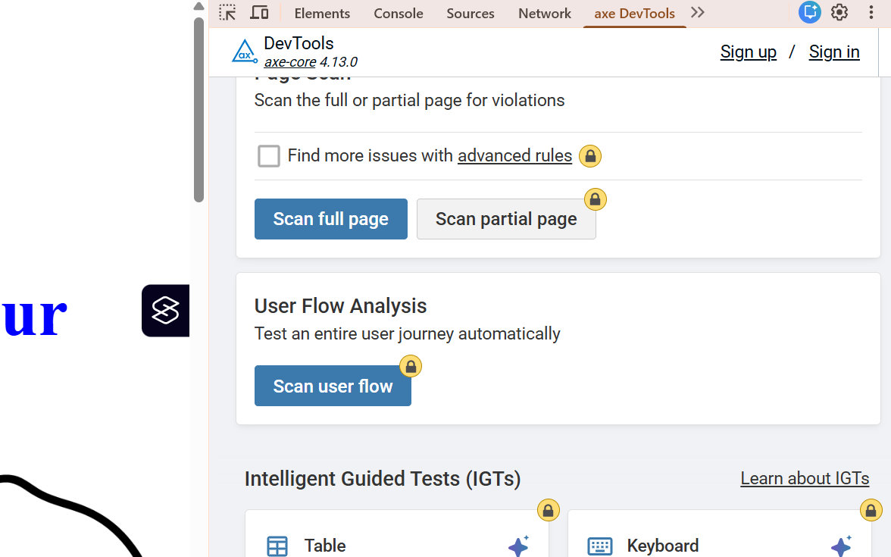
Pros: Element panels allow effective inspection of DOM nodes by focusing the elements on the DOM tree. Unlike other tools, you are allowed to modify elements and attributes. You can toggle element states, explore event listeners. Audit panel runs tests on accessibility among other things. Easy and free with right click inspect.
Cons: When modifying attributes, you will not get feedback. The DOM breakpoints and properties tabs are not keyboard accessible. Difficult to navigate between panels and tools. Better geared towards developers rather than users.
