Tools
Campaign Monitor/ none2.createsend.com
CSS page is very in-depth about what is supported and what is not. You can look up your CSS to see if it is supported by the intended client. Label and radio inputs not supported by gmail. Preview lets me compare emails in desktop vs mobile devices, but not much on comparison for different clients
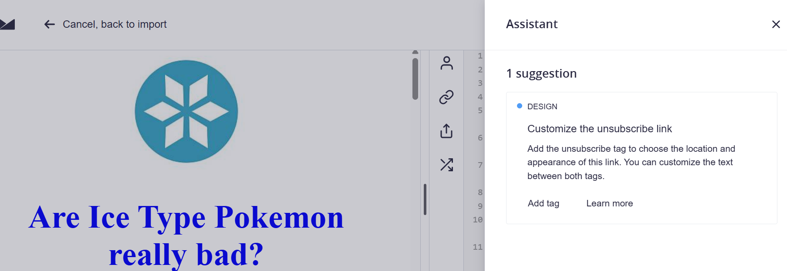
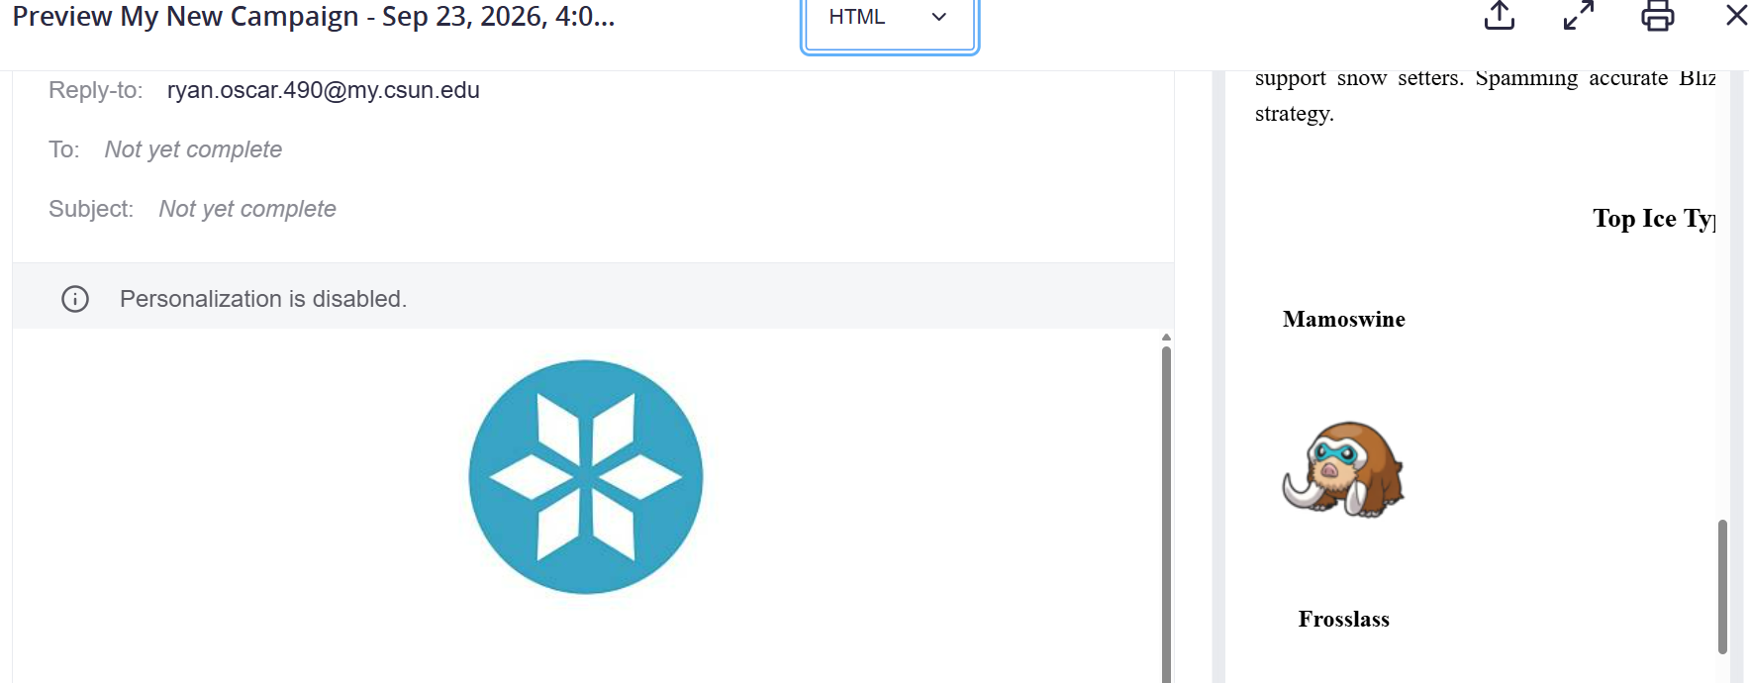
Email on Acid/ Mailgun
Can better preview compare email in many different clients at once. Easy button to swap client previews. However, the site does not give any information on CSS and what clients support which. Email and all its elements look fine in Apple Mail. In Iphone, images often don’t make it. Images also cannot be displayed in Outlook
