Ryan Otero

Instructor Hamilton

COP 2940

10 October 2019

Service Request Tracker Installation Instructions

1. Unzip ROtero_ServiceRequestTracker.zip to a user-chosen directory.
2. Navigate to <chosen_dir>\ROtero_ServiceRequestTracker\ServiceRequestTracker\Release
3. Open the web.config file in notepad or any other text editor of choice and change connection string to “<chosen_dir>\ROtero_ServiceRequestTracker\ServiceRequestTracker\Release\database.db” where <chosen_dir> is the directory that ROtero_ServiceRequestTracker was unzipped to.

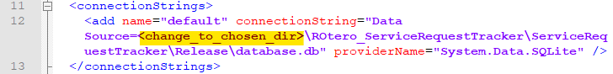

Example:

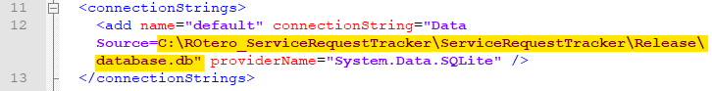

1. Save and close the web.config file.
2. 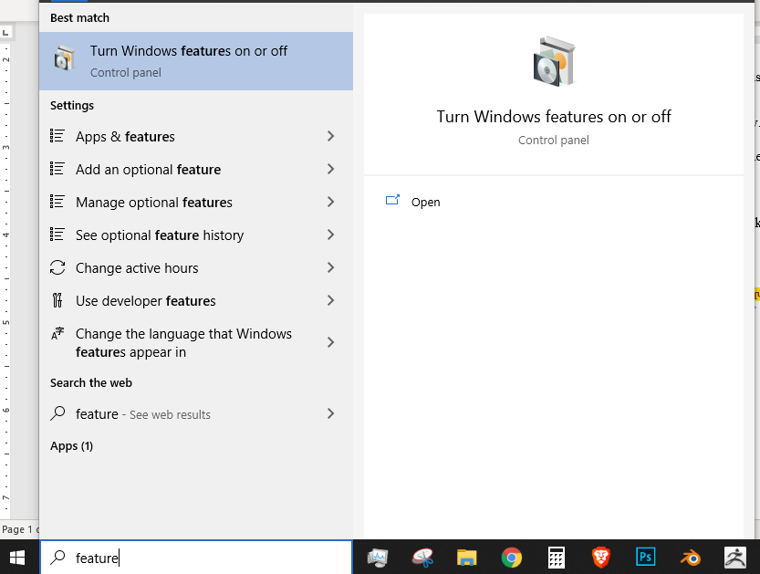If Internet Information Services is enabled, skip to step 7, otherwise search for “feature” on the task bar. Click on “Turn Windows features on or off”.
3. Enable “Internet Information Services”. Click “OK”.

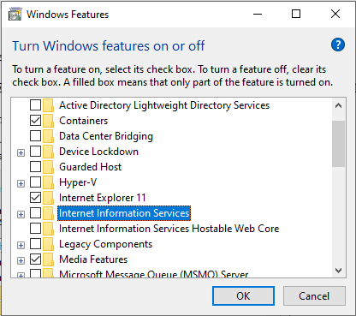

1. If “.NET Extensibility 4.8” is enabled under “Internet Information Services”, skip to step 9, otherwise search for “feature” on the task bar. Click on “Turn Windows features on or off”.
2. 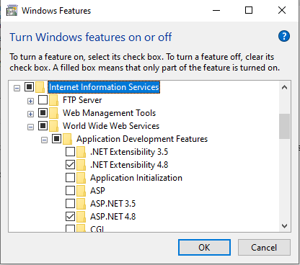Expand “Internet Information Services”. Expand “World Wide Web Services”. Expand “Application Development Features” and enable “.NET Extensibility 4.8”. Click “OK”.
3. Launch Internet Information Services by typing “IIS” into the task bar and pressing enter. Expand the localhost connection (labeled “WHITERANGER (WHITERANGER\Ryan)” in the example) in the “Connections” pane. Right-click Sites and click “Add Website…”

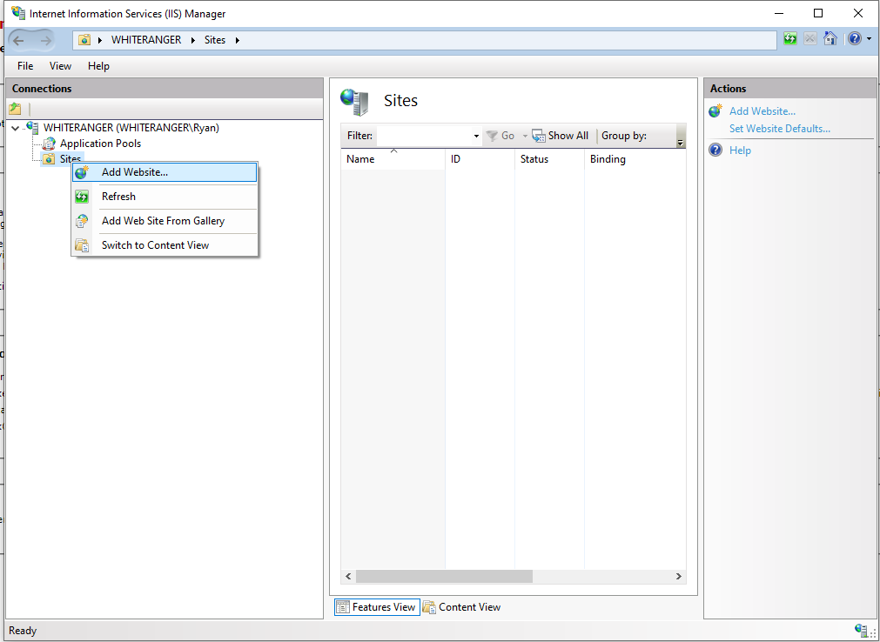

1. Type “ServiceRequestTracker” into the “Site name:” textbox. Type “<chosen_dir>\ROtero_ServiceRequestTracker\ServiceRequestTracker\Release” into the “Physical path:” textbox and click “OK”.

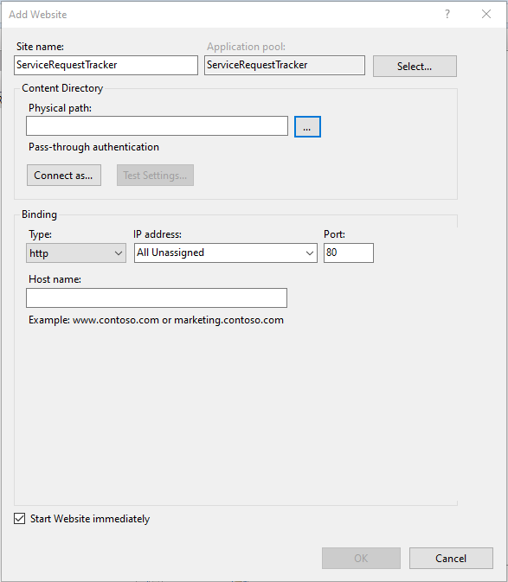

1. Right-click on ServiceRequestTracker under “sites” in the “Connections” pane. Click on “Edit Permissions…”

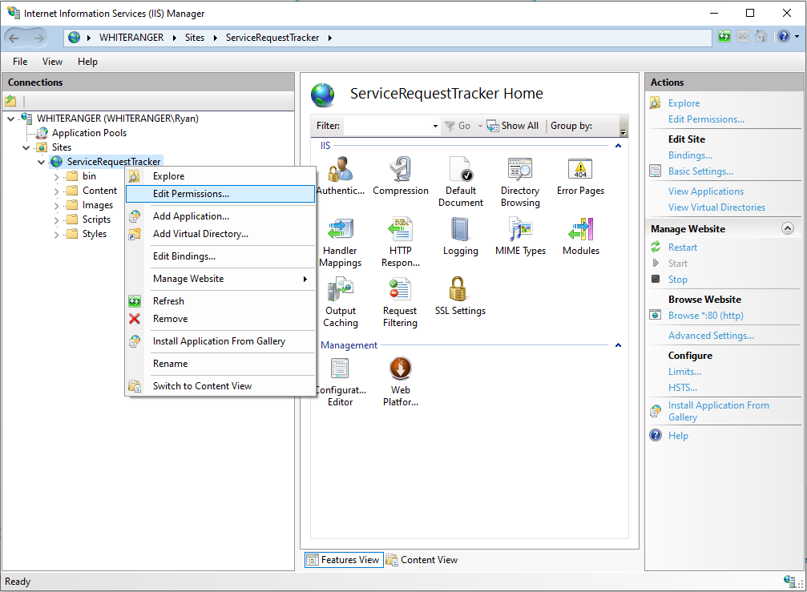

1. Click on the “Security” tab in the “Properties” window. Click “Edit…”. Click “Add…”. Type “IIS AppPool\ServiceRequestTracker; IUSR;” into the “Enter the object names to select (examples):” textbox and click “OK”.

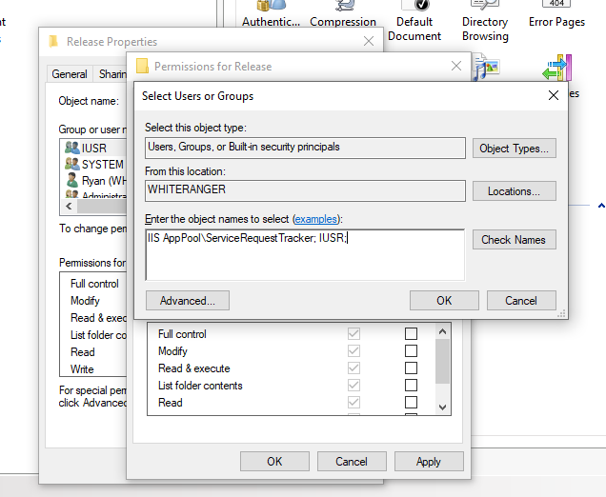

1. Click on IUSR in the “Group or user names:” pane. Click the “Full control” check box under the “Allow” column in the “Permissions for IUSR” pane. Repeat this step for ServiceRequestTracker in the “Group or user names:” pane. Click “OK” in the Permissions window and then click “OK” again in the Properties window.

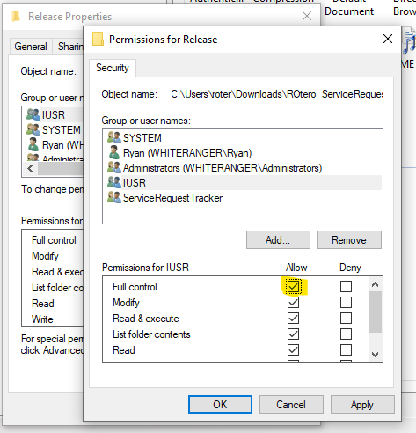

1. Open an internet browser and enter “localhost” into the address bar to open the Service Request Tracker.

