CHAPTER 3
METHODOLOGY
In this chapter, the methodology will be discussed the strategies and procedures used in conducting the study such as research design, participant selection, data collection methods, and data analysis procedures.
3.1 Research Design
3.1.1 Type of Research
To fully comprehend the study, the researchers employed a developmental and mixed-method research approach. Developmental research was utilized to systematically assess and refine the eSAS system's design and functionality, focusing on practical application and iterative improvement. This method allowed for continuous feedback and adjustments, ensuring the system's features and performance were effectively aligned with user needs (Richey & Klein, 2007).

Complementing this, a mixed-method approach combined qualitative and quantitative research to provide a comprehensive evaluation. Qualitative research explored non-numerical data, such as user feedback and experiences, to understand perceptions and gather in-depth insights. Quantitative research analyzed numerical data, including engagement metrics and performance statistics, to objectively measure the system's effectiveness. This integration of methods offered a well-rounded perspective on the eSAS system's impact and user satisfaction.
3.2 Research Design Approach
The researchers employed the Agile methodology for the study as it aligned perfectly with the nature of the research and effectively addressed the objectives. Following the six fundamental steps of requirement analysis, planning, designing, development, release, and tracking and monitoring, the Agile approach allowed the study to advance through the research process, ensuring continuous feedback, adaptability, and timely delivery of outcomes.
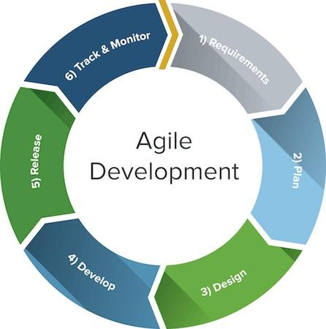

Source: (Anon 2022)
Figure 1. Agile Methodology

Requirement Analysis
Before proceeding with the steps, the researchers-initiated contact with the Admin of Student Affairs and Service, to introduce and present the proposed project and discussed the objectives, scope, and expected deliverables. Following this initial approach, the researchers were delighted to receive the SAS admin agreement to proceed with the project. After that, the researchers conducted interviews with the admin and staff to gather additional essential information required for this research. The researchers wrote a letter addressed to the SAS admin asking permission to access the Club's data and information.

Planning
The Gantt chart is a useful tool for planning the sequence of tasks as the study is being developed. Starting with information gathering and brainstorming, the researchers carefully gathered data and performed interviews with the intended user and location. The researchers were able to form the study goals as a result and gather insightful information. The Gantt chart ensured a well- structured and ordered strategy, supporting efficient progress throughout the study by visually stating the order of tasks.

Design
In this phase, the researchers used Visual Studio Code 2019 to develop the system. The icons were sourced from the Font Awesome website and the charts were integrated using CDN data tables with a combination of JavaScript and JQuery to ensure a visually appealing display.

Implementation, coding or development

Figure 4. Code Snippet of System

During the development stage, the researchers opted for Visual Studio Code as their primary framework. They employed PHP as the main backend language, while for making the layout and interface, they use Bootstrap, complemented by the versatility of JavaScript and the functionality of JQuery, the researchers also used the mySql and Xampp server. An example php file in the Visual Studio Code is shown in the figure above.
Testing
This phase involves the system’s development to test its functionality. The researchers conducted tests to ensure the there are no errors are found.
Deployment
Finally, the researchers present their final output to the course instructor and panel for approval through presentation and system demonstration. A PowerPoint was used for the presentation to show the properties and functions of the system. To evaluate the system’s quality the researchers used ISO 25010:2011, this will identify the quality features of the system.
3.3 Hardware and Software Specification
The following are the hardware and software specifications of the project. These were requirements for the implementation and design of the application.
3.3.1 Hardware Specification for Development
The table below reflects the hardware components of the project that will be used during the development phase.
Table 1. Hardware Development Specification
HARDWARE (LAPTOP) | SPECIFICATION
Processor | Atleast Intel(R)  Core(TM) 13-7100 @  3.90GHz. (4 CPUs),  ~3.9GHz
Installed RAM | At least DDR3 8GB RAM
System Type | 64-bit Operating System, x64-based processor

3.3.2 Software Specification for Development
Table 2 discusses the software specification that will be used to develop the system.
Table 2. Software Development Specification
Software | Specification
Operating System | Windows 10
WampServer | 2.4x86

3.3.3. Hardware Specification for Deployment

Table 3 discusses the hardware specifications that will be used during the systems’ deployment stage.
HARDWARE | SPECIFICATION
Processor | At least AMD A6-7480 Radeon R5, 8 Compute Cores 2C+6G 3.50 GHz or higher
Installed RAM | At least 8.00GB or higher
System Type | 64-bit Operating System, x64-based processor

3.3.4. Software Specification for Deployment
Table 4 discusses the software specifications that will be used during the systems’ deployment stage.

Table 4. Software Specification for Deployment

SOFTWARE | SPECIFICATION
XAMPP | v3.3.0
Google Chrome | V 120.0.6099.71 (64-bit)
Microsoft Edge | V 120.0.2210.121 (64-bit)
Brave | V 1.60.125 (64-bit)
Operating System | Windows 10 v21H3

3.4 System Design Architecture
This design showcases the overall program flow and system architecture
of the system. It provides a visual representation of how the system operates
and describes its operational mode. The Barangay Secretary will be able to login
and enter the dashboard where she can manage barangay staff, generate reports,
insert profiled residents and household and generate reports for the decision
support system. Meanwhile, the Barangay Captain can also login but can only
view the dashboard.

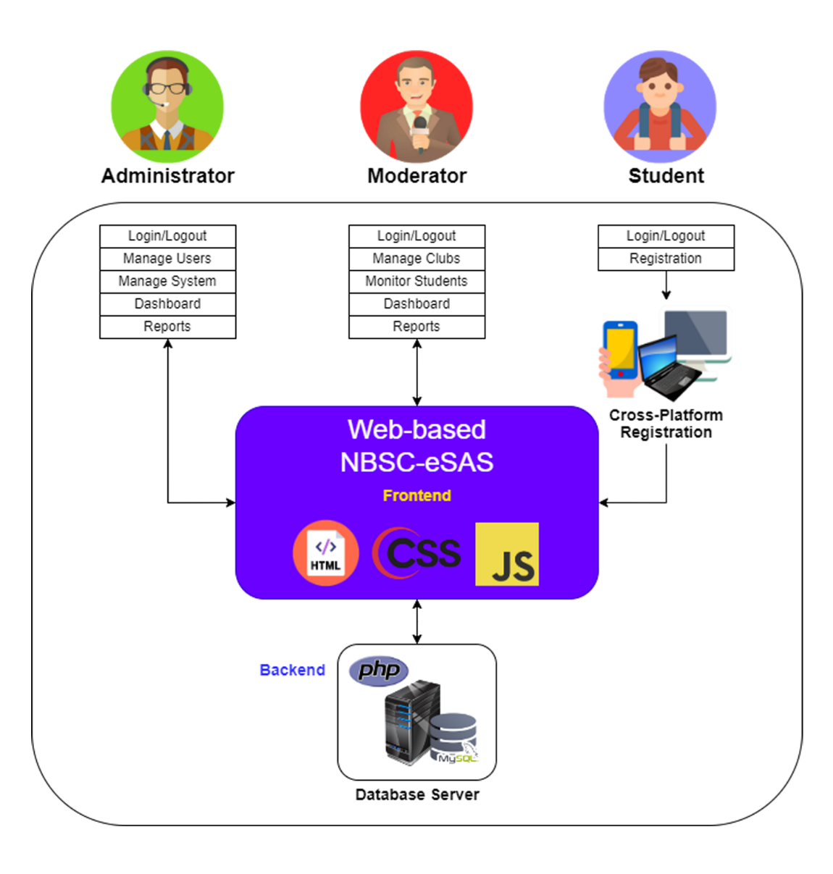
Figure 3. System Architecture
3.5 System Diagrams
Use-Case Diagram
The researchers used a Use-Case Diagram to describe what the system does and how the user interacts with it.

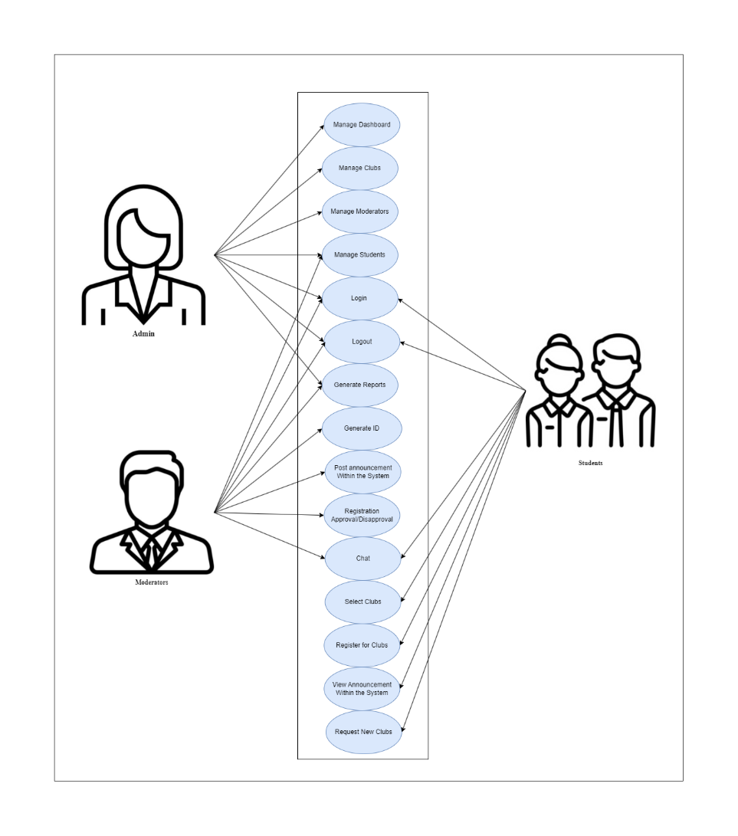
Figure 4. Use Case Diagram

Entity Relationship Diagram
The entity-relationship diagram depicts the relationship between the features
of the system.
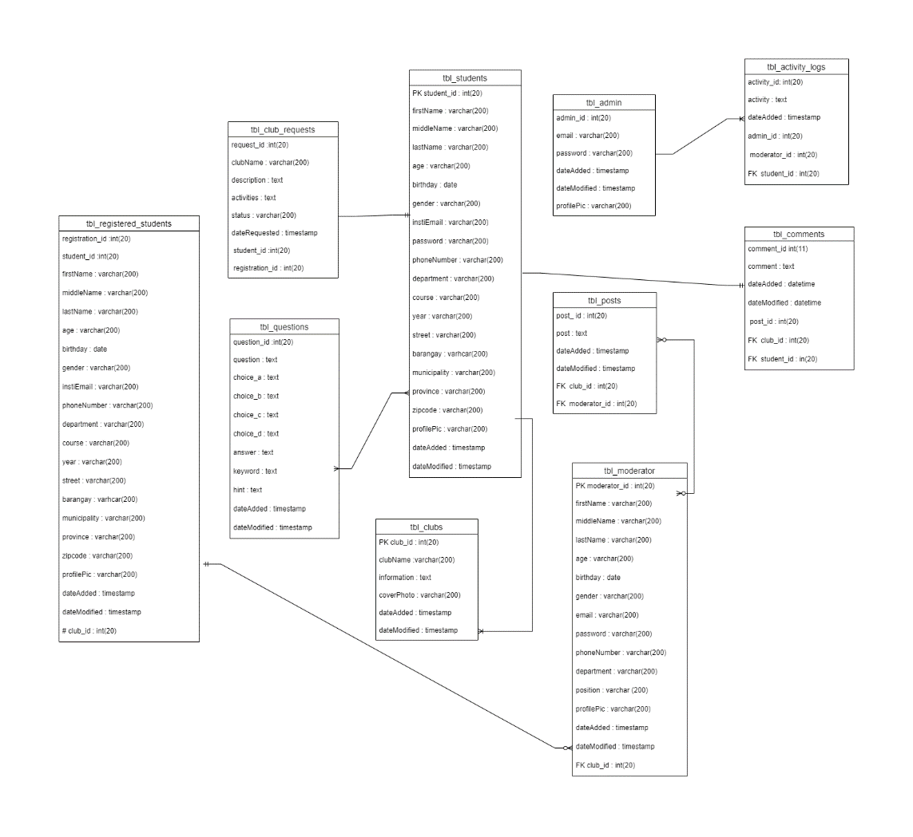

Figure 5. Entity Relationship Diagram

3.5 System Evaluation
The evaluation portion is to determine the feedback of the users and keep assured on the quality of the final output. ISO/IEC 25010 is used for the system evaluation given to the participants. The proponents chose two (2) respondents to test the application and gathered their feedback by letting the respondents answer the prepared research instrument.

Table 3. ISO/IEC 25010 Survey Test

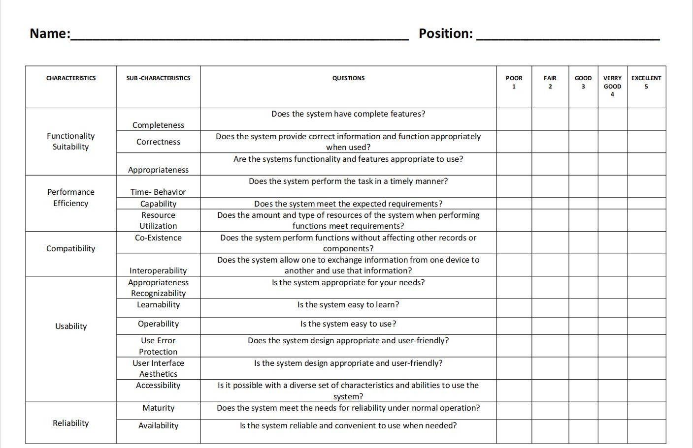

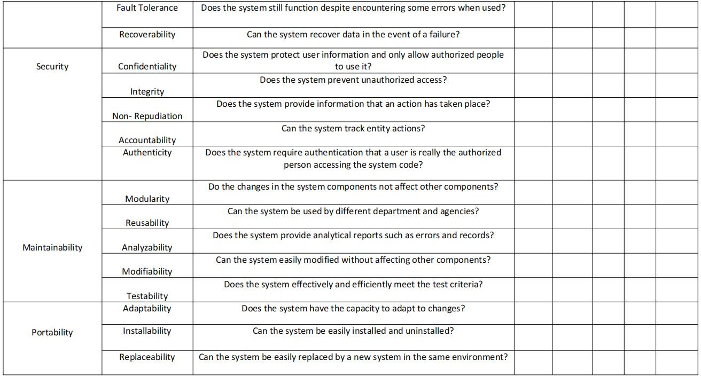

Table 6 shows the ISO/IEC 25010 Survey Test that was used during the evaluation of the system.

3.6.2 Distribution of Respondents

Table 7. Distribution of Respondents
Respondents | No. | Percentage
Total:
Table 7 shows the total number of respondents.

