# TABLE OF CONTENTS

**TABLE OF CONTENTS 1**

**Tables and Figures 2**

- Frequency Table 2

- Stem and Leaf 2

**Formulas 4**

1. Box and Plot 4

2. Trimean 5

3. Geometric Mean 5

4. Trimmed Mean 5

5. Pearson’s correlation 5

6. Probability of a Single Event 5

7. Probability of 2 or more independent events 5

8. Probability of 2 or more dependent events 5

9. Permutations 5

10. Combinations 6

11. Binomial Distribution 6

12. Poisson Distribution 6

13. Multinomial Distribution 6

14. Hypergeometric Distribution 7

15. Variance and Standard Deviation 7

**Step-by-Step Tutorials 8**

- One Way ANOVA - Independent Measures 8

- Two Way ANOVA 11

**Links 15**

# Tables and Figures

## Frequency Table

| **Previous Ownership** | **Frequency** | **Relative Frequency** |
| --- | --- | --- |
| None | 85 | $\frac{85}{500}=0.17$ |
| Windows | 60 | $\frac{60}{500}=0.12$ |
| Macintosh | 355 | $\frac{355}{500}=0.71$ |
| Total | 500 | $\frac{500}{500}=1$ |

## Stem and Leaf

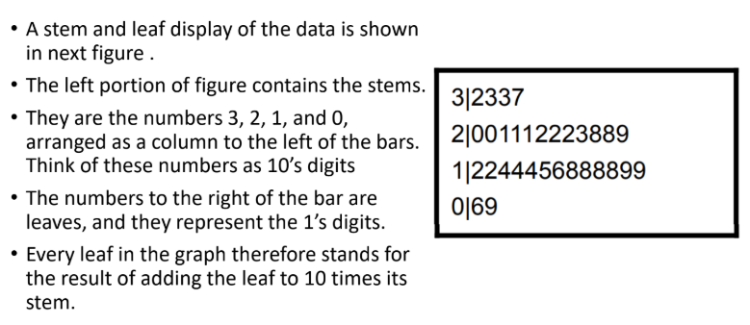

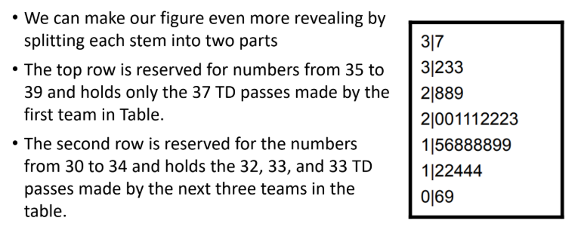

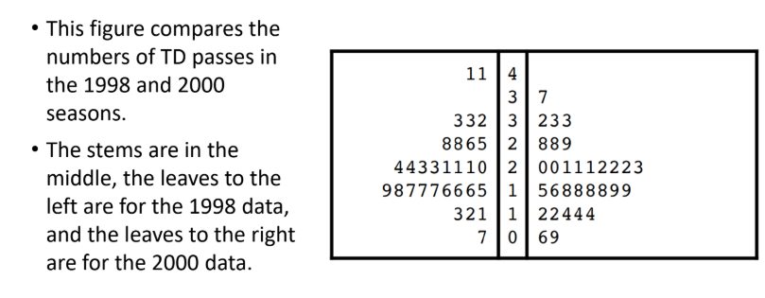

## 

# Formulas

## Box and Plot

| **Name** | **Formula** |
| --- | --- |
| 25th Quartile / Lower Hinge | $\frac{(n+1)}{4}$ th term |
| 50th Quartile / Median | When n is odd: $\frac{(n+1)}{2}$ th term  When n is even: $\frac{(\frac{n}{2})th term +( (\frac{n}{2})+1)th term}{2}$ |
| 75th Quartile / Upper Hinge | $\frac{3(n+1)}{4}$ th term |
| IQR / H-spread | Upper Hinge - Lower Hinge |
| Step | $1.5×HSpread$ |
| Upper Inner Fence | Upper Hinge + 1 Step |
| Lower Inner Fence | Lower Hinge - 1 Step |
| Upper Outer Fence | Upper Hinge + 2 Step |
| Lower Outer Fence | Lower Hinge - 2 Step |
| Upper Adjacent | Largest value below Upper Inner Fence |
| Lower Adjacent | Smallest value below Lower Inner Fence |
| Outlier | Values beyond Upper and Inner Fence |
| Extreme outlier | Values beyond Upper and Outer Fence |
| Outside Value | A value beyond an Inner fence but not beyond an Outer Fence |
| Far Out Value | A value beyond an Outer Fence |

## Trimean

$Trimean = \frac{Q_{1}+2Q_{2}+Q_{3}}{4}$

## Geometric Mean

$\underline{x} geom=\sqrt[n]{x_{1}×x_{2}× ... ×x_{n}}$

## Trimmed Mean

* Remove the values in the bottom X% and top X% of the dataset. Then, calculate the mean of the remaining values.

## Pearson’s correlation

* $r=\frac{Σxy}{\sqrt{Σx^{2}Σy^{2}}}$, where x is $X-\underline{X}$ and y is $Y-\underline{Y}$

## Probability of a Single Event

$probability=\frac{possible outcomes}{total outcomes}$

## Probability of 2 or more independent events

$P(A and B) = P(A) × P(B)$

## Probability of 2 or more dependent events

$P(A or B) = P(A)+ P(B) - P(A and B)$

* It covers 3 possibilities:

1. A occurs and B doesn’t occur
2. B occurs and A doesn’t occur
3. Both A and B occur

## Permutations

* Used when the order matters
* nPr =

## Combinations

* Used when the order doesn’t matter
* nCr =

## Binomial Distribution

$P(x)=\frac{N!}{x!(N-X)!}π^{x}{(1-π)}^{N-x}$

* N = number of trials
* x = number of successes
* $π$ = probability of success
$mean = N × π$

* $σ^{2}=Nπ(1-Π)$ → variance

## Poisson Distribution

* A discrete (countable) probability distribution, used to predict the number of times an event occurs.
$p=\frac{e^{-μ}μ^{x}}{x!}$

* e = base of natural logarithms (2.7183)
* $μ$ = mean number of successes
* x = number of successes in question
* example:

The mean number of calls to a fire station on a weekday is 8.

The probability that on a given weekday there would be 11 calls:

$p=\frac{e^{-8}8^{11}}{11!}=0.072$

## Multinomial Distribution

* Obtains a specific set of outcomes when there are k possible outcomes for every event.
$p=\frac{n!}{(n_{1}!)(n_{2}!)...(n_{k}!)}p_{1}^{n1}p_{2}^{n2}...p_{k}^{nk}$

* p = probability
* n = total number of events
* n1 = number of times Outcome 1 occurs
* nk = number of times Outcome k occurs
* p1 = probability of Outcome 1
* pk = probability of Outcome k

## Hypergeometric Distribution

* Used to calculate probabilities when sampling without replacement
$p=\frac{{}_{k}C_{x}{}_{(N-k)}C_{(n-x)}}{{}_{N}C_{n}}$

* k = total number of successes in the population
* x = number of successes in the sample
* N = total number of population
* n = number of selection or sampled
* ${}_{k}C_{x}$ = number of combinations of k things taken x at a time

$mean=\frac{nk}{N}$

$sd=\sqrt{\frac{(n)(k)(N-k)(N-n)}{N^{2}(N-1)}}$

## Variance and Standard Deviation

$Variance=σ^{2}=\frac{Σ{(x-\underline{x})}^{2}}{N}$

* $SD=σ=\sqrt{\frac{Σ{(x-\underline{x})}^{2}}{N}}$**→** population
* $SD=σ=\sqrt{\frac{Σ{(x-\underline{x})}^{2}}{N-1}}$**→** sample (for t-test)

## t-test for one sample

$t=\frac{\underline{x}-μ}{\frac{SD}{\sqrt{n}}}$

* $\underline{x}$ = calculated mean
* $μ$ = mean given in the question
* n = number of samples
* df = n - 1
* Reject the H0 if the t value is beyond the t-critical value

1. **t-test for two independent samples**

* To test if the mean of two independent groups are different.
* H0 = $μ_{1}=μ_{2}$

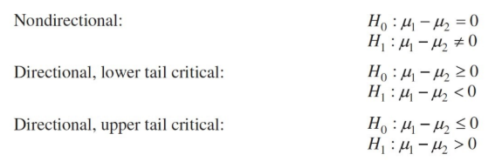

* “improves” → right tailed. Reject H0 if t-value > t-critical value
* “reduces” → left tailed. Reject H0 if t-value < t-critical value

$t=\frac{\underline{xA}-\underline{xB}}{\sqrt{\frac{{SDA}^{2}}{nA}+\frac{{SDB}^{2}}{nB}}}$

# Step-by-Step Tutorials

Reminder: Critical Values and p-values are different variables.

1. Critical Values are obtained from the distribution tables for certain tests:

* t-table ([one-tailed](https://www.statisticshowto.com/tables/t-distribution-table/) / [two tailed](https://www.statisticshowto.com/tables/t-distribution-table/#two))
  + One-tailed t-table critical values only cover left side, so if hypothesis asks for something increasing/involves using >, then it’s 1 - P(X)
  + Two-tailed critical value is +, reject null hypothesis if t-value is within the crit value
* z-table ([negative](https://z-table.com/uploads/2/1/7/9/21795380/9340559_orig.png?ezimgfmt=rs:657x781/rscb1/ng:webp/ngcb1) / [positive](https://z-table.com/uploads/2/1/7/9/21795380/8573955.png?ezimgfmt=rs:657x793/rscb1/ng:webp/ngcb1))
  + Left side describes the first two parts of the decimal of your calculated Z value.
  + Top side describes the hundredths place of your Z value.
* f-table ( ⍺ = [0.10](https://i0.wp.com/statisticsbyjim.com/wp-content/uploads/2022/02/F-table_Alpha10.png?w=814&ssl=1) / [0.05](https://i0.wp.com/statisticsbyjim.com/wp-content/uploads/2022/02/F-table_Alpha05.png?w=817&ssl=1) / [0.01](https://statisticsbyjim.com/wp-content/uploads/2022/02/F-table_Alpha01.png))

1. P-values are more of the probability, which you need to use a calculator to get. Usually, the p-value you can get from the calculated statistic and degree of freedom. After getting the p-value, compare it with the significance level which is the 𝝰.

## One Way ANOVA - Independent Measures

N = Total no. of ppl/objects in the experiment

n = No. of ppl/objects per group

a = No. of experimental groups/conditions

μ = Sample mean

SS = Sum of Squares

1. State Null and Alternate Hypothesis
   * H0 = μ1 = μ2 = … = μn.
   * H1 = Not all μ’s are the same.
2. Find degrees of freedom
   * dfbetween = a - 1 (df numerator)
   * dfwithin = N - a (df denominator)
   * dftotal = N - 1
3. Find critical value with the 2 df’s calculated.
   * [**Calculator**](https://www.socscistatistics.com/tests/criticalvalues/default.aspx) **/** [**Table**](https://statisticsbyjim.com/wp-content/uploads/2022/02/F-table_Alpha05.png)
4. Calculate F-Statistic Value:

**SS Between:**

* + SSbetween = where:
    1. $Σ{(Σa_{i})}^{2}$ is the sum of squared sums of all groups. [(ΣA)2 + (ΣB)2 + … + (ΣZ)2]
* Find total for Group A and square it, find total for Group B and square it, and so on for all groups.
  + 1. T2 is the sum of all elements and then squared[(ΣA) + (ΣB) + … + (ΣZ)]2
* Add all elements together, then square it.

**OR USE THIS:**

Stupid Language Formula:

* SSbetween = n [(mean of every group - grand mean)2  + … + (mean of every group - grand mean)2 ]

**SS Within:**

* + SSwithin = where:
    1. ΣY2 is the sum of each value squared [a2 + b2 + c2+...+z2]

**OR USE THIS:**

Stupid Language Formula:

* Calculate for every group:
* SSwithin (group A) = (every value in group A - mean of group A)2 + … + (every value in group A - mean of group A)2
* SSwithin (group B) = (every value in group B - mean of group B)2 + … + (every value in group B - mean of group B)2
* Continue for all groups
* SSwithin = Sum of all SSwithin groups

**SS Total:**

* + SStotal = SSbetween + SSwithin

1. Find Mean Squares:
   * MSbetween =
   * MSwithin =
2. Calculate F Statistic:
   * F = $\frac{{MS}_{between}}{{MS}_{within}}$
3. Compare F with the Critical Value:
   * If calculated F-statistic > critical value, reject the null hypothesis.
   * If calculated p-value < significance level, reject null hypothesis

## Two Way ANOVA

N = Total no. of ppl/objects in the experiment

n = No. of ppl/objects per group

a = No. of experimental groups/conditions

μ = Sample mean

SS = Sum of Squares

p = number of categories in Group 1

q = number of categories in Group 2

σ = Mean Square

1. State Null and Alternate Hypothesis:
   * H0 = Means across Group 1 is the same
   * H0 = Means across Group 2 is the same
   * H0 = There is no interaction between Group 1 and Group 2
2. Calculate:

* Grand Mean = $\frac{sum of all values}{N}$
* Group 1 Mean = $\frac{sum of values in group 1}{n}$
* Group 2 Mean = $\frac{sum of values in group 2}{n}$
* Mean for every Group 1 x Group 2 combination
  + If Group 1 has m categories, and Group 2 has n categories, you need to find m*n different means.

1. Total:

* SStotal = (x1 - grand mean)2 + … + (xn - grand mean)2
  + x here refers to each and every individual recorded value in the dataset.
* dftotal =
* Mean Square total =

1. Between:

* SSbetween = ((mean of every category - grand mean)2 + … + (mean of every category - grand mean)2)
  + Get the sum first THEN multiply with the n.
* dfbetween =
* Mean Squares between =

1. Group 1:

* SSgroup 1 = (mean of every category for group 1- grand mean)2 + … + (mean of every category for group 1 - grand mean)2
* Dfgroup 1 =
* Mean Squares group 1 =

1. Group 2:

* SSgroup 2 = (mean of every category for group 2- grand mean)2 + … + (mean of every category for group 2 - grand mean)2
* Dfgroup 2 =
* Mean Squares group 2 =

1. Interaction:

* SSinteraction = SSbetween - SSgroup 1 - SSgroup 2
* Dfinteraction = (p - 1) (q - 1)
* Mean Squares interaction =

1. Error:

* SSerror= (every sample - the mean of its respective category)2 + … + (every sample - the mean of its respective category)2
* Dferror = (n - 1) $×p×q$
* Mean Squares error =

1. F-Values:

* F Value Group 1: $\frac{{Mean Square}_{Group 1}}{{Mean Square}_{Error}}$
* F Value Group 2: $\frac{{Mean Square}_{Group 2}}{{Mean Square}_{Error}}$
* F Value Interaction: $\frac{{Mean Square}_{Interaction}}{{Mean Square}_{Error}}$

1. Null Hypothesis:

* Pick either method depending on what ur told to do in the question
* P-Value Method
  + Input into P Value Calculator, find P value.
  + Input F-Value Group 1, Dfgroup 1  (df numerator), and Dferror (df denominator)
  + Continue for F values of Group 2 and Interaction (df denominator is Dferror for all)
  + If value is less than the alpha given in question (in this case 0.05), reject null hypothesis.
  + If any of the f values are greater than the null hypothesis, then fail to reject hypothesis.
* F-Critical Method
  + Find F-Critical Value with calculator.
  + Input alpha (a), Dfgroup 1  (df numerator), and Dferror (df denominator)
  + Find F-Critical Value for Group 2 and Interaction as well.
  + If F value greater than F-Critical, reject null hypothesis. If smaller than, fail to reject null hypothesis.
* **Chi Square**

1. H0 = The 2 groups are independent

H1 = The 2 groups are not independent.

1. Calculate expected Frequency Table:

Eij =

1. Calculate the Chi-Square

For every cell:

X = $\frac{{(Original value -expected frequency)}^{2}}{expected frequency}$

$X^{2}=Sum of all X from all cells$

1. Calculate Degree of Freedom
$df=(no of rows-1)×(no of columns-1)$

2. Get the critical value from the table or get p value with calculator.
3. Reject H0 if $X^{2}$ > critical value.

Reject H0 if p value < significance level.

<https://www.socscistatistics.com/tests/chisquare2/default2.aspx>

# Links

1. 5 Number Summary + IQR + Inner Outer Fence + Outliers + Geometric Mean + Sum of Squares + Standard Deviation (Sample/Population) + Variance Calculator:

* <https://www.hackmath.net/en/calculator/five-number-summary>

1. Trimmed Mean Calculator:

* [Trimmed Mean Calculator](https://www.statology.org/trimmed-mean-calculator/)

1. Permutation Combination Calculator:

* <https://www.calculator.net/permutation-and-combination-calculator.html>

1. Binomial Distribution (Singular and Cumulative):

* <https://stattrek.com/online-calculator/binomial>

1. Pearson's Correlation Coefficient:

* <https://www.socscistatistics.com/tests/pearson/default2.aspx>

1. One Way ANOVA - Independent Measures

* <https://www.socscistatistics.com/tests/anova/default2.aspx>

1. One WAY ANOVA - Repeated Measures

* <https://www.socscistatistics.com/tests/anovarepeated/default.aspx>

1. Single Sample T-Test:

* <https://www.socscistatistics.com/tests/tsinglesample/default.aspx>

1. Chi-Square Test:

* <https://www.socscistatistics.com/tests/chisquare2/default2.aspx>

1. P Value from F-Statistic:

* <https://www.socscistatistics.com/pvalues/fdistribution.aspx>

1. Critical Value for Multiple Tests:

* <https://www.socscistatistics.com/tests/criticalvalues/default.aspx>

1. P Value Calculator and F Critical Table:

* <https://datatab.net/tutorial/f-distribution>

1. Pearson Edexcel Formula Book, Statistics S1, S2 and S3 with complete Z table, Normal Distribution Table, and Statistical Formula(Page 14 - 23)

* <https://qualifications.pearson.com/content/dam/pdf/International%20Advanced%20Level/Mathematics/2018/Specification-and-Sample-Assessment/IAL-Mathematics-Formula-Book.pdf>