Progress Report Document
Carleton University
Department of Systems and Computer Engineering
Course: SYSC 4805 Computer Systems Design Lab
Instructor: Dr. Abdullah Kadri
Team Name: Gold (#D4AF37)
Team Members:
- Ryan Page, 101268082, RyanPage@cmail.carleton.ca
- Neeraj Suchindrum, 101199014, neerajsuchindrum@cmail.carleton.ca
- Neel Patel, 101226947, neelpatel4@cmail.carleton.ca
- Adeyehun Folahnmi, 101237546 folahanmiadeyehun@cmail.carleton.ca

Date Submitted: Nov 14, 2025

Contents
1. Updated Project Proposal (30%) 3
1.1 Updated Project Objectives 3
1.2 Updated Requirements 3
1.2.1 Functional Requirements 3
1.2.2 Non-Functional Requirements 4
1.2.3 Constraints 4
1.3 Updated Work Breakdown Structure 5
1.4 Updated Testing Plan 5
1.4.1 Updated Integration Testing 5
1.5 Updated Schedule 6
2. Overall Architecture (10%) 7
2.1 Hardware Architecture 7
2.2 Software Architecture 8
2.3 System Communication Architecture 9
3. Diagrams (10%) 10
3.1 Statechart Diagram 10
3.2 Sequence Diagrams 13
3.3 Planed Route Diagram 16
4. Watchdog Timer Demonstration (5%) 16
5. Planned Value Analysis (10%) 17
5.1 Adjustments Made 19
6. Working Code on GitHub (10%) 19
7. Unit Testing Results (25%) 20
8. Conclusion 23

1. Updated Project Proposal
This section updates the original project proposal and addresses concerns raised during initial feedback. All clarifications and refinements to the objectives, requirements, testing plans, and scheduling have been incorporated.

1.1 Updated Project Objectives
The objective of this project is to design and build an autonomous snowplow robot capable of clearing a designated arena without any human intervention. The robot must reliably detect, classify, and avoid both stationary and moving obstacles including competing robots while maintaining precise navigation within the indoor boundary. Artificial snow, represented by 20 mm wooden cubes, must be efficiently collected and pushed beyond the perimeter using a mechanically stable plow capable of extending up to 50 mm in width and 30 mm in length. The design prioritizes a lightweight and compact structure that meets all dimensional constraints and minimizes mechanical load during operation.
The robot will begin its operation from a fixed starting corner aligned with one edge of the arena and must complete the clearing task within the five minute competition window while maintaining a safe maximum speed of 30 cm/s. Achieving this performance requires the integration of reliable obstacle detection, accurate orientation tracking, and an optimized coverage strategy that pushes cubes with minimal missed regions.
To accomplish these goals, the system is built using a modular architecture composed of independent yet cooperative subsystems including steering, boundary detection, obstacle detection, real world orientation, and plow control. Each subsystem will be developed, tested, and validated individually before full integration. Robust software components such as a state machine, sensor fusion logic, and real time communication protocols ensure consistent operation under a variety of environmental and competitive conditions.
The final solution must operate predictably and safely, minimize penalties from collisions or boundary violations, maintain compliance with all SYSC 4805 competition rules, and demonstrate reliable and repeatable performance across multiple runs.

1.2 Updated Requirements

1.2.1 Functional Requirements
- [FR1] The robot shall operate only within the black perimeter of the indoor testing arena.
- [FR2] The robot shall only start from a corner inside the perimeter, aligned with one edge of the perimeter.
- [FR3] The robot shall detect and avoid fixed obstacles within the arena.
- [FR4] The robot shall detect and avoid moving obstacles within the arena.
- [FR5] The robot shall push snow blocks to the outside of the perimeter.
- [FR6] The robot shall move all snow blocks out of the perimeter of the arena.
- [FR7] The robot shall handle errors in the system with meaningful error messages.
- [FR8] The robot shall operate autonomously once it is set up in the arena
- [FR9] The robot shall follow a predefined course of action for sweeping the arena
- [FR10] The robot shall immediately stop forward or backward motion when a boundary line is detected.
- [FR11] The robot shall execute a boundary-correction maneuver before resuming navigation.
- [FR12] The robot shall differentiate between snow blocks and obstacles using distance thresholds and sensor readings.
- [FR13] The robot shall select an avoidance path (left, right, or stop) depending on obstacle position and proximity.
- [FR14] The robot shall combine IMU, line sensor, and distance sensor data for decision-making.

1.2.2 Non-Functional Requirements
- [NFR1] The robot shall be reliable and able to complete multiple runs without hardware failure.
- [NFR2] Sensors shall provide sufficient accuracy to detect the black path boundary and obstacles reliably, such that the robot is able to complete runs with an average penalty of 35 cubes or less.
- [NFR3] The robot shall complete moving all snow blocks in 5 minutes or less.
- [NFR4] The robot shall detect obstacles at 20 cm ± 5 cm and maintain a clearance distance of 10 cm ± 2 cm to safely avoid collisions.
- [NFR5] The robot should maintain turning accuracy within ± 10°.
- [NFR6] The robot shall transition into a safe-stop state if critical sensor fails mid-run
- [NFR7] The robot should require less than 30 seconds of setup time before a run
- [NFR8] The robot shall differentiate between stationary obstacles and moving obstacles using sensor readings and detection decisions.

1.2.3 Constraints
- [C1] The robot, including the plow, shall fit within the maximum dimensions of 226 × 262 × 150 mm.
- [C2] The robot’s plow may extend up to 25 mm on each side (maximum 50 mm total in width) and up to 30 mm in length beyond the base robot dimensions.
- [C3] The robot shall not exceed the maximum allowable speed of 30 cm/s.
- [C4] The robot shall not be manually adjusted during operation.
- [C5] The robot shall not push or hit obstacles in the arena.
- [C6] The robot’s wheels shall always remain within +/-5 cm of the boundary line if detected.
- [C7] All sensors and mechanical components must be securely mounted and must withstand vibrations or minor impacts
- [C8] The robot shall operate entirely from battery power for the duration of the run.
- [C9] All components should operate within their specified voltage and current limits.
- [C10] The robot shall not interfere with competing robots or cause intentional collisions.
- [C11] The robot shall comply fully with all the SYSC 4805 competition rules.

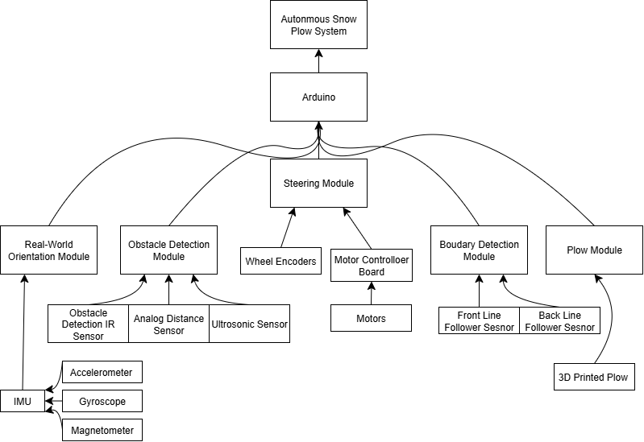
1.3 Updated Work Breakdown Structure
Figure 1 - Updated WBD Structure

1.4 Updated Testing Plan
Testing remains fairly similar to the previous testing plan. Most of the unit tests in the test plan have been implemented with the major exception of the implementation and testing of the real-world orientation module. As it was not implemented, tests were not made for the navigation/GPS of the system.
What remains now are integration tests which should validate that the system works together. Since the system is more simplified, tests for communication between the Due and Nano are not necessary, but the rest of the tests for obstacle detection, autonomous behaviors, and logging remain the same. The motor control tests can also be simplified as 90° turns will only be used for the logic of the system.

1.4.1 Updated Integration Testing
With a better idea on how the system shall function, integrated tests will test motor control, obstacle detection and perimeter validation, autonomous behaviors, and logging.
Motor Control
- Assert that all motors can move in unison
- Assert that the robot can turn 90° left
- Assert that the robot can turn 90° right
Obstacle Detection and Perimeter Validation
- Assert that data from the line following sensor moves the robot accordingly
- Assert that data from the obstacle detection sensors move the robot accordingly to avoid the obstacle
Autonomous Behaviors
- Assert that the robot can travel across and remain within the entire perimeter
- Assert that the robot can reach a given point while avoiding obstacles and staying within the perimeter
- Assert that the robot can push cubes to the edge of a perimeter without overstepping the line
Logging
- Assert that errors from each component is logged and sent to a central serial terminal and/or log file.

1.5 Updated Schedule
13 out the proposed 21 activities are completed. The missing activities are integration tests along with IMU configuration. There were problems with the configuration which will hopefully be resolved in future iterations of the system.
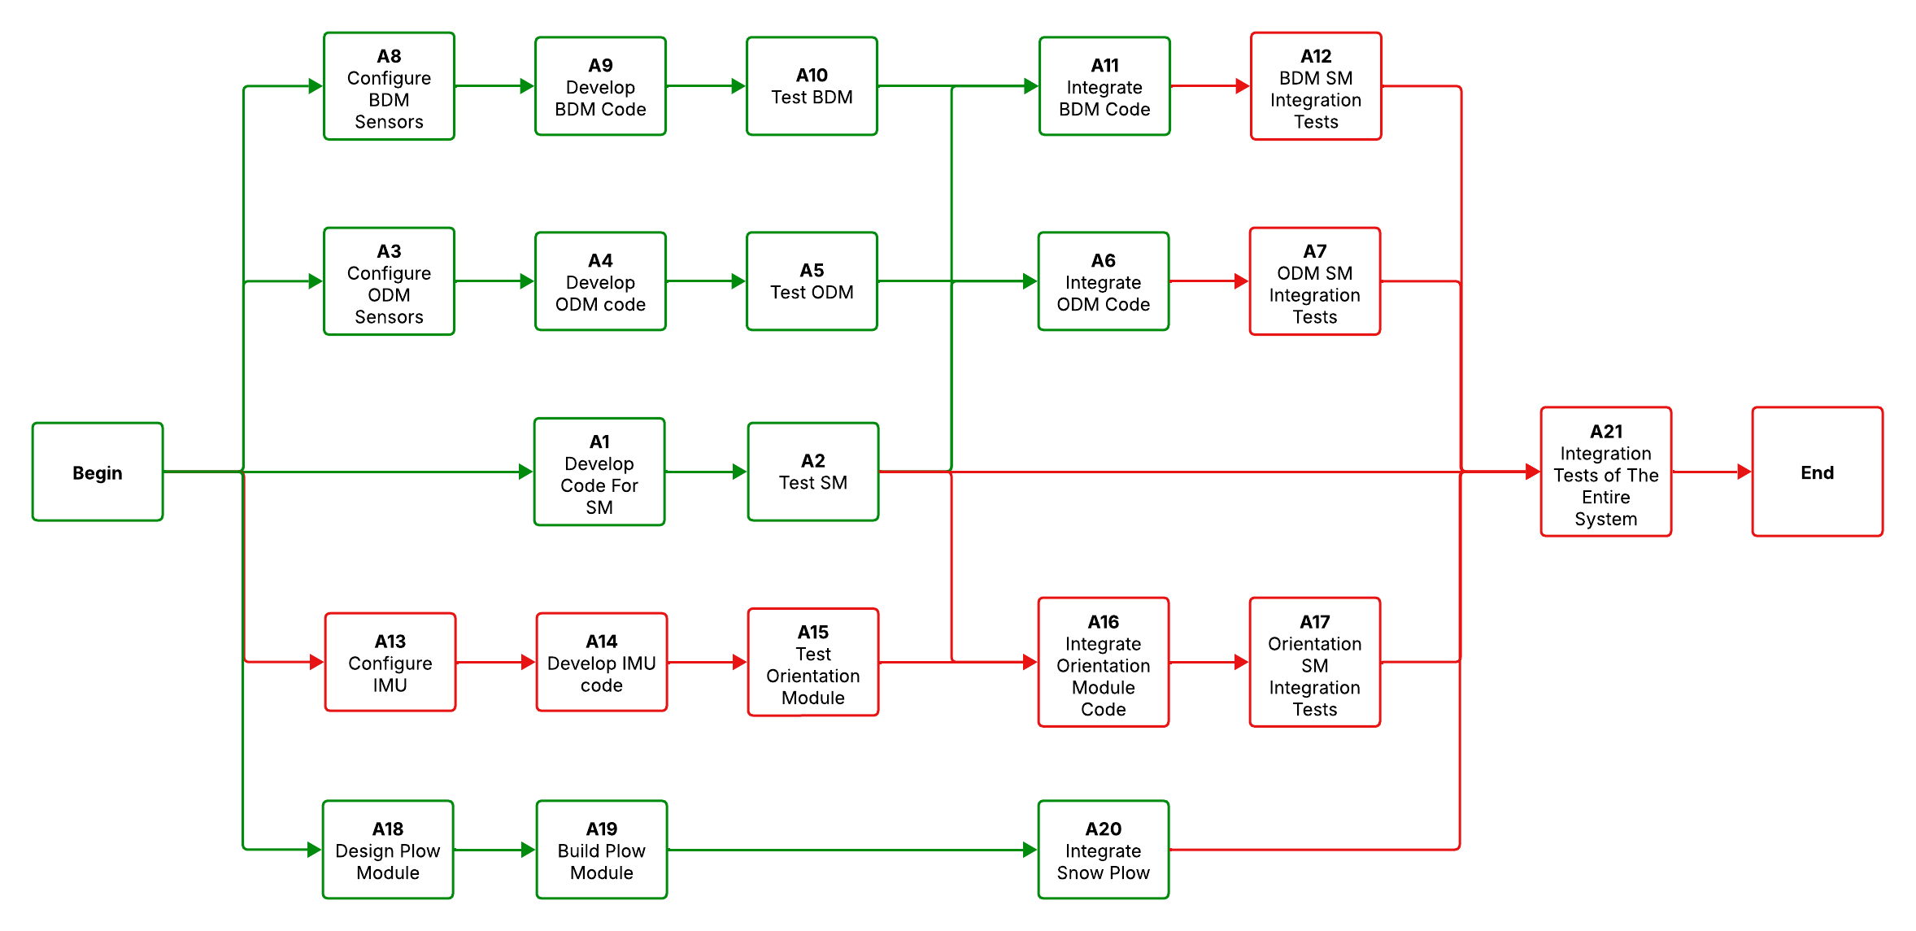Figure 2 - Colour-Coded Schedule Network Diagram (Green = Completed, Red = Incomplete)

The next deliverable is the final demonstration on November 25, which is a hard deadline to complete all major implementation tasks. This includes implementing all final sensors and the implementation of all the system logic.

2. Overall Architecture
This section provides significant expansion to the hardware and software architecture description, offering a deeper understanding of system behavior and module interaction.

2.1 Hardware Architecture
The hardware of the system consists of an Arduino Due, four independent DC motors that are driven by the Cytron motor driver, and a lean number of sensors. There is an ultrasonic sensor in the front, two Sharp GP2Y0A51SK0F distance sensors on the left and right side, and two line following sensors in the front and back. All of this creates a simple system that should still be capable of meeting the requirements of the system.
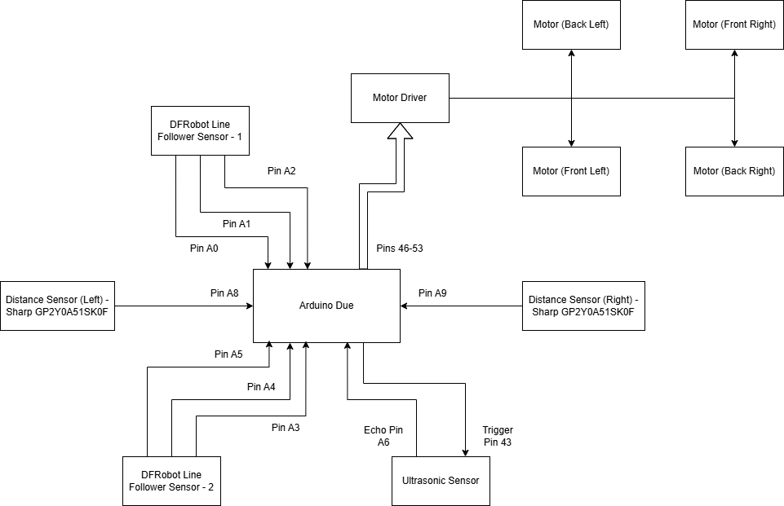
Figure 3 - Hardware Architecture of the System

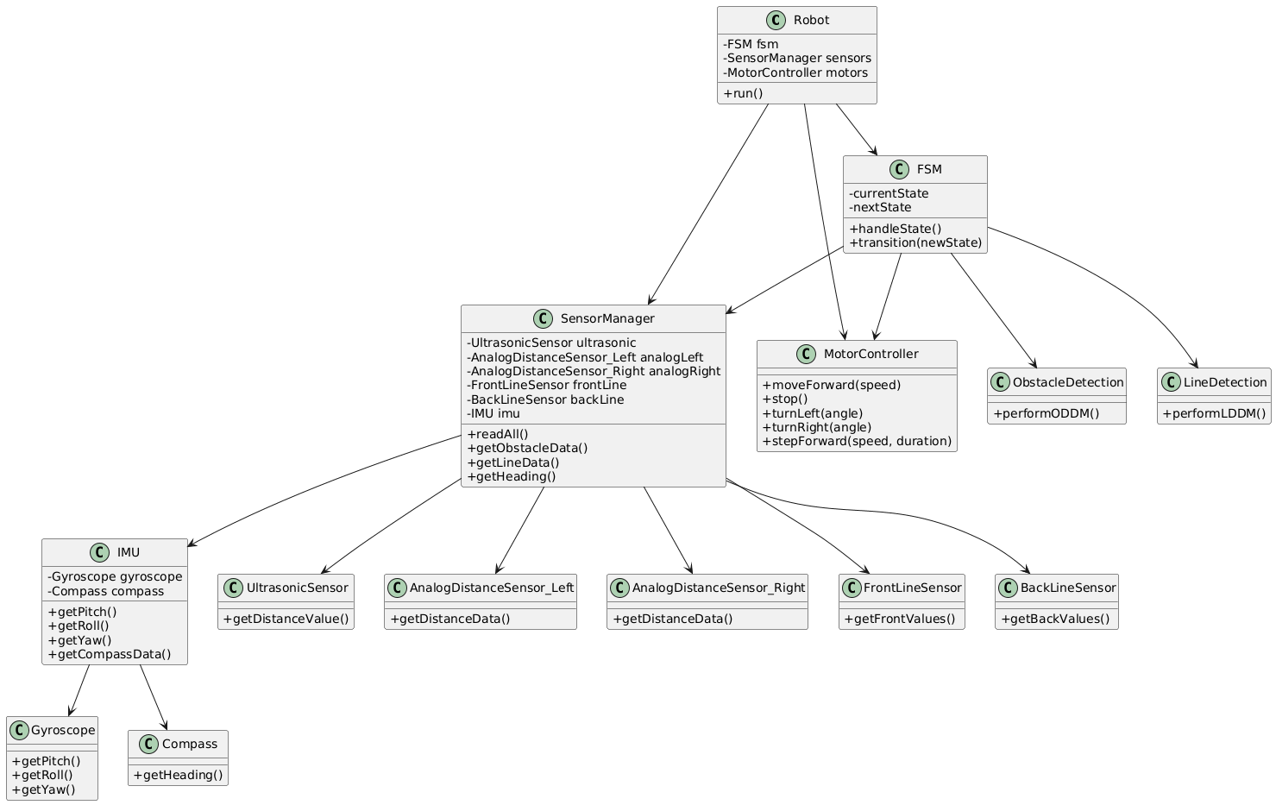
2.2 Software Architecture
Figure 4 - Software Architecture of the System

At the top level, the Robot class acts as the main controller responsible for initializing all subsystems and running the control loop. It works closely with the FSM (Finite State Machine) class, which manages the robot’s six operational states, including start-up, movement, obstacle handling, and line detection. All transitions and behavior decisions pass through the FSM, ensuring predictable and traceable robot behavior.
The SensorManager class aggregates all sensing hardware into a single access point. This includes the ultrasonic sensor for front-distance measurement, two analog distance sensors for left and right obstacle detection, a front- and back-line sensor for boundary monitoring, and the IMU module for orientation and heading estimation. By centralizing sensor access, the Robot and FSM classes can retrieve all necessary environmental data without directly referencing individual sensors.
The robot’s motion is controlled by the MotorController, which provides functions for moving forward, stopping, turning, and performing step-based movements used in both obstacle avoidance and boundary correction maneuvers. Higher-level decision modules like the ObstacleDetection and LineDetection, implement the ODDM and LDDM state behaviors. These classes use sensor data from the SensorManager and invoke motor commands to perform coordinated correction sequences when obstacles or boundary lines are detected.
Supporting the IMU system, the IMU class composes a Gyroscope and Compass. The gyroscope provides pitch, roll, and yaw information, while the compass returns heading. This layered structure allows the FSM and correction modules to access orientation data cleanly and consistently.
Overall, this architecture ensures that sensing, decision-making, and actuation remain logically separated while still functioning cohesively. The result is a robust, maintainable system capable of safely navigating the arena, avoiding obstacles, and adhering to competition constraints.

2.3 System Communication Architecture
The brain of the system is the Arduino Due. It receives basic analog or digital signals from sensors that do not use a specific communication protocol. This informs the system to move accordingly by sending PWM and digital signals to the motor driver.
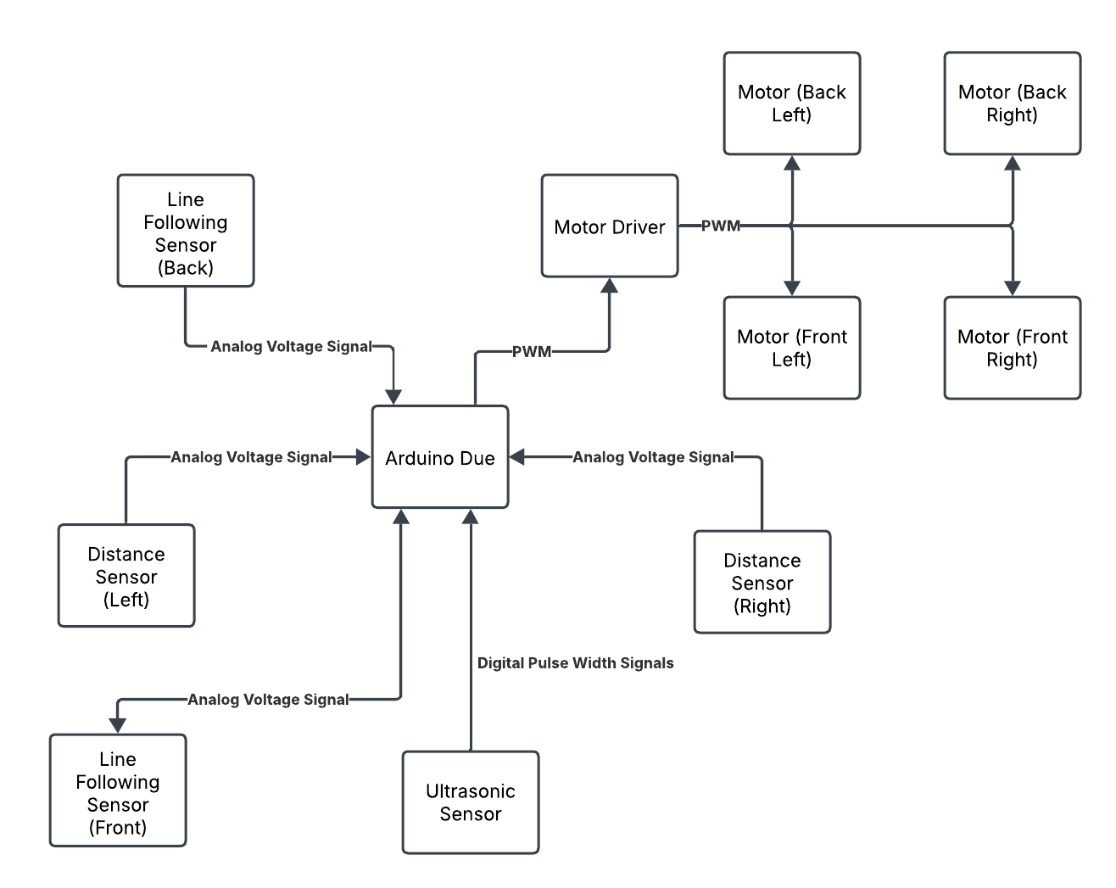
Figure 5 - Communication Diagram of System

3. Diagrams

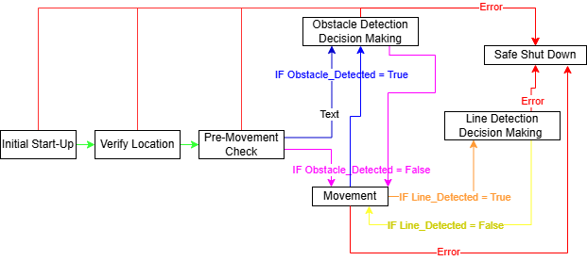
3.1 Statechart Diagram
Figure 6 - FSM Diagram (Main Loop)

Roboplow’s finite state machine has seven core states that regulate the robot’s behavior throughout an entire run. Each state is responsible for a specific operational function such as startup, movement, obstacle handling, or boundary response. By organizing the robot’s actions into these well-defined states, the system ensures predictable behavior, efficient decision-making, and safe autonomous operation within the arena.
State 1. Initial Start-Up
The Initial Start-Up state is the first state the robot enters when powered on. During this stage, the system activates all hardware components and allows time for sensors and microcontrollers to stabilize. The robot remains completely stationary in this state, and after 5 seconds it should transition to the next state.
State 2. Verify Location
In the Verify Location state, the robot determines its exact starting corner and orientation using both the digital compass and gyroscope. This state ensures the robot is placed correctly in one of the four allowable arena start positions: Top-Left Corner (TLC), Top-Right Corner (TRC), Bottom-Right Corner (BRC), or Bottom-Left Corner (BLC).
The line sensors confirm that the robot is placed inside a corner boundary, while the LIS3MDL compass and gyroscope confirm the robot’s orientation relative to the arena axes. This ensures the robot is facing an allowed direction before the run begins. For example, if the robot identifies that it is in the Top-Left Corner (TLC), it may start the run while facing either South or East, depending on the detected heading.
State 3. Pre-Movement Check
In the Pre-Movement Check state, the robot evaluates the distance values before performing any movement. If the distance values from the ultrasonic sensor and analog distance sensor seem to be detecting an obstacle, we will need to transition to ODDM. While if the values aren’t detecting anything then it can transition to Movement State.
State 4. Movement
The movement state is a large loop which performs 3 actions. If we are here the robot will initially move forward about 36 cm and stop moving the motors. Then it will look at the distance sensor values to determine if obstacles are present, if yes then transition to ODDM, if not then stay in loop. Finally, the third action performed is viewing the values of the Line Detection Sensors, if either front or back detects a line then the state will transition to LDDM and if no line is detected then it will process in the loop back to action 1. Figure 6 in section 3.2 shows this state in a sequence diagram, showing the different possibilities.
State 5. Obstacle Detection Decision Making (ODDM)
The Obstacle Detection Decision Making state is triggered whenever the robot detects an obstacle using its ultrasonic or analog distance sensors. In this state, the robot evaluates which sensor detected the object, how close the object is, and whether the obstacle is stationary or moving. The robot begins by analyzing real-time distance readings to determine the obstacle’s position relative to its current path.
Based on this information, the robot selects an appropriate avoidance maneuver. For our planned navigation strategy, one of the common avoidance routines proceeds as follows:
- Turn 90° to the right to begin moving around the obstacle.
- Move forward until the side sensor no longer detects the object, counting the number of forward steps taken.
- Turn 90° to the left and continue moving forward until the opposite side sensor no longer detects the obstacle.
- Turn 90° to the left again, now returning to the original direction of travel.
- Move forward the same number of counted steps to realign with the original path.
- Turn 90° to the right to restore the robot’s initial orientation.
This structured maneuver enables the robot to safely bypass obstacles while maintaining its planned path alignment. Once the obstacle has been fully avoided and no sensors detect it from any direction, the robot transitions back into the Movement state to continue its normal operation. Figure 7 and 8 in the section 3.2 below in sequence diagram, showing one protentional maneuver.
State 6. Line Detection Decision Making (LDDM)
The Line Detection Decision Making state is triggered whenever the robot’s line sensors detect the black boundary line of the arena. This state ensures that the robot does not cross the perimeter or incur penalties during operation. Upon entering this state, the robot immediately stops all forward motion to prevent accidental boundary violations and then performs a boundary correction maneuver.
Although several correction strategies can be used, the most common maneuver for our planned navigation pattern occurs when the front-line sensor detects a line directly ahead. In this scenario, the robot executes the following sequence:
- Back up slightly to move away from the boundary.
- Turn 90° left to face parallel to the line.
- Move forward a short distance to shift toward the next planned path lane.
- Turn 90° left again, now facing inward toward the arena.
- Back up slightly to center itself on the new lane.
- Transition back into the Movement state.
This maneuver ensures the robot aligns itself correctly after encountering a boundary line and allows it to continue following its systematic lane-by-lane clearing pattern. The robot confirms that it has successfully followed one full line of the path before executing the turning sequence to advance to the next row in its coverage pattern. Figure 9 and 10 in the section 3.2 below in sequence diagram, showing one protentional maneuver.
State 7. Safe Shut Down
The Safe Shutdown state is activated whenever a critical fault is detected in any state of the FSM. This includes sensor failures, communication errors, invalid readings, or any condition that could compromise safe operation. When triggered, the robot immediately stops all motor activity and shuts down power to components to prevent damage or unsafe behavior. This state ensures that the robot remains stationary and secure until it is manually reset or powered off.

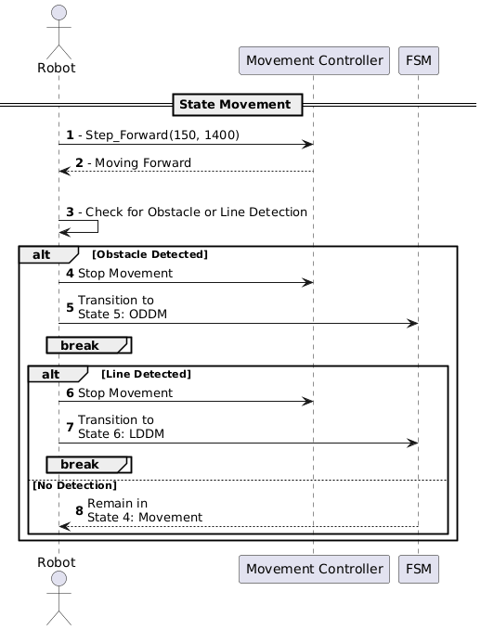
3.2 Sequence Diagrams
Figure 7 - Sequence Diagram for State 4. Movement (Described in Section 3.1)
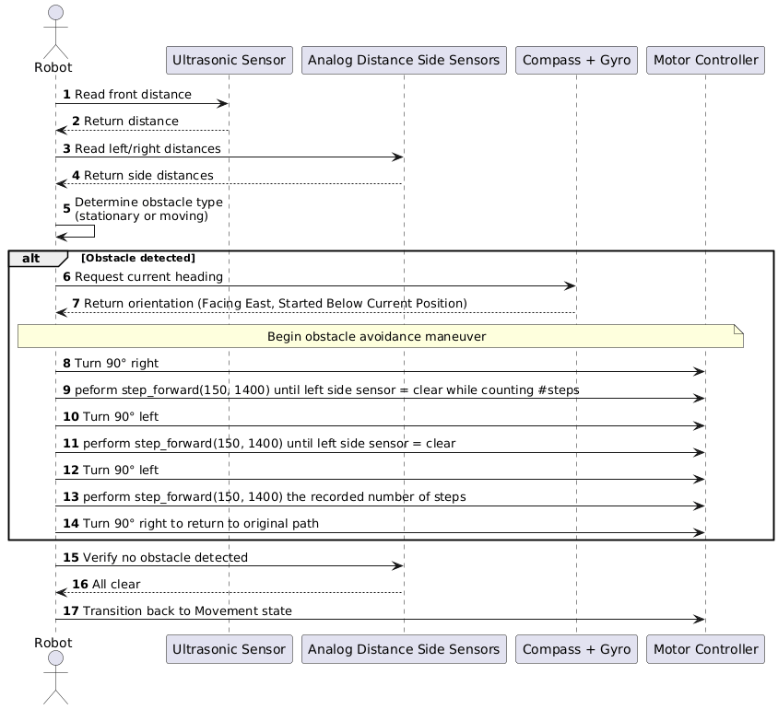
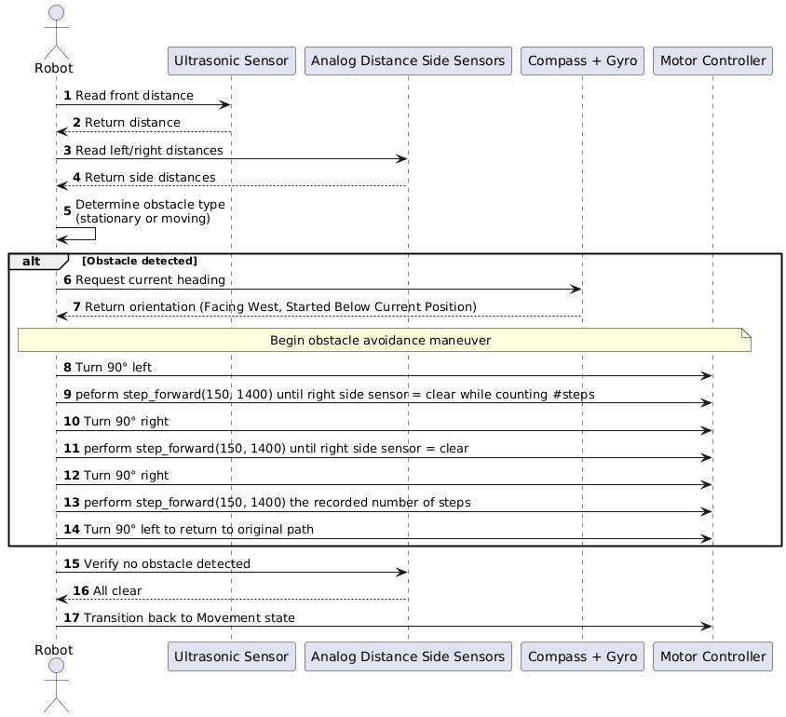
Figure 9 - Sequence Diagram of State 5. ODDM when Moving East and Starting in a South Corner (Described in Section3.1)
Figure 8 - Sequence Diagram of State 5. ODDM when Moving West and Starting in a South Corner (Described in Section3.1)
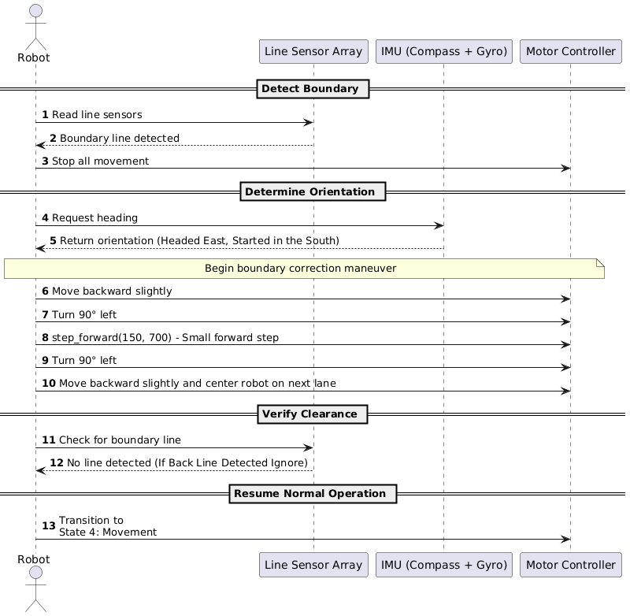
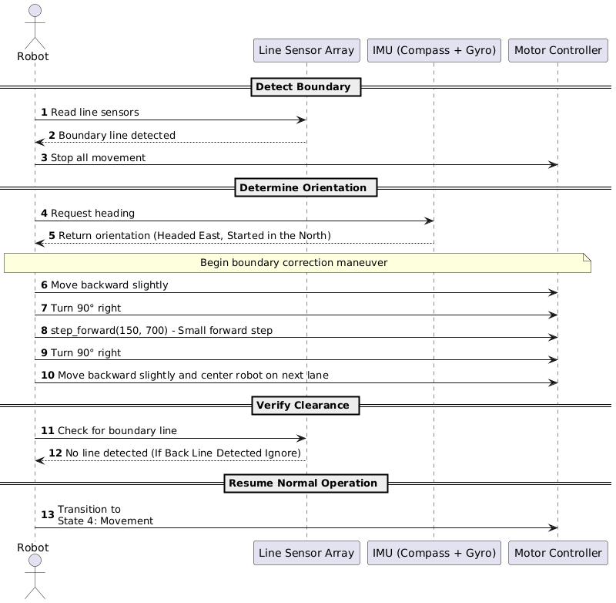
Figure 11 - Sequence Diagram of State 6. Figure 11 - Sequence Diagram of State 6. LDDM when Moving East and Starting in the NW Corner Facing East (Described in Section3.1)
Figure 10 - Sequence Diagram of State 6. LDDM when Moving East and Starting in the SW Corner Facing East (Described in Section3.1)

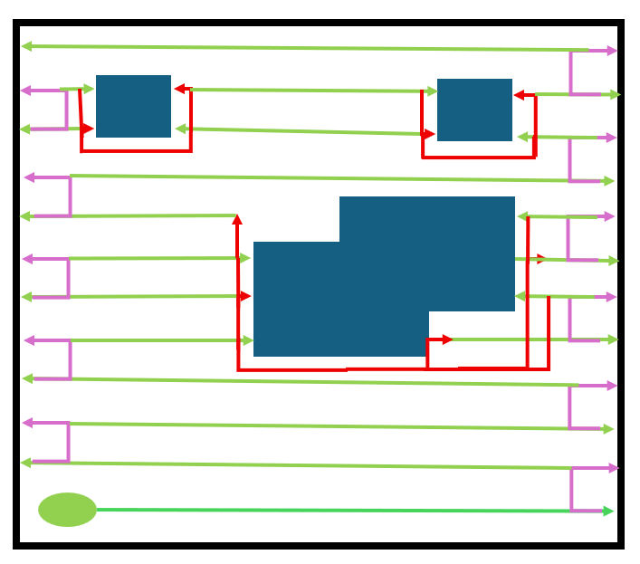
3.3 Planed Route Diagram
Figure 12 – Planned Route Diagram
The planned route diagram shows how the robot navigates the arena using three main FSM states. Green lines represent the Movement State, where the robot drives straight across each lane to push snow blocks out of the perimeter. Pink lines represent the LDDM State, which is activated when the front- or back-line sensors detect the boundary line. In this state, the robot performs a controlled lane-change maneuver that shifts it up or down by one row so it can begin clearing the next lane. Red lines represent the ODDM State, triggered when the ultrasonic or analog distance sensors detect an obstacle. The robot then performs a wrapping avoidance path around the obstacle before returning to its original lane and resuming normal movement.
Before beginning the pattern, the robot determines its starting position by checking its orientation using the IMU module. Based on compass heading and initial sensor readings, it identifies whether it is in the Top-Left (TLC), Top-Right (TRC), Bottom-Left (BLC), or Bottom-Right (BRC) corner. This ensures the planned route always begins in the correct direction regardless of how the robot is placed. Together, these three behaviors allow the robot to sweep each lane of the field in order, avoid obstacles safely, and shift between rows until the entire arena is cleared.

4. Watchdog Timer Demonstration (5%)
A watchdog timer is used to reset the system if it hangs. This is done by using Arduino’s watchdog library. It is initialized by enabling the watchdog with a time limit in the setup() function. We chose 4000ms to prevent the system from hanging for too long, while giving it enough time to run through all the actions.
watchdogEnable(4000);
The first action that is done when running loop() is resetting the watchdog timer.
watchdogReset();
If the the loop does not reset the watchdog timer in time, then the system restarts (like the equivalent of pushing the reset button on the Arduino). This is the default behaviour of the watchdog timer so the watchdogSetup function remains empty.

void watchdogSetup(void) {}
To test the watchdog timer, a modification was made to the loop to add a delay and a print statement to prove that the loop never reaches that point. As shown in figure 12, the serial monitor never prints “this” because it resets from the watchdog timer. This is further proved with the initialization message that prints at the end of the setup() function.
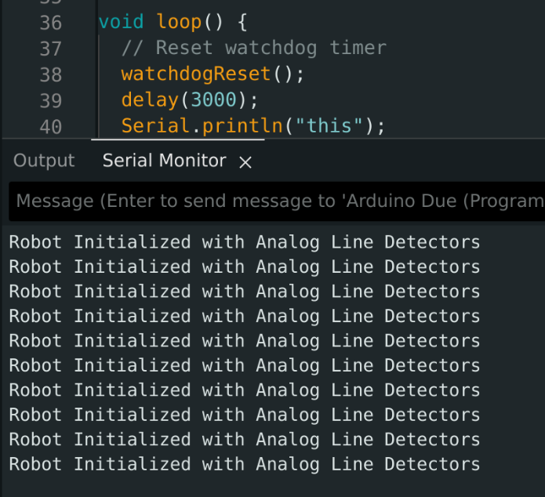
Figure 13 - Loop code and serial monitor output demonstrating functional watchdog timer

5. Planned Value Analysis
The updated Planned Value (PV) analysis for the six‑week course‑kit project assumes a team of four developers working eight hours a week at a standard rate of $50 per hour, with an overtime rate of $75 per hour. Over the course of the project each developer will clock 48 regular hours (4 developers × 8 hours × 6 weeks = 192 hours) and an additional 24 overtime hours (4 developers × 2 overtime hours × 6 weeks = 48 hours). This translates to $9,600 in regular labor costs (192 hours × $50) and $3,600 in overtime labor (48 hours × $75), for a total labor expense of $13,200. Adding the fixed course‑kit cost of $500 brings the overall project cost to $13,700. The weekly labor PV is therefore $1,600 ($9,600 ÷ 6), serving as the baseline against which actual progress will be measured. In the Earned Value Management framework, we will track the Actual Cost (AC), Planned Value (PV), and Earned Value (EV) to calculate Schedule Variance (SV = EV – PV) and Cost Variance (CV = EV – AC), enabling us to assess how closely the project stays to its planned schedule and budget.

Table 1 - Value Changes based on Week
Week | Planned % Complete | PV ($) | Actual % Complete | AC ($) | EV ($) | SV ($) | CV ($)
1 | 11.0% | 2,100 | 15% | 1,000 | 2,055 | -45 | 1,055
2 | 23.4% | 3,700 | 30% | 2,500 | 4,110 | 410 | 1,610
3 | 35.7% | 5,300 | 45% | 4,500 | 6,165 | 865 | 1,665
4 | 51.6% | 7,500 | 65% | 6,200 | 8,905 | 1,405 | 2,705
5 | 67.1% | 9,700 | 80% | 8,000 | 10,960 | 1,260 | 2,960
6 | 100% | 13,700 | 95% | 9,700 | 13,015 | -685 | 3,315

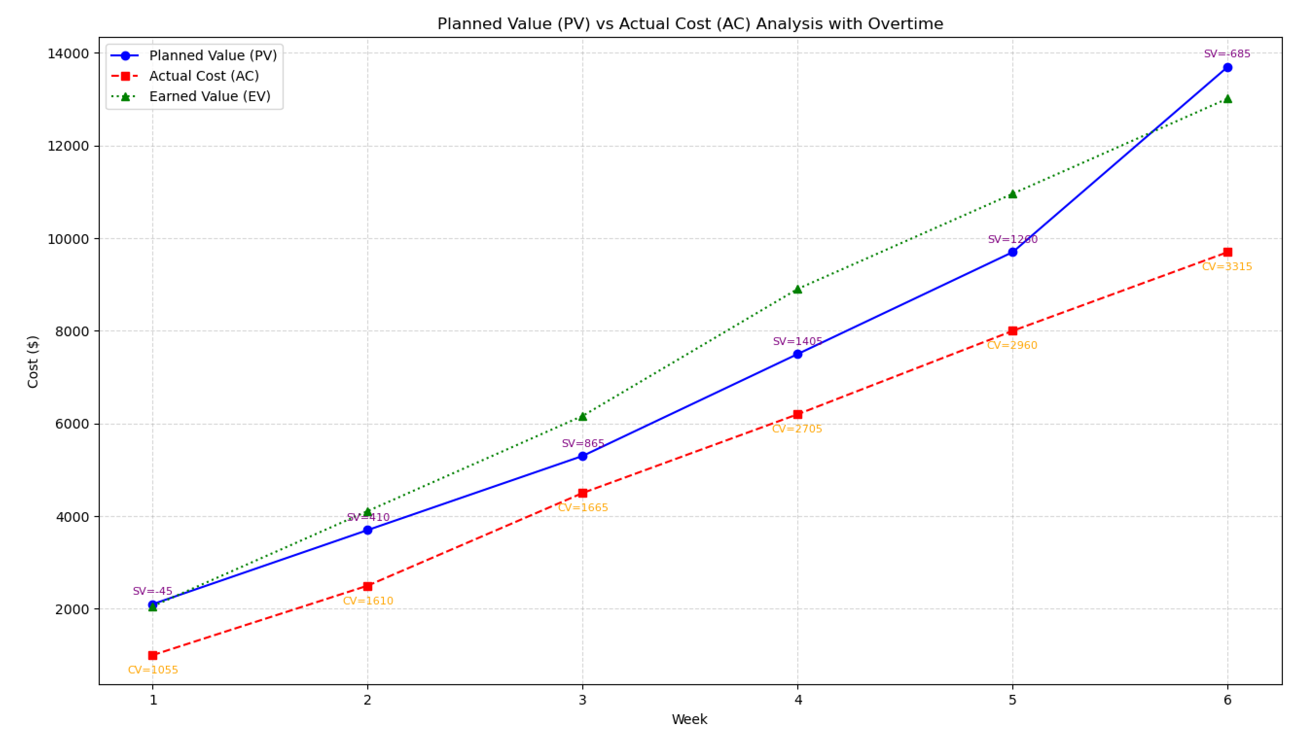Figure 14 - Planned Value vs Actual Cost vs Earned Value with Overtime Chart

Schedule Results
The use of overtime greatly improved the Scheduled Performance Index of the project schedule. While there was a slight inefficiency early in the project, adding just 2 hr/week per developer in Weeks 4, 5, and 6 brought the team back. In fact, in these weeks, progress was achieved ahead of the planned schedule, which reinforced that overtime can be a productive corrective action. By the end of the study, a small inefficiency remained, but the remaining lag will be easy to address and remediate with only minor additional effort
Cost Results
Even with the overtime used, cost performance remains healthy. On a weekly basis through the whole project, actual spending remains under the earned value, and overtime is not likely to exceed the total project budget of $13,700. The project has shown itself to be an effective use of resources and essentially all of the project schedules have shown positive cost variance.

5.1 Adjustments Made
- Overtime Application: Added 2 hours/week per developer in Weeks 4–6 to accelerate completion of critical tasks.
- Task Prioritization: Focused effort on high-priority and critical-path tasks to maximize schedule efficiency.
- Monitoring: Weekly tracking of PV, AC, EV, SV, and CV enabled proactive adjustments and resource allocation.
Outcome: Minor lag in the final week can be corrected with small additional effort. Overall, the project is expected to complete on schedule and within budget.

6. Working Code on GitHub
The Git repository, found at https://github.com/RyanPage-cu/SYSC4805_Project_Repo is used to host and manage the source code. The current structure of the root of the repository contains a README, a deliverables/ directory, and the roboplow/ directory. The README contains information about the project and setup instructions, and the deliverables/ directory contains deliverables of the project (currently contains the project proposal only).
The roboplow directory contains the source code of the system. The include/ directory contains header files and would contain any files or libraries that would be included. It currently contains sensors.hpp which initializes constants and functions used in the C++ files. The testing/ directory contains the unit tests for each of the sensors (distance, line following, motor, and ultrasonic).
Finally, the main code is in the roboplow/ directory, consisting of C++ files for each sensor and the main roboplow.ino file. The C++ files for each sensor defines the constants used in the system (such as pins used for the sensor) and functions used for reading or outputting values. The main roboplow.ino file contains the main setup and loop logic that will be used for the system’s logic. Essentially, this uses the Super Loop design architecture.

7. Unit Testing Results
Testing has been done by creating unit tests that are semi-manual with some manual validation. For each sensor, there are tests to ensure that it works independently of the system. As their purpose is to serve the system, there is a lot of shared code between the system’s implementation and the unit tests. This is mostly notable for the setup of the sensor and arbitrary limits put in place. For example, the distance sensors only need to sense objects within a certain range (0-20cm for the front ultrasonic sensor and 0-8cm for the side analog distance sensors).
The motor unit test ensures that each motor is working by testing if it can move at different speeds and move forward/backward. It is validated manually by observing the wheels as the test is running. Another part of the validation process is ensuring no errors arise when running the test.
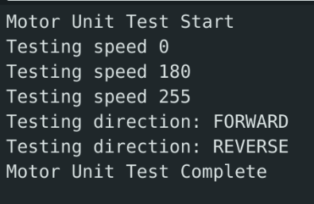
Figure 15 - Motor Unit Test Logs

Table 2 - Motor Unit Tests
Test | Outcome
PWM Speed 180 | Passed
PWM Speed 255 | Passed
Stop Motors | Passed
Move Forward | Passed
Move Backwards | Passed

The ultrasonic sensor tests ensure that the robot can detect an object that is <20cm away from it. This is done by polling the distance every 500ms. A manual check of the logs ensures that the unit tests pass. Notably, it is confirmed by ensuring an object (or a hand) is detected when close to the robot but is not detected when the object is >20cm away.

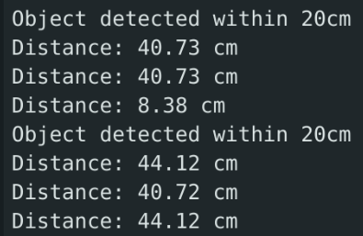
Figure 16 - Ultrasonic Sensor Unit Test Logs
Table 3 - Ultrasonic Sensor Unit Tests
Test | Outcome
Distance Displayed | Passed
Object >20cm does not trigger the detection trigger | Passed
Object <20cm Detected | Passed
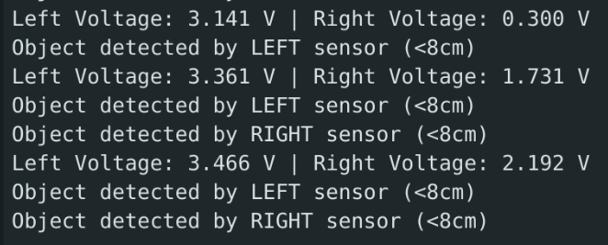
Similarly to the ultrasonic sensor tests, the left/right analog distance sensors were tested by ensuring an object that was <8cm away was detected. This unit test exposed that there are faulty values in the left analog sensor that need to be addressed. As a result, tests for the left analog sensor failed. Once again, this is validated by manually checking the logs.
Figure 17 - Analog Distance Sensor Unit Test Logs

Table 4 - Left/Right Analog Distance Sensor Unit Tests
Test | Outcome
Distance Displayed | Passed
Object >8cm not detected (Left) | Failed
Object <8cm Detected (Left) | Passed* (because the output voltage is always high)
Object >8cm not detected (Right) | Passed
Object <8cm Detected (Right) | Passed

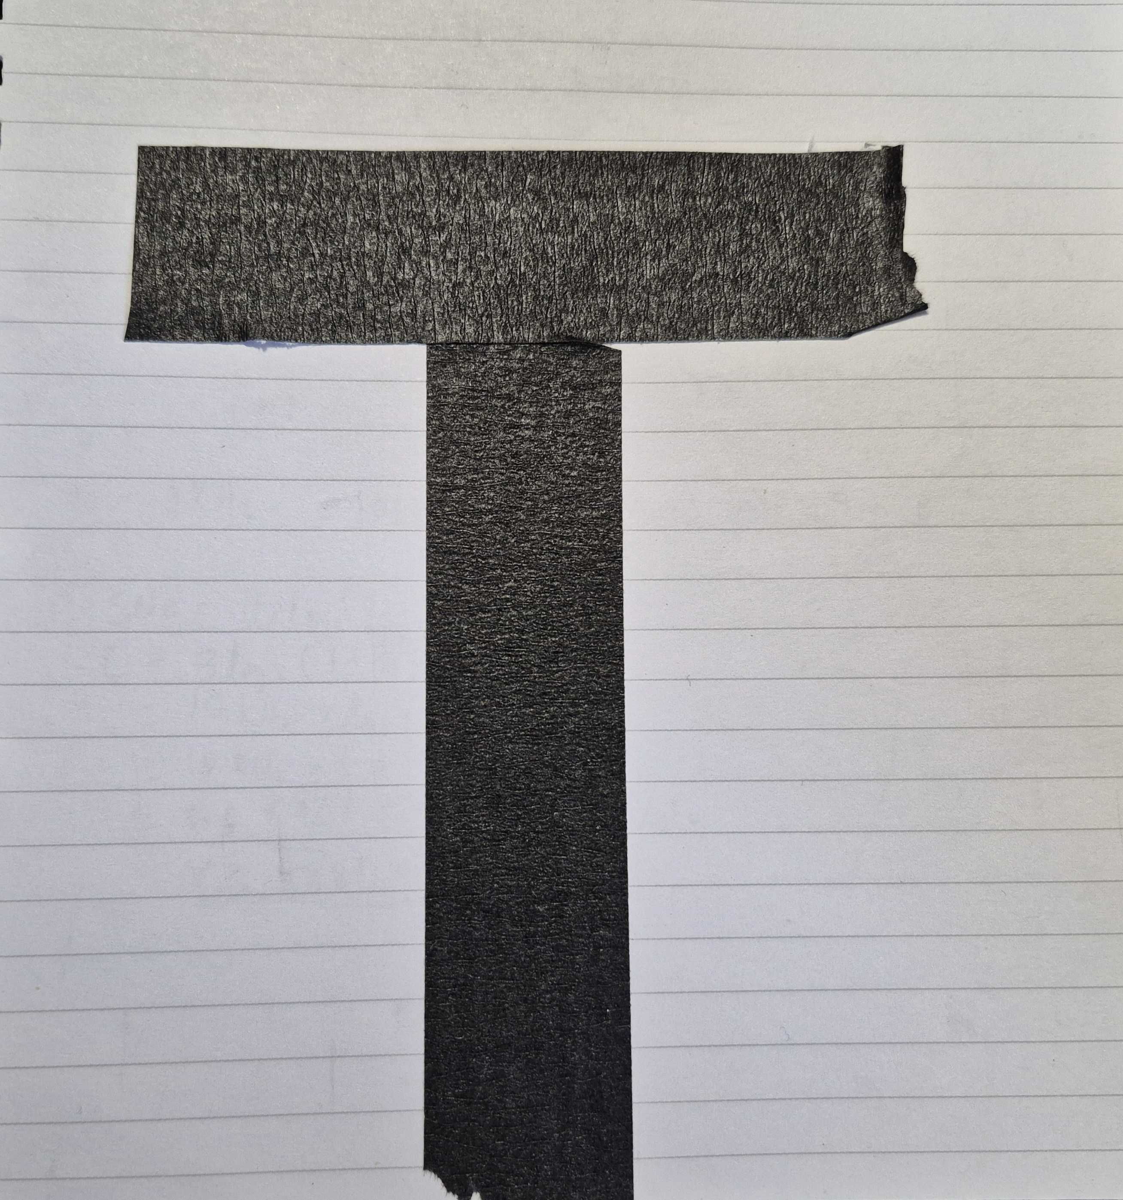
The line follower unit test tests different configurations that are possible when the robot is navigating the perimeter. This is used in conjunction with a test perimeter constructed with the same tape used for perimeters in the lab aligned in a T shape (pictured in figure 17). This provides a compact test area that covers all the cases for this unit test. When running the test, the robot is manually placed in such a way that it fits the pattern. For example, for the Vertical Line Left test, the robot is placed such that the left sensor is over the black line, while the middle and right sensors are over the paper. When the pattern is recognized by the sensor, the test passes.
Figure 18 - Perimeter used for testing when outside of laboratory

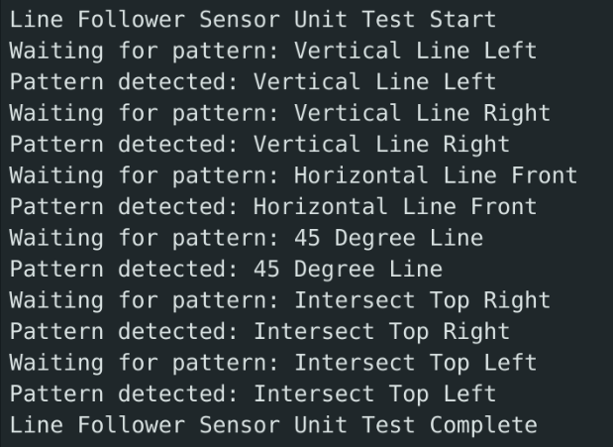
Figure 19 - Line Follower Unit Test Logs
Table 5 - Line Follower Unit Tests
Test | Outcome
Vertical Line Left | Passed
Vertical Line Right | Passed
Horizontal Line in Front | Passed
Lines detected at 45° Angle | Passed
Lines detected in top right intersection | Passed
Lines detected in top left intersection | Passed

8. Conclusion
The Roboplow project remains on track for successful completion. All major subsystems have been developed, individually tested, and partially integrated. Early mechanical and wiring issues have been resolved, and updated objectives, architecture, and testing procedures now reflect a clearer and more robust plan for the final design.
The remaining work involves full system integration, tuning the navigation algorithms, completing the cube-clearing logic, and performing comprehensive system-level tests. With the current progress and remaining timeline, the team is confident in delivering a fully functional autonomous snowplow that meets all SYSC 4805 project requirements.

