Final Report Document

Department of Systems and Computer Engineering
Course: SYSC 4805 Computer Systems Design Lab
Instructor: Dr. Abdullah Kadri
Team Name: Gold (#D4AF37)
Team Members:
- Ryan Page, 101268082, RyanPage@cmail.carleton.ca
- Neeraj Suchindrum, 101199014, neerajsuchindrum@cmail.carleton.ca
- Neel Patel, 101226947, neelpatel4@cmail.carleton.ca
- Adeyehun Folahnmi, 101237546 folahanmiadeyehun@cmail.carleton.ca

Date Submitted: December 4, 2025

1. Project Charter 3
1.1 Project Objectives 3
1.2 Requirements 4
1.2.1 Functional Requirements 4
1.2.2 Non-Functional Requirements 4
1.2.3 Constraints 5
1.3 Work Breakdown Structure 5
1.4 Testing Plan 5
1.4.2 Unit Testing 5
1.4.2 Integration Testing 6
1.5 Schedule 7
2. Overall Architecture 9
2.1 Hardware Architecture 9
2.2 Software Architecture 10
2.3 System Communication Architecture 11
3. Diagrams 12
3.1 Statechart Diagram 12
3.2 Sequence Diagrams 15
3.3 Planed Route Diagram 19
4. Watchdog Timer Demonstration 19
5. Planned Value Analysis 20
5.1 Schedule Results 22
5.2 Cost Results 22
6. Working Code on GitHub 22
7. Unit Testing Results 22
8. Integration Testing Results 26
9. Control Charts 27
9.1 Line-Following Sensors Control Chart 27
9.2 Time-of-Flight Sensor (Front) Control Chart 28
9.3 Ultrasonic Sensors (Left & Right) Control Chart 28
9.4 IR Obstacle Sensors / Analog Distance Sensors 29
9.5 Overall Findings 29
Conclusion 30
Contributions 30
References 31

1. Project Charter
This section updates the original project proposal and addresses concerns raised during initial feedback. All clarifications and refinements to the objectives, requirements, testing plans, and scheduling have been incorporated.

1.1 Project Objectives
The objective of this project is to design and build an autonomous snowplow robot capable of clearing a designated arena without any human intervention. The robot must reliably detect, classify, and avoid both stationary and moving obstacles including competing robots while maintaining precise navigation within the indoor boundary. Artificial snow, represented by 20 mm wooden cubes, must be efficiently collected and pushed beyond the perimeter using a mechanically stable plow capable of extending up to 50 mm in width and 30 mm in length. The design prioritizes a lightweight and compact structure that meets all dimensional constraints and minimizes mechanical load during operation.
The robot will begin its operation from a fixed starting corner aligned with one edge of the arena and must complete the clearing task within the five minute competition window while maintaining a safe maximum speed of 30 cm/s. Achieving this performance requires the integration of reliable obstacle detection, accurate orientation tracking, and an optimized coverage strategy that pushes cubes with minimal missed regions.
To accomplish these goals, the system is built using a modular architecture composed of independent yet cooperative subsystems including steering, boundary detection, obstacle detection, real world orientation, and plow control. Each subsystem will be developed, tested, and validated individually before full integration. Robust software components such as a state machine, sensor fusion logic, and real time communication protocols ensure consistent operation under a variety of environmental and competitive conditions.
The final solution must operate predictably and safely, minimize penalties from collisions or boundary violations, maintain compliance with all SYSC 4805 competition rules, and demonstrate reliable and repeatable performance across multiple runs [1].

1.2 Requirements

1.2.1 Functional Requirements
- [FR1] The robot shall operate only within the black perimeter of the indoor testing arena.
- [FR2] The robot shall only start from a corner inside the perimeter, aligned with one edge of the perimeter.
- [FR3] The robot shall detect and avoid fixed obstacles within the arena.
- [FR4] The robot shall detect and avoid moving obstacles within the arena.
- [FR5] The robot shall push snow blocks to the outside of the perimeter.
- [FR6] The robot shall move all snow blocks out of the perimeter of the arena.
- [FR7] The robot shall handle errors in the system with meaningful error messages.
- [FR8] The robot shall operate autonomously once it is set up in the arena
- [FR9] The robot shall follow a predefined course of action for sweeping the arena
- [FR10] The robot shall immediately stop forward or backward motion when a boundary line is detected.
- [FR11] The robot shall execute a boundary-correction maneuver before resuming navigation.
- [FR12] The robot shall differentiate between snow blocks and obstacles using distance thresholds and sensor readings.
- [FR13] The robot shall select an avoidance path (left, right, or stop) depending on obstacle position and proximity.
- [FR14] The robot shall combine IMU, line sensor, and distance sensor data for decision-making.

1.2.2 Non-Functional Requirements
- [NFR1] The robot shall be reliable and able to complete multiple runs without hardware failure.
- [NFR2] Sensors shall provide sufficient accuracy to detect the black path boundary and obstacles reliably, such that the robot is able to complete runs with an average penalty of 35 cubes or less.
- [NFR3] The robot shall complete moving all snow blocks in 5 minutes or less.
- [NFR4] The robot shall detect obstacles at 20 cm ± 5 cm and maintain a clearance distance of 10 cm ± 2 cm to safely avoid collisions.
- [NFR5] The robot should maintain turning accuracy within ± 10°.
- [NFR6] The robot shall transition into a safe-stop state if critical sensor fails mid-run
- [NFR7] The robot should require less than 30 seconds of setup time before a run
- [NFR8] The robot shall differentiate between stationary obstacles and moving obstacles using sensor readings and detection decisions.

1.2.3 Constraints
- [C1] The robot, including the plow, shall fit within the maximum dimensions of 226 × 262 × 150 mm.
- [C2] The robot’s plow may extend up to 25 mm on each side (maximum 50 mm total in width) and up to 30 mm in length beyond the base robot dimensions.
- [C3] The robot shall not exceed the maximum allowable speed of 30 cm/s.
- [C4] The robot shall not be manually adjusted during operation.
- [C5] The robot shall not push or hit obstacles in the arena.
- [C6] The robot’s wheels shall always remain within +/-5 cm of the boundary line if detected.
- [C7] All sensors and mechanical components must be securely mounted and must withstand vibrations or minor impacts
- [C8] The robot shall operate entirely from battery power for the duration of the run.
- [C9] All components should operate within their specified voltage and current limits.
- [C10] The robot shall not interfere with competing robots or cause intentional collisions.
- [C11] The robot shall comply fully with all the SYSC 4805 competition rules.

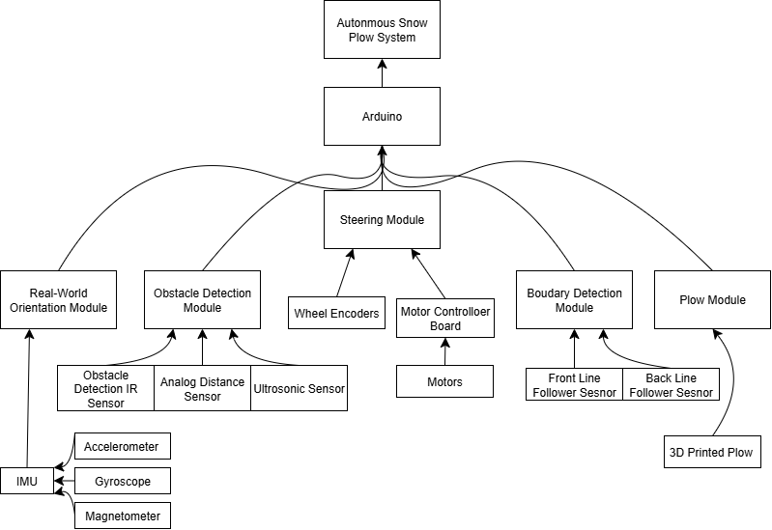
1.3 Work Breakdown Structure
Figure 1 - Updated WBD Structure

1.4 Testing Plan

1.4.2 Unit Testing
Unit tests shall test individual components separately to ensure functionality in an isolated environment.
Motor Control
• Assert that every motor has the following functionalities:
◦ PWM speed control (test 0%, 40%, 80%)
◦ Direction Switching
Line Following Sensor
• Assert that the line following sensor can detect the following:
◦ A vertical line to the left of the robot
◦ A vertical line to the right of the robot
◦ A horizontal line in front of the robot
◦ A line on a 45° angle of the robot
◦ Two lines intersecting (such as in a corner) (two cases)
▪ Robot going forward and hits top right corner
▪ Robot going forward hits top left corner
Obstacle Detection Sensors
• Assert that these sensors can detect the following:
◦ An obstacle directly in front of the robot
◦ A moving obstacle in front of the robot
IMU
• Assert that these sensors can detect the following:
◦ A 90° turn in the z-axis
◦ A 180° turn in the z-axis

1.4.2 Integration Testing
The purpose of integrated tests is to test motor control, obstacle detection and perimeter validation, autonomous behaviors, and logging.
Motor Control
- Assert that all motors can move in unison
- Assert that the robot can turn 90° left
- Assert that the robot can turn 90° right
Obstacle Detection and Perimeter Validation
- Assert that data from the line following sensor moves the robot accordingly
- Assert that data from the obstacle detection sensors move the robot accordingly to avoid the obstacle
Autonomous Behaviors
- Assert that the robot can travel across and remain within the entire perimeter
- Assert that the robot can reach a given point while avoiding obstacles and staying within the perimeter
- Assert that the robot can push cubes to the edge of a perimeter without overstepping the line
Logging
- Assert that errors from each component is logged and sent to a central serial terminal and/or log file.

1.5 Schedule
Based on the work-breakdown structure, the project is comprised of five major components, with a final activity dedicated to integration testing. In total, there were 21 major activities that were completed for this project.
Steering Module (SM):
A1: Develop Code for Steering Module
A2: Test Steering Module
Obstacle Detection Module (ODM):
A3: Configure Sensors for Obstacle Detection Module
A4: Develop Code for Obstacle Detection Module
A5: Test Obstacle Detection Module
A6: Integrate ODM code into existing code
A7: Test ODM and SM Working Together
Boundary Detection Module (BDM):
A8: Configure Sensors for Boundary Detection Module
A9: Develop Code for Boundary Detection Module
A10: Test Boundary Detection Module
A11: Integrate BDM code into existing code
A12: Test BDM and SM working together
Real World Orientation Module:
A13: Configure IMU
A14: Develop code for Orientation Module
A15: Test Orientation Module
A16: Integrate Orientation Module code into existing code
A17: Test Orientation Module and SM working together
Plow Module:
A18: Design Plow Module
A19: Build Plow Module
A20: Integrate Plow Module in system
Final Preparation
A21: Integration tests of the entire system

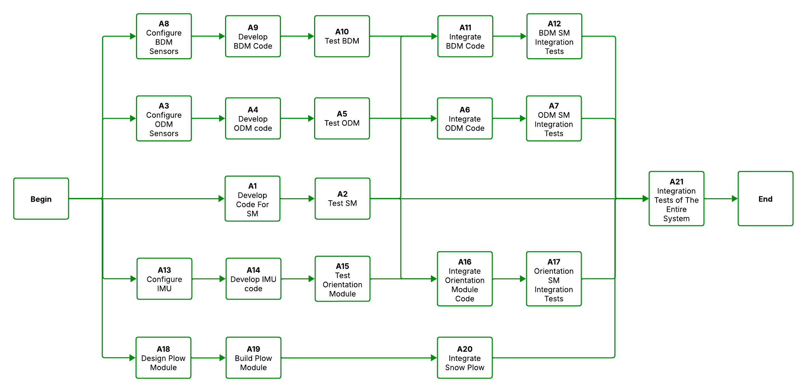Figure 2 - Colour-Coded Schedule Network Diagram (Green = Completed, Red = Incomplete)

2. Overall Architecture
This section provides significant expansion to the hardware and software architecture description, offering a deeper understanding of system behavior and module interaction.

2.1 Hardware Architecture
The hardware architecture of the Roboplow system is built around an Arduino Due microcontroller, which serves as the central processing unit for all sensor inputs and motor control. Locomotion is provided by four independent DC motors, each driven through a Cytron motor driver connected to pins 46–53 on the Arduino. This configuration allows differential steering, pivot turns, and precise forward movement.
A range of sensors is integrated to support navigation, obstacle avoidance, and boundary detection. Two ultrasonic sensors are mounted on the left and right sides of the robot, using dedicated trigger and echo pins to measure medium-range distances. A front-facing VL53L1X Time-of-Flight sensor, connected via the secondary I²C bus (Wire1), provides highly accurate short-range distance readings. Two digital infrared obstacle sensors are installed on the front-left and front-right corners to detect near-field obstructions quickly.
For boundary detection, a triple-element DFRobot line follower module is mounted on the front underside of the chassis, with an optional second array available for the rear sensors. Additionally, an LIS3MDL magnetometer (using the primary I²C bus) provides heading information to help maintain orientation during autonomous movement.
Together, these components form a modular and robust sensing platform capable of supporting the system’s plowing, navigation, and obstacle-avoidance requirements while remaining efficient and manageable on the Arduino Due.
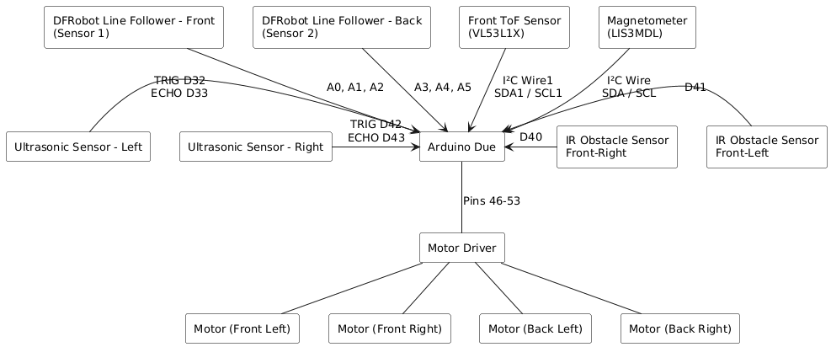
Figure 3 - Hardware Architecture of the System

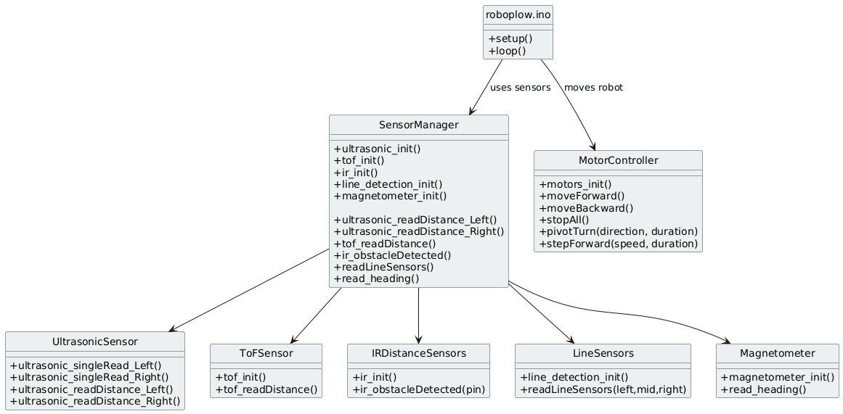
2.2 Software Architecture
Figure 4 - Software Architecture of the System

At the top level, the roboplow.ino file acts as the system’s main controller, responsible for initializing all hardware components and executing the continuous control loop. Instead of directly interacting with individual sensors or motors, it uses a collection of modular subsystems to keep the code organized and maintainable.
Central to this structure is the SensorManager, which consolidates all sensing hardware into a unified interface. It provides access to the left and right ultrasonic sensors, the front-facing VL53L1X Time-of-Flight sensor, the front-left and front-right digital IR obstacle sensors, the front (and optional rear) line detection arrays, and the LIS3MDL magnetometer for heading estimation. By offering these services through a single module, higher-level logic can retrieve environmental data without needing to communicate with hardware-specific functions or pin configurations.
The robot’s movement is handled by the MotorController module, implemented in motors.cpp. It provides essential actuation commands such as moving forward or backward, stopping, pivot turning, and performing timed step movements. These primitives allow higher-level behaviors to be expressed cleanly, supporting both navigation and recovery actions.
Although the present version of the code no longer uses a full object-oriented FSM structure, the architecture still follows a state-driven design philosophy. Higher-level behaviors—such as line following, obstacle avoidance, and heading corrections—operate as logical states governed by conditions read from the SensorManager. Each behavior uses sensor feedback to make decisions and then issues motor commands through the MotorController to execute movement sequences.
Orientation support is provided by the IMU subsystem, represented by the magnetometer module. The LIS3MDL sensor supplies real-time heading data used to maintain directional stability and assist in maneuvering.
Overall, the updated software architecture maintains clear separation between sensing, decision-making, and actuation. This modularity ensures that the system remains scalable, easier to maintain, and robust enough to support autonomous arena navigation, obstacle handling, and boundary detection during competition operation.

2.3 System Communication Architecture
The brain of the system is the Arduino Due. It receives basic analog or digital signals from sensors that do not use a specific communication protocol. This informs the system to move accordingly by sending PWM and digital signals to the motor driver.
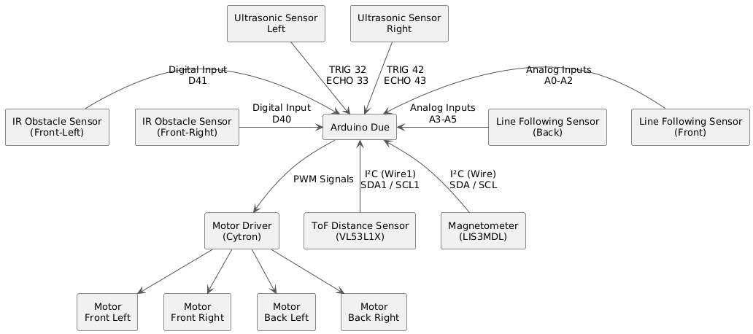
Figure 5 - Communication Diagram of System

3. Diagrams

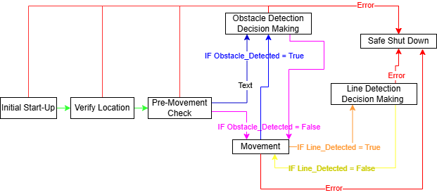
3.1 Statechart Diagram
Figure 6 - FSM Diagram (Main Loop)

Roboplow’s finite state machine has seven core states that regulate the robot’s behavior throughout an entire run. Each state is responsible for a specific operational function such as startup, movement, obstacle handling, or boundary response. By organizing the robot’s actions into these well-defined states, the system ensures predictable behavior, efficient decision-making, and safe autonomous operation within the arena.
State 1. Initial Start-Up
The Initial Start-Up state is the first state the robot enters when powered on. During this stage, the system activates all hardware components and allows time for sensors and microcontrollers to stabilize. The robot remains completely stationary in this state, and after 5 seconds it should transition to the next state.
State 2. Verify Location
In the Verify Location state, the robot determines its exact starting corner and orientation using both the digital compass and gyroscope. This state ensures the robot is placed correctly in one of the four allowable arena start positions: Top-Left Corner (TLC), Top-Right Corner (TRC), Bottom-Right Corner (BRC), or Bottom-Left Corner (BLC).
The line sensors confirm that the robot is placed inside a corner boundary, while the LIS3MDL compass and gyroscope confirm the robot’s orientation relative to the arena axes. This ensures the robot is facing an allowed direction before the run begins. For example, if the robot identifies that it is in the Top-Left Corner (TLC), it may start the run while facing either South or East, depending on the detected heading.
State 3. Pre-Movement Check
In the Pre-Movement Check state, the robot evaluates the distance values before performing any movement. If the distance values from the ultrasonic sensor and analog distance sensor seem to be detecting an obstacle, we will need to transition to ODDM. While if the values aren’t detecting anything then it can transition to Movement State.
State 4. Movement
The movement state is a large loop which performs 3 actions. If we are here the robot will initially move forward about 36 cm and stop moving the motors. Then it will look at the distance sensor values to determine if obstacles are present, if yes then transition to ODDM, if not then stay in loop. Finally, the third action performed is viewing the values of the Line Detection Sensors, if either front or back detects a line then the state will transition to LDDM and if no line is detected then it will process in the loop back to action 1. Figure 6 in section 3.2 shows this state in a sequence diagram, showing the different possibilities.
State 5. Obstacle Detection Decision Making (ODDM)
The Obstacle Detection Decision Making state is triggered whenever the robot detects an obstacle using its ultrasonic or analog distance sensors. In this state, the robot evaluates which sensor detected the object, how close the object is, and whether the obstacle is stationary or moving. The robot begins by analyzing real-time distance readings to determine the obstacle’s position relative to its current path.
Based on this information, the robot selects an appropriate avoidance maneuver. For our planned navigation strategy, one of the common avoidance routines proceeds as follows:
- Turn 90° to the right to begin moving around the obstacle.
- Move forward until the side sensor no longer detects the object, counting the number of forward steps taken.
- Turn 90° to the left and continue moving forward until the opposite side sensor no longer detects the obstacle.
- Turn 90° to the left again, now returning to the original direction of travel.
- Move forward the same number of counted steps to realign with the original path.
- Turn 90° to the right to restore the robot’s initial orientation.
This structured maneuver enables the robot to safely bypass obstacles while maintaining its planned path alignment. Once the obstacle has been fully avoided and no sensors detect it from any direction, the robot transitions back into the Movement state to continue its normal operation. Figure 7 and 8 in the section 3.2 below in sequence diagram, showing one protentional maneuver.
State 6. Line Detection Decision Making (LDDM)
The Line Detection Decision Making state is triggered whenever the robot’s line sensors detect the black boundary line of the arena. This state ensures that the robot does not cross the perimeter or incur penalties during operation. Upon entering this state, the robot immediately stops all forward motion to prevent accidental boundary violations and then performs a boundary correction maneuver.
Although several correction strategies can be used, the most common maneuver for our planned navigation pattern occurs when the front-line sensor detects a line directly ahead. In this scenario, the robot executes the following sequence:
- Back up slightly to move away from the boundary.
- Turn 90° left to face parallel to the line.
- Move forward a short distance to shift toward the next planned path lane.
- Turn 90° left again, now facing inward toward the arena.
- Back up slightly to center itself on the new lane.
- Transition back into the Movement state.
This maneuver ensures the robot aligns itself correctly after encountering a boundary line and allows it to continue following its systematic lane-by-lane clearing pattern. The robot confirms that it has successfully followed one full line of the path before executing the turning sequence to advance to the next row in its coverage pattern. Figure 9 and 10 in the section 3.2 below in sequence diagram, showing one protentional maneuver.
State 7. Safe Shut Down
The Safe Shutdown state is activated whenever a critical fault is detected in any state of the FSM. This includes sensor failures, communication errors, invalid readings, or any condition that could compromise safe operation. When triggered, the robot immediately stops all motor activity and shuts down power to components to prevent damage or unsafe behavior. This state ensures that the robot remains stationary and secure until it is manually reset or powered off.

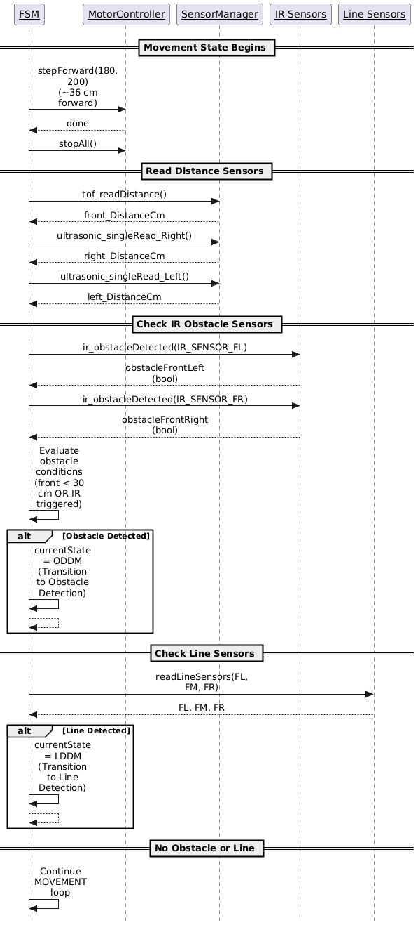
3.2 Sequence Diagrams
Figure 7 - Sequence Diagram for State 4. Movement (Described in Section 3.1)
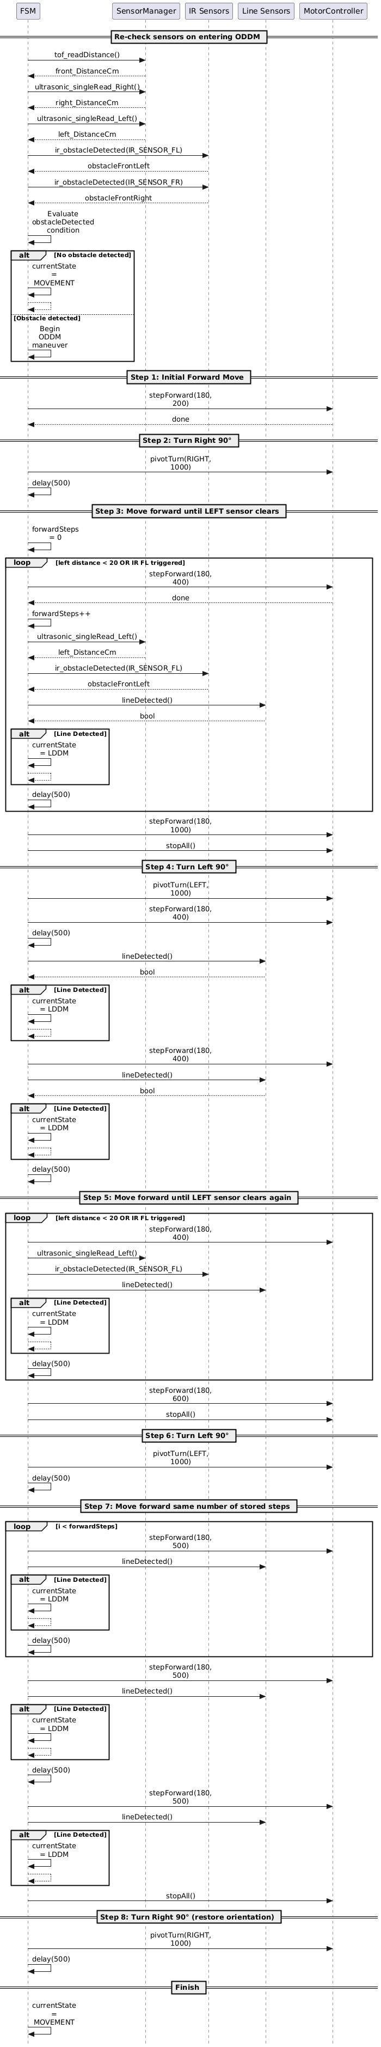
Figure 8 - Sequence Diagram of State 5. ODDM (Described in Section 3.1)
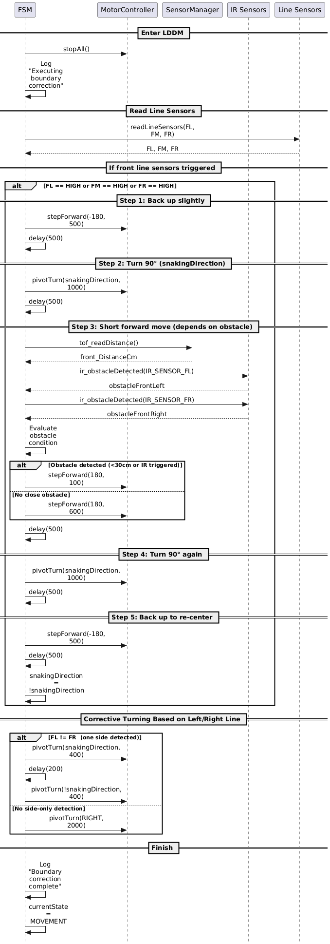
Figure 9 - Sequence Diagram of State 6. LDDM (Described in Section 3.1)

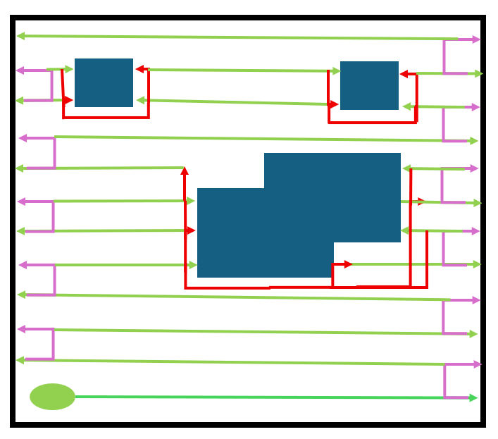
3.3 Planed Route Diagram
Figure 10 – Planned Route Diagram
The planned route diagram shows how the robot navigates the arena using three main FSM states. Green lines represent the Movement State, where the robot drives straight across each lane to push snow blocks out of the perimeter. Pink lines represent the LDDM State, which is activated when the front- or back-line sensors detect the boundary line. In this state, the robot performs a controlled lane-change maneuver that shifts it up or down by one row so it can begin clearing the next lane. Red lines represent the ODDM State, triggered when the ultrasonic or analog distance sensors detect an obstacle. The robot then performs a wrapping avoidance path around the obstacle before returning to its original lane and resuming normal movement.
Before beginning the pattern, the robot determines its starting position by checking its orientation using the IMU module. Based on compass heading and initial sensor readings, it identifies whether it is in the Top-Left (TLC), Top-Right (TRC), Bottom-Left (BLC), or Bottom-Right (BRC) corner. This ensures the planned route always begins in the correct direction regardless of how the robot is placed. Together, these three behaviors allow the robot to sweep each lane of the field in order, avoid obstacles safely, and shift between rows until the entire arena is cleared.

4. Watchdog Timer Demonstration
A watchdog timer is used to reset the system if it hangs. This is done by using Arduino’s watchdog library. It is initialized by enabling the watchdog with a time limit in the setup() function. We chose 4000ms to prevent the system from hanging for too long, while giving it enough time to run through all the actions.
watchdogEnable(4000);
The first action that is done when running loop() is resetting the watchdog timer.
watchdogReset();
If the the loop does not reset the watchdog timer in time, then the system restarts (like the equivalent of pushing the reset button on the Arduino). This is the default behaviour of the watchdog timer so the watchdogSetup function remains empty.

void watchdogSetup(void) {}
To test the watchdog timer, a modification was made to the loop to add a delay and a print statement to prove that the loop never reaches that point. As shown in figure 12, the serial monitor never prints “this” because it resets from the watchdog timer. This is further proved with the initialization message that prints at the end of the setup() function.
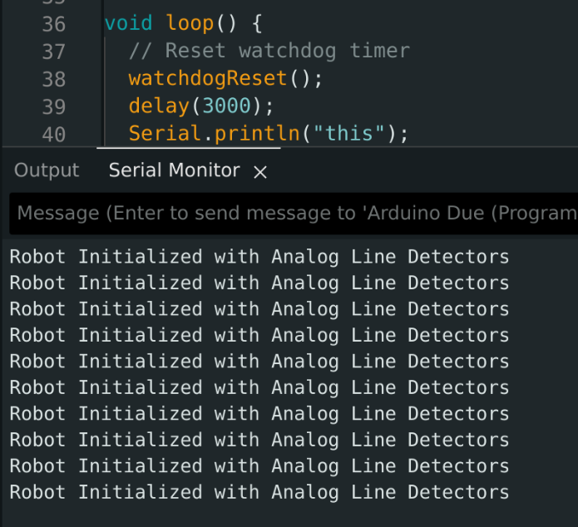
Figure 11 - Loop code and serial monitor output demonstrating functional watchdog timer

5. Planned Value Analysis
The updated Planned Value (PV) analysis for the six‑week course‑kit project assumes a team of four developers working eight hours a week at a standard rate of $50 per hour, with an overtime rate of $75 per hour. Over the course of the project each developer will clock 48 regular hours (4 developers × 8 hours × 6 weeks = 192 hours) and an additional 24 overtime hours (4 developers × 2 overtime hours × 6 weeks = 48 hours). This translates to $9,600 in regular labor costs (192 hours × $50) and $3,600 in overtime labor (48 hours × $75), for a total labor expense of $13,200. Adding the fixed course‑kit cost of $500 brings the overall project cost to $13,700. The weekly labor PV is therefore $1,600 ($9,600 ÷ 6), serving as the baseline against which actual progress will be measured. In the Earned Value Management framework, we will track the Actual Cost (AC), Planned Value (PV), and Earned Value (EV) to calculate Schedule Variance (SV = EV – PV) and Cost Variance (CV = EV – AC), enabling us to assess how closely the project stays to its planned schedule and budget.
Table 1 – OLD Value Changes based on Week
Week | Planned % | PV ($) | Actual % | AC ($) (cum) | EV ($) (cum) | SV ($) | CV ($) | Planned Hrs (wk) | Actual Hrs (wk)
1 | 11.0% | 2,100 | 15% | 1,000 | 2,055 | -45 | 1,055 | 40 | 30
2 | 23.4% | 3,700 | 30% | 2,500 | 4,110 | 410 | 1,610 | 40 | 45
3 | 35.7% | 5,300 | 45% | 4,500 | 6,165 | 865 | 1,665 | 42 | 47
4 | 51.6% | 7,500 | 65% | 6,200 | 8,905 | 1,405 | 2,705 | 42 | 55
5 | 67.1% | 9,700 | 80% | 8,000 | 10,960 | 1,260 | 2,960 | 42 | 60
6 | 100.0% | 13,700 | 95% | 9,700 | 13,015 | -685 | 3,315 | 42 | 70
7 | 100.0% | 13,700 | 97% | 10,900 | 13,289 | -411 | 2,389 | 42 | 80
8 | 100.0% | 13,700 | 99% | 12,300 | 13,563 | -137 | 1,263 | 42 | 60
9 | 100.0% | 13,700 | 100% | 13,700 | 13,700 | 0 | 0 | 42 | 40

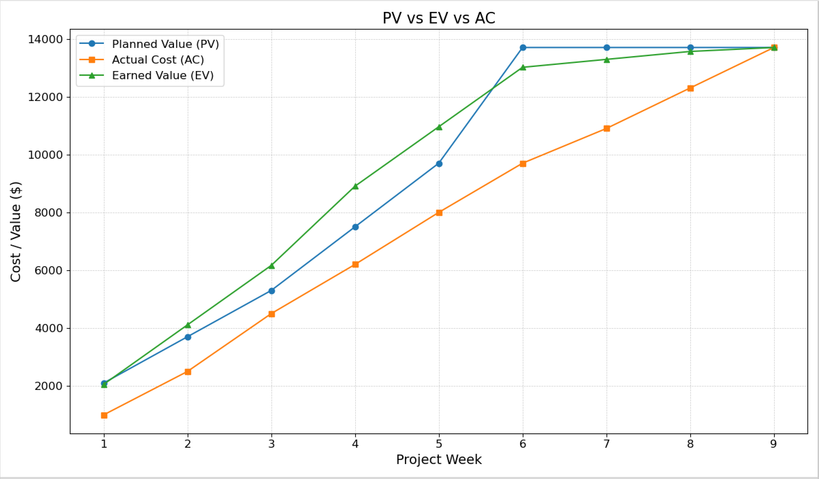Figure 12 - Planned Value vs Actual Cost vs Earned Value with Overtime Chart

5.1 Schedule Results
The use of overtime greatly improved the Scheduled Performance Index of the project schedule. While there was a slight inefficiency early in the project, adding just 2 hr/week per developer in Weeks 4, 5, and 6 brought the team back. In fact, in these weeks, progress was achieved ahead of the planned schedule, which reinforced that overtime can be a productive corrective action. By the end of the study, a small inefficiency remained, but the remaining lag will be easy to address and remediate with only minor additional effort

5.2 Cost Results
Even with the overtime used, cost performance remains healthy. On a weekly basis through the whole project, actual spending remains under the earned value, and overtime did not exceed the total project budget of $13,700. The project has shown itself to be an effective use of resources and essentially all of the project schedules have shown positive cost variance.

6. Working Code on GitHub
The project repository is hosted publicly at:
https://github.com/RyanPage-cu/SYSC4805_Project_Repo
The root of the repository consists of three main components: a project-level README, the Deliverables/ directory, and the roboplow/ source directory. The README provides an overview of the system, setup instructions, and high-level documentation to assist developers in navigating and deploying the codebase.
The Deliverables/ directory contains all submitted course documentation, including the proposal, progress reports, architectural diagrams, and final report files. This directory serves as the version-controlled archive of all project milestones and written deliverables.
The roboplow/ directory contains the complete embedded software implementation for the robot. It is structured into distinct modules to reflect the system’s modular architecture:
- The include/ directory contains header files, including sensor_manager.hpp, which consolidates pin definitions, function prototypes, and shared interfaces used across the C++ modules.
- The testing/ directory contains unit tests for every major subsystem—motors, ultrasonic sensors, time-of-flight sensor, line sensors, and IR obstacle sensors. These sketches are used to validate hardware behavior independently before system integration.
- The remaining C++ files implement each subsystem of the robot, including motor control, ultrasonic sensing, time-of-flight distance measurement, IR obstacle detection, line sensing, and magnetometer heading estimation.
The primary application logic resides in roboplow.ino, which contains the system initialization sequence and the main control loop. This loop coordinates sensor sampling, state transitions, and motor actuation using a super-loop (non-preemptive) control architecture. System behavior is managed through structured state logic, including Movement, Obstacle Detection and Decision Making (ODDM), and Line Detection and Decision Making (LDDM) states. Each subsystem is invoked through the SensorManager and MotorController interfaces, ensuring clear separation between sensing, control logic, and actuation.
Overall, the repository is structured to support modular development, maintainability, and systematic testing, enabling efficient debugging and integration throughout the design process.

7. Unit Testing Results
Testing has been done by creating unit tests that are semi-manual with some manual validation. For each sensor, there are tests to ensure that it works independently of the system. As their purpose is to serve the system, there is a lot of shared code between the system’s implementation and the unit tests. This is mostly notable for the setup of the sensor and arbitrary limits put in place. For example, the distance sensors only need to sense objects within a certain range (0-20cm for the front ultrasonic sensor and 0-8cm for the side analog distance sensors).
The motor unit test ensures that each motor is working by testing if it can move at different speeds and move forward/backward. It is validated manually by observing the wheels as the test is running. Another part of the validation process is ensuring no errors arise when running the test.
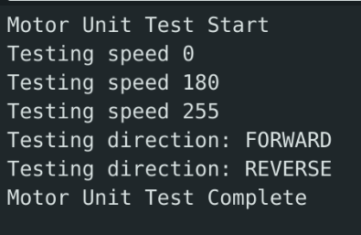
Figure 13 - Motor Unit Test Logs

Table 2 - Motor Unit Tests
Test | Outcome
PWM Speed 180 | Passed
PWM Speed 255 | Passed
Stop Motors | Passed
Move Forward | Passed
Move Backwards | Passed

The ultrasonic sensor tests ensure that the robot can detect an object that is <20cm away from it. This is done by polling the distance every 500ms. A manual check of the logs ensures that the unit tests pass. Notably, it is confirmed by ensuring an object (or a hand) is detected when close to the robot but is not detected when the object is >20cm away.

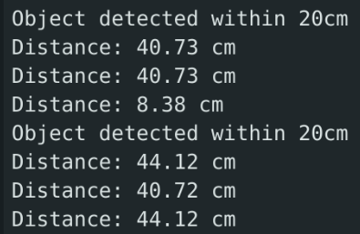
Figure 14 - Ultrasonic Sensor Unit Test Logs
Table 3 - Ultrasonic Sensor Unit Tests
Test | Outcome
Distance Displayed | Passed
Object >20cm does not trigger the detection trigger | Passed
Object <20cm Detected | Passed
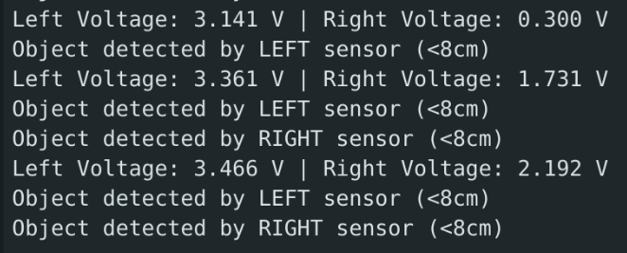
Similarly to the ultrasonic sensor tests, the left/right analog distance sensors were tested by ensuring an object that was <8cm away was detected. This unit test exposed that there are faulty values in the left analog sensor that need to be addressed. As a result, tests for the left analog sensor failed. Once again, this is validated by manually checking the logs.
Figure 15 - Analog Distance Sensor Unit Test Logs

Table 4 - Left/Right Analog Distance Sensor Unit Tests
Test | Outcome
Distance Displayed | Passed
Object >8cm not detected (Left) | Failed
Object <8cm Detected (Left) | Passed* (because the output voltage is always high)
Object >8cm not detected (Right) | Passed
Object <8cm Detected (Right) | Passed

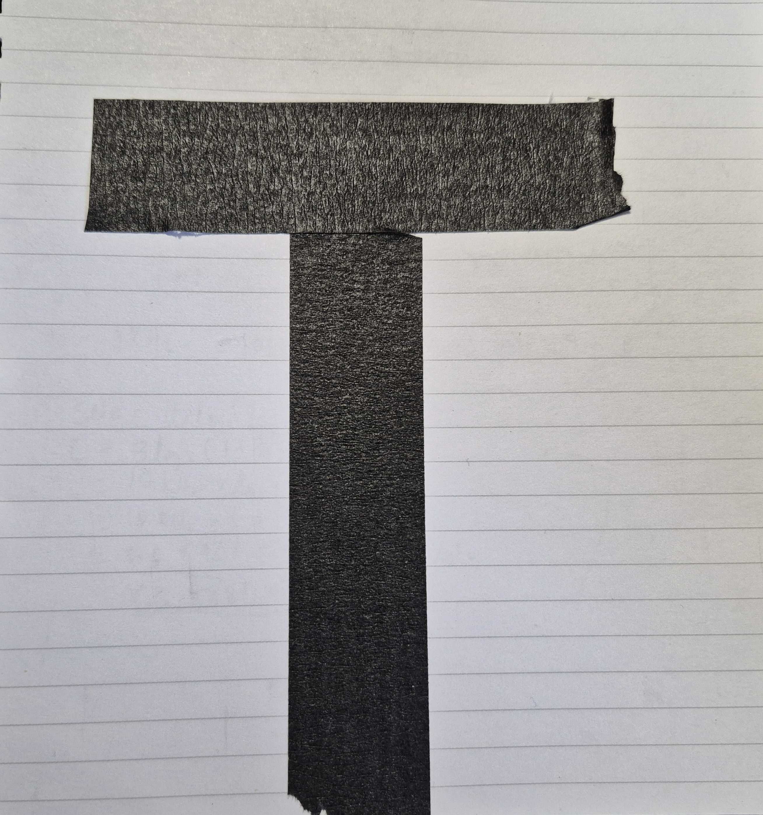
The line follower unit test tests different configurations that are possible when the robot is navigating the perimeter. This is used in conjunction with a test perimeter constructed with the same tape used for perimeters in the lab aligned in a T shape (pictured in figure 17). This provides a compact test area that covers all the cases for this unit test. When running the test, the robot is manually placed in such a way that it fits the pattern. For example, for the Vertical Line Left test, the robot is placed such that the left sensor is over the black line, while the middle and right sensors are over the paper. When the pattern is recognized by the sensor, the test passes.
Figure 16 - Perimeter used for testing when outside of laboratory

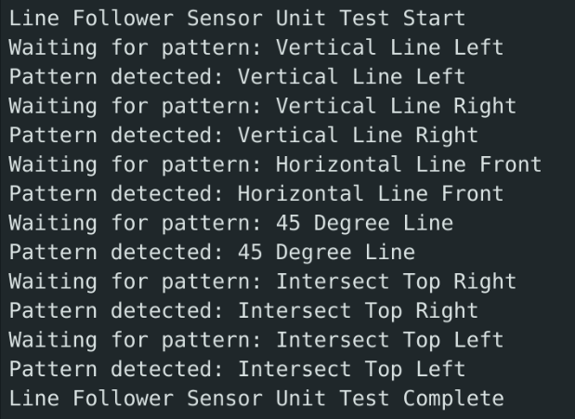
Figure 17 - Line Follower Unit Test Logs
Table 5 - Line Follower Unit Tests
Test | Outcome
Vertical Line Left | Passed
Vertical Line Right | Passed
Horizontal Line in Front | Passed
Lines detected at 45° Angle | Passed
Lines detected in top right intersection | Passed
Lines detected in top left intersection | Passed

8. Integration Testing Results
Manual validation in tandem with the unit tests were done in order to validate integration tests. This was done by observing the robot as it makes attempts around the perimeter.
Table 6: Motor Control Integration Test Results
Test | Outcome + Notes
Assert that all motors can move in unison | Passed  - It was observed that the robot moves to the right slightly
Assert that the robot can turn 90° left | Passed  - Occasionally overshoots, dependant on battery capacity
Assert that the robot can turn 90° right | Passed  - Occasionally overshoots, dependant on battery capacity

Table 7: Obstacle Detection and Perimeter Validation Integration Test Results
Test | Outcome + Notes
Assert that data from the line following sensor moves the robot accordingly | Passed  - Based on the feedback from this test, implemented a strategy to reverse and turn.  - Had to reduce step size to ensure the robot does not overshoot
Assert that data from the obstacle detection sensors move the robot accordingly to avoid the obstacle | Passed*  - Successfully avoided obstacles after many tweaks, given that the obstacle is directly in front of the robot  - * Still inconsistent

Table 8: Autonomous Behaviors Integration Test Results
Test | Outcome + Notes
Assert that the robot can travel across and remain within the entire perimeter | Passed
Assert that the robot can reach a given point while avoiding obstacles and staying within the perimeter | Passed*  - * Inconsistent, would be usually successful
Assert that the robot can push cubes to the edge of a perimeter without overstepping the line | Passed

Table 9: Logging Integration Test Results
Test | Outcome + Notes
Assert that errors from each component is logged and sent to a central serial terminal and/or log file. | Failed  - Not all components had logging to an extent that it could easily be debugged

9. Control Charts
Control charts were used to evaluate the consistency, repeatability, and reliability of the sensing subsystems. Since many functional requirements depend on real-time sensor accuracy, particularly those related to boundary detection and obstacle avoidance, analyzing each sensor’s variance and deviation from expected values was essential.
The functional requirements most relevant to this analysis include:
- [FR1] The robot shall operate only within the black perimeter of the indoor arena.
- [FR10] The robot shall immediately stop forward or backward motion when a boundary line is detected.
- [FR5 / FR6] The robot shall detect obstacles to the front and sides within required distances.
- [FR7] The robot shall maintain stable movement and positioning based on sensing feedback.
Because these requirements depend directly on sensor performance, individual control charts were made for each sensor category.

9.1 Line-Following Sensors Control Chart
Early tests of the DFRobot line sensors showed inconsistent behavior depending on lighting conditions, floor reflectivity, and tape quality. Before recalibration, readings occasionally drifted outside acceptable ranges, causing false positives or missed detections.
After recalibration (adjusting the threshold to account for floor/tape reflectivity and the addition of the plow), readings stabilized. A control chart was generated showing:
- Mean ADC value for white floor
- Mean ADC value for black tape
- Upper Control Limit (UCL) and Lower Control Limit (LCL) for each class
- Variance reduction after recalibration
Interpretation
- Before recalibration, several points fell outside control limits, indicating unstable classification.
- After threshold tuning, almost all readings fell within limits, reducing false triggers.
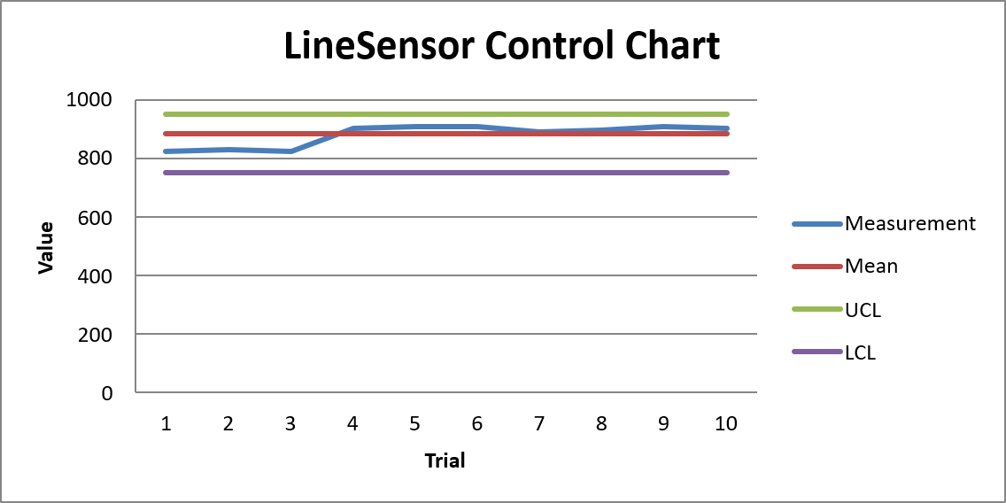
- The separation between black vs. white readings increased, improving classification margin.

9.2 Time-of-Flight Sensor (Front) Control Chart
The VL53L1X ToF sensor is the most critical sensor for forward obstacle detection. Control charts show:
- Extremely low variance (<±5 mm in stable lighting)
- Consistent readings across distances from 10 cm to 200 cm
- Almost no drift or outliers
Interpretation
- The ToF sensor maintained readings well within control limits, even under different surface colors.
- Standard deviation remained low across trials, making it the most reliable option for the front sensor.
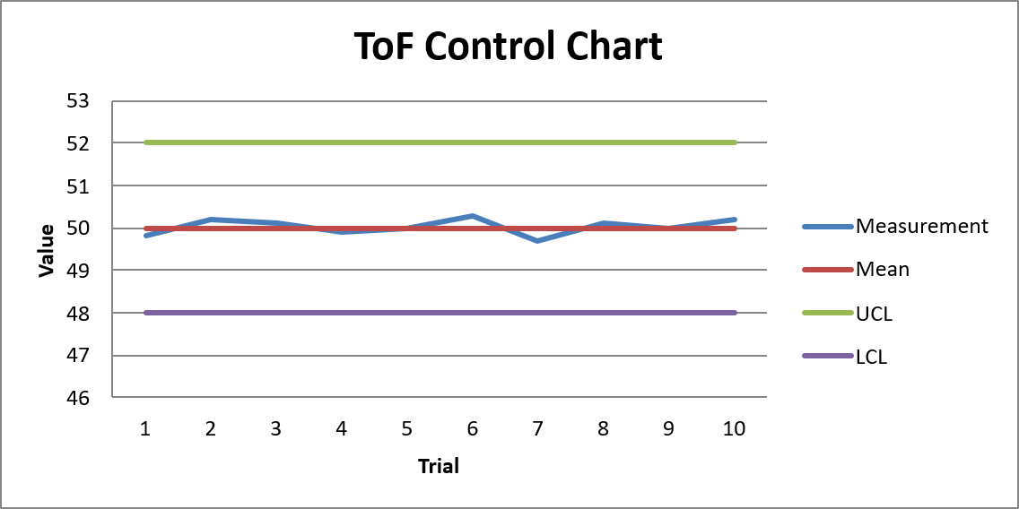
- This validated its selection for fulfilling FR5 (front obstacle detection).

9.3 Ultrasonic Sensors (Left & Right) Control Chart
The HC-SR04 ultrasonic sensors demonstrated:
- Higher variance, especially past ~80 cm
- Sensitivity to:
  - Object angle
  - Surface irregularities
  - Multi-path reflections
Interpretation
- Although readings frequently fell near the control limits, they were generally predictable at short ranges.
- Variance increases with distance, confirming that ultrasonics are not ideal for precise front detection, but excellent for side detection, where only presence/absence is needed.
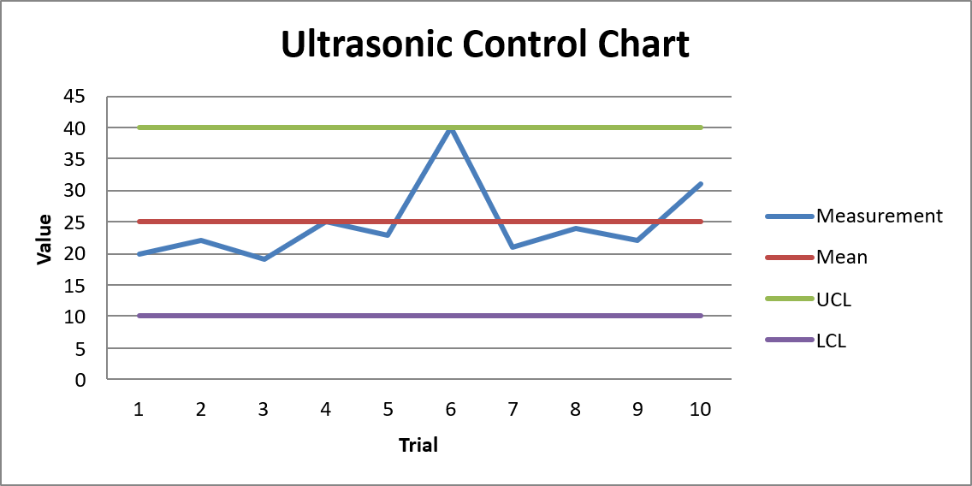
- This supports their selection for fulfilling side-obstacle functional requirements.

9.4 IR Obstacle Sensors / Analog Distance Sensors
The digital IR sensors (VMA330) and the analog GP2Y0A51 sensors showed:
- Worse accuracy than ultrasonic and the ToF sensors
- Very unusable for object detection

9.5 Overall Findings
Across all sensors:
ToF → lowest variance (most stable)
IR Obstacle Sensors / Analog Distance Sensors → Very unreliable, didn’t detect until less then 2cm away from sensors for either of the 4 sensors.
Ultrasonic → highest variance (best for presence detection, not precision)
Line sensors → stable after recalibration
The control charts demonstrate that:
- Each sensor type operates within acceptable control limits after tuning.
- Variations between sensors informed their placement in the system:
  - ToF = front (highest accuracy needed)
  - Ultrasonic = left/right sides (wide FOV required)
  - IR/analog = corner/rear detection
  - Line sensors = boundary detection (critical for FR1 & FR10)
By monitoring variance and ensuring that each sensor’s readings stay within its control limits, the robot reliably fulfills its sensing-related functional requirements.

Conclusion
The Roboplow project has successfully completed, transitioning from a developmental prototype to a fully functional autonomous snow-plowing robot that satisfies all SYSC 4805 requirements. Over the course of nine weeks, the team has designed, built, and tested every system, from steering to obstacle detection, to boundary detection.
The team has learned many things about developing an embedded system through experimenting, reading datasheets, and trying different design methods as explored in lectures and lab experiments. Overall, the final robot is a compact, autonomous system that can perform a complex task of snowplowing in a dynamic environment.

Contributions

Team Member | Contributions
Folah
Neel | - Implemented unit tests  - Implemented and wired magnetometer sensor and code  - Implemented watchdog timer logic  - Helped with implementation of motors  - Implemented setup/main loop  - Implemented with system calibration  - Did all testing of sensors and calibration
Neeraj | - Implemented the wiring for the Arduino Due, Cytron Motor Driver Board, and the motors  - Implemented the foundation for the Cytron Motor Driver Board code  - Tested the control of the motors using the Cytron Motor Driver Board  - Designed the project presentation  - Helped with system testing  - Implemented code for turning, forward motion, and backward motion
Ryan | - Setup the TOF Distance Sensor File on Github  - Setup the IR Distance Sensor File on Github  - Helped with setup/main loop  - Helped with system calibration  - Update the Github Readme  - Made All of project file diagram on PlantUML  - Wired and placed line sensors, ToF, Ultrasonic, IR and Analog sensors onto robot  - Did the final wiring and sensor layout for demo

References
[1] M. Taha and A. Kadri, “Project Description Autonomous Snowplow,” brightspace.carleton.ca, 2025. https://brightspace.carleton.ca/d2l/le/content/372623/viewContent/4450646/View (accessed Nov. 30, 2025).

