Project Proposal Document
Course: SYSC 4805 Computer Systems Design Lab
Team Name: Gold (#D4AF37)
Team Members:
- Ryan Page, 101268082, RyanPage@cmail.carleton.ca
- Neeraj Suchindrum, 101199014, neerajsuchindrum@cmail.carleton.ca
- Neel Patel, 101226947, neelpatel4@cmail.carleton.ca
- Adeyehun Folahnmi, 101237546 folahanmiadeyehun@cmail.carleton.ca

Date Submitted: Oct 16, 2025

Contents
1.0 Project Charter 2
1.1 Project Title 2
1.2 Project Objectives 2
1.3 Project Deliverables 3
1.3.1 – Project Proposal 3
1.3.2 – Project Progress Report/Document 3
1.3.3 – Final Project Report/Document 3
1.3.4 – In-Person Project Presentation 3
2.0 Project Scope 3
2.1 Requirements 3
2.1.1 Functional Requirements 3
2.1.2 Non-Functional Requirements 4
2.1.3 Constraints 4
2.2 Work Breakdown Structure 4
2.3 Testing Plan 5
2.3.1 Unit Testing 5
2.3.2 Integration Testing 6
3.0 Project Schedule 6
3.1 Project Activities 7
3.2 Schedule Network Diagram 8
3.3 Gantt Chart 8
4.0 Project Cost 9
5.0 Human Resources ID 9
6.0 References 11

1.0 Project Charter

1.1 Project Title
Project Name – Roboplow
Team Name – Gold (#D4AF37)

1.2 Project Objectives
The goal of this project is to design and build an autonomous snowplow capable of clearing a marked area without human control. The system must reliably detect and avoid both stationary and dynamic obstacles, including competing robots, while maintaining precise navigation within the defined perimeter. Artificial snow, represented by 20 mm wooden cubes, must be pushed beyond the boundary in an orderly fashion using a plow mechanism that can expand up to 50 mm in width and 30 mm in length. The design emphasizes a lightweight structure to ensure efficiency, reduce strain on the robot, and remain within specified size limits. The robot will begin its operation from a designated corner inside the field, aligned with one edge, and must complete the snow-clearing task in under five minutes while maintaining a safe maximum speed of 30 cm/s.
To achieve this, the robot will integrate reliable obstacle detection, autonomous navigation, and an effective plowing system, supported by modular software and hardware components. Each subsystem will be developed and tested independently, with results documented and code saved for later use of the final implementation. The final solution must operate consistently, minimize penalties from collisions, boundary violations, or speeding, and meet all requirements for accuracy, performance, and compliance.

1.3 Project Deliverables
All 4 deliverables are described below with due dates included.

1.3.1 – Project Proposal
This proposal is a detailed document that outlines the team’s proposed solution to solve the task we’ve been given. This includes a timeline of events/milestone, planned testing for each subsystem, a cost analysis of the project and finally a breakdown of all the responsibilities to complete the project on time.

1.3.2 – Project Progress Report/Document
This is a midterm report that summarizes the team’s progress for the first half of the semester. It will highlight all the completed tasks and testing that have been verified but will also include remaining tasks that need to be completed and some tasks that have been added since the project proposal. A section will also describe the challenges we faced in the first half of the project.

1.3.3 – Final Project Report/Document
A comprehensive report submitted at the end of the semester, consolidating material from both the proposal and progress reports. It will document the final design and results, along with a critical evaluation of what worked well, what issues arose, and recommendations for future improvements.

1.3.4 – In-Person Project Presentation
An in-person demonstration of the team’s autonomous snowplow in action. This presentation will highlight the robot’s ability to clear wooden cubes from within the designated area while maintaining consistent speed, avoiding obstacles, and staying within the demonstration boundaries. This final presentation will validate all the design, implementation, and testing that was done over the course of the project.

2.0 Project Scope

2.1 Requirements

2.1.1 Functional Requirements
- The robot shall operate only within the black perimeter of the indoor testing arena.
- The robot shall only start from a corner inside the perimeter, aligned with one edge of the perimeter.
- The robot shall detect and avoid fixed obstacles within the arena.
- The robot shall detect and avoid moving obstacles within the arena.
- The robot shall push snow blocks to the outside of the perimeter.
- The robot shall move all snow blocks out of the perimeter of the arena.
- The robot shall handle errors in the system with meaningful error messages.
- The robot shall operate autonomously once it is setup in the arena.

2.1.2 Non-Functional Requirements
- The robot shall be reliable and able to complete multiple runs without hardware failure.
- Sensors shall provide sufficient accuracy to detect the black path boundary and obstacles reliably, such that the robot is able to complete runs with an average penalty of 35 cubes or less.
- The robot shall complete moving all snow blocks in 5 minutes or less.

2.1.3 Constraints
- The robot, including the plow, shall fit within the maximum dimensions of 226 x 262 x 150 mm.
- The robot’s plow may extend up to 25 mm on each side (maximum 50 mm total in width) and up to 30 mm in length beyond the base robot dimensions.
- The robot shall not exceed the maximum allowable speed of 30 cm/s.
- The robot shall not be manually adjusted during operation.
- The robot shall not push or hit obstacles in the arena.
- The robot’s wheels shall remain within 5 cm of the boundary line at all times.

2.2 Work Breakdown Structure
The system can be broken down into five separate modules. The real-world orientation module contains gyroscopic data from the IMU sensor that should ensure that the system is spatially aware (this is critical for identifying the angle that the robot has turned). The obstacle detection module is responsible for identifying objects, which is done by attaching an ultrasonic sensor to the front and a TOF sensor on the left and right sides. The three sensors shall detect objects, which should trigger the system to move in such a way that it avoids the objects. The boundary detection module uses a line following sensor to identify the black perimeter and ensures that the system remains within the confines of the perimeter. Finally, the plow module is a mechanically designed object that is used to help the robot plow the snow blocks.
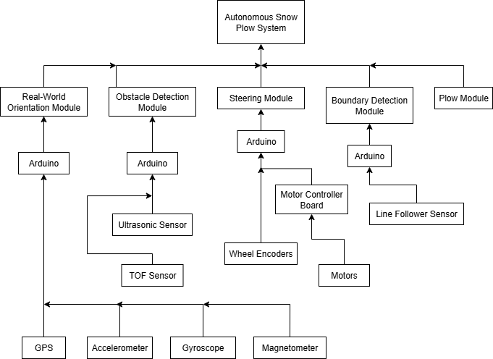Figure 1: Work Breakdown Structure of All Systems and Subsystems

2.3 Testing Plan

2.3.1 Unit Testing
Unit tests shall test individual components separately to ensure functionality in an isolated environment.
Motor Control
- Assert that every motor has the following functionalities:
  - PWM speed control (test 0%, 40%, 80%)
  - Direction Switching
Line Following Sensor
- Assert that the line following sensor can detect the following:
  - A vertical line to the left of the robot
  - A vertical line to the right of the robot
  - A horizontal line in front of the robot
  - A line on a 45° angle of the robot
  - Two lines intersecting (such as in a corner) (two cases)
    - Robot going forward and hits top right corner
    - Robot going forward hits top left corner
Obstacle Detection Sensors
- Assert that these sensors can detect the following:
  - An obstacle directly in front of the robot
  - A moving obstacle in front of the robot

IMU
- Assert that these sensors can detect the following:
  - A 90° turn in the z-axis
  - A 180° turn in the z-axis

2.3.2 Integration Testing
Integration tests shall cover communication between devices.
Arduino Due and Nano Communication
- Assert and validate sending/receiving messages between the Due to the Nano
- Assert that even during operations, messages are being received and acknowledged (ex: while the robot is moving, actively detecting a line, etc.)
Motor Control
- Assert that all motors can move in unison
- Assert that the robot can turn 90° left
- Assert that the robot can turn 90° right
- Assert that the robot can make a gradual left turn
- Assert that the robot can make a gradual right turn
Obstacle Detection and Perimeter Validation
- Assert that data from the line following sensor moves the robot accordingly
- Assert that data from the obstacle detection sensors move the robot accordingly to avoid the obstacle
Autonomous Behaviors
- Assert that the robot can travel across and remain within the entire perimeter
- Assert that the robot can reach a given point while avoiding obstacles and staying within the perimeter
- Assert that the robot can push cubes to the edge of a perimeter without overstepping the line
Logging
- Assert that errors from each component is logged and sent to a central serial terminal and/or log file.

3.0 Project Schedule

3.1 Project Activities
Based on the work-breakdown structure, the project is comprised of five major components, with a final activity dedicated to integration testing. In total, there are 21 major activities that shall be completed for this project.
Steering Module (SM):
A1: Develop Code for Steering Module
A2: Test Steering Module
Obstacle Detection Module (ODM):
A3: Configure Sensors for Obstacle Detection Module
A4: Develop Code for Obstacle Detection Module
A5: Test Obstacle Detection Module
A6: Integrate ODM code into existing code
A7: Test ODM and SM Working Together
Boundary Detection Module (BDM):
A8: Configure Sensors for Boundary Detection Module
A9: Develop Code for Boundary Detection Module
A10: Test Boundary Detection Module
A11: Integrate BDM code into existing code
A12: Test BDM and SM working together

Real World Orientation Module:
A13: Configure IMU
A14: Develop code for Orientation Module
A15: Test Orientation Module
A16: Integrate Orientation Module code into existing code
A17: Test Orientation Module and SM working together
Plow Module:
A18: Design Plow Module
A19: Build Plow Module
A20: Integrate Plow Module in system
Final Preparation
A21: Integration tests of the entire system

3.2 Schedule Network Diagram
The individual components of this project highly depend on the steering module for integration testing, but generally can be designed, implemented, and tested individually. This allows for a system that can be developed in parallel while covering all parts.
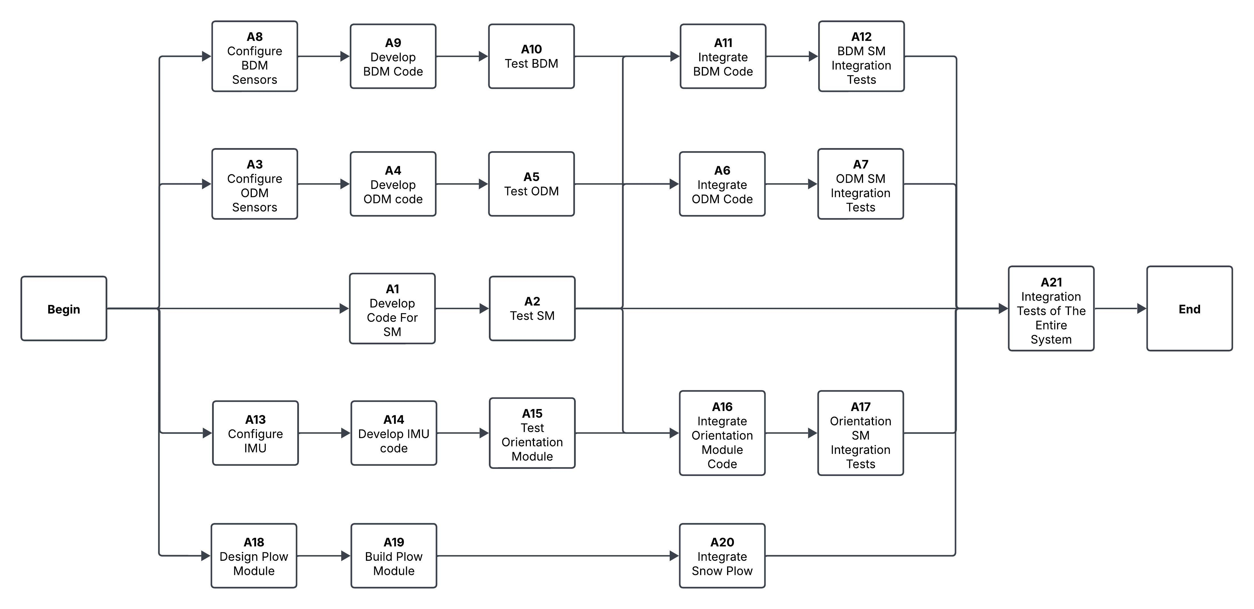Figure 2: Schedule Network Diagram

3.3 Gantt Chart
Due to the design of the activities, the Gantt chart can have multiple activities being worked on, in parallel. Figure 3 demonstrates this with 3-5 activities being worked on at a time.
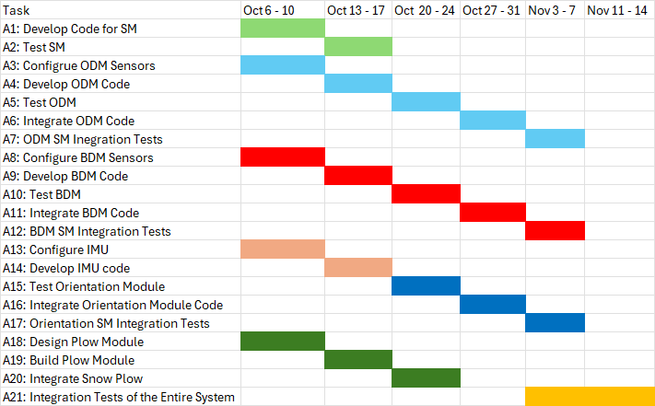Figure 3: Gantt Chart with All Activities

4.0 Project Cost
The total project cost consists of the course kit and the labor cost for four developers. Each developer works an estimated 8 hours per week for six weeks at a rate of $50 per hour.
Cost Component | Details | Calculation | Total ($)
Course Kit | Hardware and materials required for the project | Fixed | 500
Developer Labor | 4 developers × $50/hour × 8 hours/week × 6 weeks | 4 × (50 × 8 × 6) | 9,600
Total Project Cost |  | 500 + 9,600 | 10,100

Estimated Total Cost: $10,100

5.0 Human Resources ID

ID | Activity (from your schedule) | Responsible (R) | Approver (A)
A1 | Develop code for Steering Module (SM) | Adeyehun Folahanmi, Neel Patel | Neeraj Suchindrum
A2 | Test Steering Module | Adeyehun Folahanmi, Neel Patel | Neeraj Suchindrum
A3 | Configure sensors for Obstacle Detection Module (ODM) | Ryan Page, Neeraj Suchindrum | Ryan Page
A4 | Develop code for Obstacle Detection Module | Ryan Page, Neeraj Suchindrum | Ryan Page
A5 | Test obstacle detection module | Neel Patel, Adeyehun Folahanmi | Ryan Page
A6 | Integrate ODM Code into existing code | Neel Patel, Adeyehun Folahanmi | Ryan Page
A7 | Test ODM and SM working together | Neeraj Suchindrum, Neel Patel | Neel Patel
A8 | Configure sensors for Boundary Detection Module (BDM) | Neeraj Suchindrum, Neel Patel | Neel Patel
A9 | Develop code for Boundary Detection Module | Adeyehun Folahanmi, Neeraj Suchindrum | Neel Patel
A10 | Test Boundary Detection Module | Adeyehun Folahanmi, Neeraj Suchindrum | Neel Patel
A11 | Integrate BDM code into existing code | Ryan Page,  Adeyehun Folahanmi | Neeraj Suchindrum
A12 | Test BDM, ODM, and SM working together | Ryan Page,  Adeyehun Folahanmi | Neeraj Suchindrum
A13 | Configure IMU | Neel Patel,  Ryan Page | Neeraj Suchindrum
A14 | Develop code for Orientation Module | Neel Patel,  Ryan Page | Neeraj Suchindrum
A15 | Test Orientation Module | Neel Patel,  Ryan Page | Neeraj Suchindrum
A16 | Integrate Orientation Module code into existing code | Neeraj Suchindrum,  Ryan Page | Adeyehun Folahanmi
A17 | Test Orientation Module and SM working together | Neeraj Suchindrum,  Ryan Page | Adeyehun Folahanmi
A18 | Design Plow Module | Adeyehun Folahanmi,  Neel Patel | Adeyehun Folahanmi
A19 | Build Plow Module | Adeyehun Folahanmi,  Neel Patel | Adeyehun Folahanmi
A20 | Integrate Plow Module in system | Ryan Page,  Adeyehun Folahanmi | Ryan Page
A21 | Integration tests of the entire system | Ryan Page,  Adeyehun Folahanmi | Neel Patel

6.0 References

