Sample School — Test Document
Science — Class 8
Time: 3 hours Maximum Marks: 100

General Instructions:
- Answer all questions.
- Figures are for reference only.
- Marks are shown against each question.

Section A — Multiple Choice
Choose one answer.
1. Which part of a cell controls its activities? [1]
(a) Nucleus
(b) Wall
(c) Vacuole
(d) Membrane
2. Which force pulls objects toward Earth? [1]
(a) Friction
(b) Gravity
(c) Magnetism
(d) Tension
3. What is the SI unit of force? [1]
(a) Joule
(b) Newton
(c) Watt
(d) Pascal
4. Which gas do plants release in photosynthesis? [1]
(a) Oxygen
(b) Carbon dioxide
(c) Nitrogen
(d) Methane
5. What happens to water at 100 °C at normal pressure? [1]
(a) It freezes
(b) It boils
(c) It condenses
(d) It sublimes
6. Which material conducts electricity well? [1]
(a) Rubber
(b) Wood
(c) Copper
(d) Glass
7. Which organ filters blood to make urine? [1]
(a) Heart
(b) Kidney
(c) Liver
(d) Lung
8. Which energy source is renewable? [1]
(a) Coal
(b) Petroleum
(c) Solar
(d) Natural gas
9. Which lens is thicker in the middle? [1]
(a) Concave
(b) Convex
(c) Plane
(d) Cylindrical
10. Which state of matter has a fixed volume but no fixed shape? [1]
(a) Solid
(b) Liquid
(c) Gas
(d) Plasma
11. Which organism is a decomposer? [1]
(a) Fungus
(b) Grass
(c) Rabbit
(d) Eagle
12. What is the main source of energy for Earth? [1]
(a) Moon
(b) Sun
(c) Wind
(d) Ocean
13. Which simple machine is a seesaw? [1]
(a) Pulley
(b) Lever
(c) Wheel
(d) Screw
14. What is the pH of pure water? [1]
(a) 2
(b) 5
(c) 7
(d) 12
15. Which blood cells carry oxygen? [1]
(a) White cells
(b) Red cells
(c) Platelets
(d) Plasma
16. Which process turns water vapour into liquid? [1]
(a) Evaporation
(b) Condensation
(c) Melting
(d) Freezing
17. Which planet is known for its rings? [1]
(a) Mars
(b) Venus
(c) Saturn
(d) Mercury
18. Which part of the ear detects sound vibrations? [1]
(a) Retina
(b) Eardrum
(c) Tongue
(d) Nostril
19. Which substance is a good insulator? [1]
(a) Copper
(b) Aluminium
(c) Plastic
(d) Iron
20. What does a thermometer measure? [1]
(a) Mass
(b) Temperature
(c) Speed
(d) Volume
Section B — Short Answer
Answer briefly.
1. State two differences between plant and animal cells. [2]
2. Explain why friction can be useful. [2]
3. Define pressure and write its formula. [2]
4. What is respiration? [2]
5. Describe evaporation in one sentence. [2]
6. Name two conductors and two insulators. [2]
7. Use the circuit diagram to explain why the bulb lights. [2]
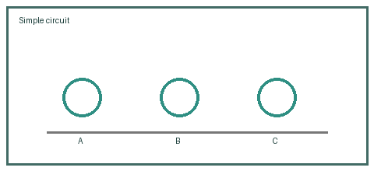
8. Give two advantages of solar energy. [2]
9. What is the difference between reflection and refraction? [2]
10. Why can a liquid take the shape of its container? [2]
11. What role do decomposers play in an ecosystem? [2]
12. Explain one way to conserve water at home. [2]
Water use | Saving method

13. What is a lever? Give one example. [2]
14. How can litmus identify an acid? [2]
15. State the function of red blood cells. [2]
16. Name the three states of water. [2]
17. Why do we see phases of the Moon? [2]
18. Explain how sound reaches the inner ear. [2]
19. Why is plastic used to cover electrical wires? [2]
(i) Name one conductor. [1]
(ii) Name one insulator. [1]
20. What is the normal unit for measuring temperature in school experiments? [2]
Section C — Long Answer
Explain your answer.
1. Complete the results table and explain how light affects plant growth. [5]
Light | Growth | Notes

2. Describe an experiment to compare friction on smooth and rough surfaces. [5]
3. Use the energy-flow diagram to explain a simple food chain.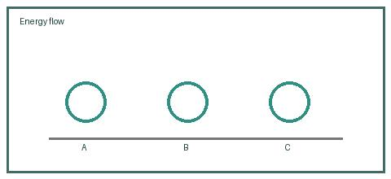 [5]
4. Explain the water cycle using evaporation, condensation and precipitation. [5]
5. Describe how a simple electric circuit works and draw its main parts. [5]
6. Compare acids and bases using indicators and two everyday examples. [5]
7. Explain how the respiratory and circulatory systems work together. [5]
8. Discuss two causes of water pollution and two ways to reduce it. [5]

