Sample School — Test Document
Biology — Class 6
Time: 1 hour Maximum Marks: 25

General Instructions:
- Answer all questions.
- Figures are for reference only.
- Marks are shown against each question.

Section A — Multiple Choice
Choose one answer.
1. Which part of a plant absorbs water from soil? [1]
(a) Leaf
(b) Root
(c) Flower
(d) Fruit
2. Which organ pumps blood around the body? [1]
(a) Lung
(b) Heart
(c) Stomach
(d) Brain
3. What do plants absorb to make food? [1]
(a) Oxygen
(b) Nitrogen
(c) Carbon dioxide
(d) Hydrogen
4. Which substance gives leaves their green colour? [1]
(a) Chlorophyll
(b) Haemoglobin
(c) Starch
(d) Protein
5. Which bones protect the brain? [1]
(a) Ribs
(b) Skull
(c) Spine
(d) Pelvis
Section B — Short Answer
Answer briefly.
1. Define habitat and give one example. [2]
2. Look at the plant diagram. State two functions of the stem. [2]
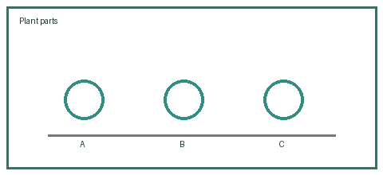
3. Explain photosynthesis briefly. [2]
(i) Name the gas absorbed by plants. [1]
(ii) Name the gas released by plants. [1]
4. Name two organs in the digestive system and state one function of each. [2]
5. Why do humans need to breathe? [2]
Section C — Long Answer
Explain your answer.
1. Complete the observation table for a growing seed, then explain what a seed needs to germinate. [5]
Condition | Observation

2. Describe the path air takes from the nose to the lungs and explain gas exchange. [5]

