Sample School — Test Document
Chemistry — Class 7
Time: 2 hours Maximum Marks: 50

General Instructions:
- Answer all questions.
- Figures are for reference only.
- Marks are shown against each question.

Section A — Multiple Choice
Choose one answer.
1. Which solution is acidic? [1]
(a) Soap water
(b) Lemon juice
(c) Baking soda
(d) Salt water
2. What is the smallest unit of an element? [1]
(a) Molecule
(b) Atom
(c) Cell
(d) Crystal
3. Which metal is liquid near room temperature? [1]
(a) Iron
(b) Copper
(c) Mercury
(d) Aluminium
4. What is the pH of a neutral solution? [1]
(a) 0
(b) 3
(c) 7
(d) 14
5. What is the chemical formula of water? [1]
(a) H₂O
(b) CO₂
(c) O₂
(d) NaCl
6. Which change is reversible? [1]
(a) Burning paper
(b) Rusting iron
(c) Melting ice
(d) Cooking an egg
7. Use the pH scale diagram. Which number is strongly acidic?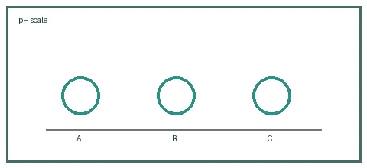 [1]
(a) 2
(b) 7
(c) 10
(d) 14
8. Which method separates sand from water? [1]
(a) Evaporation
(b) Filtration
(c) Magnetism
(d) Sublimation
9. Which gas is needed for iron to rust? [1]
(a) Oxygen
(b) Helium
(c) Neon
(d) Hydrogen
10. An acid reacts with a base to form salt and what else? [1]
(a) Oxygen
(b) Water
(c) Carbon
(d) Iron
Section B — Short Answer
Answer briefly.
1. State two properties of acids. [2]
2. What is an element? Give one example. [2]
3. Explain the difference between melting and dissolving. [2]
4. Fill the table with one use each for copper, iron and aluminium. [2]
Metal | Property | Use

5. Why is distilled water a poor conductor of electricity? [2]
6. Name two ways to prevent rusting. [2]
7. What does a pH value below 7 indicate? [2]
8. Explain what a solute and solvent are. [2]
9. Write the formula of carbon dioxide and water. [2]
(i) Write the formula for water. [1]
(ii) Write the formula for carbon dioxide. [1]
10. Give one sign that a chemical reaction has occurred. [2]
Section C — Long Answer
Explain your answer.
1. Compare physical and chemical changes with two examples of each. [5]
2. Explain neutralisation and give an everyday example. [5]
3. Describe how to separate a mixture of sand, salt and water. [5]
4. Explain the particle arrangement in solids, liquids and gases. [5]

