St Vincent Pallotti School
Unit Test-1
Chemistry — Class VII
Maximum Marks: 25

Section I — Question 1(a): Multiple Choice
Choose the correct answer.
1. Vishal has a mixture of methyl alcohol and water. Which method will he choose to separate them? [0.5]
(a) Evaporation
(b) Distillation
(c) Sublimation
(d) Fractional Distillation
2. Iron has a variable valency of ____. [0.5]
(a) 1 & 2
(b) 2 & 3
(c) 3 & 4
(d) 2 & 4
3. The element showing poly atomicity ____________. [0.5]
(a) Boron
(b) Radon
(c) Sulphur
(d) Hydrogen
4. Radical with positive valency is ________. [0.5]
(a) Carbonate
(b) Bicarbonate
(c) Ammonium
(d) Hydroxide
5. Which among the following is an example of homogeneous mixture? [0.5]
(a) Chalk & water
(b) Iodine & alcohol
(c) Kerosene & water
(d) Iron & sulphur
6. The least reactive metal placed in the activity series is ______. [0.5]
(a) Silver
(b) Gold
(c) Potassium
(d) Iron
Question 1(b): Short Answer
1. Potassium nitride [1]
2. Calcium phosphate [1]
3. Aluminium bisulphate [1]
Question 1(c): Assertion and Reason
1. 1. Assertion: An atom is electrically neutral. Reason: Atoms have equal number of protons and electrons. [1]
(a) Both Assertion (A) and Reason (R) are true and Reason is the correct explanation of the Assertion
(b) Both Assertion (A) and Reason (R) are true but (R) is Not the correct explanation of the Assertion.
(c) Assertion(A) is true, but Reason (R) is false.
(d) Assertion (A) is false but Reason(R) is true.
2. 2. Assertion(A): Both elements and compounds are called pure substances. Reason (R): They are made of same kinds of atoms. [1]
(a) Both Assertion (A) and Reason (R) are true and Reason is the correct explanation of the Assertion
(b) Both Assertion (A) and Reason (R) are true but (R) is Not the correct explanation of the Assertion.
(c) Assertion is true, but Reason is false.
(d) Assertion (A) is false but Reason(R) is true
3. Assertion (A): A solution of table salt in a glass of water is homogeneous. Reason(R): A solution having different composition throughout is heterogeneous. [1]
(a) Both Assertion (A) and Reason (R) are true and Reason is the correct explanation of the Assertion
(b) Both Assertion (A) and Reason (R) are true but (R) is Not the correct explanation of the Assertion.
(c) Assertion (A) true, but Reason (R)is false.
(d) Assertion (A) is false but Reason(R) is true.
Question 1(d): Chemistry
1. Magnesium bi sulphate [1]
2. Aluminium chlorate [1]
3. Ammonium chloride [1]
Question 1(e): Case Study
Read the passage and answer the questions.
1. Atoms are incredibly small particles that make up everything around us. An atom consists of three main components: proteins, neutrons, and electrons. Protons have a positive charge, neutrons have no charge, and electrons have a negative charge. The protons and neutrons are located in the nucleus, which is at the centre of the atom, while the electrons orbit around the nucleus in specific energy levels called electron shells, the number of protons determines the atomic number of an atom and the sum of protons and neutrons gives the atomic mass, which makes them unique. The number of electrons in the valence shell of the given atom is: [1]
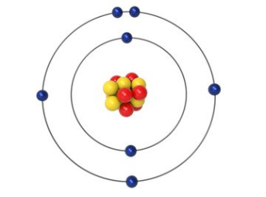
(a) 5
(b) 6
(c) 7
(d) 8
2. Where are the protons and neutrons located in an atom? [1]
(a) Moving around the nucleus
(b) In the electron shells
(c) In the energy levels
(d) In the nucleus
3. What determines the mass number of an atom? [1]
(a) The number of neutrons
(b) The number of protons and electrons
(c) The number of electrons
(d) The sum of protons and neutrons
Section II — Questions 2 to 4
Answer any 2 questions.
2. Answer the following parts. [5]
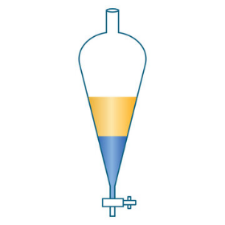
(i) Potassium is the most reactive metal in the activity series. Justify. [1]
(ii) Write the chemical name of Nitric acid and name the elements present in it. [1]
(iii) Which among the following is immiscible liquids (Kerosene and water, lemon juice in water ..) [0.5]
(iv) What is sublimation? Give an example of a sublime substance [1]
(v) Study the method of separating a mixture of water and mercury. And answer the questions given Identify the component marked X and Y State the principle for this separation technique. [1]
(vi) Name the method that is used to separate the dyes of a marker pen ink. [0.5]
3. Answer the following parts. [5]
(i) Elements in the periodic table are arranged in the increasing order of ____________. Define it. [1]
(ii) State the atomicity a. Sodium b. Sulphur. [1]
(iii) Name the basic radical and acid radical in the compound, Magnesium sulphate. [0.5]
(iv) Valency of Copper in Copper (II) sulphate is ________. Write the formula [1]
(v) State one property of Group 17 elements. [1]
(vi) Write the number of atoms of each element present in Ammonium chloride. [0.5]
4. Answer the following parts. [5]
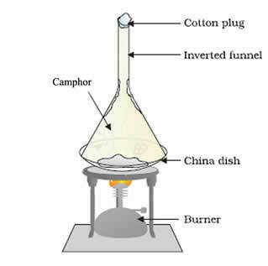
(i) Study the picture and answer the question given A mixture of ammonium chloride and sodium chloride are heated. Name the substance that collects in the funnel. Give reason. [1]
(ii) Why is Aluminium chosen in the packaging industry for the production of cans, foils etc. [1]
(iii) Give the chemical name of baking soda. [0.5]
(iv) What are cations and anions? [1]
(v) Name a radical having carbon and oxygen atoms. Give its symbol [1]
(vi) Nitrogen atom has 7 neutrons and electrons. State its mass number. [0.5]

