St Vincent Pallotti School
Unit Test-1
Subject-Chemistry
Class-VII Marks:25
Section- 1
Question 1
- Choose the correct answer: - (6x1/2=3)
1.Vishal has a mixture of methyl alcohol and water. Which method will he choose to separate them?
i. Evaporation ii. Distillation iii. Sublimation iv. Fractional Distillation
2.Iron has a variable valency of ____.
- 1&2 ii.2&3 iii.3&4 iv. 2&4
3.The element showing poly atomicity ____________.
i. Boron ii. Radon iii. Sulphur iv. Hydrogen .
4. Radical with positive valency is ________.
i. Carbonate ii. Bicarbonate iii. Ammonium iv. Hydroxide
- Which among the following is an example of homogeneous mixture?
i. Chalk & water ii. iodine &alcohol iii. Kerosene &water iv. Iron &sulphur,
6. The least reactive metal placed in the activity series is ______.
i. Silver ii. Gold iii. Potassium iv. Iron

- Derive the molecular formula (3x1=3)
- Potassium nitride
- Calcium phosphate
- Aluminium bisulphate

c. Assertion based Question. (3x1=3)
1. Assertion: An atom is electrically neutral.
Reason: Atoms have equal number of protons and electrons.
i. Both Assertion (A) and Reason (R) are true and Reason is the correct explanation of the Assertion
ii. Both Assertion (A) and Reason (R) are true but (R) is Not the correct explanation of the Assertion.
iii. Assertion(A) is true, but Reason (R) is false.
iv. Assertion (A) is false but Reason(R) is true.
2. Assertion(A): Both elements and compounds are called pure substances.
Reason (R): They are made of same kinds of atoms.
i. Both Assertion (A) and Reason (R) are true and Reason is the correct explanation of the Assertion
ii. Both Assertion (A) and Reason (R) are true but (R) is Not the correct explanation of the Assertion.
iii. Assertion is true, but Reason is false.
Iv. Assertion (A) is false but Reason(R) is true
- Assertion (A): A solution of table salt in a glass of water is homogeneous.
Reason(R): A solution having different composition throughout is heterogeneous.
i. Both Assertion (A) and Reason (R) are true and Reason is the correct explanation of the Assertion
ii. Both Assertion (A) and Reason (R) are true but (R) is Not the correct explanation of the Assertion.
iii. Assertion (A) true, but Reason (R)is false.
iv. Assertion (A) is false but Reason(R) is true.

d. Identify the radical and write its symbol with valency. (3x1=3)
- Magnesium bi sulphate
- Aluminium chlorate
- Ammonium chloride
e. Case study. Read the information and answer the questions given: (3x1=3)
Atoms are incredibly small particles that make up everything around us. An atom consists of three main components: proteins, neutrons, and electrons. Protons have a positive charge, neutrons have no charge, and electrons have a negative charge. The protons and neutrons are located in the nucleus, which is at the centre of the atom, while the electrons orbit around the nucleus in specific energy levels called electron shells, the number of protons determines the atomic number of an atom and the sum of protons and neutrons gives the atomic mass, which makes them unique.
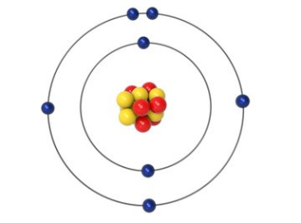
- The number of electrons in the valence shell of the given atom is:
- 5 ii. 6. I ii. 7 iv. 8
- Where are the protons and neutrons located in an atom?
- Moving around the nucleus. iii. In the energy levels
- In the electron shells. iv. In the nucleus.
- What determines the mass number of an atom?
- The number of neutrons iii. The number of electrons
- The number of protons and electrons iv. The sum of protons and neutrons.

Section -II
(Answer any 2 questions)
Question 2
- ,
- Potassium is the most reactive metal in the activity series. Justify. (1)
- Write the chemical name of Nitric acid and name the elements present in it. (1)
- Which among the following is immiscible liquids (Kerosene and
water, lemon juice in water ..) (1/2)
- ,
- What is sublimation? Give an example of a sublime substance (1)
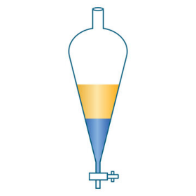
- Study the method of separating a mixture of water
and mercury. And answer the questions given
- Identify the component marked X and Y (1)
- State the principle for this separation technique.
- Name the method that is used to separate the dyes of a marker pen ink. (1/2)
Question 3
- ,
- Elements in the periodic table are arranged in the increasing order of ____________.
Define it. (1)
- State the atomicity
a. Sodium b. Sulphur. (1)
- Name the basic radical and acid radical in the compound, Magnesium
sulphate. (1/2)
- ,
- Valency of Copper in Copper (II) sulphate is ________. Write the formula (1)
- State one property of Group 17 elements. (1)
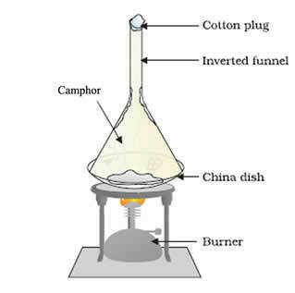
- Write the number of atoms of each element present in Ammonium chloride. (1/2)
Question 4
- ,
- Study the picture and answer the question given
A mixture of ammonium chloride and sodium chloride are heated. Name the substance that collects in the funnel.
Give reason. (1)
- Why is Aluminium chosen in the packaging industry for the production of cans, foils etc. (1)
- Give the chemical name of baking soda. (1/2)
- What are cations and anions? (1)
- Name a radical having carbon and oxygen atoms. Give its symbol (1)
- Nitrogen atom has 7 neutrons and electrons.
State its mass number. (1/2)

