Lab-4.R

ryans

2024-10-11

#My first R Script  
x <- 1:50  
plot(x)

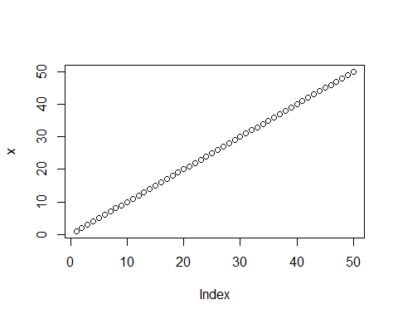

plot(x, sin(x), type="l", col="red", lwd=4)

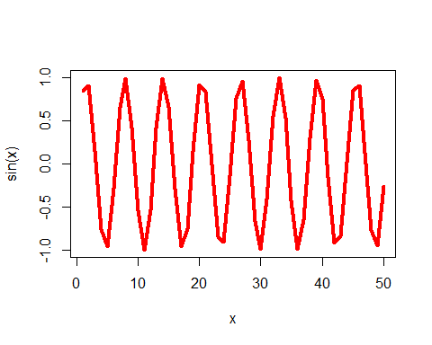

plot(x=x, y=sin(x), col="blue", typ="l", lwd=2)

