MLR

Brian Dehlinger

December 1, 2019

set.seed(10035)  
remove_singularities <- function(dataset, gene_name){  
 dataset_copy <- dataset  
 item <- paste(gene_name, "~.", sep="")  
 full_formula <- as.formula(item)  
 fit <- lm(full_formula, data=dataset)  
 singularities <- attributes(alias(fit)$Complete)$dimnames[[1]]  
 for (singularity in singularities){  
 dataset_copy[singularity] <- NULL  
 }  
 return(dataset_copy)  
}  
read_in_pruned_datasets_for_gene_0.8 <- function(gene_name, path){  
 full_path0.8 <- paste(path, gene_name, "_for_r_0.8.txt", sep="")  
 Data0.8 <- read.table(full_path0.8, header=TRUE, sep=',')  
 Data0.8 <- remove_singularities(Data0.8, gene_name)  
 return(Data0.8)  
}  
#install.packages("DAAG")  
#install.packages("caret")  
#install.packages("lmtest")  
#install.packages("MASS")  
#install.packages("car")  
#install.packages("reshape")  
#install.packages("plotmo")  
#install.packages("olsrr")  
library(caret)

## Loading required package: lattice

## Loading required package: ggplot2

library(lmtest)

## Loading required package: zoo

##   
## Attaching package: 'zoo'

## The following objects are masked from 'package:base':  
##   
## as.Date, as.Date.numeric

library(MASS)  
library(car)

## Loading required package: carData

library(reshape)  
library(plotmo)

## Loading required package: Formula

## Loading required package: plotrix

## Loading required package: TeachingDemos

library(olsrr)

##   
## Attaching package: 'olsrr'

## The following object is masked from 'package:MASS':  
##   
## cement

## The following object is masked from 'package:datasets':  
##   
## rivers

library(DAAG)

##   
## Attaching package: 'DAAG'

## The following object is masked from 'package:car':  
##   
## vif

## The following object is masked from 'package:MASS':  
##   
## hills

gene_data <- read_in_pruned_datasets_for_gene_0.8("ENSG00000142794", "D:\\Project\\GitStash\\Applied_regression_project\\")  
gene_data <- as.data.frame(gene_data)  
hist(gene_data[["ENSG00000142794"]], main="ENSG0000014279 Gene Expression Distribution", ylab="Frequency", xlab="Gene Expression Value")

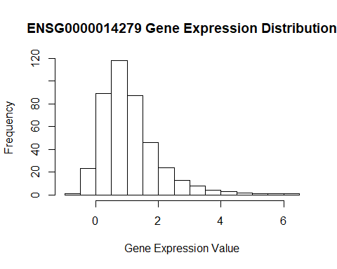

boxplot(gene_data[["ENSG00000142794"]], main="Boxplot of ENSG0000014279 expression", ylab="Expression value", xlab="Boxplot")

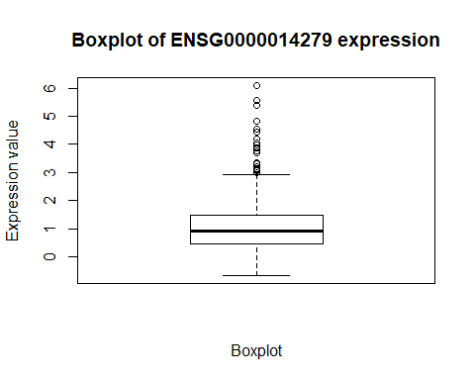

# We notice that the Expression Data is skewed to the right.  
trainIndex <- createDataPartition(gene_data[["ENSG00000142794"]], p=.8, list = FALSE, times=1)  
  
# We do test train split and explicitly create the data partition indexs   
# because of the difference seed values produce in different R versions

gene_data <- gene_data[train_index,]  
gene_test <- gene_data[-train_index,]  
#We do a train validation split here.

model <- lm(ENSG00000142794~., data=gene_data)  
summary(model)

##   
## Call:  
## lm(formula = ENSG00000142794 ~ ., data = gene_data)  
##   
## Residuals:  
## Min 1Q Median 3Q Max   
## -1.4584 -0.3311 -0.0545 0.2781 3.2295   
##   
## Coefficients:  
## Estimate Std. Error t value Pr(>|t|)   
## (Intercept) 1.0773438 0.8375846 1.286 0.1996   
## rs12734589 -0.2426399 0.3650244 -0.665 0.5069   
## rs2004380 0.1102502 1.0093512 0.109 0.9131   
## rs10737456 -0.1014757 0.2853902 -0.356 0.7225   
## rs10799692 0.0890538 0.5131390 0.174 0.8624   
## rs3820296 -0.2600382 0.3517204 -0.739 0.4604   
## rs10916988 0.1944314 0.1744793 1.114 0.2663   
## rs1976403 0.5034704 0.4112980 1.224 0.2222   
## rs1780324 0.4284627 0.2894724 1.480 0.1402   
## rs4654753 -0.4658774 0.4593801 -1.014 0.3116   
## rs79760554 0.0278784 0.1362679 0.205 0.8381   
## rs12729540 -0.0386049 0.2499062 -0.154 0.8774   
## rs12043777 -0.1137017 0.1445647 -0.787 0.4324   
## rs10799702 0.1519789 0.2212533 0.687 0.4928   
## rs4061838 -0.1683068 0.1846747 -0.911 0.3630   
## rs7545635 0.0693701 0.2444405 0.284 0.7768   
## rs4654946 -0.0593146 0.5275433 -0.112 0.9106   
## rs2047653 -0.0215676 0.4805840 -0.045 0.9642   
## rs4079441 0.0160076 0.5254259 0.030 0.9757   
## rs12034222 0.1939562 0.1212573 1.600 0.1111   
## rs3820292 -0.0718418 0.1268148 -0.567 0.5716   
## rs75417796 0.1798876 0.3004644 0.599 0.5500   
## rs7541779 0.0238033 0.2965717 0.080 0.9361   
## rs75417790 0.0475355 0.2394576 0.199 0.8428   
## rs10799691 -0.0251948 0.2950647 -0.085 0.9320   
## rs1971328 0.2014015 0.2281684 0.883 0.3783   
## rs12744514 0.6974904 0.5034685 1.385 0.1673   
## rs41310392 -0.4924510 0.3108441 -1.584 0.1145   
## rs75056920 0.0976996 0.1316812 0.742 0.4589   
## rs1697421 -0.2674773 0.2314293 -1.156 0.2490   
## rs146767219 0.0388611 0.1074221 0.362 0.7179   
## rs12132412 0.0488435 0.1550308 0.315 0.7530   
## rs112985962 -0.1747530 0.6483509 -0.270 0.7878   
## rs147900768 0.1793372 0.2227159 0.805 0.4215   
## rs1814737 -0.6478764 0.7304950 -0.887 0.3760   
## rs56286426 -0.0108865 0.1338131 -0.081 0.9352   
## rs17420195 1.2040546 0.9058701 1.329 0.1851   
## rs113548640 0.1619209 0.3515875 0.461 0.6456   
## rs146564096 -0.1459169 0.1311852 -1.112 0.2672   
## rs10916989 0.0113086 0.2306912 0.049 0.9609   
## rs150401191 0.0091174 0.6004537 0.015 0.9879   
## rs3010180 -0.1346392 0.1276371 -1.055 0.2926   
## rs78885464 0.1262377 0.1141166 1.106 0.2698   
## rs6694671 0.0356021 0.3917338 0.091 0.9277   
## rs144522615 -0.0696422 0.1296253 -0.537 0.5916   
## rs61775934 -0.1628478 0.4170355 -0.390 0.6965   
## rs3010181 0.1408603 0.1079256 1.305 0.1931   
## rs1780323 -0.0641018 0.1257974 -0.510 0.6108   
## rs61778366 -0.3494258 0.2960935 -1.180 0.2392   
## rs79659018 0.0159360 0.1274369 0.125 0.9006   
## rs10737458 -0.3630167 0.4858445 -0.747 0.4557   
## rs11584744 0.5002325 0.3351833 1.492 0.1369   
## rs201590042 -0.0149337 0.1038923 -0.144 0.8858   
## rs1566524 -0.1873926 0.4552565 -0.412 0.6810   
## rs61775950 0.0831508 0.0978564 0.850 0.3964   
## rs144443608 0.0877285 0.1013082 0.866 0.3874   
## rs10916986 0.3573069 0.2995042 1.193 0.2341   
## rs904927 0.1363907 0.3373079 0.404 0.6863   
## rs190849739 0.0054703 0.1267022 0.043 0.9656   
## rs143561157 0.1553284 0.1161436 1.337 0.1824   
## rs12740648 -0.0110182 0.1509227 -0.073 0.9419   
## rs12118362 0.0390582 0.1495256 0.261 0.7942   
## rs1809914 -0.4849652 0.2207155 -2.197 0.0290 *  
## rs41310412 0.0082098 0.2822820 0.029 0.9768   
## rs6423191 0.0007244 0.1983363 0.004 0.9971   
## rs140609058 -0.2737547 0.3502827 -0.782 0.4353   
## rs7555005 -0.1160461 0.2698248 -0.430 0.6675   
## rs71512991 -0.0922331 0.1062848 -0.868 0.3864   
## rs139043162 -0.0988816 0.3860193 -0.256 0.7981   
## rs2800935 -0.0890408 0.1292364 -0.689 0.4915   
## rs113324018 0.1567611 0.2392068 0.655 0.5129   
## rs904928 0.0440956 0.1553133 0.284 0.7767   
## rs7533048 0.1191272 0.2959662 0.403 0.6877   
## rs12239666 -0.1800842 0.2227685 -0.808 0.4197   
## rs972662 0.1707553 0.2390314 0.714 0.4757   
## rs9726624 -0.0631679 0.1772911 -0.356 0.7219   
## rs2800774 0.0266631 0.0939158 0.284 0.7767   
## rs56268398 0.0605925 0.1983985 0.305 0.7603   
## rs12082914 0.1894957 0.3400845 0.557 0.5779   
## rs78566499 0.0775510 0.2753531 0.282 0.7785   
## rs1809915 0.2982296 0.1990040 1.499 0.1353   
## rs7547671 0.2785216 0.8860444 0.314 0.7535   
## rs146549873 -0.0763266 0.0938884 -0.813 0.4171   
## rs113934925 -0.1689566 0.9265713 -0.182 0.8555   
## rs200384063 -0.0353196 0.2725797 -0.130 0.8970   
## rs4654930 0.3933332 0.3124555 1.259 0.2093   
## rs3855556 0.0959987 0.1545367 0.621 0.5351   
## rs35836191 -0.6655432 0.5295844 -1.257 0.2101   
## rs60803995 0.1947940 0.1536928 1.267 0.2063   
## rs12037596 -0.1170011 0.1806859 -0.648 0.5179   
## rs2651402 0.4172604 0.3110401 1.342 0.1811   
## rs41290414 -0.3163552 0.4893582 -0.646 0.5186   
## rs72476502 0.0790231 0.2649570 0.298 0.7658   
## rs58090121 -0.0165627 0.1430192 -0.116 0.9079   
## rs904937 -0.1079859 0.1691946 -0.638 0.5239   
## rs41265985 -0.3857862 0.2618278 -1.473 0.1420   
## rs77025042 -0.0157810 0.1191521 -0.132 0.8947   
## rs7417849 -0.1141053 0.1663477 -0.686 0.4934   
## rs113558389 -0.1506948 0.2873036 -0.525 0.6004   
## rs904929 0.1129374 0.1973569 0.572 0.5677   
## rs10799704 -0.0001877 0.0840813 -0.002 0.9982   
## rs148061397 0.0406450 0.2051900 0.198 0.8432   
## rs115933091 0.1055186 0.3592554 0.294 0.7692   
## rs143553186 0.5298658 0.2947059 1.798 0.0735 .  
## ---  
## Signif. codes: 0 '***' 0.001 '**' 0.01 '*' 0.05 '.' 0.1 ' ' 1  
##   
## Residual standard error: 0.6711 on 233 degrees of freedom  
## Multiple R-squared: 0.6148, Adjusted R-squared: 0.4446   
## F-statistic: 3.611 on 103 and 233 DF, p-value: 2.972e-16

plot(model, which=1)

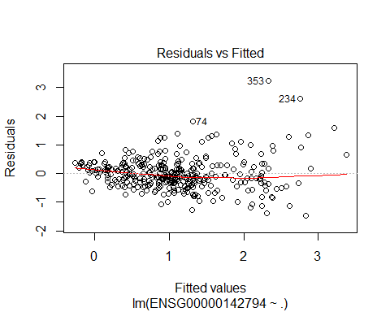

bptest(model)

##   
## studentized Breusch-Pagan test  
##   
## data: model  
## BP = 96.199, df = 103, p-value = 0.6693

# We note from the Residuals Vs Fitted Plot that there   
#might be a slight concern with nonconstant variance but for the Breusch-Pagan test   
# we fail to reject with an alpha of 0.05.  
  
plot(model, which=2)

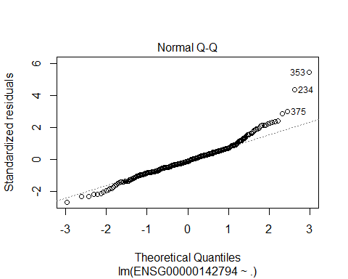

shapiro.test(model$residuals)

##   
## Shapiro-Wilk normality test  
##   
## data: model$residuals  
## W = 0.94027, p-value = 2.08e-10

# However, we notice an issue with normality from a QQPlot that   
# suggests the data is skewed and we reject the shapiro-wilks test with an alpha of 0.05  
  
plot(model, which=3)

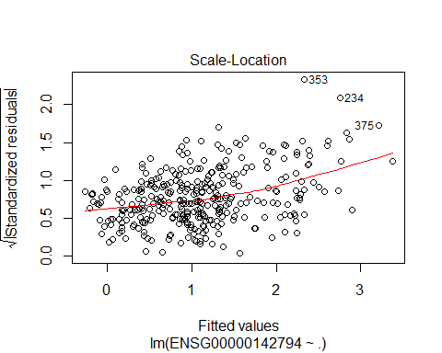

#The Scale-Location plot has a slope most likely because there isn't enough data for the fitted values.  
  
plot(model, which=4)

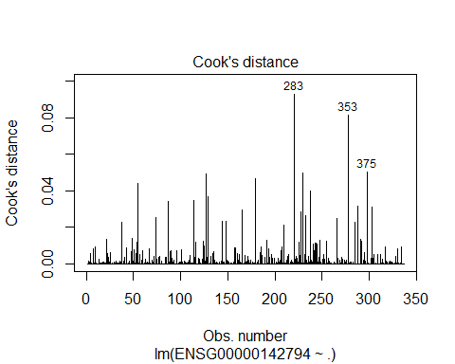

plot(model, which=5)

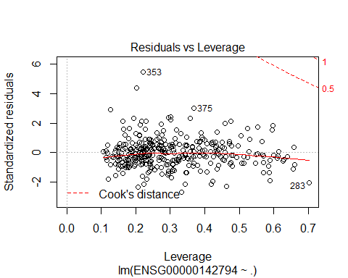

# We don't notice an issues with overly influential points in the residuals vs Leverage Plot.   
# However, we do note some points are considered to have high leverage later on. But these points   
# are actually important to the variation we want to capture in our data.  
  
summary(model)$adj.r.squared

## [1] 0.444552

# We have an adjusted R-squared of 0.44452.   
  
test <- model <- lm(ENSG00000142794+2~., data=gene_data)  
# We do a Boxcox on the model and note that we should do a transformation on Y(1/sqrt(Y+2))  
boxcox(test)

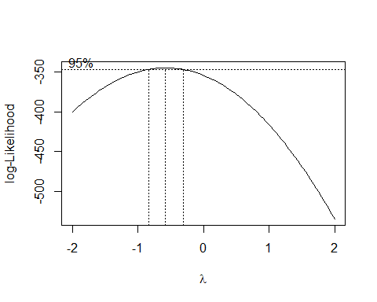

# VIF Calculation and setting N and P   
n <- nrow(gene_data)  
p <- length(model$coefficients)  
  
# There is an indication of severe multicolinearity.   
car::vif(model)  
test <- lm(ENSG00000142794+2~., data=gene_data)

# The added variable plots suggest a lot of the predictors do not   
# add new information when the other predictors are included in the model.  
pdf("AddedVariablesBeforeSelection.pdf")  
avPlots(model, ask=FALSE)  
dev.off()

## png   
## 2

# We do the transform on the train and test datasets. # We also set n.  
# Additionally, we also plot the transformed values and note they appear to be normally distributed.   
transformed_gene_data <- gene_data  
transformed_gene_test <- gene_test  
n <- nrow(transformed_gene_data)  
transformed_gene_data[["ENSG00000142794"]] <- 1/(sqrt(transformed_gene_data[["ENSG00000142794"]]+2))  
transformed_gene_test[["ENSG00000142794"]] <- 1/(sqrt(transformed_gene_test[["ENSG00000142794"]]+2))  
boxplot(transformed_gene_data["ENSG00000142794"], main="Boxplot of Transformed Gene Expression Values", ylab="Gene Expression Transformed Value", xlab="Boxplot")

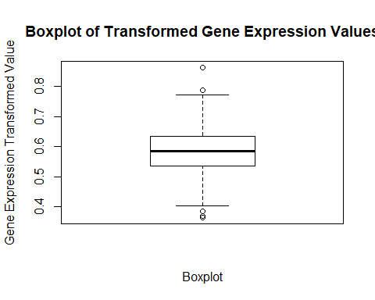

hist(transformed_gene_data[["ENSG00000142794"]], main="Transformed ENSG0000014279 Gene Expression Distribution", ylab="Frequency", xlab="Transformed Gene Expression Value")

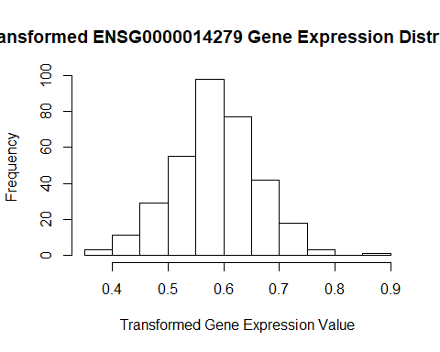

# We do variable selection and we do a strict variable selection with a p-value of 0.01. Step-Forward BIC, and Step-Backward BIC.  
# We then put the selected variables for each model together and do a best subset exhaustive search over just these variables.   
  
naieve_model <- lm(ENSG00000142794~., data=transformed_gene_data)  
naieve_model_empty <- lm(ENSG00000142794~1, data=transformed_gene_data)  
  
  
selected_p <- ols_step_backward_p(naieve_model, prem=0.01)  
selected_p_model <- selected_p$model  
p <- length(selected_p_model$coefficients)  
RSS_selected <- c(crossprod(selected_p_model$residuals))  
MSE <- RSS_selected / length(selected_p_model$residuals)  
selected_p_stats <- rbind(sqrt(MSE), BIC(selected_p_model), summary(selected_p_model)$adj.r.squared, DAAG::press(selected_p_model))  
  
  
  
  
selected<- stepAIC(naieve_model, k=log(n))  
p <- length(selected$coefficients)  
RSS_selected <- c(crossprod(selected$residuals))  
MSE <- RSS_selected / length(selected$residuals)  
selected_stats <- rbind(sqrt(MSE), BIC(selected), summary(selected)$adj.r.squared, DAAG::press(selected))  
  
forward_bic <- stepAIC(naieve_model_empty, scope = list(upper=naieve_model, lower=naieve_model_empty), direction="forward", k=log(n))  
p <- length(forward_bic$coefficients)  
RSS_selected <- c(crossprod(forward_bic$residuals))  
MSE <- RSS_selected / length(forward_bic$residuals)  
forward_bic_stats <- rbind(sqrt(MSE), BIC(forward_bic), summary(forward_bic)$adj.r.squared, DAAG::press(forward_bic))

car::vif(selected)

## rs12734589 rs10799692 rs113548640 rs6694671 rs1566524 rs35836191   
## 5.036327 4.997166 2.697843 3.118706 3.069425 1.694852   
## rs60803995   
## 2.351035

car::vif(selected_p_model)

## rs12734589 rs113548640 rs6694671 rs1566524 rs35836191 rs60803995   
## 3.283511 2.146153 2.669397 3.068997 1.694835 2.347506

car::vif(forward_bic)

## rs12734589 rs1976403 rs4654753 rs6694671 rs113548640 rs10916989   
## 3.192661 2.848736 4.706859 3.299466 5.526336 3.981726

# We now do not see any issues with multicolinearity which suggests   
# we do not need to use ridge regression on these reduced variable models.

search_full_model <- lm(ENSG00000142794~rs12734589 + rs1976403 + rs4654753 + rs6694671 + rs113548640 + rs10916989 + rs1566524, rs35836191 + rs60803995 + rs10799692, data=transformed_gene_data)  
  
all_possible <- ols_step_best_subset(search_full_model)  
all_possible

## Best Subsets Regression   
## ----------------------------------------------------------------------------------------  
## Model Index Predictors  
## ----------------------------------------------------------------------------------------  
## 1 rs12734589   
## 2 rs6694671 rs113548640   
## 3 rs12734589 rs6694671 rs113548640   
## 4 rs12734589 rs1976403 rs6694671 rs113548640   
## 5 rs12734589 rs4654753 rs6694671 rs113548640 rs10916989   
## 6 rs12734589 rs1976403 rs4654753 rs6694671 rs113548640 rs10916989   
## 7 rs12734589 rs1976403 rs4654753 rs6694671 rs113548640 rs10916989 rs1566524   
## ----------------------------------------------------------------------------------------  
##   
## Subsets Regression Summary   
## -----------------------------------------------------------------------------------------------------------------------------------  
## Adj. Pred   
## Model R-Square R-Square R-Square C(p) AIC SBIC SBC MSEP FPE HSP APC   
## -----------------------------------------------------------------------------------------------------------------------------------  
## 1 0.4428 0.4412 0.4356 12886.6397 -972.0540 NA -960.5938 0.0033 0.0033 0.0000 0.5638   
## 2 0.5173 0.5144 0.5077 11122.3098 -1018.3882 NA -1003.1079 0.0028 0.0028 0.0000 0.4914   
## 3 0.5479 0.5438 0.5357 10397.7557 -1038.4744 NA -1019.3740 0.0027 0.0027 0.0000 0.4630   
## 4 0.5550 0.5496 0.5398 10231.6838 -1041.7965 NA -1018.8760 0.0026 0.0026 0.0000 0.4584   
## 5 0.5639 0.5573 0.5477 10021.9716 -1046.6223 NA -1019.8817 0.0026 0.0026 0.0000 0.4519   
## 6 0.5751 0.5674 0.556 9758.9045 -1053.3680 NA -1022.8074 0.0026 0.0026 0.0000 0.4429   
## 7 0.5798 0.5709 0.5588 9649.2532 -1055.1209 NA -1020.7402 0.0025 0.0025 0.0000 0.4406   
## -----------------------------------------------------------------------------------------------------------------------------------  
## AIC: Akaike Information Criteria   
## SBIC: Sawa's Bayesian Information Criteria   
## SBC: Schwarz Bayesian Criteria   
## MSEP: Estimated error of prediction, assuming multivariate normality   
## FPE: Final Prediction Error   
## HSP: Hocking's Sp   
## APC: Amemiya Prediction Criteria

final_stats <- cbind(selected_p_stats,selected_stats,forward_bic_stats)  
row.names(final_stats) <- c("RMSE", "BIC", "ADJ-R-Squared", "PRESS")  
colnames(final_stats) <- c("BackwardSelected_By_P_0.01", "Backward_BIC", "ForwardBIC")  
knitr::kable(final_stats)

|  |  |  |  |
| --- | --- | --- | --- |
|  | BackwardSelected_By_P_0.01 | Backward_BIC | ForwardBIC |
| RMSE | 0.0498458 | 0.0493727 | 0.0495121 |
| BIC | -1018.2806629 | -1018.8876841 | -1022.8073740 |
| ADJ-R-Squared | 0.5615122 | 0.5684880 | 0.5673627 |
| PRESS | 0.8735692 | 0.8599983 | 0.8632144 |

# We note that the optimal model is the one selected by forward_bic   
# if we consider all the variables all these models give us and their best possible subsets.  
# We try to minimize SBC(BIC) and keep a reasonable Adj-R-Squared(>0.55) and MSE.   
# We note that MSE is near minmal at 4 predictors. But we have a lower SBC with 6 predictors and a slightly higher R-squared.  
model <- forward_bic

# We redo the model diagnostics from the beginning on the selected model.   
# We will then compare this to one of the other models in our testing.  
summary(model)

##   
## Call:  
## lm(formula = ENSG00000142794 ~ rs12734589 + rs1976403 + rs4654753 +   
## rs6694671 + rs113548640 + rs10916989, data = transformed_gene_data)  
##   
## Residuals:  
## Min 1Q Median 3Q Max   
## -0.134598 -0.026933 0.000069 0.028130 0.194233   
##   
## Coefficients:  
## Estimate Std. Error t value Pr(>|t|)   
## (Intercept) 0.524253 0.010447 50.183 < 2e-16 ***  
## rs12734589 0.027072 0.006622 4.088 5.46e-05 ***  
## rs1976403 -0.019831 0.006733 -2.946 0.003453 **   
## rs4654753 0.033980 0.008821 3.852 0.000141 ***  
## rs6694671 0.035719 0.007743 4.613 5.68e-06 ***  
## rs113548640 -0.036296 0.011122 -3.263 0.001216 **   
## rs10916989 -0.024367 0.007821 -3.116 0.001995 **   
## ---  
## Signif. codes: 0 '***' 0.001 '**' 0.01 '*' 0.05 '.' 0.1 ' ' 1  
##   
## Residual standard error: 0.05003 on 330 degrees of freedom  
## Multiple R-squared: 0.5751, Adjusted R-squared: 0.5674   
## F-statistic: 74.44 on 6 and 330 DF, p-value: < 2.2e-16

# All variables appear significant  
  
  
  
  
  
# We note that the residual vs fitted plot appears to be random.   
plot(model, which=1)

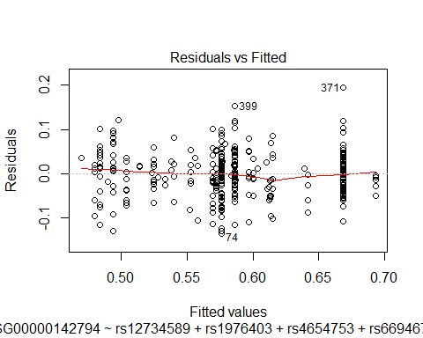

# We notice a small issue with normality still but this can probably be ignored.   
# There is no issue with non constant error variance which is more important.  
plot(model, which=2)

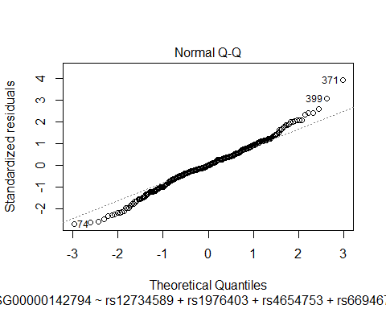

shapiro.test(model$residuals)

##   
## Shapiro-Wilk normality test  
##   
## data: model$residuals  
## W = 0.98986, p-value = 0.01963

bptest(model)

##   
## studentized Breusch-Pagan test  
##   
## data: model  
## BP = 2.7847, df = 6, p-value = 0.8353

# We notice potential outliers in the Cook's Distance Plot and Residuals vs Leverage Plot   
# so we will do further analysis on these points.  
# Particulary points 283, 309, and 317 have a high cook's distance and are candidate outliers.  
# The Scale Location Plot doesn't appear to have a slope which is good.  
plot(model, which=3)

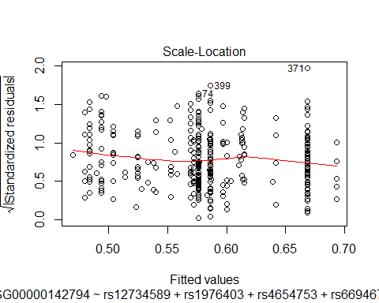

plot(model, which=4)

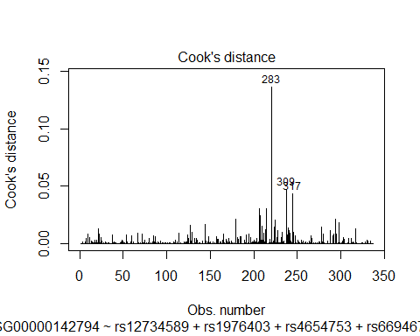

plot(model, which=5)

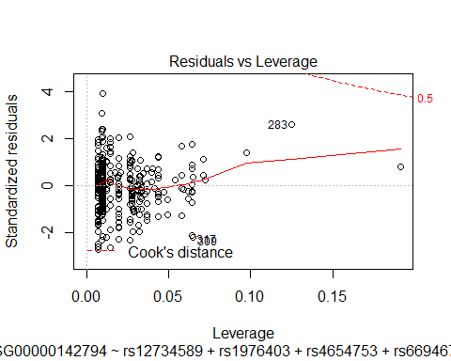

# The added variable plots look much better.   
  
pdf("AddedVariablesAfterSelection.pdf")  
avPlots(model, ask=FALSE)  
dev.off()

## png   
## 2

# All variables appear significant.  
# MSE looks very good.   
knitr::kable(anova(model))

|  |  |  |  |  |  |
| --- | --- | --- | --- | --- | --- |
|  | Df | Sum Sq | Mean Sq | F value | Pr(>F) |
| rs12734589 | 1 | 0.8610066 | 0.8610066 | 343.928080 | 0.0000000 |
| rs1976403 | 1 | 0.1251881 | 0.1251881 | 50.006228 | 0.0000000 |
| rs4654753 | 1 | 0.0464546 | 0.0464546 | 18.556256 | 0.0000218 |
| rs6694671 | 1 | 0.0403177 | 0.0403177 | 16.104843 | 0.0000742 |
| rs113548640 | 1 | 0.0208500 | 0.0208500 | 8.328506 | 0.0041598 |
| rs10916989 | 1 | 0.0243041 | 0.0243041 | 9.708235 | 0.0019954 |
| Residuals | 330 | 0.8261383 | 0.0025034 | NA | NA |

# We do outlier analysis here  
  
cd <- cooks.distance(model)  
transformed_gene_dropped <- model$model[-c(which(cd > 4 / (n-p))),]  
cooks_distance_model <- lm(ENSG00000142794~., data=transformed_gene_dropped)  
  
  
# We note that we would like to retain these points regardless as they are interesting and represent variation   
# in the population that can be informative in clinical situations.   
# We opt to not use Robust Regression since the effect on the final model is not serious enough.  
  
  
  
leverage_threshold <- (3*(p))/n  
leverage_values <- hatvalues(model)  
transformed_gene_dropped_leverage <- model$model[-c(which(leverage_values > leverage_threshold)),]  
leverage_model <- lm(ENSG00000142794~., data=transformed_gene_dropped_leverage)  
  
betas <- as.data.frame(dfbetas(model))  
  
# We print the largest DFBeta for each parameter and the index of that DFBeta.  
to_remove <- c()  
for(column in betas){  
 outliers <- which(abs(column) > 0.11)  
 print(max(abs(column)))  
 print(which(abs(column) == max(abs(column))))  
 to_remove <- union(to_remove, outliers)  
}

## [1] 0.4216956  
## [1] 238  
## [1] 0.5156542  
## [1] 245  
## [1] 0.8014485  
## [1] 221  
## [1] 0.3773799  
## [1] 221  
## [1] 0.7861822  
## [1] 221  
## [1] 0.8713133  
## [1] 221  
## [1] 0.3917799  
## [1] 238

# One of 238, 245, and 221 give the max DFBetas the coefficients. These are the greatest outliers for DFBetas.  
transformed_gene_dropped_betas <- model$model[-c(to_remove),]  
new_model_betas <- lm(ENSG00000142794~., data=transformed_gene_dropped_betas)  
coefficients <- rbind(model$coefficients,new_model_betas$coefficients,cooks_distance_model$coefficients, leverage_model$coefficients)  
row.names(coefficients) <- c("Normal Model", "DroppedHighDFBetas", "DroppedHighCooks", "DroppedHighLeverage")

# We make a summary table that shows what happens when we drop high DFBetas, highCooks, and High Leverage Points from the model.  
model_data <- c()  
add_to_coefficients_data <- function(model, model_data){  
 current_model <- model  
 RSS_selected <- c(crossprod(current_model$residuals))  
 MSE <- RSS_selected / length(current_model$residuals)  
 current_model_stats <- cbind(sqrt(MSE), BIC(current_model), summary(current_model)$adj.r.squared, DAAG::press(current_model), shapiro.test(model$residuals)$p.value, bptest(model)$p.value)  
 colnames(current_model_stats) <- c("RMSE", "BIC", "ADJ-R-Squared", "PRESS", "Shapiro_Wilks_Test_P_value", "Breusch-Pagan_Test_P_value")  
 model_data <- rbind(model_data, current_model_stats)  
 shapiro.test(model$residuals)  
 return(model_data)  
}  
model_data <- add_to_coefficients_data(model, model_data)  
model_data <- add_to_coefficients_data(cooks_distance_model, model_data)  
model_data <- add_to_coefficients_data(new_model_betas, model_data)  
model_data <- add_to_coefficients_data(leverage_model, model_data)  
  
# Here is the summary table  
summary_of_excluding_points <- cbind(coefficients, model_data)  
knitr::kable(summary_of_excluding_points)

|  |  |  |  |  |  |  |  |  |  |  |  |  |  |
| --- | --- | --- | --- | --- | --- | --- | --- | --- | --- | --- | --- | --- | --- |
|  | (Intercept) | rs12734589 | rs1976403 | rs4654753 | rs6694671 | rs113548640 | rs10916989 | RMSE | BIC | ADJ-R-Squared | PRESS | Shapiro_Wilks_Test_P_value | Breusch-Pagan_Test_P_value |
| Normal Model | 0.5242534 | 0.0270721 | -0.0198311 | 0.0339801 | 0.0357185 | -0.0362962 | -0.0243674 | 0.0495121 | -1022.8074 | 0.5673627 | 0.8632144 | 0.0196253 | 0.8353379 |
| DroppedHighDFBetas | 0.5242154 | 0.0268792 | -0.0159879 | 0.0372453 | 0.0372679 | -0.0397645 | -0.0286545 | 0.0441744 | -1038.9073 | 0.6071241 | 0.6451452 | 0.1451441 | 0.9307043 |
| DroppedHighCooks | 0.5288562 | 0.0291684 | -0.0170019 | 0.0298446 | 0.0345575 | -0.0387295 | -0.0245814 | 0.0434263 | -947.5295 | 0.6313659 | 0.5618019 | 0.0006252 | 0.0465953 |
| DroppedHighLeverage | 0.5282415 | 0.0369003 | -0.0150414 | 0.0312738 | 0.0309058 | -0.0392810 | -0.0287681 | 0.0488392 | -981.2104 | 0.5852552 | 0.7975638 | 0.0208370 | 0.8598845 |

# We only would consider dropping HighDF Betas since dropping the other elements hurts BIC and might   
# even cause the non constant error vairance assumption not to hold. We choose not to drop any points.   
#The coefficients are not changed greatly enough to warrant us to exclude so many   
# points that contain valuable variation from the overall population.  
  
# Dropping the High DFBetas points might be something we would consider if   
# we had more data to represent the true diversity of the population but dropping   
# these points might exclude points that include important variation.

# We compare the validation model and original model and get MSPR and compare it to MSE.  
  
predictions <- predict(model, transformed_gene_test)  
validation_model_one <- lm(formula(model), data=transformed_gene_test)  
  
# Comparison of Model Stats   
model_stats <- cbind(sigma(model)^2, summary(model)$adj.r.squared, DAAG::press(model))  
validation_model_stats <- cbind(sigma(validation_model_one)^2, summary(validation_model_one)$adj.r.squared, DAAG::press(validation_model_one))  
comparison_of_stats <- rbind(model_stats, validation_model_stats)  
colnames(comparison_of_stats) <- c("MSE", "Adj-R-Squared","PRESS")  
rownames(comparison_of_stats) <- c("Original Model", "Validation Model")  
comparison_of_stats

## MSE Adj-R-Squared PRESS  
## Original Model 0.002503449 0.5673627 0.8632144  
## Validation Model 0.002299010 0.5480023 0.1912980

knitr::kable(comparison_of_stats)

|  |  |  |  |
| --- | --- | --- | --- |
|  | MSE | Adj-R-Squared | PRESS |
| Original Model | 0.0025034 | 0.5673627 | 0.8632144 |
| Validation Model | 0.0022990 | 0.5480023 | 0.1912980 |

# MSE vs MSPR  
mspr_vs_mse <- cbind(sigma(model)^2, mean((transformed_gene_test[["ENSG00000142794"]]-predictions)^2))  
colnames(mspr_vs_mse) <- c("MSE", "MSPR")  
knitr::kable(mspr_vs_mse)

|  |  |
| --- | --- |
| MSE | MSPR |
| 0.0025034 | 0.0021703 |

# Fitting the Final Multiple Linear Regression Model :)  
final_gene_data <- read_in_pruned_datasets_for_gene_0.8("ENSG00000142794", "D:\\Project\\GitStash\\Applied_regression_project\\")  
transformed_final_gene_data <- final_gene_data  
transformed_final_gene_data[["ENSG00000142794"]] <- 1/(sqrt(transformed_final_gene_data[["ENSG00000142794"]]+2))  
final_model <- lm(formula(model), data=transformed_gene_data)  
summary(final_model)

##   
## Call:  
## lm(formula = formula(model), data = transformed_gene_data)  
##   
## Residuals:  
## Min 1Q Median 3Q Max   
## -0.134598 -0.026933 0.000069 0.028130 0.194233   
##   
## Coefficients:  
## Estimate Std. Error t value Pr(>|t|)   
## (Intercept) 0.524253 0.010447 50.183 < 2e-16 ***  
## rs12734589 0.027072 0.006622 4.088 5.46e-05 ***  
## rs1976403 -0.019831 0.006733 -2.946 0.003453 **   
## rs4654753 0.033980 0.008821 3.852 0.000141 ***  
## rs6694671 0.035719 0.007743 4.613 5.68e-06 ***  
## rs113548640 -0.036296 0.011122 -3.263 0.001216 **   
## rs10916989 -0.024367 0.007821 -3.116 0.001995 **   
## ---  
## Signif. codes: 0 '***' 0.001 '**' 0.01 '*' 0.05 '.' 0.1 ' ' 1  
##   
## Residual standard error: 0.05003 on 330 degrees of freedom  
## Multiple R-squared: 0.5751, Adjusted R-squared: 0.5674   
## F-statistic: 74.44 on 6 and 330 DF, p-value: < 2.2e-16

knitr::kable(anova(final_model))

|  |  |  |  |  |  |
| --- | --- | --- | --- | --- | --- |
|  | Df | Sum Sq | Mean Sq | F value | Pr(>F) |
| rs12734589 | 1 | 0.8610066 | 0.8610066 | 343.928080 | 0.0000000 |
| rs1976403 | 1 | 0.1251881 | 0.1251881 | 50.006228 | 0.0000000 |
| rs4654753 | 1 | 0.0464546 | 0.0464546 | 18.556256 | 0.0000218 |
| rs6694671 | 1 | 0.0403177 | 0.0403177 | 16.104843 | 0.0000742 |
| rs113548640 | 1 | 0.0208500 | 0.0208500 | 8.328506 | 0.0041598 |
| rs10916989 | 1 | 0.0243041 | 0.0243041 | 9.708235 | 0.0019954 |
| Residuals | 330 | 0.8261383 | 0.0025034 | NA | NA |

plot(final_model, which=1)

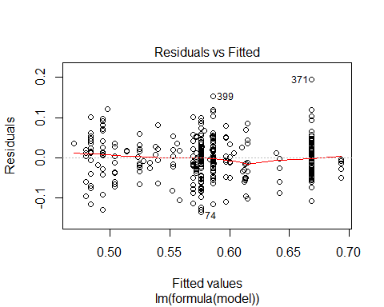

plot(final_model, which=2)

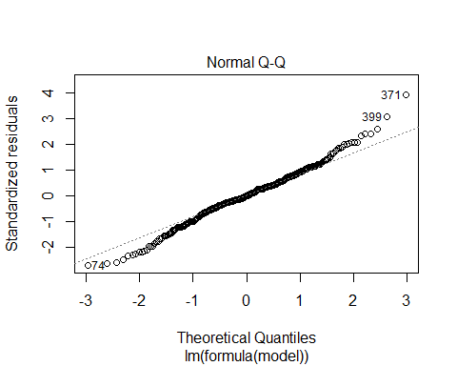

plot(final_model, which=3)

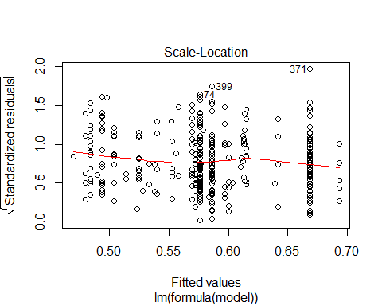

plot(final_model, which=4)

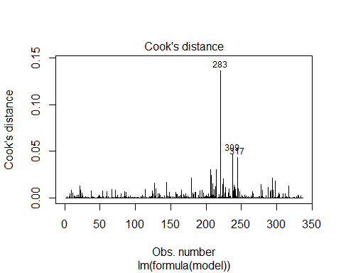

plot(final_model, which=5)

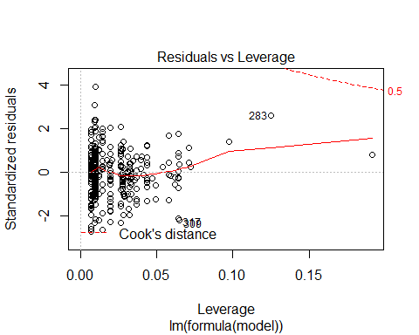

shapiro.test(model$residuals)

##   
## Shapiro-Wilk normality test  
##   
## data: model$residuals  
## W = 0.98986, p-value = 0.01963

bptest(final_model)

##   
## studentized Breusch-Pagan test  
##   
## data: final_model  
## BP = 2.7847, df = 6, p-value = 0.8353

# We note the same diagnostic findings as we did from the selected model. There is a slight issue with normality and some outliers.

n <- nrow(transformed_final_gene_data)  
p <- length(final_model$coefficients)  
model <- final_model  
# We do outlier analysis here  
  
cd <- cooks.distance(model)  
transformed_gene_dropped <- model$model[-c(which(cd > 4 / (n-p))),]  
cooks_distance_model <- lm(ENSG00000142794~., data=transformed_gene_dropped)  
  
  
  
leverage_threshold <- (3*(p))/n  
leverage_values <- hatvalues(model)  
transformed_gene_dropped_leverage <- model$model[-c(which(leverage_values > leverage_threshold)),]  
leverage_model <- lm(ENSG00000142794~., data=transformed_gene_dropped_leverage)  
  
betas <- as.data.frame(dfbetas(model))  
  
# We print the largest DFBeta for each parameter and the index of that DFBeta.  
to_remove <- c()  
for(column in betas){  
 outliers <- which(abs(column) > 2/sqrt(n))  
 print(max(abs(column)))  
 print(which(abs(column) == max(abs(column))))  
 to_remove <- union(to_remove, outliers)  
}

## [1] 0.4216956  
## [1] 238  
## [1] 0.5156542  
## [1] 245  
## [1] 0.8014485  
## [1] 221  
## [1] 0.3773799  
## [1] 221  
## [1] 0.7861822  
## [1] 221  
## [1] 0.8713133  
## [1] 221  
## [1] 0.3917799  
## [1] 238

#238, 221, and 245 are possible massive outliers   
transformed_gene_dropped_betas <- model$model[-c(to_remove),]  
new_model_betas <- lm(ENSG00000142794~., data=transformed_gene_dropped_betas)  
coefficients <- rbind(model$coefficients,new_model_betas$coefficients, cooks_distance_model$coefficients, leverage_model$coefficients)  
row.names(coefficients) <- c("Normal Model", "DroppedHighDFBetas", "DroppedHighCooks", "DroppedHighLeverage")

# We make a summary table that shows what happens when we drop high DFBetas, highCooks, and High Leverage Points from the model.  
model_data <- c()  
add_to_coefficients_data <- function(model, model_data){  
 current_model <- model  
 RSS_selected <- c(crossprod(current_model$residuals))  
 MSE <- RSS_selected / length(current_model$residuals)  
 current_model_stats <- cbind(sqrt(MSE), BIC(current_model), summary(current_model)$adj.r.squared, DAAG::press(current_model), shapiro.test(model$residuals)$p.value, bptest(model)$p.value)  
 colnames(current_model_stats) <- c("RMSE", "BIC", "ADJ-R-Squared", "PRESS", "Shapiro_Wilks_Test_P_value", "Breusch-Pagan_Test_P_value")  
 model_data <- rbind(model_data, current_model_stats)  
 shapiro.test(model$residuals)  
 return(model_data)  
}  
model_data <- add_to_coefficients_data(model, model_data)  
model_data <- add_to_coefficients_data(cooks_distance_model, model_data)  
model_data <- add_to_coefficients_data(new_model_betas, model_data)  
model_data <- add_to_coefficients_data(leverage_model, model_data)  
  
# Here is the summary table  
summary_of_excluding_points <- cbind(coefficients, model_data)  
knitr::kable(summary_of_excluding_points)

|  |  |  |  |  |  |  |  |  |  |  |  |  |  |
| --- | --- | --- | --- | --- | --- | --- | --- | --- | --- | --- | --- | --- | --- |
|  | (Intercept) | rs12734589 | rs1976403 | rs4654753 | rs6694671 | rs113548640 | rs10916989 | RMSE | BIC | ADJ-R-Squared | PRESS | Shapiro_Wilks_Test_P_value | Breusch-Pagan_Test_P_value |
| Normal Model | 0.5242534 | 0.0270721 | -0.0198311 | 0.0339801 | 0.0357185 | -0.0362962 | -0.0243674 | 0.0495121 | -1022.8074 | 0.5673627 | 0.8632144 | 0.0196253 | 0.8353379 |
| DroppedHighDFBetas | 0.5244619 | 0.0294151 | -0.0164700 | 0.0376958 | 0.0333010 | -0.0355336 | -0.0282190 | 0.0434386 | -1029.1651 | 0.6155703 | 0.6111564 | 0.0857069 | 0.6765788 |
| DroppedHighCooks | 0.5242282 | 0.0298767 | -0.0116887 | 0.0281422 | 0.0377016 | -0.0447463 | -0.0243940 | 0.0425174 | -921.8093 | 0.6437677 | 0.5179535 | 0.0002389 | 0.0167372 |
| DroppedHighLeverage | 0.5282157 | 0.0376963 | -0.0170775 | 0.0327219 | 0.0280078 | -0.0343316 | -0.0281172 | 0.0490726 | -952.8234 | 0.5846780 | 0.7864094 | 0.0226870 | 0.8651839 |

#We note that dropping the high DFBetas again results in a satisfied normality assumption but we choose to retain these points.