JD Severtsen

Dr. Brooks

Senior Design Lab

October 9, 2020

Chassis Research Write-Up

The biggest challenge in finding a chassis for our mail delivery application is price. For my search, I was given three websites and told to also look at FIRST Robotics kits. Every affordable robot I found would still need some (if not all) electronic components, a package carrying structure, and waterproofing. The first website, provided by Bob Terhune, was a list consisting of ROS enabled complete chassis and hardware kits. A few of these kits seemed perfect for our application; however, under further investigation these kits were at least 6 times our total budget. The FIRST Robotics kits, found at andymark.com, won’t work for our application either due to minimal ground clearance and a two wheel drive setup.

Bob also provided a link to a robot from RobotShop.com which seems to match our application and budget ($770); this robot can be seen in Figure 1. This robot is all wheel drive, about a foot square, comes with an Arduino board, and seems to have around an inch of ground clearance. I don’t believe this robot would need anything the other robots in our price range wouldn’t also need and as such I believe it to be the best choice. My second choice comes from andymark.com, a site provided by Dr. Brooks and Dr. Mohr; the Outdoor Rhino Track Drive (Figure 2). The biggest pro for this robot is that it is designed for outdoor use, while the second is that it satisfies Devin’s desire for a tracked vehicle. The downside for this chassis lies in its cost; a whopping $1,250, without any electrical components.

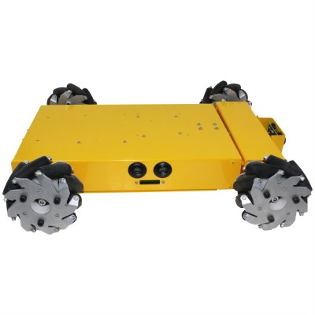

*Figure 1: AWD Robot – RobotShop.com*

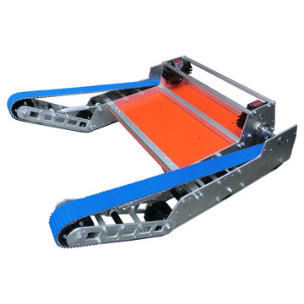

*Figure 2: Outdoor Rhino Track Drive*

**References**

<https://www.andymark.com/categories/drive-systems-bases-chassis>

<https://www.robotshop.com/en/4wd-arduino-compatible-mecanum-robot.html#What-s-Included>

<https://robots.ros.org/category/ground/>