Project Milestone7_Group45

Augustus Barnes and Ryan Shuman

We didn’t use a project tracker since there were only 2 of us

**GitHub Repository**

<https://github.com/RyanShuman/SoftDev3308_45>

**Deployment:**

download xampp go to the apache configuration file in the config menu find DocumentRoot "/home/user/Desktop" and <Directory "/home/user/Desktop"> is one line below

put the location of the parent directory of where the project folder is inside both of the quotes. Use my example if you put project folder on desktop

run apache server and mysql database

go to localhost/phpmyadmin and create a database from the code in database.sql, make sure to name the database "database"

go to localhost/project in web browser to view/use website

**Contributions:**

Unfortunatly we wernt considering having a history of what who had done what so in the codes final form only Augustus’s contributions exist on GitHub under Project was Augustus’s

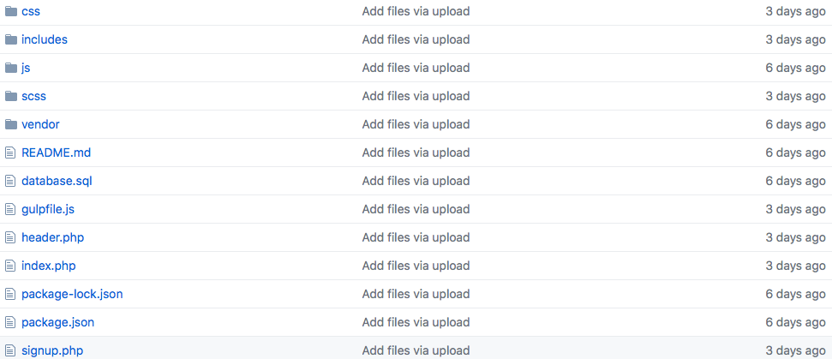

Ryan’s Contributions consists of milestone 6 and 7:asdf.tiff

as well as all php and database code written for the sign up sign in system however it was all deleted and overwritten when Augustus connected it to xampp