**Lab 02 DSA**

**Task 1:**

#include <iostream>

using namespace std;

int main(void)

{

int *salary= new int[20];

int i;

for (i=0;i<20;++i)

      {

cout<<"Enter Salary: ";

cin>>*(salary+i);

     }

for (i=0;i<20;++i)

*(salary+i)=*(salary+i)+*(salary+i)/(i+1);

delete []salary;

return 0;

}

**Task 2:**

#include <iostream>

using namespace std;

void analyze_pointer(int *ptr)

{

    cout<<"Memory Address of the pointer is: "<<ptr<<endl;

    cout<<"The Value pointer by the pointer is: "<<*ptr<<endl;

}

int main(void)

{

    int* ptr= new int(10);

    int i = 20;

    analyze_pointer(&i);

    cout<< endl;

    analyze_pointer(ptr);

    delete ptr;

return 0;

}

**Output:**

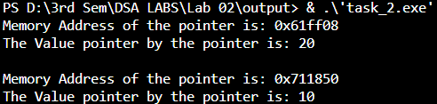

**Task 3:**

#include <iostream>

using namespace std;

struct Area

{

    private:

    string unit;

    float area_value;

    public:

    Area(string uni, float value)

    {

        unit = uni;

        area_value= value;

    }

    float half_area()

    {

        return area_value/2;

    }

    float quarter_area()

    {

        return area_value/4;

    }

    void display()

    {

        cout<<"The Unit is: "<<unit<<endl;

        cout<<"The value is: "<<area_value;

    }

};

int main()

{

    Area* shape= new Area("cm^2",100);

    cout<<"The Half area is: "<<(*shape).half_area()<<endl;

    cout<<"The Quarter Area is: "<<(*shape).quarter_area()<<endl;

    (*shape).display();

delete shape;

}

**Output:**

