# Faculty of Computing

**CS220: Database Systems**

**Class: BESE-13A**

# Lab 11: Views in MySQL

# Date: December 11, 2023

# Time:02:00-05:00

# Instructor: Dr. Shah Khalid

# Lab Engineer: Sundas Dawood

**Lab 11: Views in MySQL**

**Lab Tasks**

Given the following **database schema**:

**Student (snum: integer, sname: char(30), major: char(25), level: char(2))**

**Faculty (fid: integer, fname: char(30), deptid: integer)**

**Class (cname: char(40), meets_at: char(20), room: char(10), fid: integer | fid REFS Faculty.fid)**

**Enrolled (snum: integer, cname: char(40) | snum REFS student.snum, cname REFS class.name)**

1. Create a view named v1 which has the name of faculty members who do not teach any course.

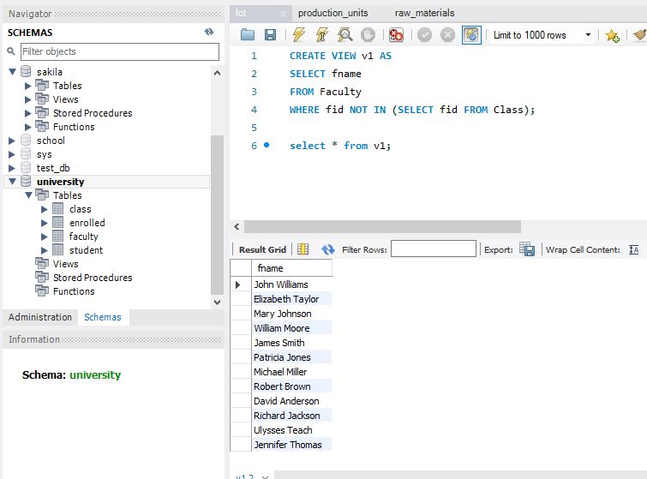

1. Create another view named v2 which has the names of students who are enrolled in a course taught by faculty member “Ivana Teach”.

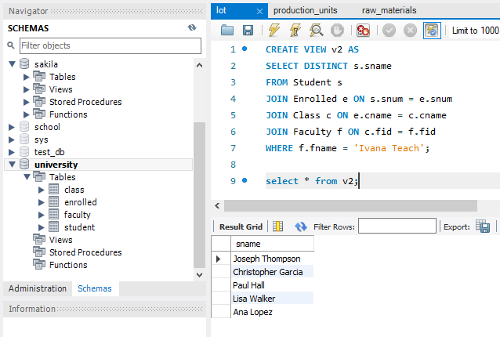

1. Create a view stdVu that is based on the student relation.

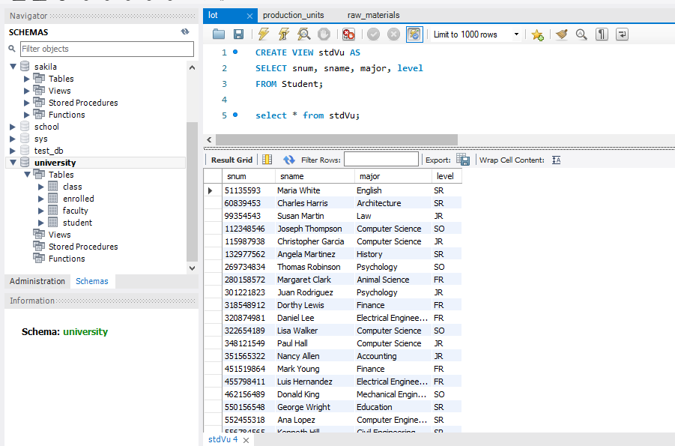

1. Alter the definition of student table. Add a column course to the student’s relation.

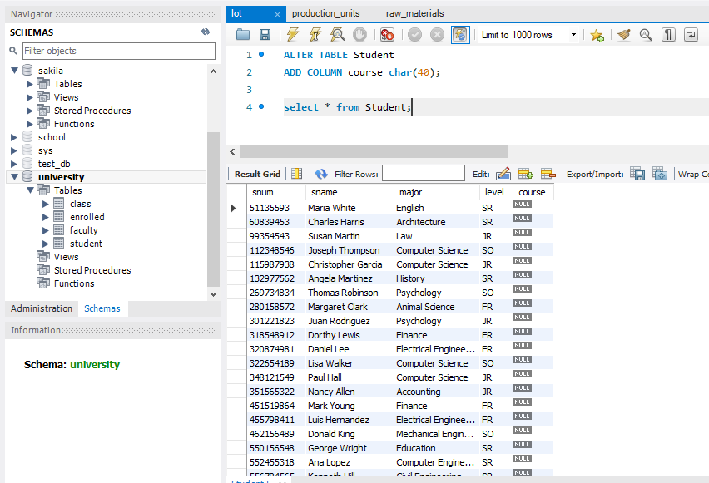

1. Notice the changes in views which are based on student relation. Comment what happens to view data if the base table is modified.

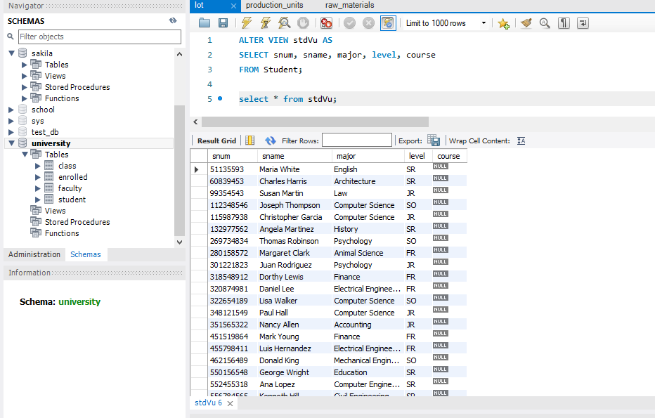

*Views based on the Student table will not automatically reflect the changes made to the base table. The views will need to be modified accordingly to include the new column. In this case, you might need to alter the stdVu view to include the new column:*

1. Alter view v2 based on the definition: It has the names of all juniors (Level = JR) who are enrolled in a class taught by ‘Ivana Teach’.

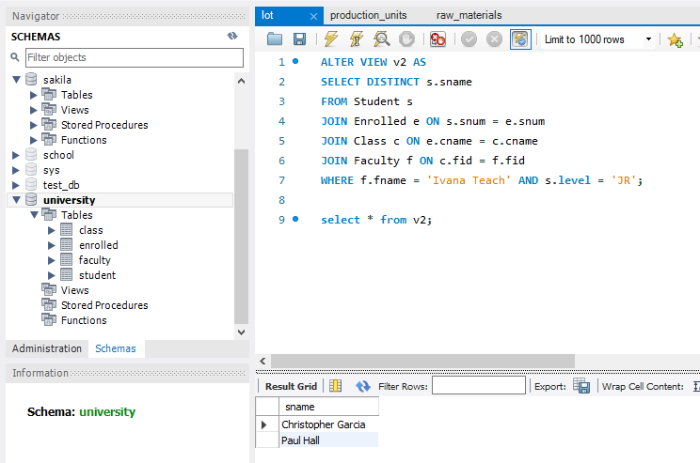

1. Create views based on the following queries also:
   1. The names of students majoring in ‘Computer Science’.

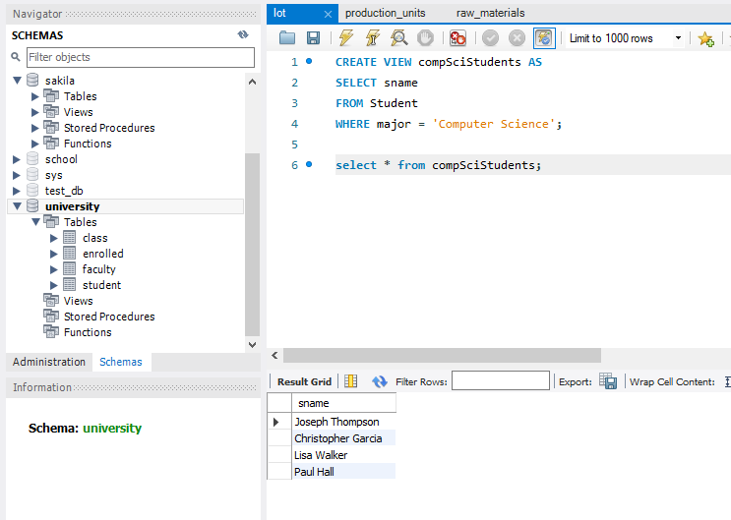

* 1. The names of classes taught by ‘John Williams’ in dept # 68.

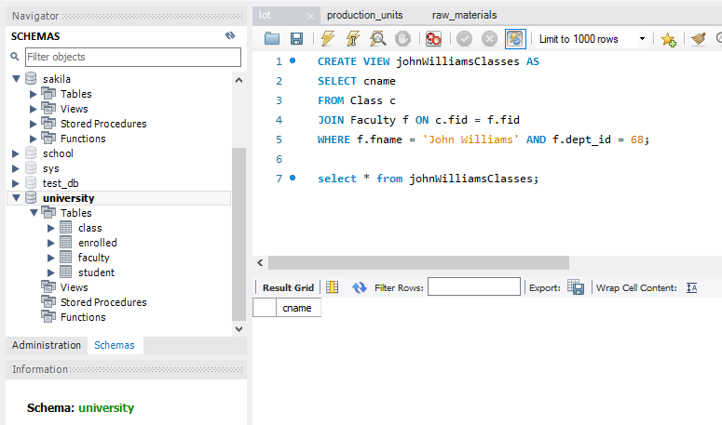

* 1. The distinct student level in ‘Database Systems’ class in descending order.

* 1. The name of ‘Christopher Garcia’s teachers.

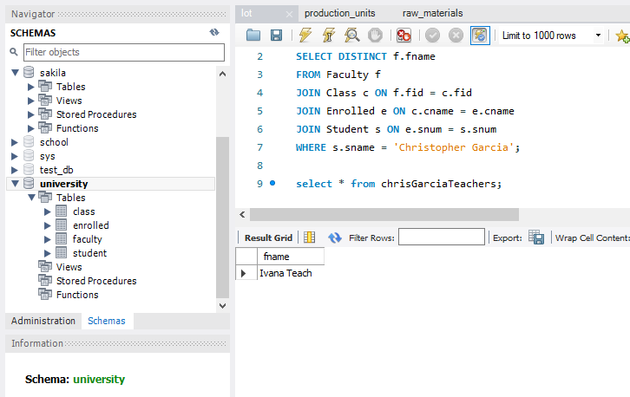

1. Drop view v1, v2.

# Deliverables

Complete your lab tasks in SQL workbench and submit a word file with queries and the screenshots of the results to all the questions attempted. Upload it on LMS. Late submissions will not be accepted.