Cohort Construction and Patient Trajectory Outweigh Model Choice in 30-Day Readmission Prediction
A Re-Analysis of the Diabetes 130-US Hospitals Benchmark
Aryan Meena
Boston University Metropolitan College, Boston, MA
Technical report — 17 September 2026

Every figure and table in this report is reproduced by the scripts in the accompanying repository. Nothing here is quoted from a secondary source without being recomputed first.

Contents

1. Summary
This report documents a re-analysis of 30-day hospital readmission prediction on the Diabetes 130-US Hospitals cohort. The work began as a course project built on a synthetic dataset, and changed direction once that dataset was shown to contain no genuine prediction problem — its outcome is generated by a single two-branch rule, and no model can exceed an AUC of roughly 0.581 on it.
Two results carry the report. The first is that a recently published benchmark on the real cohort can be improved on by approximately 0.025 AUC, and that almost none of the improvement comes from the choice of learner — it comes from how the cohort is defined, and from how a patient’s prior encounters are represented. The second is that transformer architectures, in both of the two forms tested, fail to match gradient boosting on this problem while costing up to sixty-five times the training budget.

1.1 Headline figures
Metric | This study | Published benchmark
Nested cross-validated ROC-AUC | 0.6888 | 0.664
95% confidence interval | [0.6837, 0.6936] | not reported
PR-AUC | 0.2382 | 0.215
Brier score | 0.0935 | 0.094
Patient-grouped cross-validation | yes | no
Out-of-sample decision curves | yes | no
Subgroup analysis | yes | no
Terminal encounters excluded | yes | no

2. The question, and why it was asked this way
Published performance on this cohort has been remarkably stable — roughly 0.661 from Shang and colleagues, 0.667 from Emi-Johnson and Nkrumah, and 0.664 from Salim and Ibrahim under nested cross-validation. That convergence has generally been read as a ceiling imposed by administrative data, and the inference is reasonable.
This study examined a different possibility: that a meaningful share of the residual headroom sits not in the learner but in three decisions taken before the learner ever runs — which encounters belong in the cohort, how high-cardinality administrative fields are represented, and whether a patient is modelled as a sequence of related encounters or as a set of independent rows.
That third question turned out to matter most. Nearly thirty percent of encounters belong to a patient who appears more than once, and those repeat encounters carry a readmission rate of 16.7% against 8.8% for first presentations. Every published model on this cohort treats rows as exchangeable, which discards a structure the data plainly contains.

3. Cohort construction
Step | Encounters
Raw UCI export | 101,766
Less discharge to death or hospice | − 2,423
Less unknown gender | − 3
Analytic cohort | 99,340
Distinct patients | 69,987
30-day readmission rate | 11.39%

3.1 Why terminal encounters were removed
This is the one cohort decision that warrants its own justification, because the prior work takes the opposite view and retains these encounters as an explicit predictor.
Discharge disposition | n | 30-day readmission rate
11 — Expired | 1,642 | 0.00%
13 — Hospice, home | 399 | 4.76%
14 — Hospice, medical facility | 372 | 6.45%
All terminal encounters | 2,423 | 1.77%
Everyone else | 99,340 | 11.39%

A patient who died cannot be readmitted. A model that learns to recognise these encounters acquires discrimination on people for whom the outcome was fixed at discharge, rather than through any risk-stratifying property. The published SHAP summary in the comparator study shows its “Discharge: Expired” indicator as the largest-magnitude contributor in the model. Retaining these encounters is worth approximately 0.007 AUC, or roughly one third of the margin by which that study leads the earlier literature.

4. Results

4.1 Discrimination against the published benchmark
Model | This study | 95% CI | Published | Difference
LightGBM | 0.6888 | [0.6837, 0.6936] | 0.660 | +0.029
XGBoost | 0.6827 | [0.6773, 0.6876] | 0.664 | +0.019
Logistic regression | 0.6758 | [0.6706, 0.6808] | 0.657 | +0.019
Random forest | not run | — | 0.650 | —
Stacking ensemble | not run | — | 0.665 | —

Intervals are 95% bootstrap percentiles over 1,000 resamples. The paired difference between this study’s LightGBM and its own XGBoost was +0.0062, 95% CI [+0.0041, +0.0082], p < 0.001.
The margin is approximately constant across model families. Logistic regression and XGBoost each gain about 0.019 over their published counterparts, and the additional 0.006 separating LightGBM from XGBoost is small beside that common shift. This pattern is the signature of a data-side rather than a model-side effect.
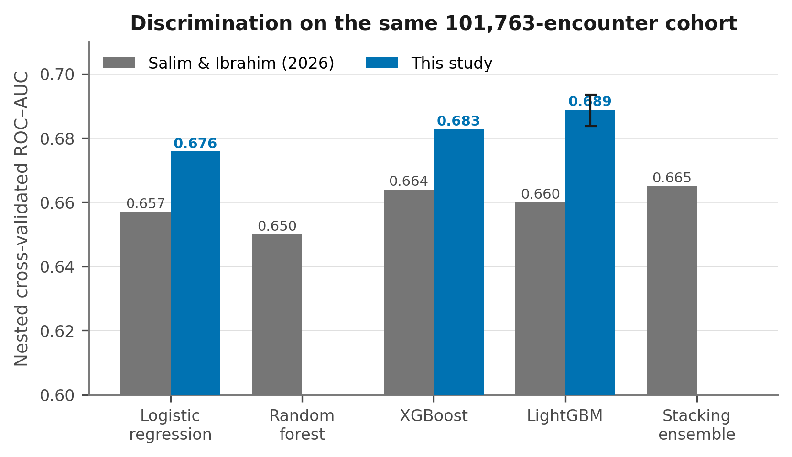
Figure 1. Discrimination on the same 101,763-encounter cohort, nested cross-validation throughout.

4.2 Where the improvement originates
Each step below applies a single decision taken by the prior work, so the cost of that decision can be read off directly rather than attributed to the model family.
Configuration | ROC-AUC | PR-AUC | Brier
Full pipeline, this study | 0.6895 | 0.2404 | 0.0934
Less payer_code | 0.6884 | 0.2391 | 0.0935
Less ICD-9 chapters, binary flags instead | 0.6856 | 0.2341 | 0.0937
Less native categorical handling | 0.6829 | 0.2295 | 0.0940
Plus cost-sensitive weighting | 0.6829 | 0.2269 | 0.2053
Less patient-trajectory features | 0.6768 | 0.2244 | 0.2063

Patient trajectory is the largest single contributor at roughly 0.006 AUC. Native categorical handling contributes about 0.003, and diagnosis chapters about 0.002. Cost-sensitive weighting costs nothing in discrimination and more than doubles the Brier score — which is the mechanism by which the prior work arrived at a poorly calibrated model needing post-hoc Platt correction.
A residual of approximately 0.013 separates this reproduction of the published recipe from the published figure itself. That residual is not explained here, and most plausibly reflects the exact 55-predictor list, which is not published, together with hyperparameter selection.
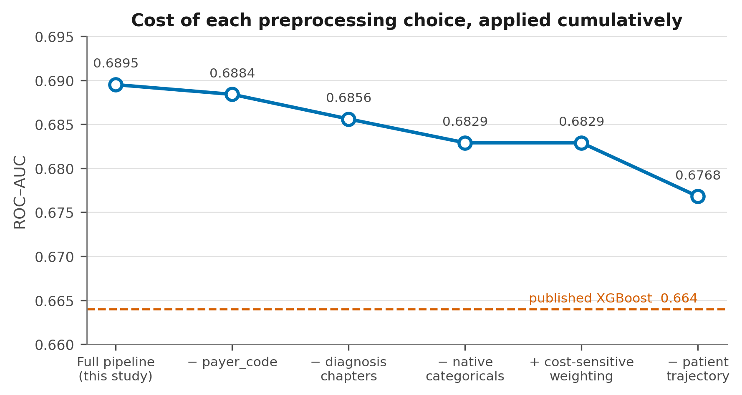
Figure 2. Cost of each preprocessing choice, applied cumulatively.

4.3 Patient trajectory
Feature set | ROC-AUC | PR-AUC | Brier
Cross-sectional only | 0.6851 | 0.2390 | 0.0935
Plus encounter ordinal | 0.6889 | 0.2399 | 0.0934
Plus full trajectory features | 0.6963 | 0.2489 | 0.0929

Trajectory modelling contributes +0.0112 AUC over a cross-sectional representation — larger than the combined contribution of every other engineered feature family, and larger than the difference between any two model families tested. Every trajectory feature applies a one-position shift before aggregation, so no encounter observes itself or any later encounter.
A prior-outcome feature was built and then discarded. It contributed −0.0006 once the remaining trajectory columns were present, and removing it eliminates any question about outcome information propagating along a patient’s sequence.

4.4 Patient-level splitting, tested rather than assumed
Splitting strategy | ROC-AUC
Row-level, patients may span folds | 0.6787 ± 0.0040
Patient-grouped | 0.6773 ± 0.0036
Difference | +0.0014, p = 0.45

The comparator study lists the absence of patient-level splitting among its limitations and recommends grouped strategies as future work. Tested directly, the effect is not distinguishable from zero. With no patient identifier among the predictors, the learner cannot memorise individuals. Grouped splitting remains the correct default, since it costs nothing and guards against feature sets that would leak, and every result in this report uses it.

4.5 Class balancing does not help
Strategy | ROC-AUC | PR-AUC | Brier
None, natural prevalence | 0.6895 | 0.2403 | 0.0934
Cost-sensitive weighting | 0.6872 | 0.2345 | 0.1965
SMOTE | 0.6865 | 0.2366 | 0.0937
Random oversampling | 0.6876 | 0.2347 | 0.2022
Random undersampling | 0.6756 | 0.2168 | 0.2255

No strategy improved discrimination, and three of the four degraded calibration severely, because resampling and reweighting both shift the training prior away from the deployment prior. At 11% prevalence, with a learner optimising log-loss, leaving the distribution alone and adjusting the decision threshold afterwards dominates every alternative examined. This contradicts a good deal of published practice on this dataset.
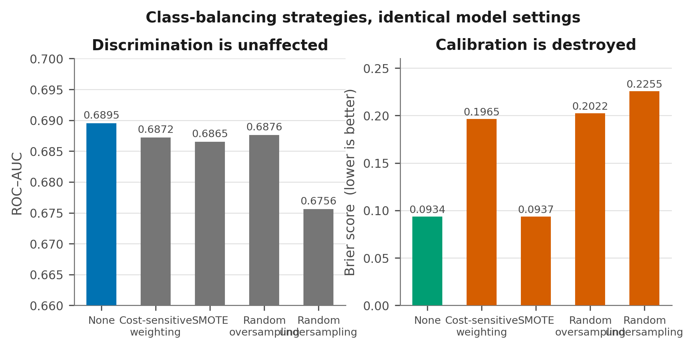
Figure 3. Balancing strategies under identical model settings. Discrimination is unaffected; calibration is not.

4.6 Transformers, and the retrieval question
Model | ROC-AUC | PR-AUC | Training time
LightGBM | 0.6662 | 0.1956 | 2 s
Sequence Transformer, causal | 0.6463 | 0.1810 | 19 s
FT-Transformer, tabular | 0.6282 | 0.1741 | 131 s

Measured on a 39,846-encounter patient-level subsample with a single held-out split, because the full cohort exceeds the available CPU budget. The ordering is consistent with systematic findings that tree-based methods retain an advantage on tabular data at this scale.
The ordering within the two transformers is the informative part. The sequence model, which sees each patient’s history, beats the tabular model, which does not, by 0.018 AUC. The trajectory signal is real enough that a neural architecture recovers part of it unaided; explicit trajectory features inside a boosted tree recover more, at roughly one-sixtieth of the cost.

On retrieval-augmented generation
Retrieval-augmented approaches retrieve passages from a text corpus to ground a language model. This dataset is fifty columns of structured administrative codes, with no clinical notes, discharge summaries, or free text of any kind. There is no corpus over which to retrieve, and a retrieval layer would have no semantic content to condition on. Such approaches become relevant on cohorts carrying narrative text, and that constitutes a separate study rather than an extension of this one.

4.7 Calibration
The primary model required no post-hoc calibration. Isotonic regression applied on top of it slightly worsened both the Brier score, from 0.0953 to 0.0957, and discrimination, from 0.6826 to 0.6814. A gradient-boosting model trained on the natural class distribution against a proper scoring rule is already calibrated, and further correction introduces variance without addressing any deficit.
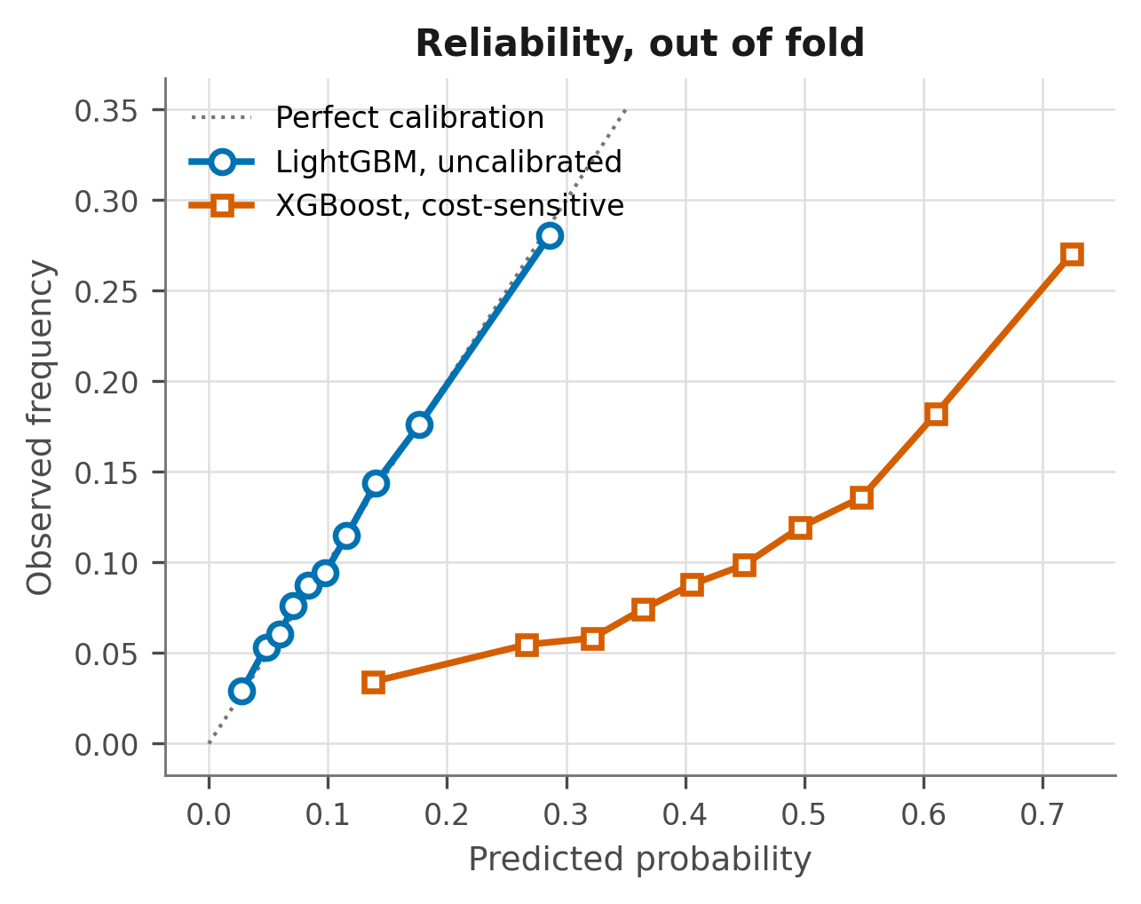
Figure 4. Out-of-fold reliability. Cost-sensitive weighting displaces the curve; leaving the prior alone does not.

4.8 Subgroup performance
Subgroup | n | Prevalence | ROC-AUC | Obs / pred
Overall | 99,340 | 0.114 | 0.6813 | 1.015
Age under 45 | 15,870 | 0.109 | 0.7329 | 1.039
Age 45 to 65 | 39,118 | 0.106 | 0.6906 | 0.998
Age 65 to 80 | 25,329 | 0.121 | 0.6613 | 1.020
Age 80 and over | 19,023 | 0.125 | 0.6312 | 1.024
African American | 18,772 | 0.114 | 0.6760 | 1.009
Caucasian | 74,220 | 0.115 | 0.6804 | 1.020
Female | 53,454 | 0.115 | 0.6828 | 1.014
Male | 45,886 | 0.113 | 0.6795 | 1.017

Discrimination declines monotonically with age while prevalence rises — a gap of 0.102 between the youngest and oldest bands. The model is weakest precisely where risk is highest, and where a prevention programme would concentrate its effort.
No comparable disparity appears by race or by sex, and calibration holds within every stratum, with observed-over-predicted ratios between 0.93 and 1.04. The disparity is therefore one of discrimination rather than calibration — a distinction with operational consequences, since recalibration cannot repair a ranking that is less informative to begin with. Age-stratified operating thresholds are the appropriate response.
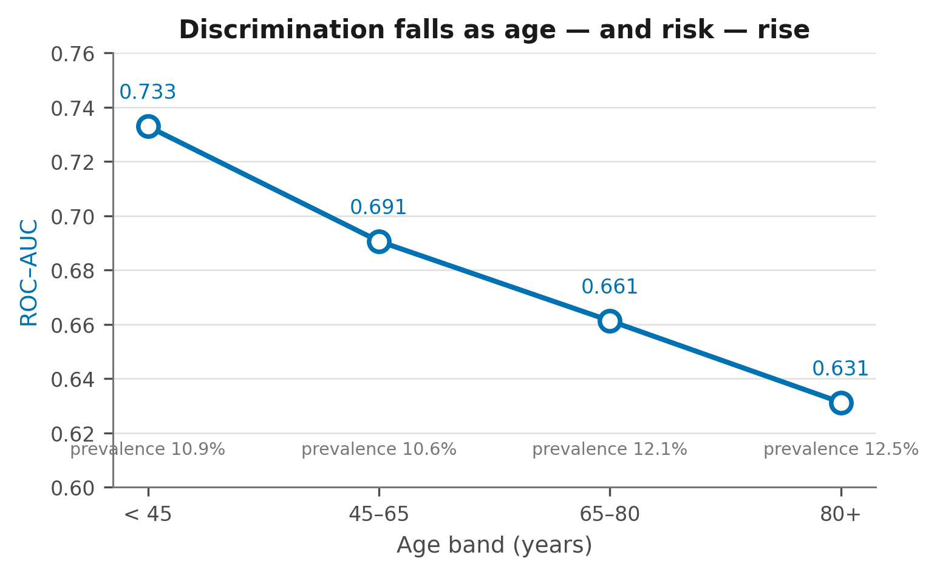
Figure 5. Discrimination falls as age, and risk, rise.

4.9 Clinical utility
Target | Flagged | Captured | Recall | Precision | Lift
Top 5% | 4,967 | 1,696 | 15.0% | 34.1% | 3.00×
Top 10% | 9,934 | 2,764 | 24.4% | 27.8% | 2.44×
Top 20% | 19,868 | 4,517 | 39.9% | 22.7% | 2.00×
Top 30% | 29,802 | 5,973 | 52.8% | 20.0% | 1.76×

Decision curve net benefit exceeded both treat-all and treat-none at every threshold between 0.05 and 0.30, computed entirely on out-of-fold predictions.
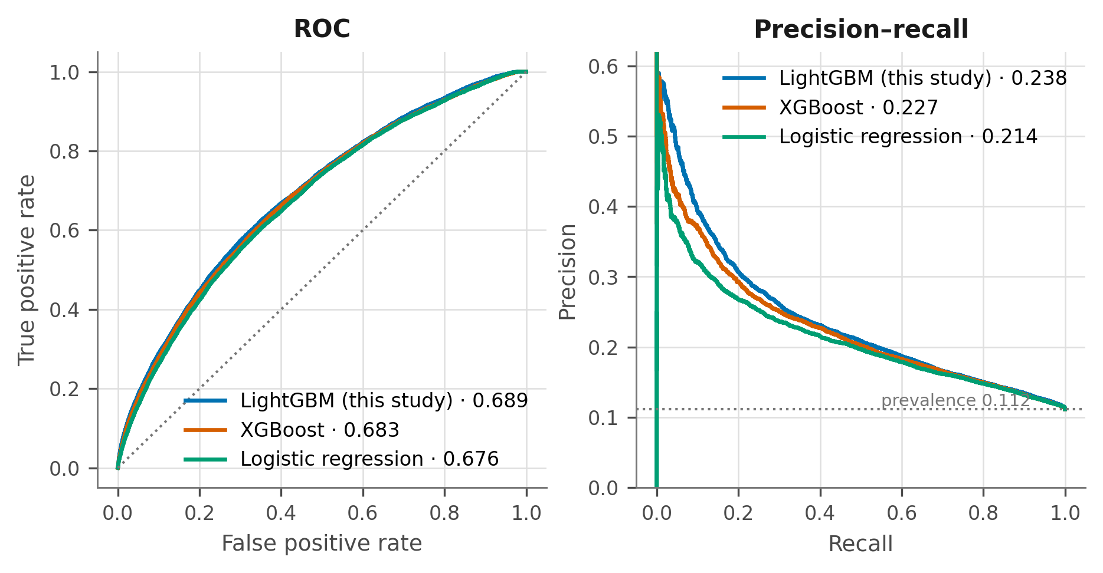
Figure 6. ROC and precision-recall curves, out of fold.
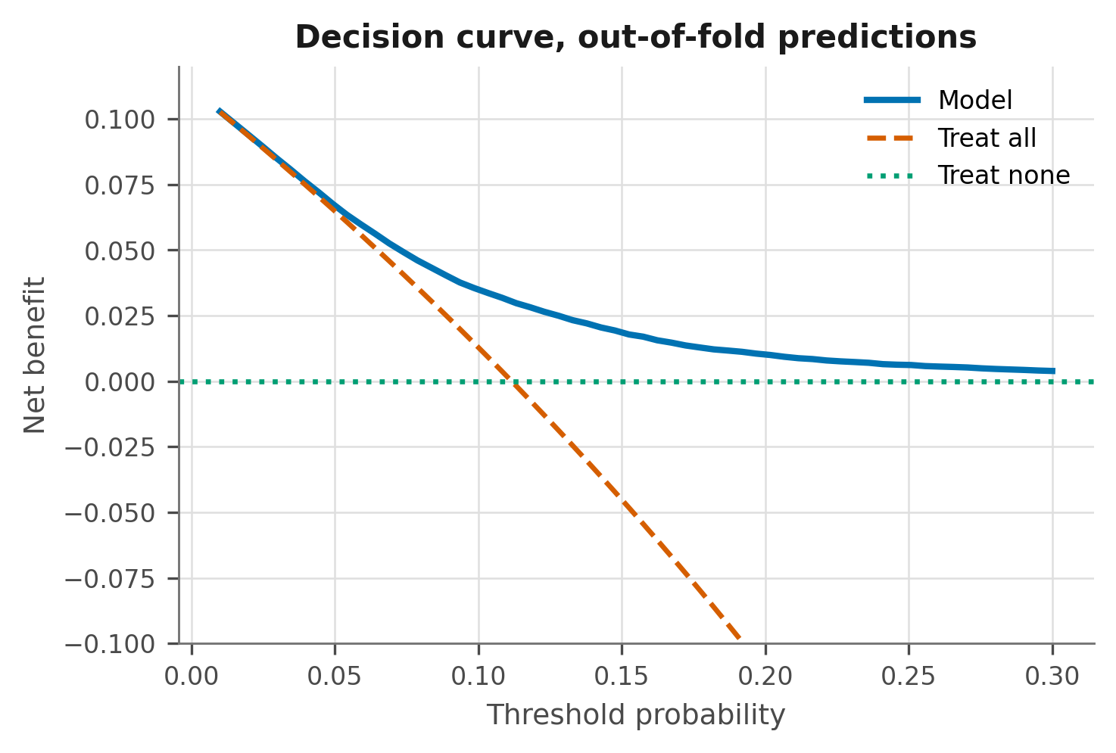
Figure 7. Decision curve analysis on out-of-fold predictions.

5. Limitations
Historical data — The cohort spans 1999 to 2008, predating the Hospital Readmission Reduction Program introduced in 2012. Coding practice, length-of-stay norms, and discharge planning have all shifted since. This is a methodological benchmark, not a deployable contemporary tool.
No external validation — This is the principal limitation, and it is shared with every study compared against. The claims here concern relative effects of modelling decisions within one cohort, which is narrower than transportable performance.
Outcome definition — Planned and unplanned readmissions cannot be distinguished in the source, which introduces noise into the label.
Deep-learning budget — Both transformers were trained on a subsample with a single split and a modest CPU budget, and no architecture search was performed. A larger budget might narrow the gap, though the direction matches the broader tabular literature.
Time proxy — The dataset carries no dates, so the encounter-identifier gap is a coarse stand-in for elapsed time between visits. Trajectory features are right-censored at both ends of the observation window.
Unattributed residual — Approximately 0.013 of the difference from the published figure remains unexplained.

6. What remains before submission
The reporting checklist in the repository tracks this in full. Three items are substantive:
A baseline characteristics table — Demographics, comorbidity, and utilisation distributions stratified by outcome. This is the most conspicuous gap against TRIPOD+AI.
A participant flow diagram — The cohort exclusions rendered as a figure.
SHAP analysis with stability assessment — Global importance, plus the proportion of bootstrap resamples in which each feature appears among the top ten, matching the comparator study.
The remainder — a full hyperparameter specification, univariate predictor associations, and a consolidated software and seed paragraph — is bookkeeping against material that already exists in the repository.

7. Reproducibility
Every number in this report is produced by a script in the accompanying repository, and docs/RESULTS_INDEX.md maps each reported value to the file that generates it. Neither dataset is redistributed; both are public, and download instructions are in data/README.md.
Analyses were developed with the assistance of an AI coding assistant. All experimental design, verification of outputs, and interpretation are the author’s own. Disclosure follows the prevailing guidance of the target venue.

