Memory Addressing (Ch. 2) Notes

**notes from “Understanding the Linux Kernel 3rd edition”
**dealing with 80 x 86 microprocessors (x86)

Memory Addresses

- Logical address
  - Included in the machine language instructions to specify the address of an operand or of an instruction. Each logical address consists of segment and offset
- Linear address
  - also known as virtual address
- physical address
  - used to address memory cells in memory chips
  - correspond to the electrical signals sent along the address pins of the microprocessor to the memory bus
- Memory Management Unit (MMU) transforms a logical address into a linear address by means of the segmentation unit. A second hardware circuit called a paging unit transforms the linear address into a physical address.

Segmentation in Hardware

- introduced into 80 x 86 microprocessors to encourage programmers to split their applications into logically related entities, such as subroutines or global and local data areas.

- Segment Selectors and Segmentation Registers
  - Logical address consists of two parts
    - segment identifier (segment selector)
      - 16-bits
      - index into a descriptor table for a certain segment descriptor
      - format:
        - index: identifies the segment descriptor entry in the GDT or in the LDT
        - table indicator (TI): specifies whether the segment descriptor is included in the GDT (TI = 0) or in the LDT (TI = 1)
        - requestor privilege level (RPL): specifies the Current Privilege Level (CPL) of the CPU when the corresponding Segment Selector is loaded into the cs register
          - RPL also corresponds to last two bits of DS, ES, SS, FS, GS registers
          - since processes may pass their data segment to system calls (as a parameter for example), the RPL is good for security hardening to ensure that even though the CPL of the system call operating in kernel mode is good, the user space application requested something that they are allowed to access. (1)
    - offset that specifies relative address within segment
      - 32-bits
  - segmentation registers
    - make it easy to access certain segment selectors (segment identifiers) quickly
    - purpose is to hold segment selectors
    - cs
      - code segment register, which points to a segment containing program instructions
      - also includes 2-bit field which specifies Current Privilege Level (CPL) of the CPU (as cs register will contain the currently executing code). 0 = highest privilege level (Kernel mode), 3 = lowest (User mode)
    - ss
      - stack segment register, which points to a segment containing the current program stack
    - ds
      - data segment register, which points to a segment containing global and static data
  - segment descriptors
    - each segment is represented by an 8-byte Segment Descriptor that describes the segment characteristics
    - stored in either the Global Descriptor Table (GDT) or in the Local Descriptor Table (LDT).
      - address and size of GDT in main memory are stored in gdtr control register, while address and size of currently used LDT are contained in the ldtr control register
    - each process can have its own LDT if it needs additional segments besides those stored in the GDT
    - Format
      - segment descriptor has different fields
      - peep table 2-1
      - Base
        - linear address of the first byte of the segment
      - Limit
        - Holds the offset of the last memory cell in the segment
      - DPL
        - descriptor privilege level
        - used to restrict accesses to the segment
        - minimal CPU privilege level required for accessing the segment
      - Type
        - Characterizes the segment type and its access tables
        - Possible types:
          - code segment descriptor
            - indicates the descriptor refers to a code segment
          - data segment descriptor
            - indicates that the descriptor refers to a data segment
          - task state segment descriptor
            - segment used to save the contents of the processor registers
          - Local Descriptor Table Descriptor
            - refers to a segment containing an LDT (can only appear once in the GDT)
        - relative address inside the GDT or LDT is obtained by multiplying the 13-bit index field of the Segment Selector by 8.
  - Fast Access to Segment Descriptors
    - 80 x 86 processor provides an additional nonprogrammable register for each of the six programmable segmentation registers (which store segment selectors)
      - each of these nonprogrammable registers is set to the value of the segment descriptor for the corresponding segment selector
      - therefore translation can occur without needing to access the GDT or LDT from memory, we can just look at those non-programmable registers instead
      - accesses to the GDT or LDT are necessary only when the contents of the segmentation registers change
        - ?? Wait, I would assume that the nonprogrammable registers would change in this case as well ??
    - 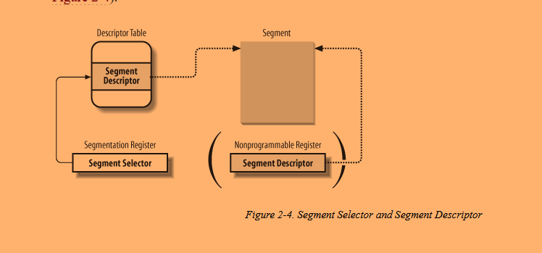
  - Segmentation Unit
    - segmentation unit translate logical address into the corresponding linear address
    - 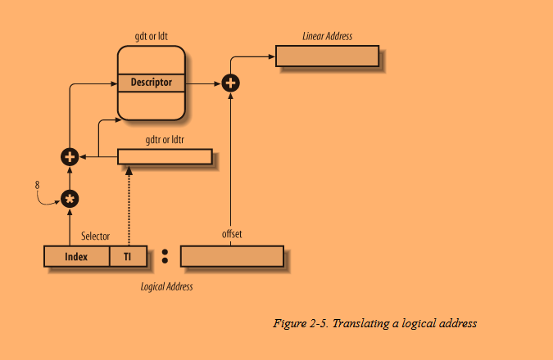
    - this hardware unit performs the following operations:
      - examines the TI field of the segment selector to determine which descriptor table stores the segment descriptor.
      - computes the address of the segment descriptor from the index field of the selector. index field is multiplied by 8 (the size of a segment descriptor) and the result is added to the content of the gdtr or ldtr register
      - adds the offset of the logical address to the Base field of the segment descriptor, thus obtaining the linear address
      - note: the first two operations mentioned above only need to be performed when a segmentation register has changed, since the nonprogrammable registers will have the descriptor loaded into them after that

Segmentation in Linux

- Segmentation and paging are somewhat redundant
  - both can be used to separate the physical address spaces of processes
    - segmentation can assign different linear address space to each process while paging can map the same linear address space into different physical address spaces
- Linux prefers paging over segmentation
  - memory management is simpler when all processes share the same set of linear addresses
  - one of the design objectives of Linux is portability to a wide range of architectures; RISC architectures in particular have limited support for segmentation
- As of Linux 2.6 version, Linux only uses segmentation when it’s required to by the 80 x 86 architecture
- all User Mode Linux processes use the same two segments
  - user code segment
  - user data segment
- all Kernel Mode Linux processes use the same two segments
  - kernel code segment
  - kernel data segment
- 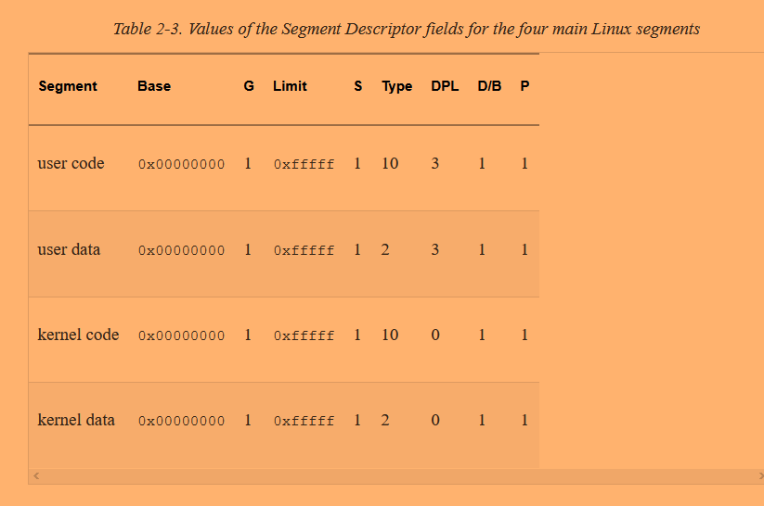
- These four segments have their corresponding segment selectors defined by the macros __USER_CS, __USER_DS, __KERNEL_CS, and __KERNEL_DS
- notice that all segments have the same base and limit!
  - This means that all processes, either in User Mode or in Kernel Mode, may use the same logical addresses.
  - also means that logical addresses coincide with linear addresses
- Whenever the CPL is changed (as indicated by last two bits of cs segmentation register), some segmentation registers must be correspondingly updated
  - for example, when CPL is equal to 3 (User Mode) the ds register must contain the segment selector of the user data segment, but when the CPL is equal to 0, the ds register must contain the segment selector of the kernel data segment
  - same thing occurs with ss register
- When saving a pointer to an instruction or a data structure, the Kernel doesn’t need to store the segment selector component of the logical address, since the ss register already has the current segment selector loaded.
  - Example: call assembly instruction just specifies the offset component of the logical address since the segment selector component is the same one that is referred to in the cs register

- The Linux GDT
- Global Descriptor Table
- one per CPU
- GDTs are stored in the cpu_gdt_table array while the addresses and sizes of the GDTs are stored in the cpu_gdt_descr array.
- layout
  - each GDT includes 18 segment descriptors and 14 null, unused, or reserved entries.
  - 18 segment descriptors:
    - four user and kernel code and data segments
    - Task State Segment (TSS)
      - different for each processor in the system
      - find more about how Linux uses TSSs in chapter 3
    - a segment that has the default Local Descriptor Table, this is usually shared by all processes
    - Three Thread-Local-Storage (TLS)
      - allow processes to make use of up to three segments containing data local to each thread. set_thread_area() and get_thread_area() are two system calls which create and retrieve a TLS segment for the executing process
    - Three segments related to Advanced Power Management (APM)
    - Five segments related to Plug and Play (PnP) BIOS services
    - A special TSS segment used by the kernel to handle “Double fault” exceptions
- all copies of the GDT store identical entries, except for a few cases (LDT and TLS Segment Descriptors)
- The Linux LDTs
- Local Descriptor Table
- Since most processors don’t make use of a LDT, the kernel defines a default LDT to be shared by all processes
  - stored in default_ldt array
- modift_ldt() available in User Mode as well

Paging in Hardware

- paging unit translates linear addresses into physical ones
- linear addresses are grouped in fixed-length intervals called pages
- contiguous addresses within a page are mapped to contiguous physical addresses
- paging unit thinks of all RAM as partitioned into fixed-length page frames
  - each frame contains a page
- page tables
  - data structures that map linear to physical addresses
  - stored in main memory
  - initialized by kernel before enabling the paging unit
- linear address format
  - assuming 32 bits, a linear address contains 3 fields
    - Directory (most significant 10 bits)
    - Table (intermediate 10 bits)
    - Offset (least significant 12 bits)
- translation of linear addresses to physical has to main steps, each based off a type of translation table. Page Directory and Page Table.
  - two level scheme reduces the amount of RAM required for per-process Page Tables
  - each active process has a Page Directory assigned to it
  - RAM is only allocated for a Page Table when a process needs it
  - Page Directory and Page Tables are both stored in RAM
- physical address of the Page Directory is stored in a control register named cr3
- directory field within linear address determines the entry in the Page Directory that points to the proper Page Table. The linear address’s Table field then determines the entry in the Page Table that contains the physical address of the page frame containing the page. The offset field in the linear address determines the relative byte within that page frame to access (byte addressed!)
- 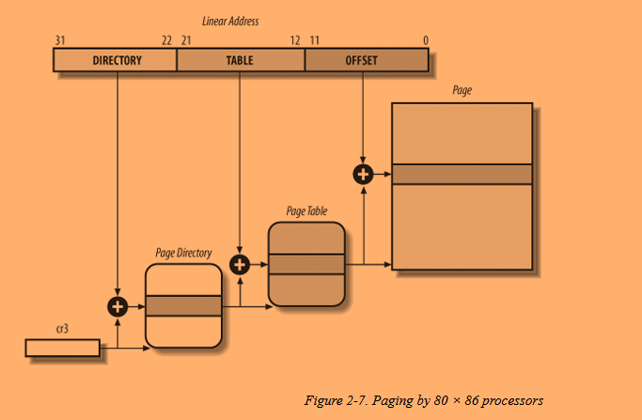
- entries of Page Directories and Page Tables have same format and include the following fields
  - Present flag
    - if set, page is in main memory. if it is not set, then the paging unit stores the linear address in a control register named cr2 and generates exception 14: the Page Fault exception
  - Field containing 20 most significant bits of a page frame physical address
    - since each page frame is 4-KB, the physical address must be a multiple of 4096. Therefore, the least significant 12 bits of the address are always 0s.
  - Accessed flag
    - set each time the paging unit addresses the corresponding page frame.
    - the OS resets this flag
    - used by OS when selecting pages to be swapped out
  - Dirty flag
    - only applies to Page Table entries
    - set each time a write operation is performed on a page frame
    - used by the OS when selecting pages to be swapped out
    - OS resets this flag
  - Read/Write flag
    - the access right (Read/Write or Read) of the page or of the Page Table
    - if 0, the corresponding Page Table or page can only be read
    - if 1, the corresponding Page Table or page can be read and written
  - User/Supervisor flag
    - privilege level required to access the page or Page Table
    - if flag is 0, the page can only be addressed when the CPL (review segmentation section to learn about CPL) is less than 3 (Kernel Mode)
    - if flag is 1, the page can always be addressed
  - PCD and PWT flags
    - controls the way the page or Page Table is handled by the hardware cache
  - Page Size flag
    - applies only to page directory entries. if it is set, the entry refers to a 2 MB or 4 MB-long page frame
  - Global flag
    - applies only to Page Table entries. prevents frequently used pages from being flushed from the TLB cache
- Extended Paging
  - allows page frames to be 4 MB instead of 4 KB in size
  - useful for translating large contiguous linear addresses to physical ones
  - 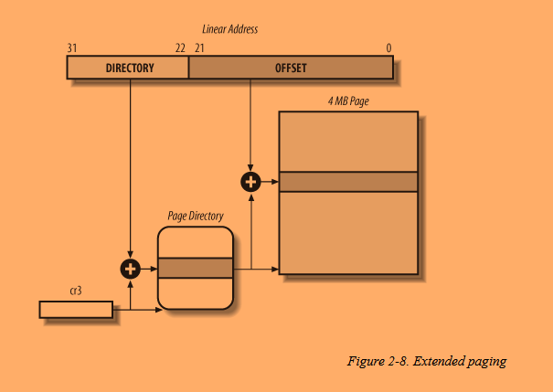
  - Page Directory entries are slightly different
    - Page Size flag must be set
    - only the 10 most significant bits of the 20-bit physical address field are significant since each physical address is aligned on a 4 MB boundary. the 22 least significant bits of the address are 0
  - paging unit divides 32-bit linear address into two fields
    - Directory
    - Offset
  - coexists with regular paging. enabled by setting the PSE flag of the cr4 processor register
- Hardware Protection Scheme
  - paging unit uses different protection scheme than segmentation unit
    - 80 x 86 processors allow four possible privilege levels to a segment
    - only two privilege levels are associated with pages and Page Tables
  - privileges are controlled by the User/Supervisor flag mentioned in the earlier section “Regular Paging”
    - if flag is 0, the page can only be addressed when the CPL (review segmentation section to learn about CPL) is less than 3 (Kernel Mode)
    - if flag is 1, the page can always be addressed
- An Example of Regular Paging
  - kernel assigns linear address space between x and y to a running process
  - if the process tries to access an address outside its assigned range then a page fault exception will be thrown
  - a page fault exception also occurs when the page is not in memory (present flag is set to 0)
- Older 32 bit processors had to use “The Physical Address Extension (PAE) Paging Mechanism” to be able to address more than 4 GB of RAM
  - not a problem on modern 64-bit processors
- Paging for 64-bit Architectures
  - two-level paging is not suitable for computers that adopt a 64-bit architecture
    - Page Directory and Page Tables of each process will have more than 256,000 entries, way too many!
    - use additional paging levels to resolve the above problem!
    - number of paging levels depends on specific processor
      - x86_64 uses 3 paging levels
        - 41 address bits used
        - page size of 4 KB
- Hardware Cache
  - CPU may be slowed down considerably while executing instructions that require fetching operands from RAM and/or storing results into RAM
  - hardware cache memories were introduced to reduce the speed mismatch between CPU and RAM
  - locality principle
    - addresses close to the ones most recently used have a high probability of being used soon
  - makes sense to introduce smaller and faster memory that contains most recently used code and data
  - 80 x 86 architecture introduced a hardware unit called the line which consists of a few dozen contiguous bytes that are transferred in bursts between slow DRAM and fast on-chip RAM (SRAM) used to implement caches
  - the on-chip SRAM cache is subdivided into subsets of lines
    - direct mapped: a line in memory is always stored at the exact same location in the cache
    - fully associative: any line in memory can be stored at any location in the cache.
    - N-way associative: any line of main memory can be stored in any one of N lines in the cache. e.g. a line of memory can be stored in two different lines of a two-way set associative cache
  - cache unit is inserted inside the CPU between the paging unit and the external main memory (DRAM)
    - cache unit consists of cache controller and the SRAM cache itself
    - 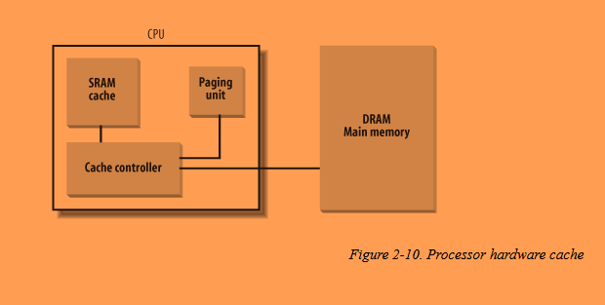
    - cache memory (SRAM cache) stores the actual lines of memory
    - cache controller stores an array of entries, one entry for each line of the cache memory
      - each entry includes tag and a few flags that describe the status of the cache line
      - tag: some bits that allow the cache controller to recognize the memory location currently mapped by the line
    - cache controller splits the bits of the memory’s physical address into three groups
      - most significant bits correspond to the tag
      - middle bits correspond to the cache controller subset index
      - least significant bits correspond to the offset within the line
    - !! Would be good to go back to computer architecture book and notes to explore how this cache controller tag stuff and such is implemented
    - when accessing a RAM memory cell, CPU extracts the subset index from the address and compares the tag of all lines in the subset with the high-order bits of the physical address. If there is a match, it is a cache hit, otherwise it’s a cache miss
      - cache hit
        - on read, controller just selects the data from the cache line and transfers it into a CPU register
        - on write, behavior depends on whether the policy is write-through or write-back
          - write-through: controller always writes into both RAM and the cache line (so RAM is updated ASAP)
          - write-back: more efficient. only the cache line is updated. cache controller writes the cache line back into RAM only when the CPU executes an instruction requiring a flush of cache entries or when a FLUSH hardware signal occurs (usually after a cache miss)
      - cache miss
        - correct line is fetched from RAM into the cache entry (any old entries that get removed have their cache line written to memory before removal)
    - cache snooping is implemented in hardware on multiprocessor systems since each CPU has its own local hardware cache
    - Intel processors typically have L1, L2, and L3-caches
    - Linux ignores the fact that processors may have multiple caches and instead assumes there is a single cache
    - Pentium Cache lets an OS associate a different cache management policy for each page frame. This is the purpose of the flags PCD (Page Cache Disable) and PWT (Page Write-Through) that are in the Page Table/ Page Directory entries
- Translation Lookaside Buffers (TLB)
  - another cache that is used to speed up linear address translation
  - when a linear address is translated to a physical address, that physical address is stored in a TLB entry so that future references to the linear address can be translated quickly
  - each CPU has its own TLB
    - unlike general hardware caches, TLBs are not synchronized among CPUs

Paging in Linux

- Linux uses a four-level paging model
  - A linear address can be split into 5 parts, one for each of the following (specific size of each portion depends on architecture)
  - Page Global Directory
    - Contains addresses of several Page Upper Directories
  - Page Upper Directory
    - Contains addresses of Page Middle Directories
  - Page Middle Directory
    - Contains the addresses of several Page Tables
  - Page Table
    - Each Page Table entry points to a page frame (section in RAM where page is stored)
    - Same concept as Page Table discussed in the last section
- 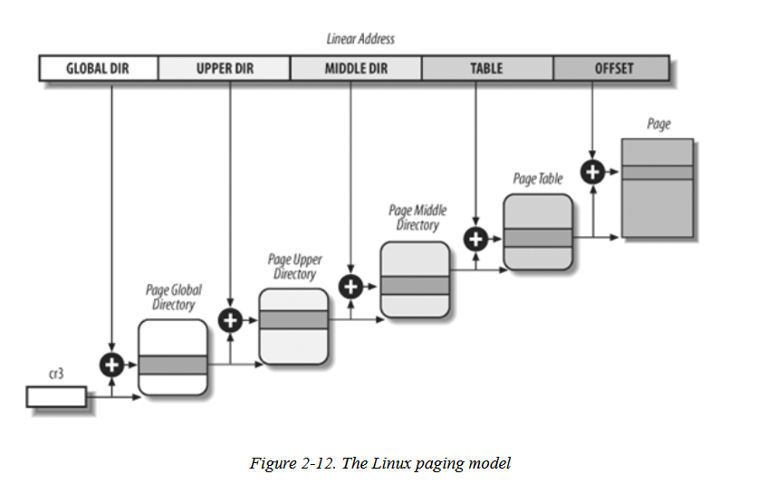
- For 32-bit architectures without Physical Address Extension, two paging levels are sufficient so Linux eliminates the Page Upper Directory and Page Middle Directory by saying they contain zero bits.
  - Kernel still keeps pointers to these sections so that code is compatible with 64-bit architectures as well
- 32-bit architectures with Physical Address Extension
  - Linux’s Page Global Directory = 80 x 86’s Page Directory Pointer Table
  - Linux’s Page Upper Directory = Eliminated
  - Linux Page Middle Directory = 80 x 86’s Page Directory
  - Linux’s Page Table = 80 x 86’s Page Table
- Design objectives
  - Assign a different physical address space to each process, ensuring efficient protection against addressing errors
  - Distinguish Pages from page frames.
    - Allows the same page to be stored in a page frame, then saved to disk and later reloaded in a different page frame
    - Basic ingredient of the virtual memory mechanism
- Each process has its own Page Global Directory and its own set of Page Tables
- When a process switch occurs, Linux saves the cr3 control register in the descriptor of the process previously in execution and then loads cr3 with the value stored in the descriptor of the process to be executed next. Thus when a new process resumes its execution on the CPU, the paging unit refers to the correct set of Page Tables
- Page Table Handling
  - pte_t, pmd_t, pud_t, and pgd_t describe the format of, respectively, a Page Table, a Page Middle Directory, a Page Upper Directory, and a Page Global Directory entry.
  - 64-bit data types when PAE is enabled and 32-bit data types otherwise
  - pgprot_t is a datatype that represents the flags associated with a single entry
  - Type conversion macros between unsigned integers and one of the above types
  - Kernel provides several macros and functions to read or modify page table entries
    - pte_read reads the user/supervisor flag (might be interesting if I’m exploring permissions)
  - Set of functions that set the value of the flags in a Page Table entry (Table 2-6. Page flag setting functions)
  - Set of macros which combine page address and a group of protection flags into a page table entry or preform the reverse operation of extracting the page address from a page table entry (Table 2-7. Macros acting on Page Table entries)
  - Set of functions which allocate the page organization structures (e.g. a function that allocates a new Page Middle Directory for the linear address addr
- Physical Memory Layout
  - During initialization phase the kernel builds a physical addresses map that specifies which physical address ranges are usable by the kernel and which are unavailable (either because they map hardware devices’ I/O shared memory or because the corresponding page frames contain BIOS data)
  - Kernel considers a page frame reserved if it falls within the unavailable physical address ranges or it contains the kernel’s code and initialized data structures
  - Linux kernel is installed in RAM starting from the physical address 0x00100000 (i.e., from the second megabyte)
  - # of page frames depends on how the kernel is configured- typically the kernel can be loaded in less than 3 MB of RAM
  - In early stages of boot sequence, the kernel queries the BIOS and learns the size of the physical memory
    - Kernel also invokes a BIOS procedure to build a list of physical address ranges and their corresponding memory types
  - kernel executes machine_specific_memory_setup() function which builds the physical addresses map
  - kernel executes setup_memory() after previous function
    - analyzes the table of physical memory regions and initializes variables that describe the kernel’s physical memory layout
      - num_physpages
      - totalram_pages
      - Table 2-10. Variables describing the kernel’s physical memory layout
  - How Linux fills the first 3 MB of ram
    - 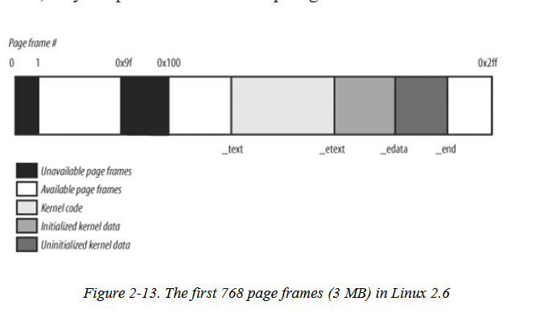
- Process Page Tables
  - Linear address space of a process is divided into two parts
    - (I assume the following is for 32-bit architectures)
    - 0x00000000 to 0xbfffffff
      - can be addressed when the process runs in either User or Kernel Mode
      - Contents of the Page Global Directory that map these linear addresses depend on the specific process that is running
    - 0xc0000000 to 0xffffffff
      - can be addressed only when the process runs in Kernel Mode
      - Contents of the Page Global Directory that map these linear addresses is the same for all processes and equal to the corresponding entries of the master kernel Page Global Directory
  - When a process runs in User Mode it issues linear addresses smaller than 0xc0000000
  - When a process runs in Kernel Mode, it issues linear addresses greater than or equal to 0xc0000000. However, in some cases, the kernel must access the User Mode linear address space to retrieve or store data
  - PAGE_OFFSET = 0xc0000000 = offset in the linear address space where the kernel lives
- Kernel Page Tables
  - kernel maintains a set of page tables for its own use rooted a the master kernel Page Global Directory
    - after initialization, this set of page tables isn’t directly used by any process or kernel thread. Instead, the highest entries of the master kernel Page Global Directory are the reference model for the corresponding entries of the Page Global Directories of every regular process in the system
  - How the kernel initializes its own page tables
    - right after the kernel image is loaded into memory, the CPU is still running in real mode; thus paging is not enabled
    - two phases
      - kernel creates a limited address space which includes the kernel’s code and data segments, the initial Page Tables, and 128 KB for some dynamic data structures
        - this minimal address space is just large enough to install the kernel in RAM and to initialize its core data structures
      - kernel takes advantage of all the existing RAM to properly setup its page tables
        - details of this process in the section ‘Provisional Kernel Plage Tables’
- Handling the Hardware Cache and the TLB
  - Handling the Hardware Cache
    - hardware caches are addressed by cache lines (from last major section on paging)
    - L1_CACHE_BYTES = size of a cache line in bytes
    - kernel attempts to optimize hit rate
      - the most frequently used fields of a data structure are placed at the low offset within the data structure, so they can be cached in the same line
      - when allocating a large set of data structures, the kernel tries to store each of them in memory in such a way that all cache lines are used uniformly
    - cache synchronization performed automatically by the 80 x 86 microprocessors
    - kernel provides cache flushing interfaces for processors that do not synchronize caches
  - Handling the TLB
    - processors cannot synchronize their own TLB cache automatically because the kernel, not the hardware, is what decides when a mapping between a linear and a physical address is no longer valid
    - Table 2-11. Architecture-independent TLB-invalidating methods
    - General rule- any process switch implies changing the set of active page tables. Therefore, local TLB entries relative to the old page tables must be flushed as well. This is done automatically when the new Page Global Directory has its address written into the cr3 control register.
    - TLB flushes avoid in two cases
      - when performing a process witch between two regular processes that use the same set of page tables
      - When performing a process switch between a regular process and a kernel thread. Kernel threads do not have their own set of page tables, they use the set of page tables owned by the regular process that was scheduled last for execution on the CPU (since kernel page tables are the same for each process)

*quick recap: segmentation registers store segment selectors which point to the segment descriptors (which have segment access rights DPL and location)

Additional Sources:
https://iambvk.wordpress.com/2007/10/10/notes-on-cpl-dpl-and-rpl-terms/ (1)

Other interesting links:
https://developer.arm.com/architectures/learn-the-architecture/memory-management/the-memory-management-unit-mmu

Blog Post Ideas:
-How privileges are handled via segmentation and paging in the Linux kernel
-Hack the Linux Kernel to ignore permissions..
-Detailed code on how the kernel initializes its page tables (tbh I think this is kind of boring)

Hacking the Kernel to Ignore Permissions

