How to install MacPower
MacPower is a menu-bar battery monitor. It does not appear in the Dock. It requires macOS 14 or later and an Apple silicon MacBook with a battery.
The disk image is not notarized by Apple. I do not have an Apple Developer account, which costs 99 USD a year, so macOS blocks the first launch. This is not a virus. MacPower is open source. The code is in the repository, and a virus in it would be visible there.

Disk image
- Open the MacPower-*.dmg in this folder and drag MacPower into Applications.
- Double-click MacPower. macOS shows the window below. Click Done. Do not click Move to Trash. Both methods start after this window.
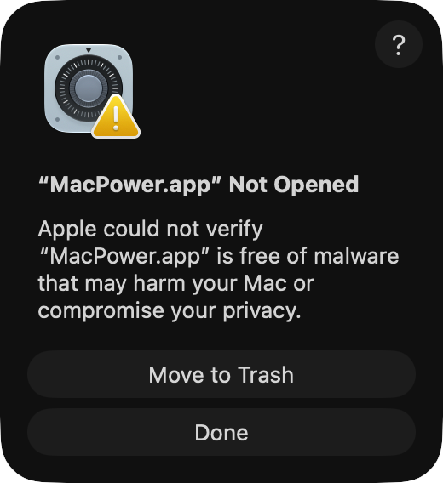
- Then allow it with method 1. Use method 2 if method 1 does not work.
- Open System Settings → Menu Bar, allow MacPower to appear in the menu bar, then launch it from Applications.

Method 1: Allow it in System Settings
Open System Settings → Privacy & Security and scroll the page to the bottom of the Security section. When you see “MacPower.app” was blocked to protect your Mac, click Open Anyway and confirm the prompt.
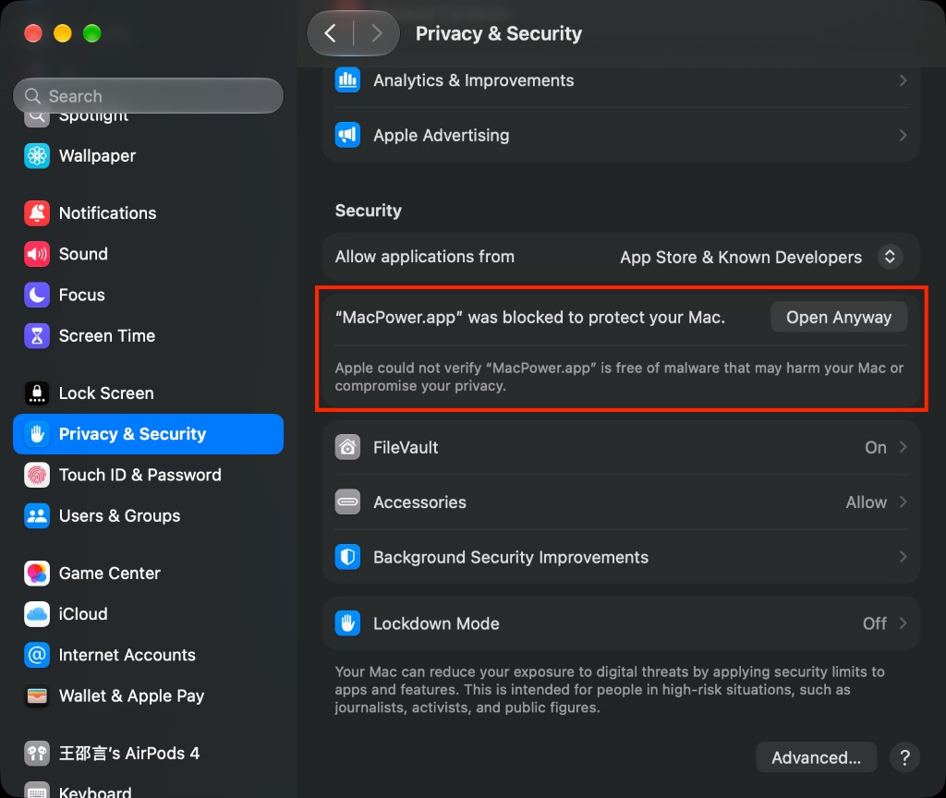

Method 2: Clear quarantine in Terminal
Open Terminal, paste the command below, and press Enter. Nothing appears while you type the password. Press Enter when you finish:
sudo xattr -rd com.apple.quarantine /Applications/MacPower.app

Homebrew
You can skip the disk image and run this in Terminal instead:
brew install --cask --no-quarantine ryanstarfox/tap/macpower
--no-quarantine is required. Official homebrew/cask does not accept this kind of package, so the command uses a personal tap.

