# Lab 1: Preparing your Hands-On-Lab environment

## What you will learn

In this first lab, you prepare the baseline for executing all hands-on-labs exercises:

* Log on to your Azure subscription;
* Deploy the lab-jumpVM within your Azure subscription;
* Verify and install the required tools to run the lab exercises;
* Deploy the 2-tiered Azure Virtual Machine infrastructure (WebVM and SQLVM);

## Time estimate

This lab is estimated to take **60min**, assuming your Azure subscription is already available.

## Task 1: Deploying the lab-jumpVM Virtual Machine using Azure Portal Template deployment

In this task, you start from deploying the “lab-jumpVM” Virtual Machine in your Azure environment. This machine becomes the starting point for all future exercises, as it has most required tools already installed.

1. Once you are logged on to your Azure subscription, select **Create a Resource**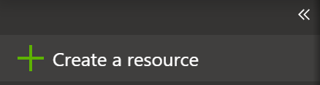
2. In the Search Azure Marketplace field, type “template deployment”  
     
   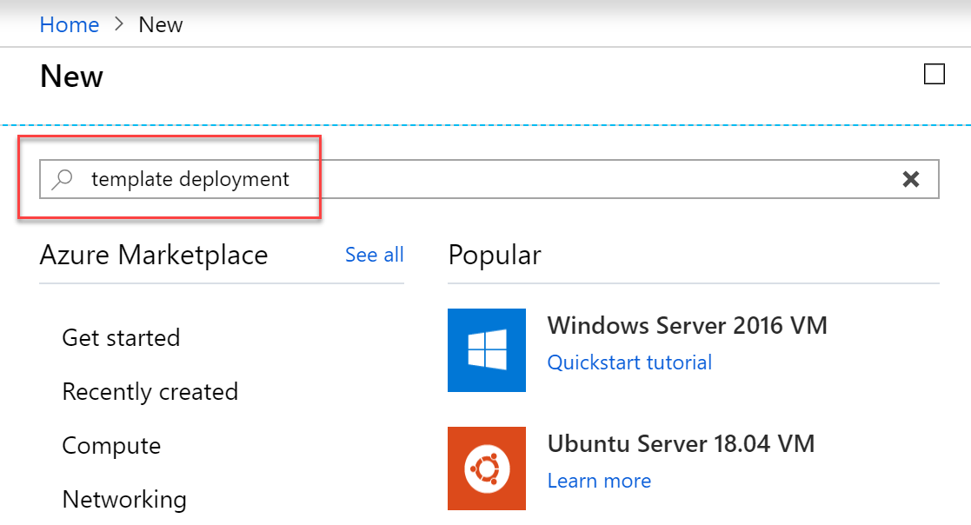
3. And select **template deployment** from the list of MarketPlace results. Followed by clicking the **Create** button down at the bottom.  
     
   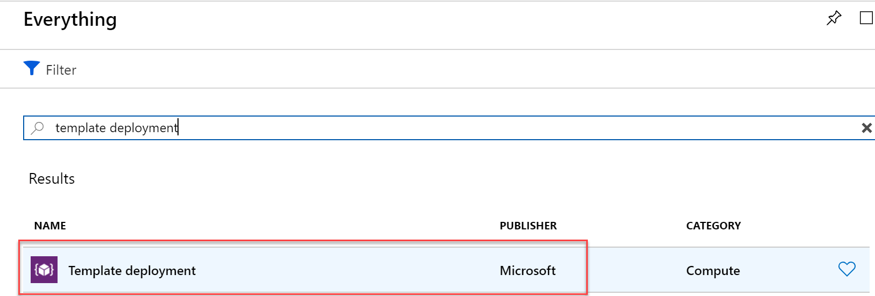
4. This opens the **Custom Deployment** blade. Here, **select** “**build your own template in the editor”**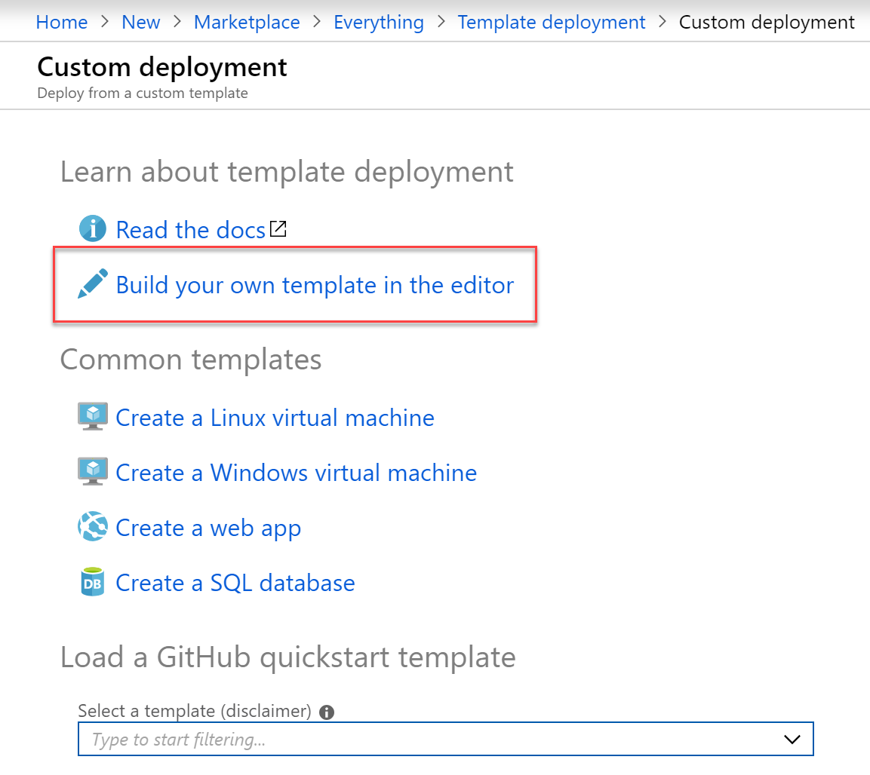
5. First, from a **second tab** in your browser window, go to the following URL on GitHub, browsing the source files repository for this lab, specifically the LabjumpVM folder:  
   <https://github.com/pdtit/ADS-Containers/tree/master/Sources/LabJumpVM>  
     
   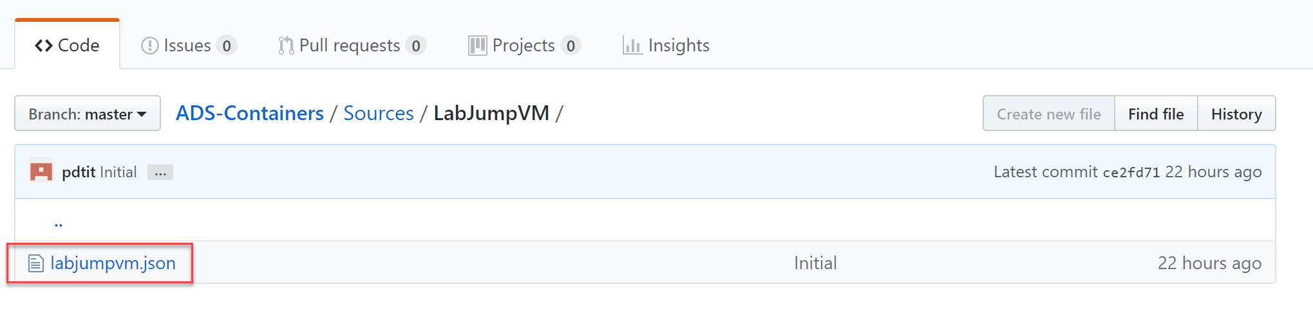
6. **Select** the labjumpvm.json object in there. This exposes the details of the actual JSON deployment file. **Click** the **Raw** button, to open the actual file in your browser.  
     
   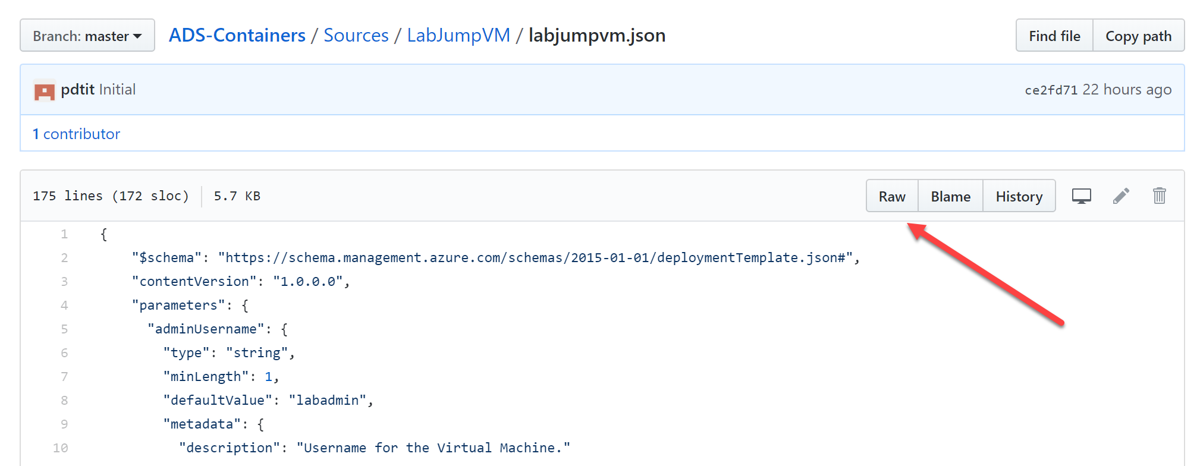
7. Your browser should show the content as follows:  
     
   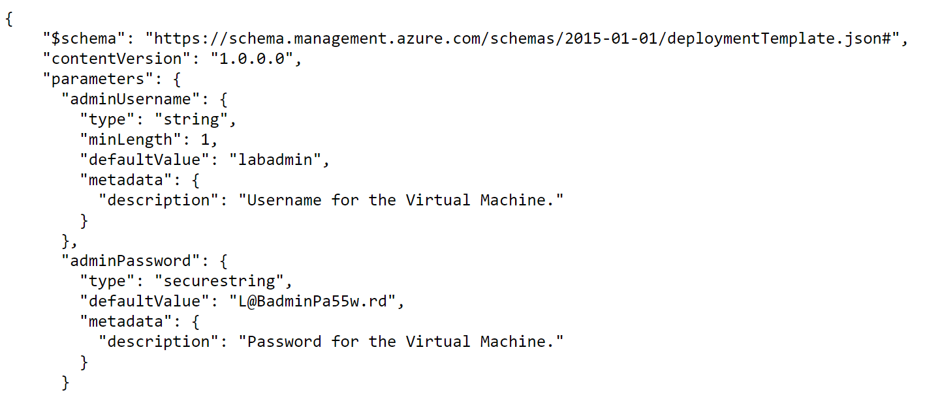
8. Here, use **Ctrl+A** to **select all lines in the JSON** file, and use **Ctrl+C** to copy it to the clipboard.
9. **Go back** to the **Azure Portal**; From the **Edit Template** blade, **remove the first 6 lines of code** you see in there, and **paste in the JSON content from the clipboard.**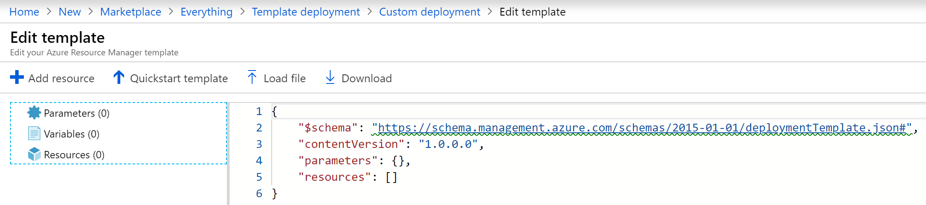
10. The Edit template blade should recognize the content of the JSON file, and showing the details in the JSON Outline on the left  
      
    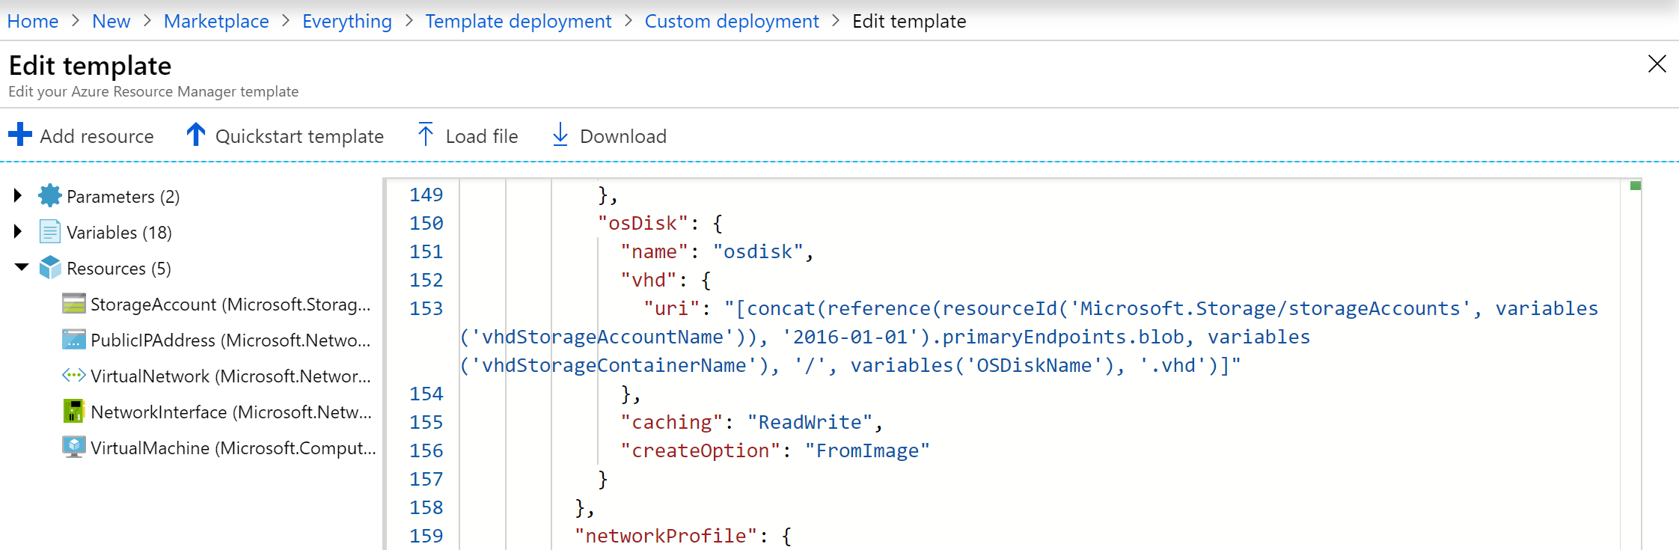
11. **Press** the **Save** button.
12. This **redirects** you back to the Custom deployment blade, from where you will **execute** the actual template deployment, filling in the required fields as follows:  
    **- Subscription: your Azure subscription  
    - Resource Group: Create New / SUFFIX-JumpVMRG  
    - Location: your closest by Azure Region  
    - Admin Username: labadmin** (this information is picked up from the ARM-template; although you could change this, we recommend you to not do so for consistency with the lab guide instructions)  
    **- Admin Password:** [**L@BadminPa55w.rd**](mailto:L@BadminPa55w.rd)(this information is picked up from the ARM-template; although you could change this, we recommend you to not do so for consistency with the lab guide instructions)  
    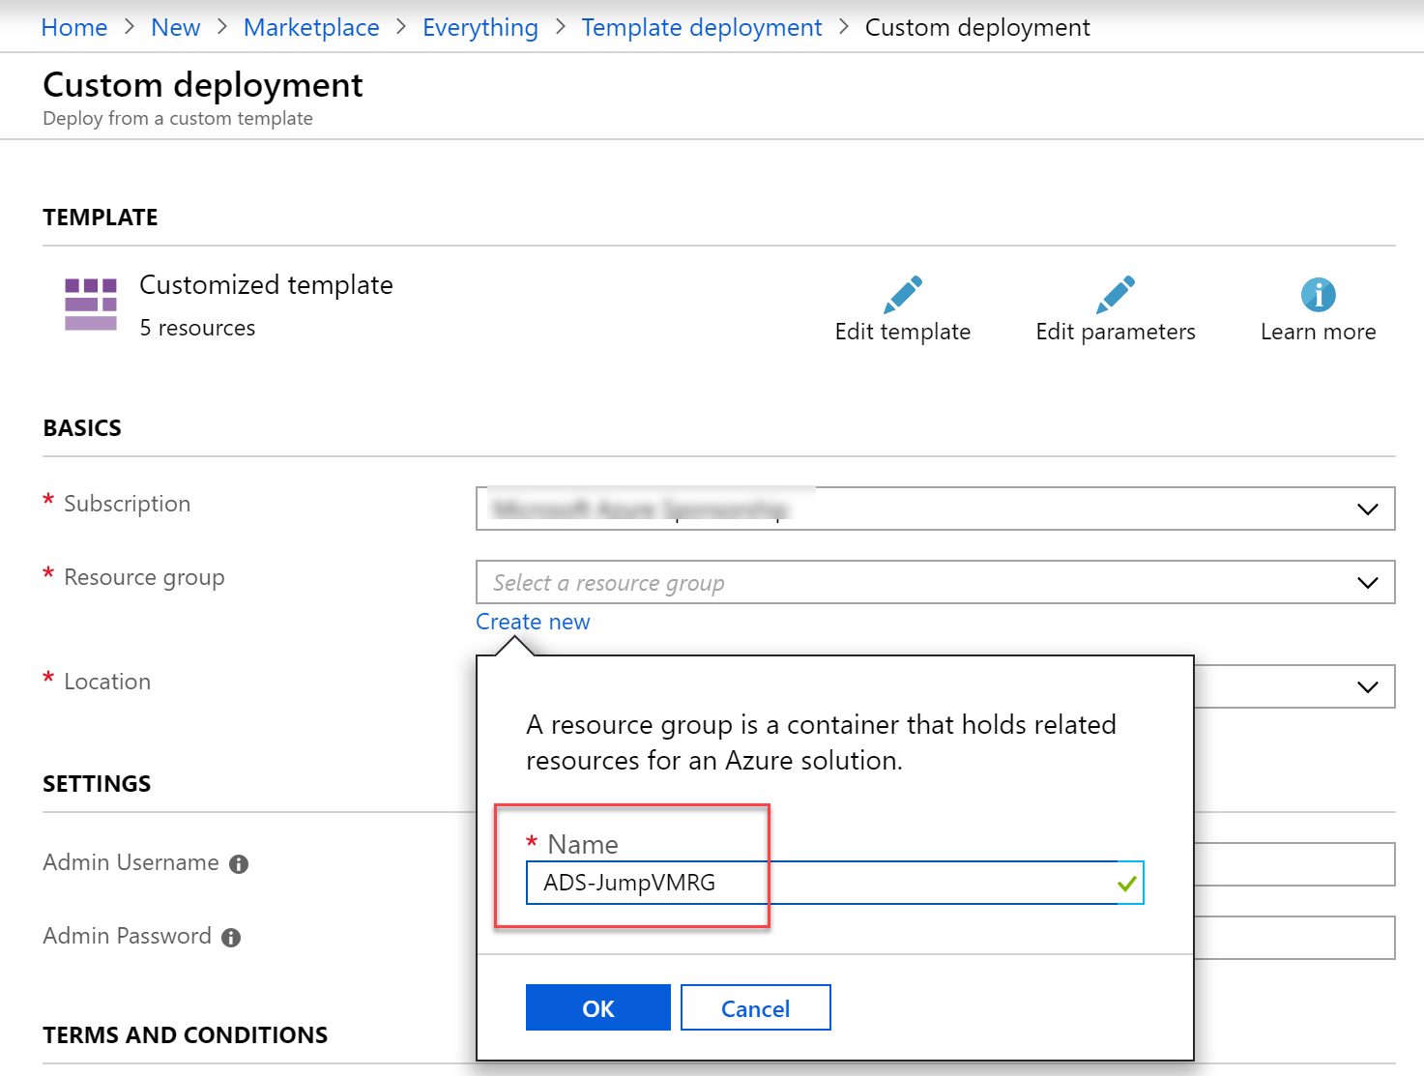
13. When all fields have been completed, scroll down in the blade. Under the terms and conditions section, **Check “I agree to the terms and conditions state above”**, and **press** the **Purchase** button.  
      
    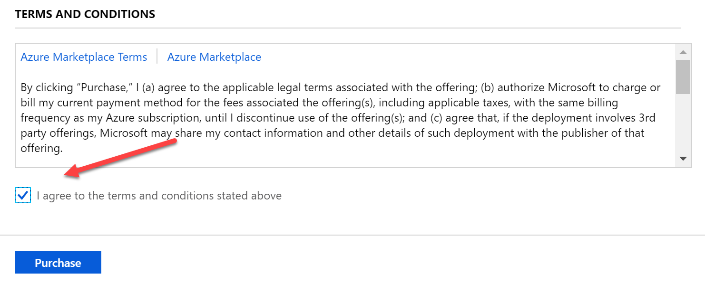
14. This sets off the actual Azure Resource deployment process. From the **notification area**, you can get update information about the deployment.  
      
    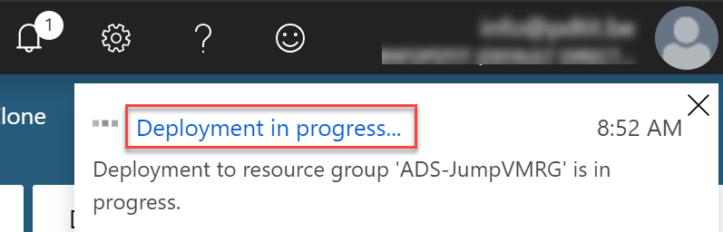
15. If you click the “…Deployment in progress…”, you will get redirected to the Microsoft template Overview blade, showing you the details of each Azure Resource getting deployed.  
      
    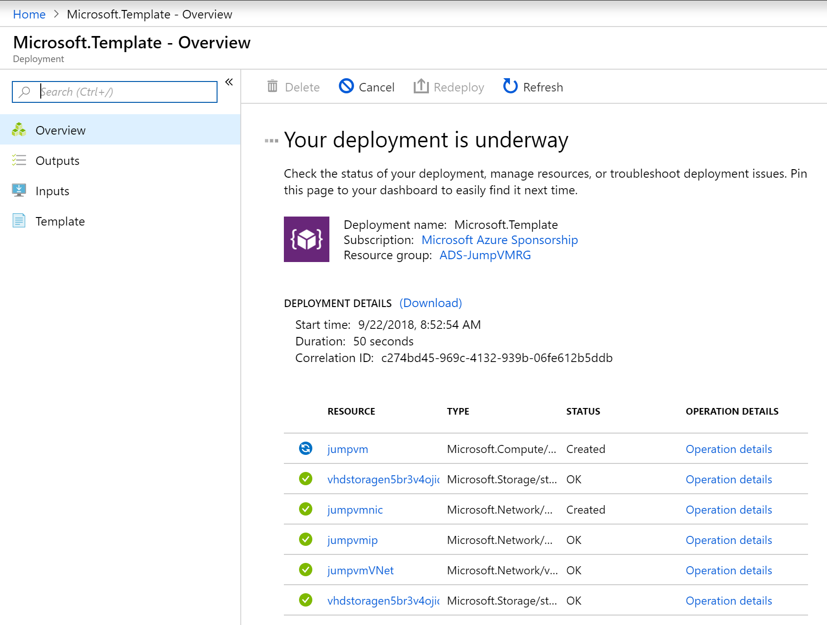
16. Wait for the deployment to complete successfully, which you can see from this detailed view, or from the notification area.  
      
    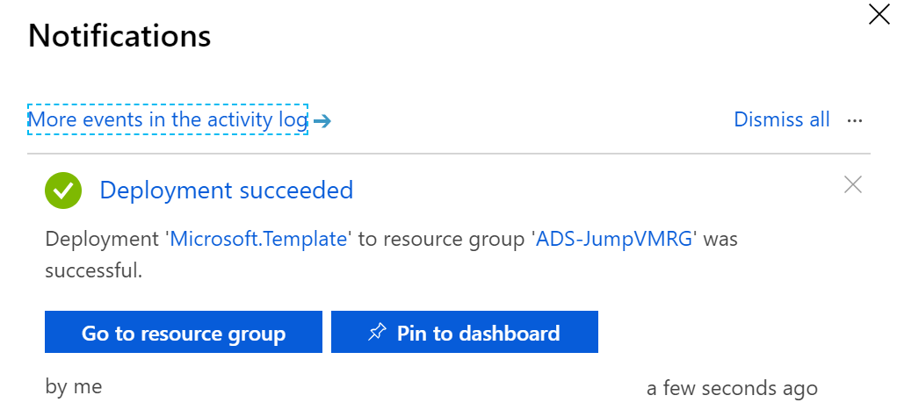
17. From the notification message, **click** “Go to resource group”. (If you already closed the notification message, from the Azure Portal navigation menu to the left, select Resource Groups).   
      
    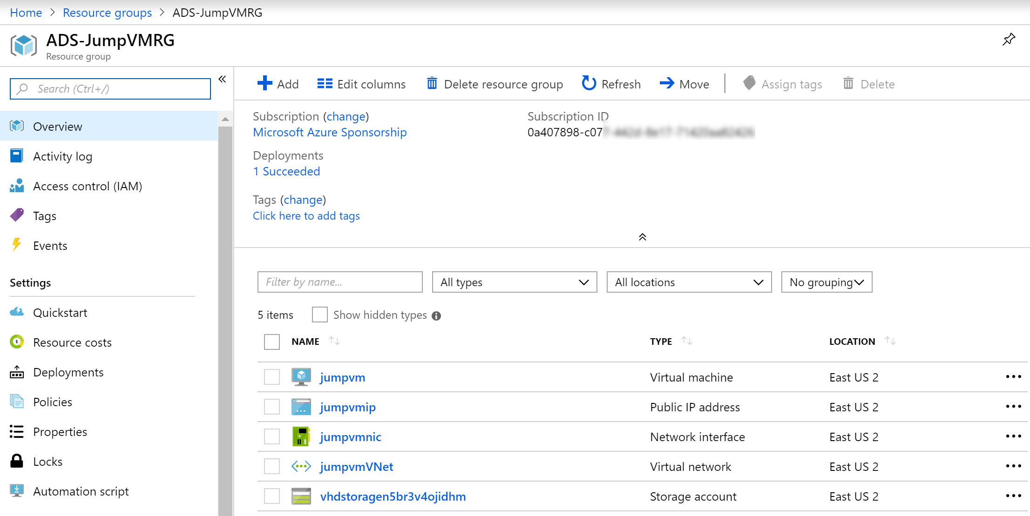
18. **Click** on the **jumpvm Azure Virtual Machine** resource. This redirects you to the detailed blade for the jumpvm resource. Here, **press** the **Connect** button.

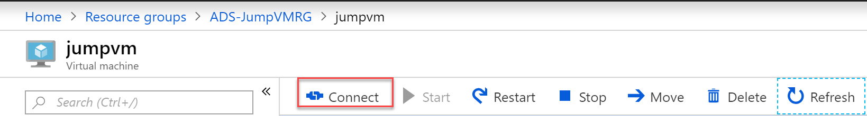

1. From the **Connect to Virtual machine** blade, notice the **public IP-address and port 3389**. This allows you to establish an RDP session to the Azure VM. Do this by **clicking** the **Download RDP file** button.  
     
   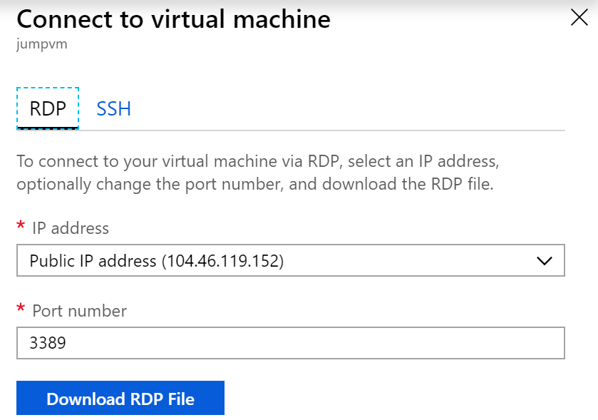
2. After the RDP connection file has been **downloaded**, **open** it up, which will launch the **Remote Desktop Connection** to that VM. In the appearing popup window, set the flag to “Don’t ask me again for connections to this computer.   
     
   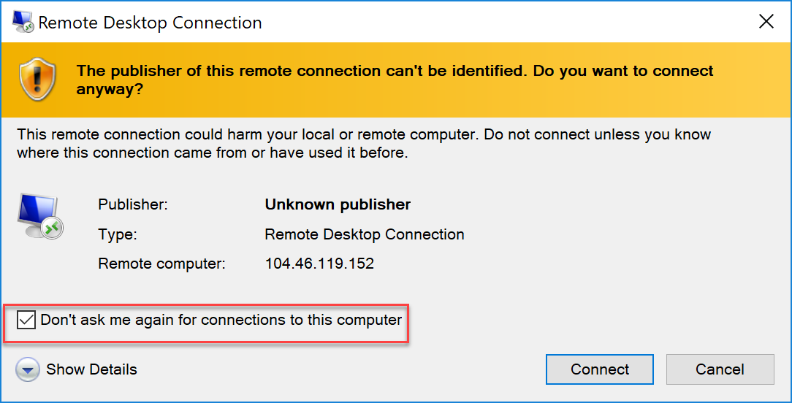
3. Press the **Connect** button; when it is asking for your **VM machine admin credentials** in the next step, provide the **VM administrator name (labadmin) as well as its password**.
4. Your Remote Desktop session to this Azure VM gets established.
5. **Close** the appearing “**Server Manager**”, you will access it again later.

This completes this task, in which you deployed a Windows 2016 lab-VM, by using Azure Resource Manager template-based deployment.

## Task 2: Deploying the baseline Virtual Machine environment using an ARM-template from within Visual Studio 2017

In this task, you run the ARM-template which deploys the baseline Virtual Machine environment you need in the next lab. Deployment will be performed from within Visual Studio 2017.

1. From within the lab-JumpVM Virtual Machine RDP-session, open a browser session to <https://github.com/pdtit/ADS-Containers/>, and **click** the **green Clone or Download button**.  
     
   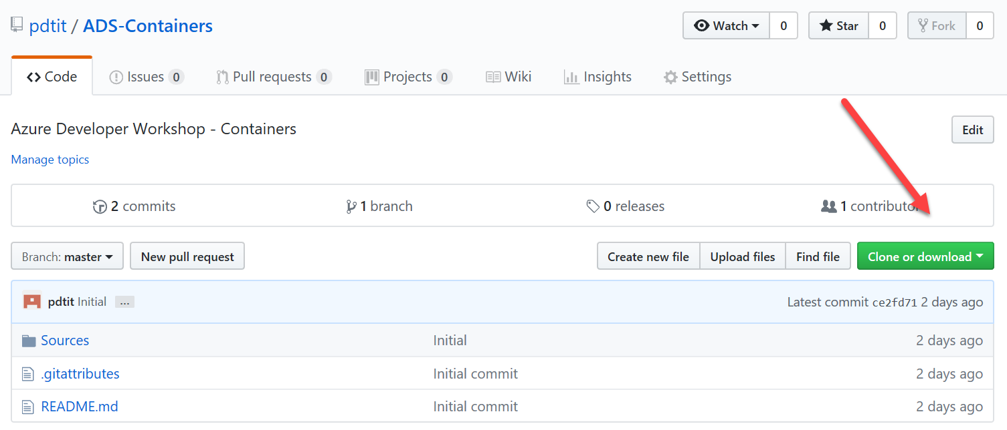
2. From the appearing popup, select **Download Zip.** This downloads the sources directory to the downloads folder on the lab-jumpVM.   
   **(note: if the Internet Explorer browser doesn’t allow downloads, go into its settings / internet options / and enable File Downloads and Font Downloads), and restart the browser.**
3. Once downloaded, **open** the downloads folder from within **File Explorer**, **right-click** the ADS-Containers.zip downloaded file, **choose Extract all…**   
   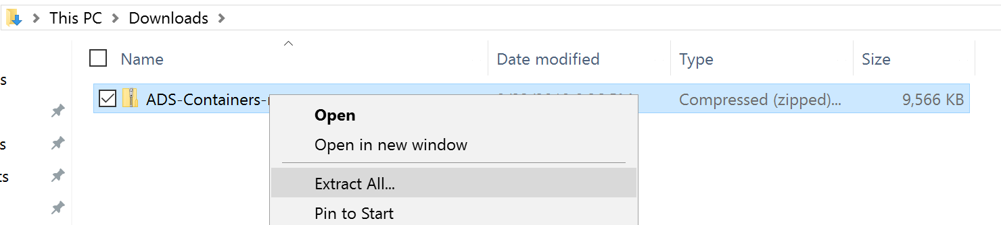
4. Extract the files to c:\ADS-Containers, or any other folder location of your choice.  
   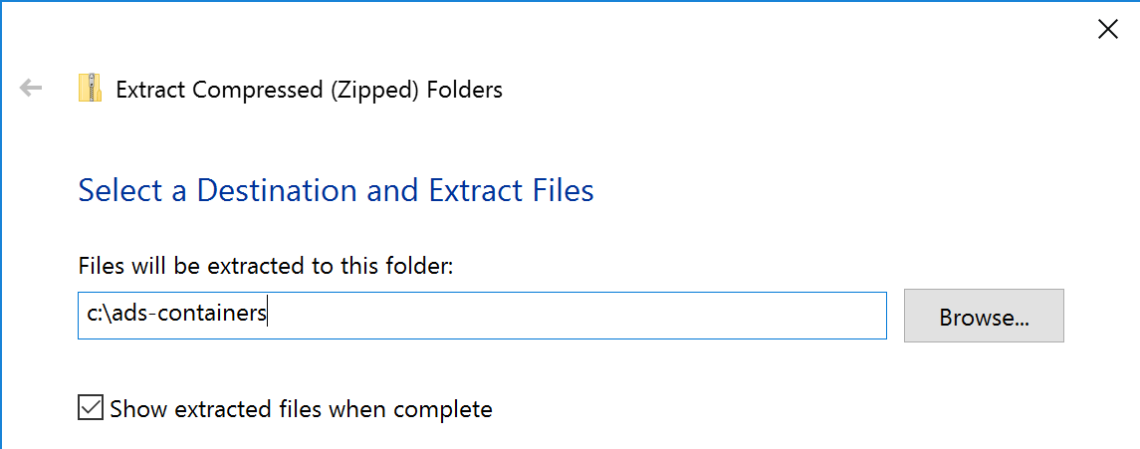
5. Once the extraction is completed successfully, **browse to the folder**. Within the folder, browse to **\ads-containers\ADS-Containers-master\Sources**. **Select** the compressed file “**ProductCat-VM-ARM-Deploy**”. **Right-click** this file, **choose Extract all**, and extract its content in a folder of choice, for example **c:\ProductCat-VM-ARM-Deploy**.
6. From the **lab-JumpVM Start Menu** or the shortcut on the desktop, **open Visual Studio 2017.** Since this is the first time you launch Visual Studio after a fresh install, you are greeted with the Visual Studio welcome message.   
   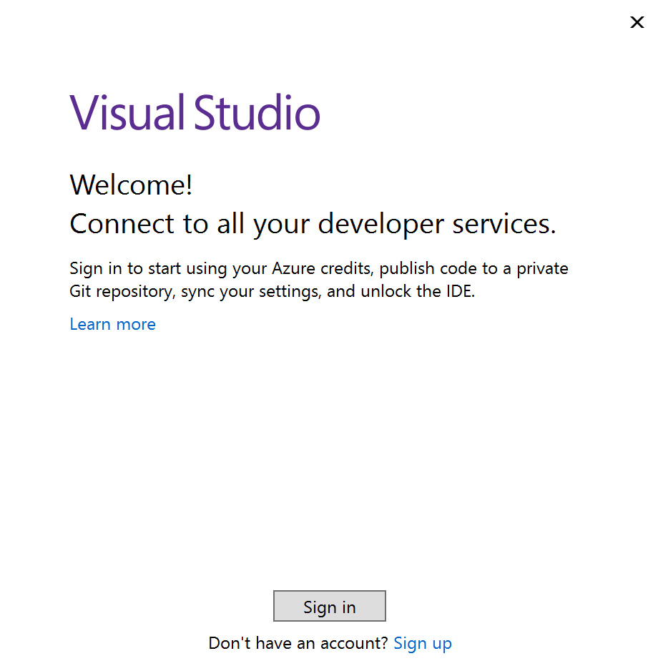
7. It asks you to sign in, so press that button. Here, authenticate with your **Azure subscription credentials.**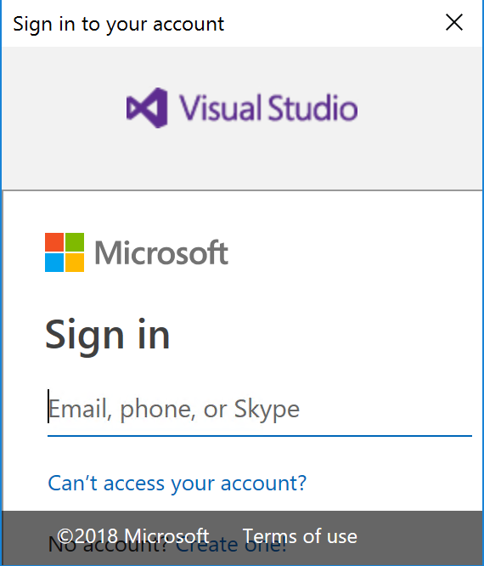
8. After successful authentication, you can choose a layout theme. Select a theme of choice, and wait until the Visual Studio environment completed loading.
9. From the Visual Studio menu, click File / Open / Project/Solution…  
     
   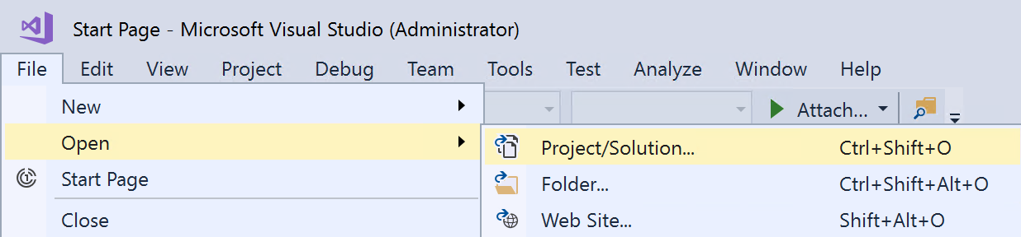
10. Browse to the folder where you extracted the “productCat-VM-ARM-Deploy” files. Click through the subfolders until you are at the folder showing **AzureResourceGroup44 Microsoft Visual Studio Project file type** (in our setup, this is c:\ProductCat-VM-ARM-deploy\ARM-Template-WebandSQL-finalversion)  
      
    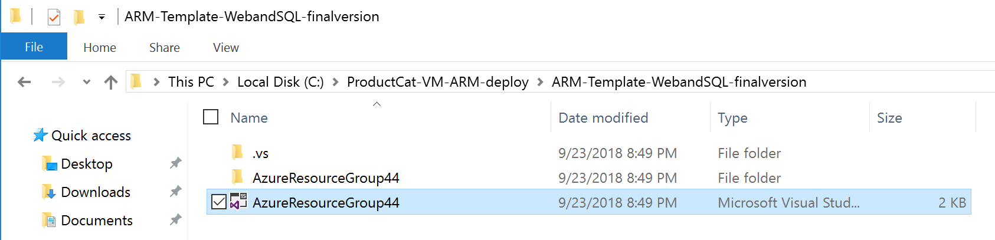
11. **Confirm** to open this project by pressing the **Open** button. This loads the project in Visual Studio.
12. Visual Studio will throw a security warning popup message; this is to warn you to only open Projects from trusted locations. **Press** the **Ok button** to continue.   
      
    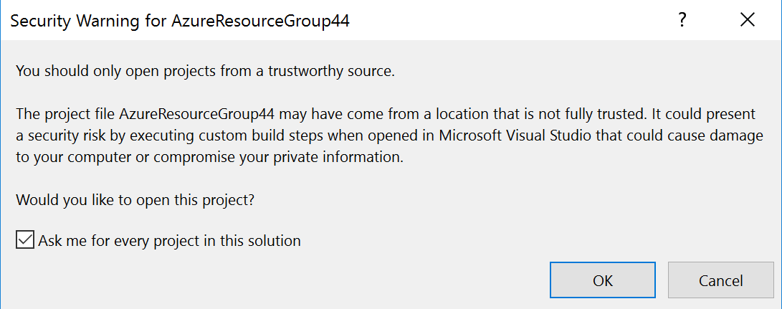
13. Once the project is opened in Visual Studio, you should have the Solution Explorer to the right of the screen, showing the actual deployment project folder and file structure.  
      
    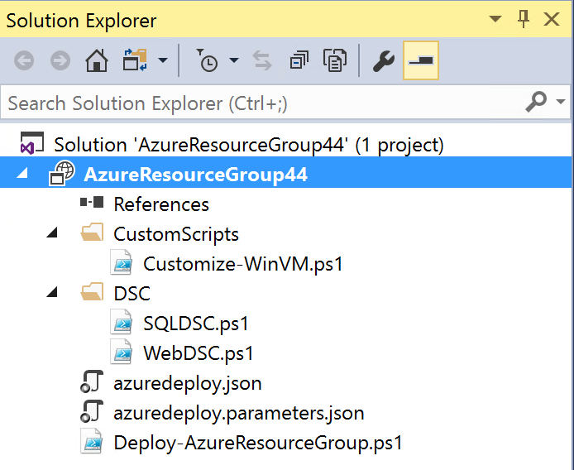
14. In short, these files are doing the following:

|  |  |
| --- | --- |
| **File** | **Purpose** |
| Azuredeploy.json | The actual ARM-template deployment file, which creates the different Azure Resources for both WebVM and SQLVM infrastructure. |
| Azuredeploy.parameters.json | The ARM-template parameters file |
| \CustomScripts\Customize-WinVM.ps1 | A PowerShell script, containing specific settings that get applied to both VMs using PowerShell |
| DSC\SQLDSC.ps1 | A PowerShell script that is used to customize the installation and configuration of SQL Server on the SQLVM |
| DSC\WebDSC.ps1 | A PowerShell script that is used to customize the installation and configuration of IIS Web Server on the WebVM |
| Deploy-AzureResourceGroup.ps1 | A PowerShell script that is used by VS2017 to run the actual deployment of the ARM-template |
|  |  |

1. From within the Solution Explorer window, select the **AzureResourceGroup44** project, **right-click** it and from the context menu, select **Deployment / New…**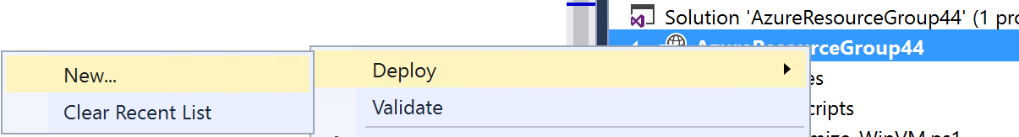
2. In the appearing “Deploy to Resource Group” popup, complete the following settings:

* Subscription: **Your Azure Subscription**
* Resource Group: **Create New / SUFFIX-VMs** – location = **closest by to your location**
* Deployment template: **azuredeploy.json**
* Template Parameters File: **azuredeploy.parameters.json**  
    
  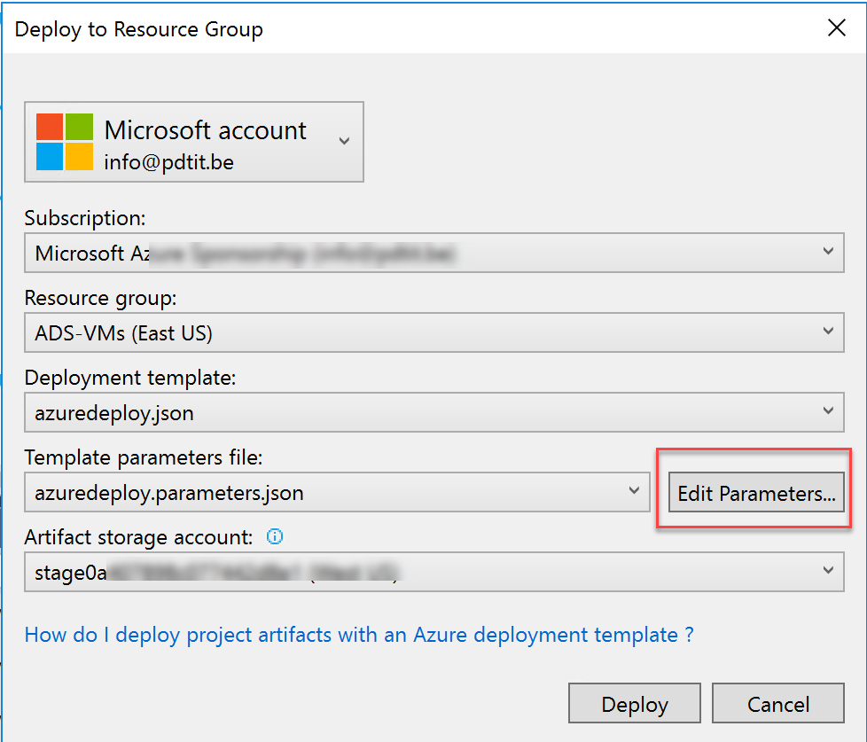

1. **Before pressing the Deploy** button, complete some additional deployment settings by **pressing the Edit Parameters button**:  
     
   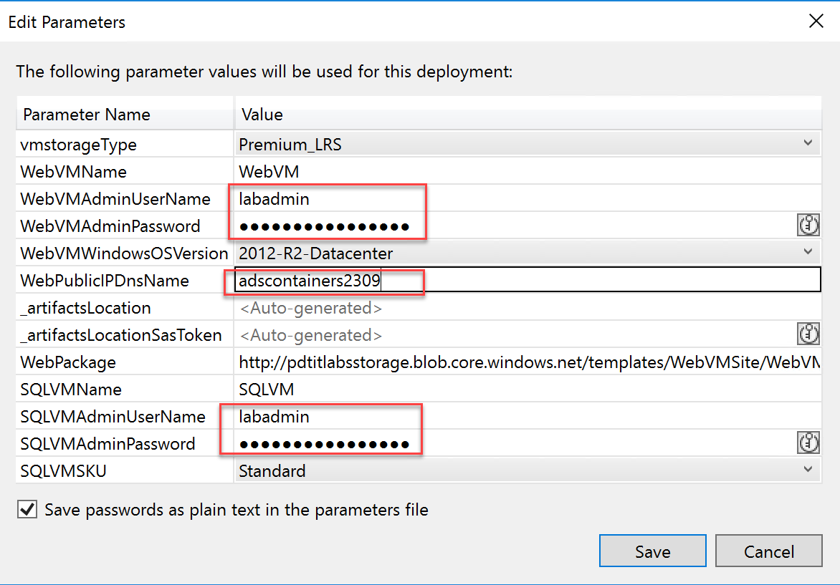

* **WebVMName: WebVM**
* **WebVMAdminUserName: labadmin**
* **WebVMAdminPassword:** [**L@BadminPa55w.rd**](mailto:L@BadminPa55w.rd) **(do not alter this password, as otherwise the customization script later on won’t work)**
* **WebVMWindowsOSVersion: 2012-R2-Datacenter**
* **WebPublicIPDnsName: SUFFIXcontainersDATE**
* **SQLVMName: SQLVM**
* **SQLVMAdminUsername: labadmin**
* **SQLVM WebVMAdminPassword:** [**L@BadminPa55w.rd**](mailto:L@BadminPa55w.rd) **(do not alter this password, as otherwise the customization script later on won’t work)**

1. **Check** the “Save passwords as plain text in the parameters file”. (Note: This is ok in this lab environment, but not recommended in production deployments. If this option is not checked, you will get a PowerShell window appearing, asking you for this administrator password there).
2. Once all settings have been completed in the Parameters popup window, click **Save**. You are redirected to the “Deploy to Resource Group” window. Start the actual deployment by pressing the **Deploy** button.  
     
   
3. The Azure Resources deployment kicks off, which can be followed from the Visual Studio **Output** window. (**For your info, this deployment takes about 15-20min might be a good time for a break 😊).**  
     
   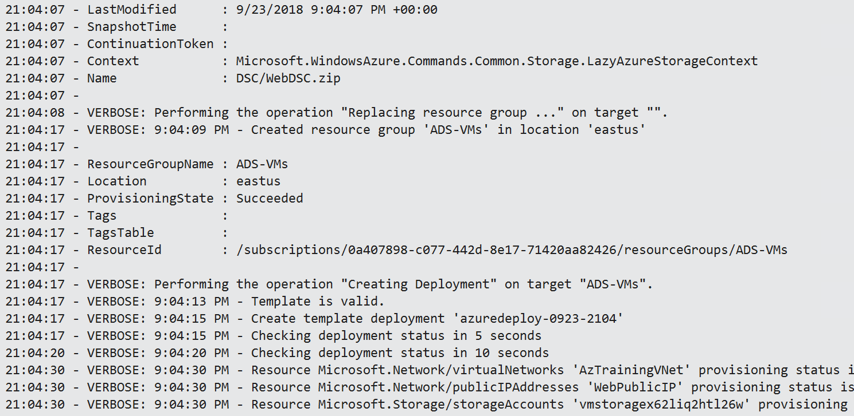
4. The different Azure Resources **get deployed**; from your **internet browser**, **connect** to <http://portal.azure.com>, **authenticate** with your Azure subscription credentials. **Go to Resource Groups, open the SUFFIXcontainersDATE Resource Group**. Here, you can see the different resources getting created.  
     
   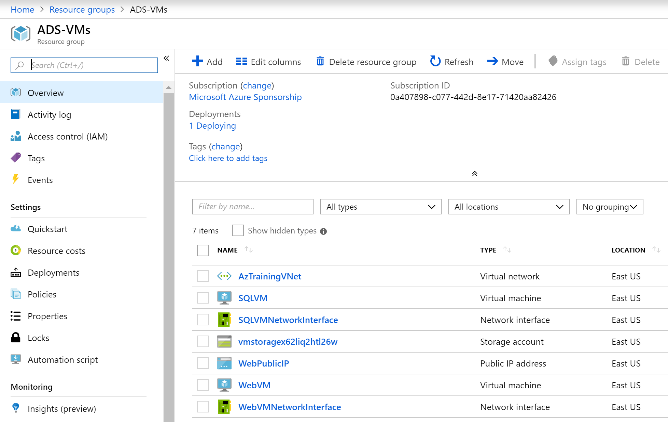
5. From the **Resource Group** blade, **Settings** section, click **Deployments.**
6. This **shows** the actual running deployment task.  
     
   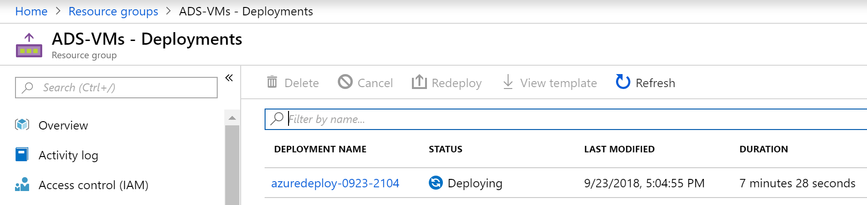
7. **Click the deployment name <e.g. azuredeploy-0923-2104>,** which shows you more details about the actual deployment process, including the already deployed resources.  
     
   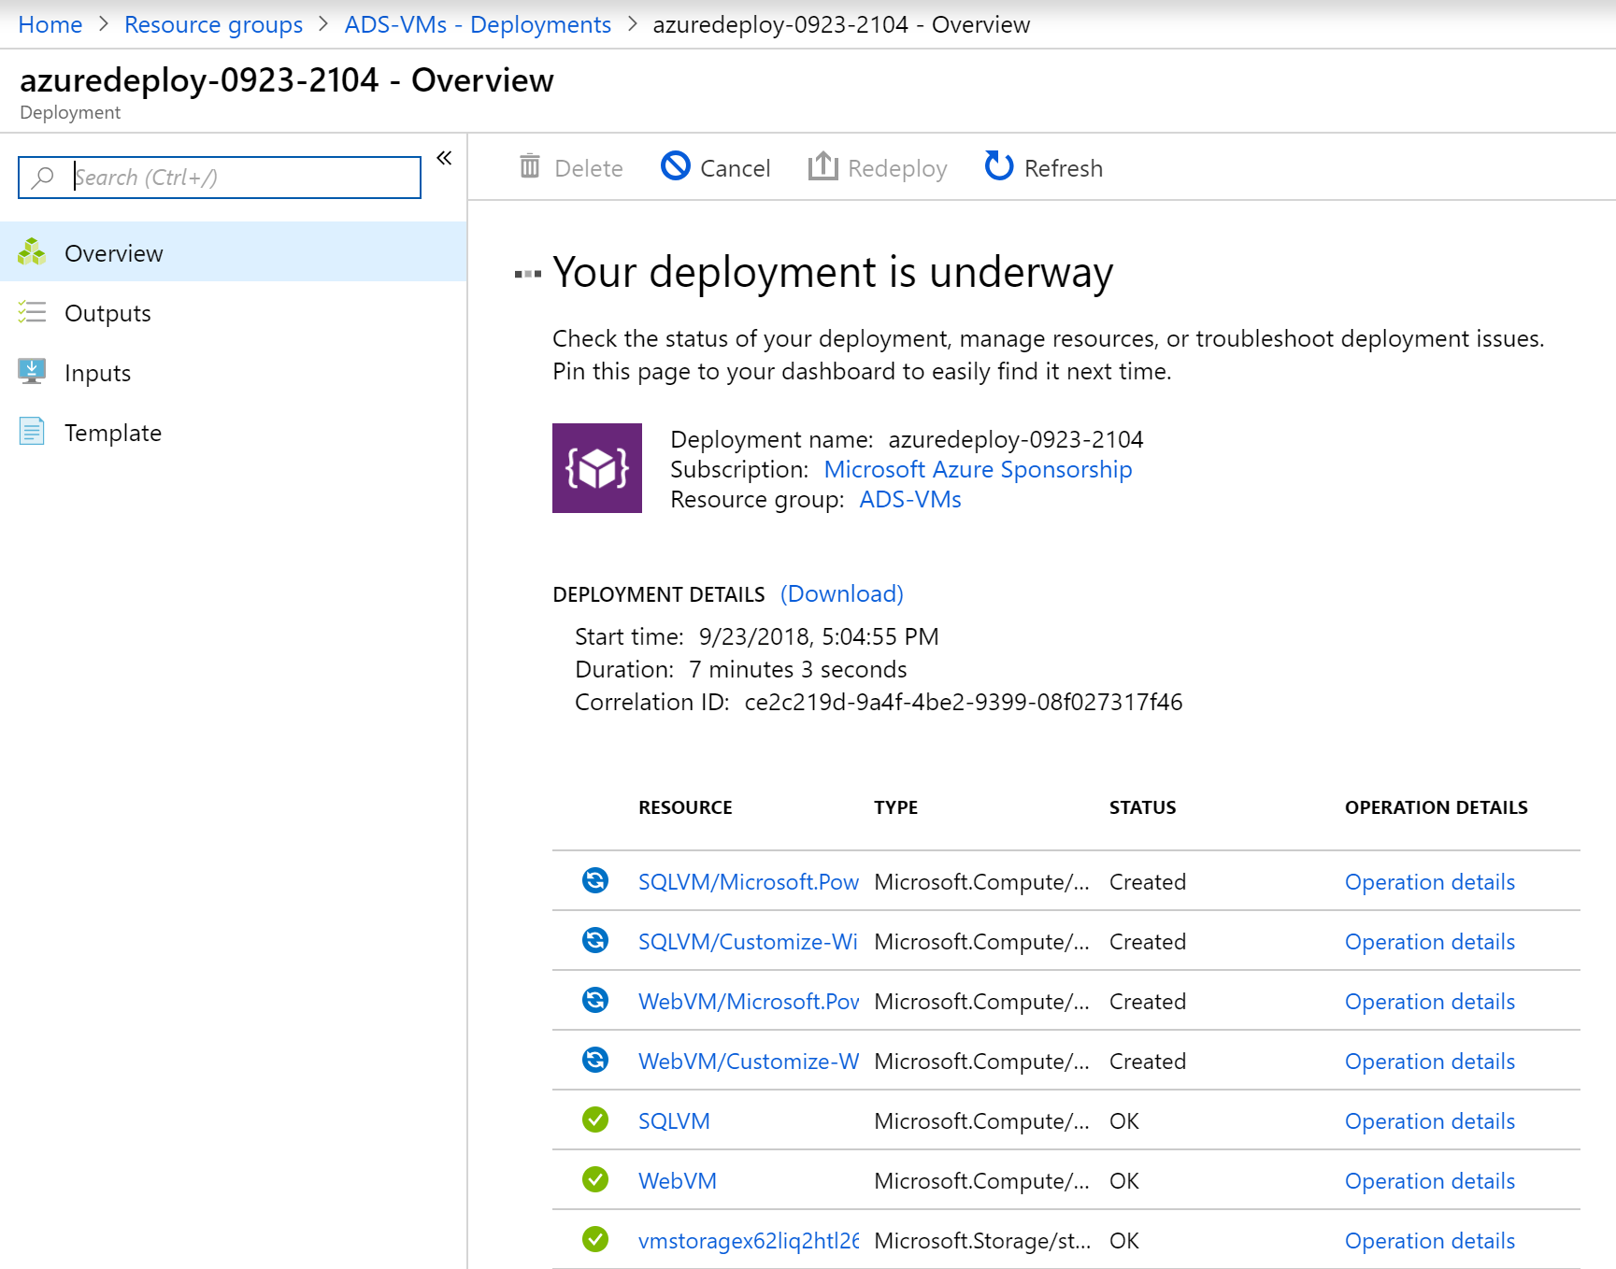
8. **Wait for the deployment to complete successful**. This is noticeable from within the Visual Studio Output window, or from within the Azure Portal deployment blade you were in before.  
     
   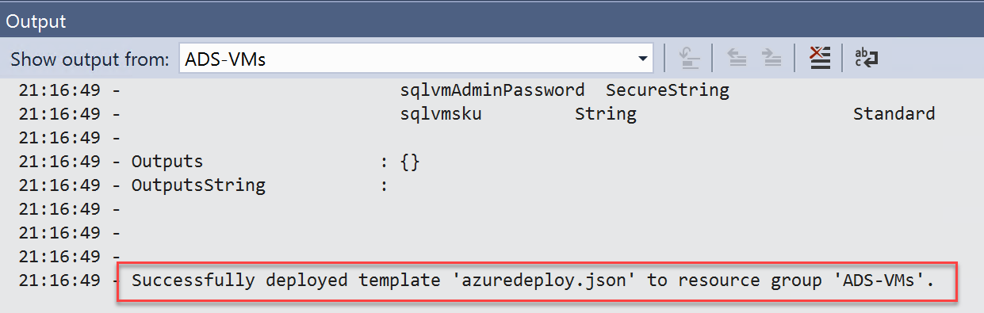  
     
   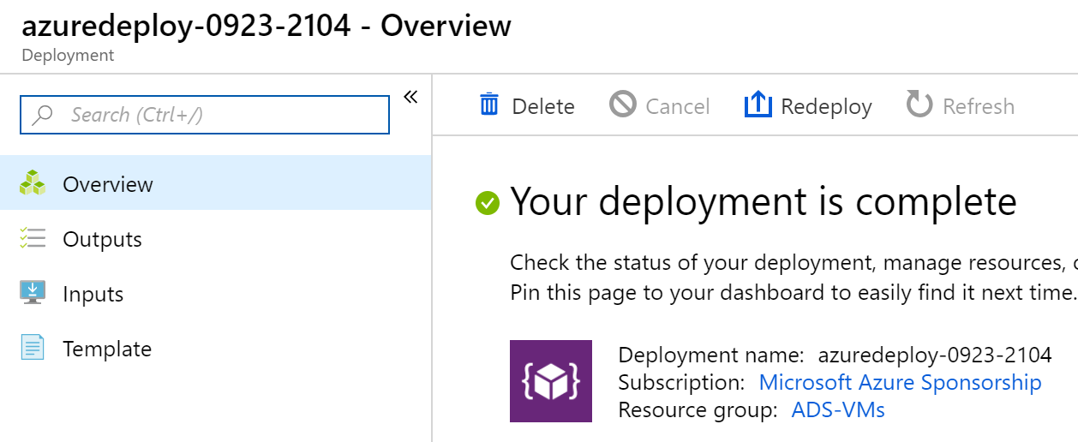
9. **Close Visual Studio** without saving changes to the project.

To verify all went fine during the deployment of the Azure Resources, as well as the customization and configuration using PowerShell Desired State Configuration, log on to the WebVM to validate the web application is running as expected.

1. From within the **Azure Portal**, go to **Resource Groups**, and select the Resource Group where **you deployed the VMs**. In here, **select the WebVM** Virtual Machine by **clicking** on it. This **opens the WebVM detailed blade**.   
     
   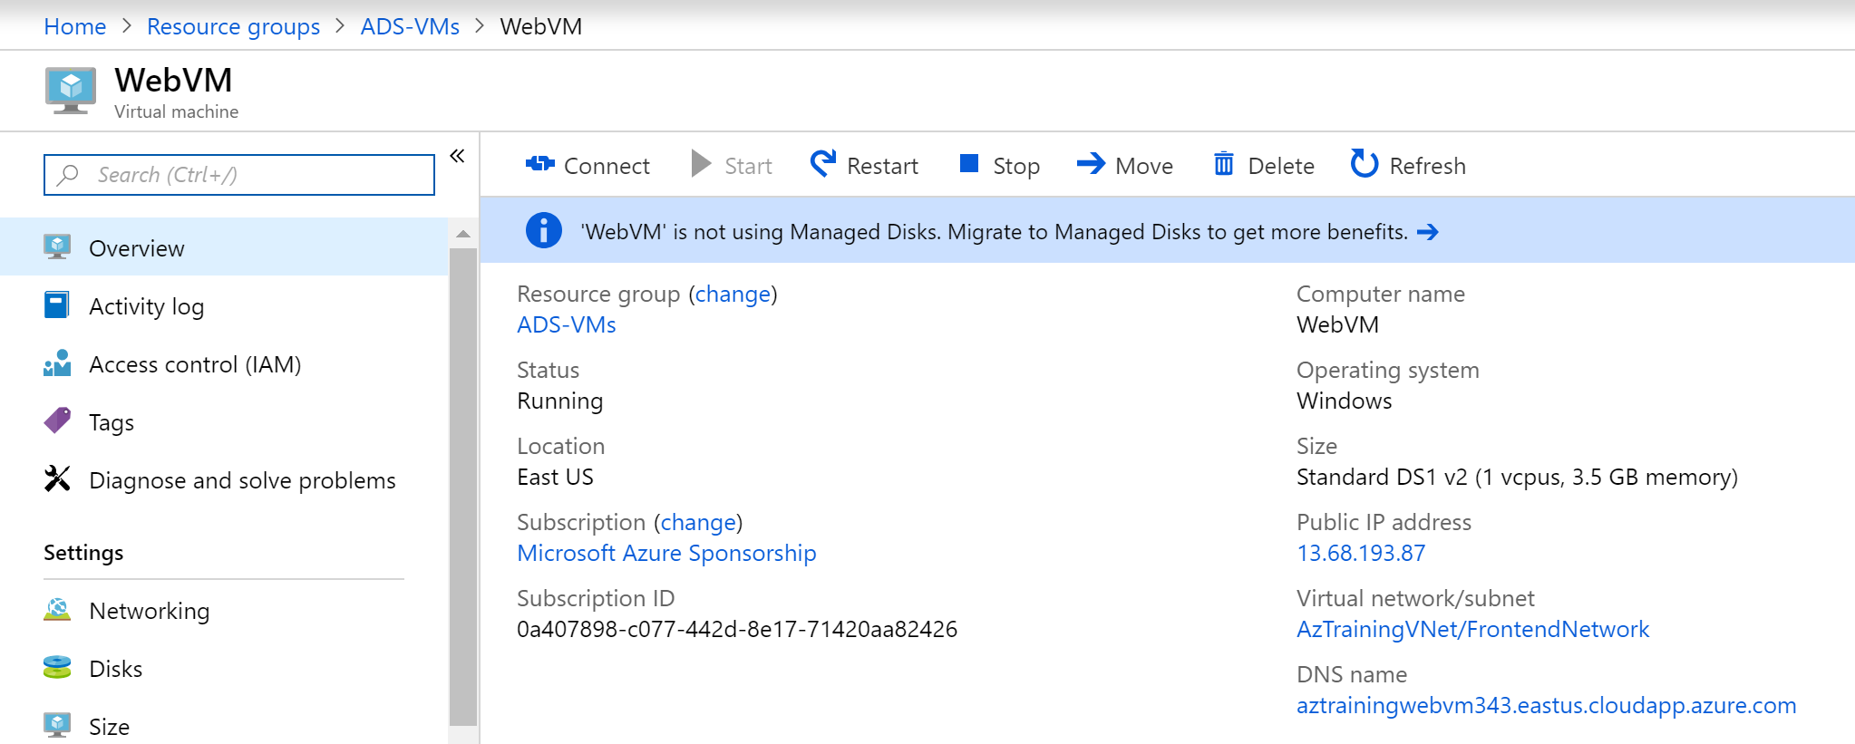
2. Similar to what you did with the lab-JumpVM, press the **Connect** button, to open the Remote Dekstop session to this WebVM Virtual Machine.   
     
   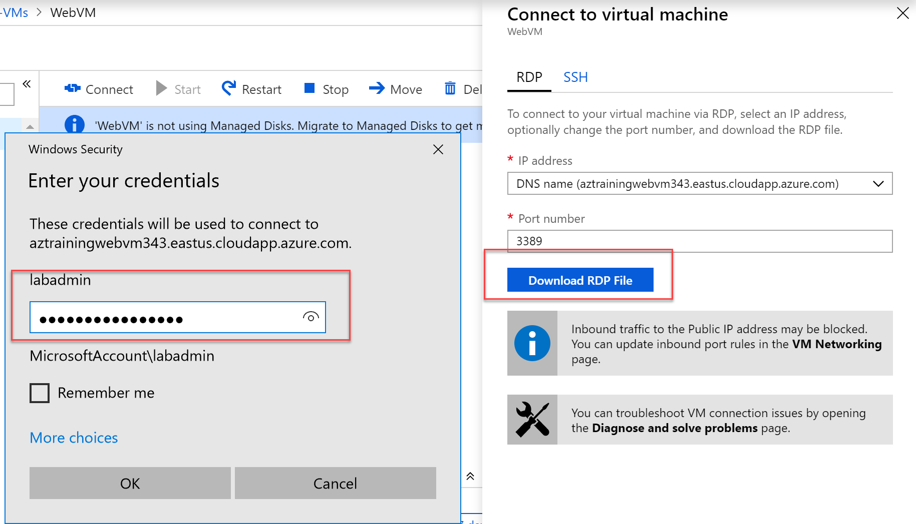
3. Here, log on with the credentials from the ARM template (labadmin / [L@BadminPa55w.rd](mailto:L@BadminPa55w.rd)) unless you changed those before the deployment.
4. From within the WebVM RDP-session, open an internet browser, and browse to <http://localhost>. This opens the Product Catalog web application, establishing a connection to the SQLVM to connect to the underlying SQL database.  
     
   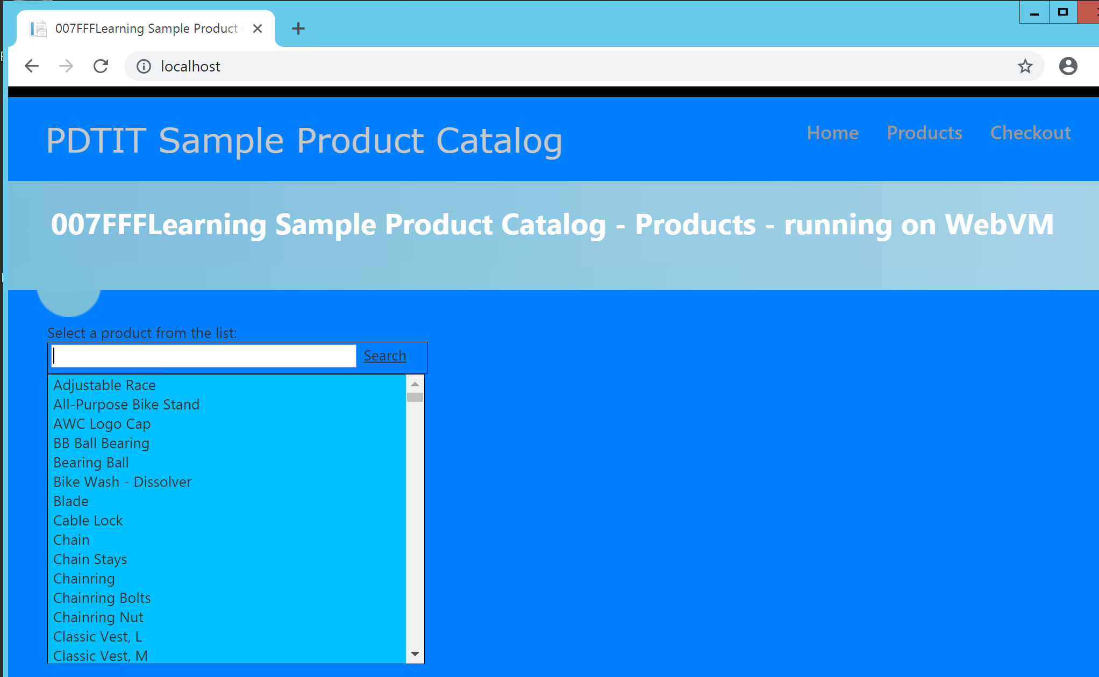
5. Close the browser session on the WebVM.
6. Close the RDP session for the WebVM Virtual Machine.

This completes the task in which you deployed Azure Resources using Visual Studio 2017 ARM-template with customizations, and validated the good functioning of the web application.

# Summary

In this lab, you started with deploying an ARM-template from within the Azure Portal, deploying a lab-JumpVM Virtual Machine in Azure. In the next task, you learned how to deploy a more complex Azure environment, again using an ARM-template, where deployment was executed from within Visual Studio 2017.