**Minix3: Deep Dive**

**Benjamin Sanders, MS** February 10, 2020

# First Steps

1. Install Minix3 over a Virtual Machine.

https://wiki.minix3.org/

# Tetris

1. Navigate to /usr/games
2. Play a round of tetris
3. Using a web browser, navigate to: https://github.com/Stichting-MINIX-Research-Foundation/minix/tree/master/games/tetris
4. Download the files to a local directory.
5. Attempt to compile these files. Can you compile these files? If not, explain why.
   1. I can run it.
6. Create your own shape: a heart or a smiley face, etc., and take a screenshot of the code you modified tocreate this shape.

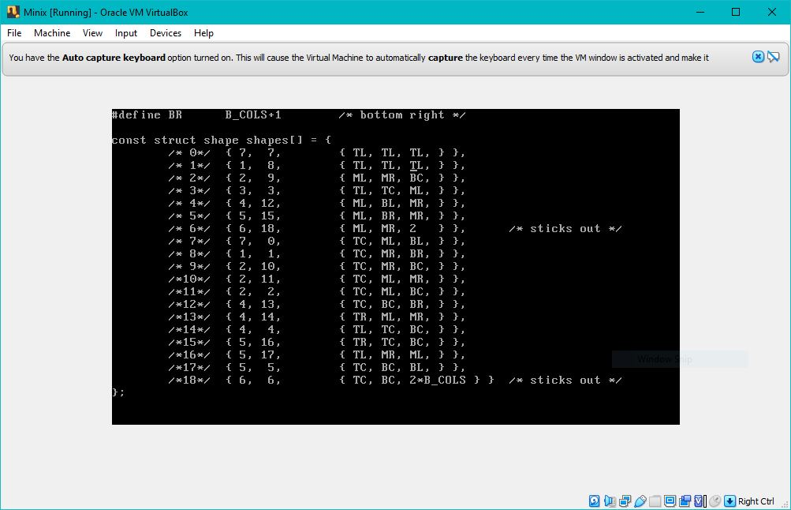

# Adventure

1. Navigate to /usr/games
2. Try the game adventure
3. Using a web browser, navigate to: https://github.com/Stichting-MINIX-Research-Foundation/minix/tree/master/games/adventure
4. Download the files to a local directory.
5. Attempt to compile these files. Can you compile these files? If not, explain why.
   1. I can’t compile these files, and I am not sure why. I have downloaded everything correctly and have all of the correct files. I have made it clean and it still does not want to run it. Since I can’t run the file I can’t write my own command pager
6. Write your own command: pager which displays a random phone number to the player and can be called at any point in the game. The phone number should be formatted as follows: (XXX)XXX-XXXX Take a screenshot of the code you modified to create this functionality.

1