Ryan Stearns  
Lab 8

After configuring the switch with a VLAN with the IP address of 10.1.2.1/24, I assigned the Windows machine with an IP address of 10.1.2.2, and the Kali Machine with an IP address of 10.1.2.3. I then uncommented the two iptables rules from the etter.conf file.

This directs traffic to the IPTable Pre-Routing Chain first, then redirects it to a port. Rport matches the port listening on SSLStrip.

The following security exceptions were found when attempting to open an SSL page on the following browsers.

**Google Chrome**

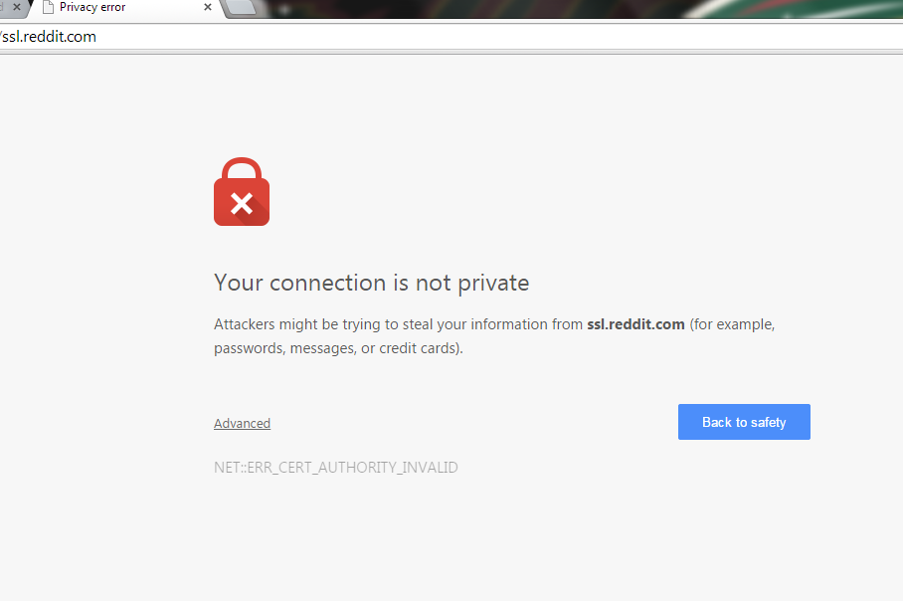

**Firefox**

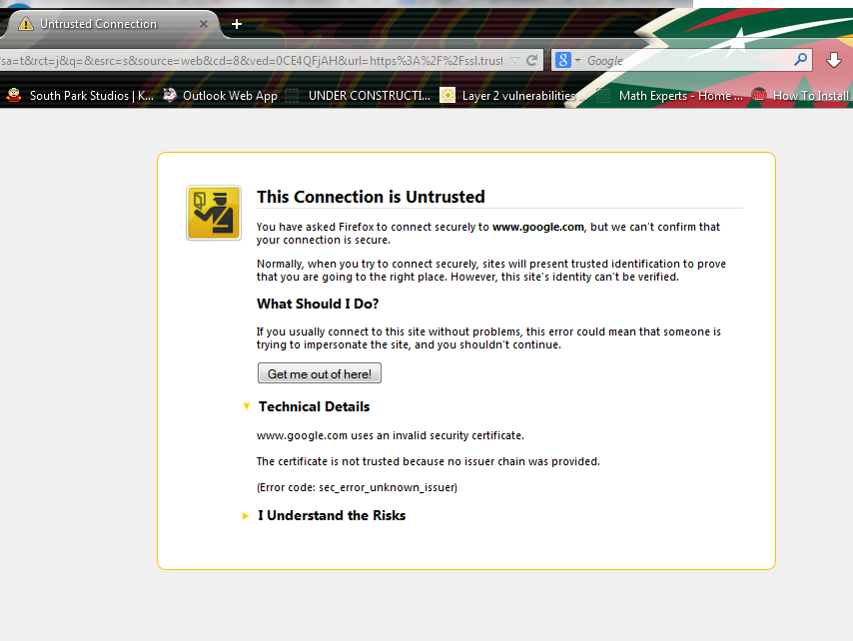

**Internet Explorer**