**An Overview of Data Mining**

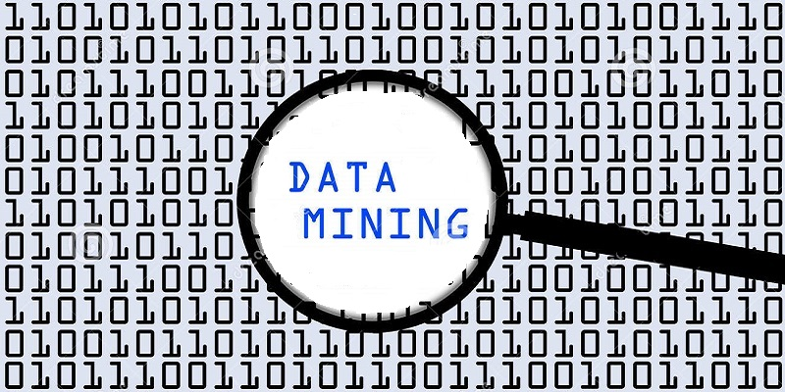

A comprehensive look at Data Mining Architectures, designs, algorithms, and implementations

A technical paper by : Ryan T. Stearns  
 St. Cloud State University  
 Information Technology – Security

Table Of Contents

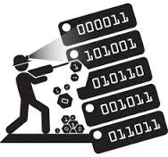

One of the most prevalent terms being frequently discussed not only in computing, but also in any business that can benefit from advanced statistical analysis.