Assignment 2 – Intro Java
(Drawing Designer)

Student: Zhiyi Zeng
Date: 27/04/2017
Unit: ICTPRG418
Teacher: Mark O’Reilly

IPO Chart

Input | Process | Output | Storage
- Run the program | - Initial all components  - Add Action Listener to colour buttons  - Add DrawPanel to the main Frame | - Show UI with initial DrawPanel | - Create a DrawPanel global variable called drawPanel in RAM memory
- Each Colour button | - Get clicked button background colour as currentColor  - Set drawPanel currentColor property to currentColor  - Set btnSelectedColor background to currentColor | - btnSelectedColor background change to corresponding colour | - Update currentColor in drawPanel in RAM memory
- drawPanel panel | - Get location of the mouse  - Get currentColor  - Set stringArray corresponding item to currentColor | - Image in drawPanel would change  - New stringArray | - Update stringArray property in drawPanel in RAM memory
- Grid checkbox | - Set isShowGrid property in drawPanel to Grid checkbox’s value  - Paint the drawPanel  - drawRect () would (or not) be invoked during painting | - Grid shows (or disappears) in DrawPanel | - Update isShowGrid property in drawPanel in RAM memory
- Clear button | - Set all items in stringArray in drawPanel to “W”  - Paint the drawPanel | - drawPanel would be blank  - Initial stringArray | - Initial stringArray property in drawPanel in RAM memory
- Rotate 90 button | - Process stringArray (for more details please click here)  - Paint the drawPanel | - Image in drawPanel would rotate 90° clockwise  - New stringArray | - Update stringArray property in drawPanel in RAM memory
- Flip Horizontally button | - Process stringArray(for more details please click here)  - Paint the drawPanel | - Image in drawPanel would flip horizontally  - New stringArray | - Update stringArray property in drawPanel in RAM memory
- Flip Vertically button | - Process stringArray(for more details please click here)  Paint the drawPanel | - Image in drawPanel would flip vertically  - New stringArray | - Update stringArray property in drawPanel in RAM memory
- Open button | - Create a FileChoose with *.csv, *.txt, *.abc and *.raf FileNameExtensionFilters  - Retrieve the file through FileChoose  - Load stringArray in file  - Paint the drawPanel | - Image in drawPanel would be changed accordingly  - New stringArray | - Update stringArray property in drawPanel in RAM memory  - Update fileName global variable in RAM memory
- Save button | - Create a FileChoose with *.csv, *.txt and *.abc FileNameExtensionFilters  - Retrieve the fileName through FileChoose  - Export stringArray property in drawPanel to the file | - MessageDialog shows that “Image has been saved to selected file”  - A new file contains the stringArray data | - Create or cover a file contain the stringArray data on the disk  - Update fileName global variable in RAM memory
- Save RAF button | - Create a FileChoose with *.raf FileNameExtensionFilter  - Retrieve the fileName through FileChoose  - Export stringArray property in drawPanel to the raf file | - MessageDialog shows that “Image has been saved to selected file”  - A new file contains the stringArray data | - Create or cover a file contain the stringArray data on the disk  - Update fileName global variable in RAM memory
- Quit button | Close the program | - Nothing | - Nothing

TOE Chart
Task | Object | Event
Initialize the main form and display it | Form | Open
Change the currentColor | Colour buttons | Click
Change the colour of the grid which has been clicked | DrawPanel panel | Click
Paint the grid line in DrawPanel | Grid checkbox | Check
Clear the image in DrawPanel | Clear button | Click
Rotate the image 90 degreed clockwise | Rotate 90 button | Click
Flip the image horizontally | Flip Horizontally button | Click
Flip the image vertically | Flip Vertically button | Click
Load the image from a file | Open button | Click
Save the current image to a file (*.csv, *.txt or *.abc) | Save button | Click
Save the current image to a file (*.raf) | Save RAF button | Click
Close the program | Quit button | Click

Stylised Data Flow
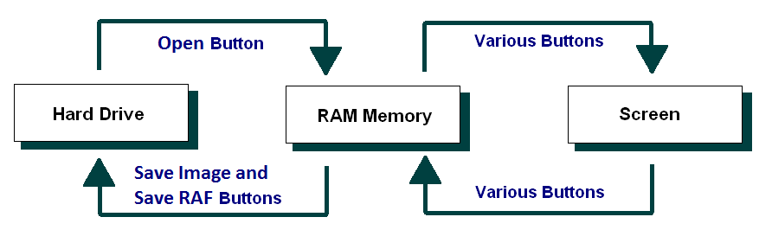

Selected Pseudo Code

PaintImage
Set width = panelWidth/countX
Set height = panelWidth/countY
For all entries in the stringArray[][], index are y,x
Set graphics.color = this entry
Fill rectangle located at (x*width, y*height) and set its width and height as above width and height
End For

SaveImage
Get a filename from a Save File Dialog
If filename.extension == csv, then: save the stringArray into *.csv file
Else if filename.extension == txt, then: save the stringArray into *.txt file
Else if filename.extension == abc, then: save the stringArray into *.abc file
Else if filename.extension == raf, then: save the stringArray into *.raf file

SaveRAF
Get a filename from a Save File Dialog
if filename.extension == raf, then: save the stringArray into *.raf file

Open
Get a filename from a Open File Dialog
If filename.extension == csv, then: read the stringArray from *.csv file
Else if filename.extension == txt, then: read the stringArray from *.txt file
Else if filename.extension == abc, then: read the stringArray from *.abc file
Else if filename.extension == raf, then: read the stringArray from *.raf file

Rotate
Create copy of stringArray call tempStringArray
For all entries in stringArray[][], index are y,x
Set stringArray[x][countY-1-y] = tempStringArray[y][x]
End for
PaintImage

Flip Horizontally
Create copy of stringArray call tempStringArray
For all entries in stringArray[][], index are y,x
Set stringArray[y][x] = tempStringArray[y][countX-1-x]
End for
PaintImage

Flip Vertically
Create copy of stringArray call tempStringArray
For all entries in stringArray[][], index are y,x
Set stringArray[y][x] = tempStringArray[countY-1-x][x]
End for
PaintImage

Clear
For all entries in stringArray
Set this entry = ‘W’
End for
PaintImage

Exit
Write the Person list data to the data file
Quit the program

Class diagram
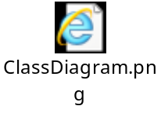

Debugging:
Check the rotate function:
Track the stringArray

Before rotate:
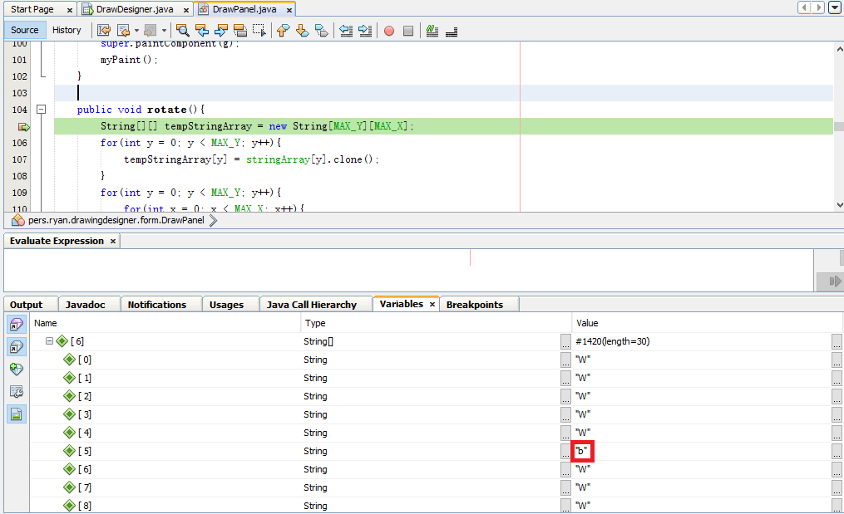

Only stringArray [6][5] = “b”, other items = “W”.

After rotate:
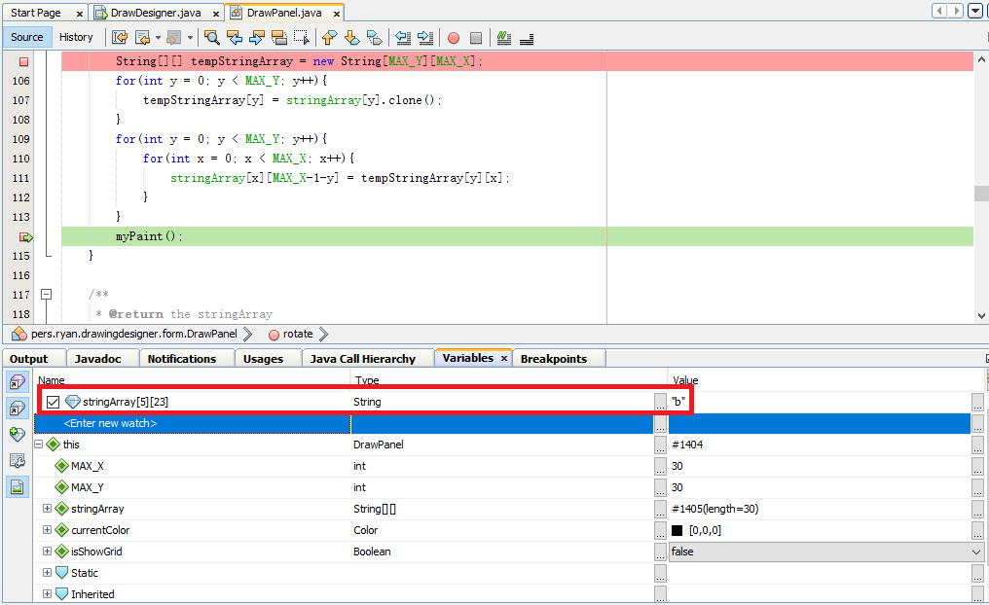

As expected, stringArray [5][23] = “b”, other items = “W”.
Check the flip horizontally function:
Track the stringArray
Before flip:
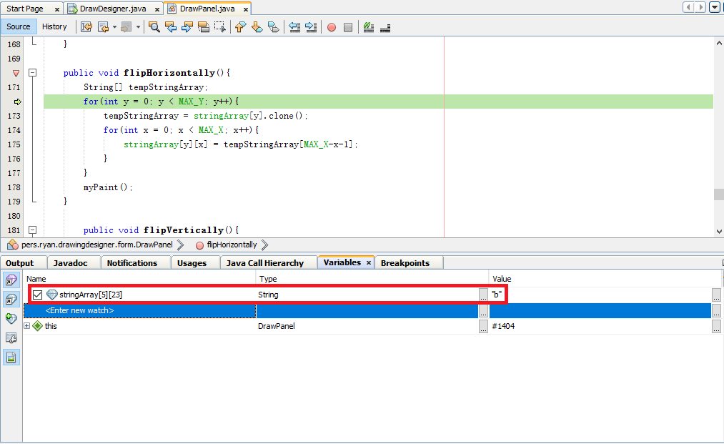
Only stringArray [5][23] = “b”, other items = “W”.

After flip:
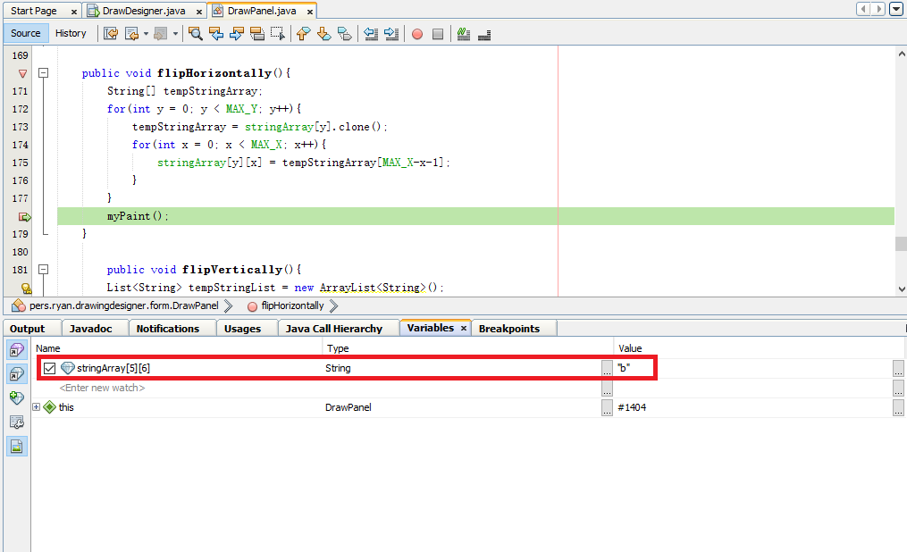
As expected stringArray [5][6] = “b”, other items = “W”.
Check the flip horizontally function:
Track the stringArray
Before flip:
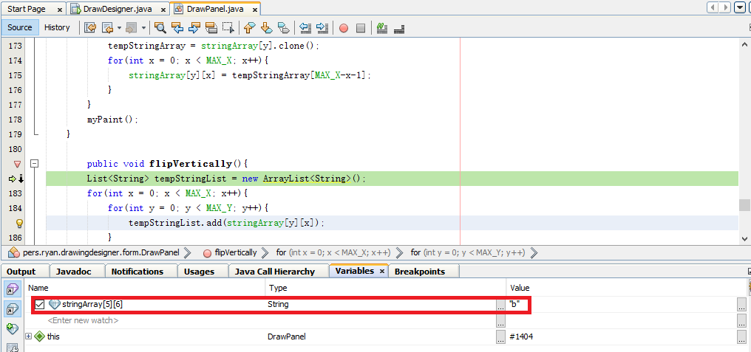
Only stringArray [5][6] = “b”, other items = “W”.

After flip:
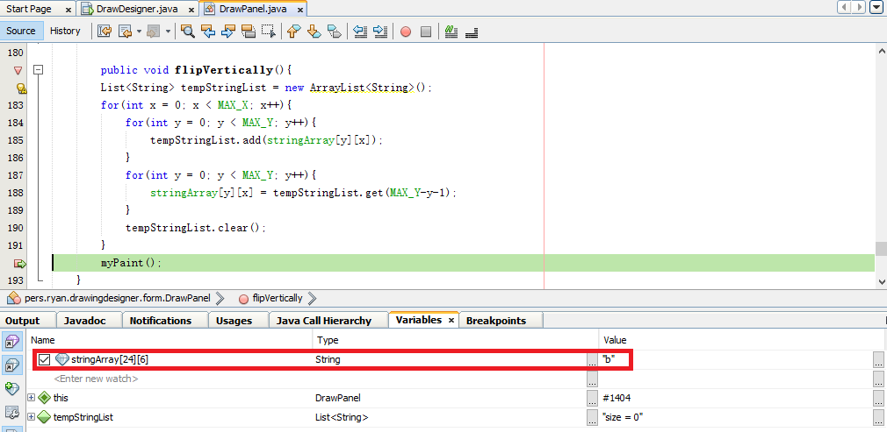
As expected stringArray [24][6] = “b”, other items = “W”.

Appendix B - Stylised Representation of the Flow of Data

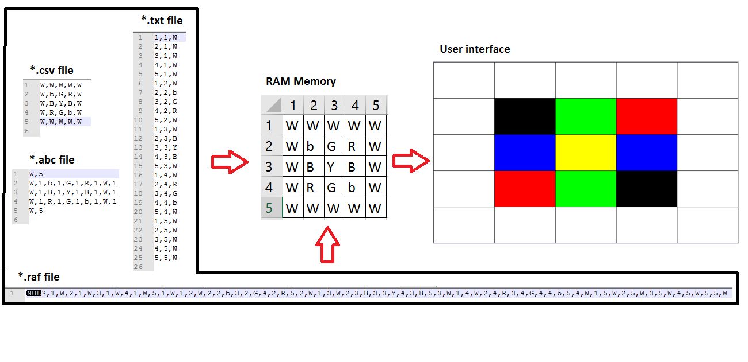

User Manual for: Draw Designer
Prepared for: Sample Business/Organisation
Author: Zhiyi Zeng
Date Prepared: 18/05/2016

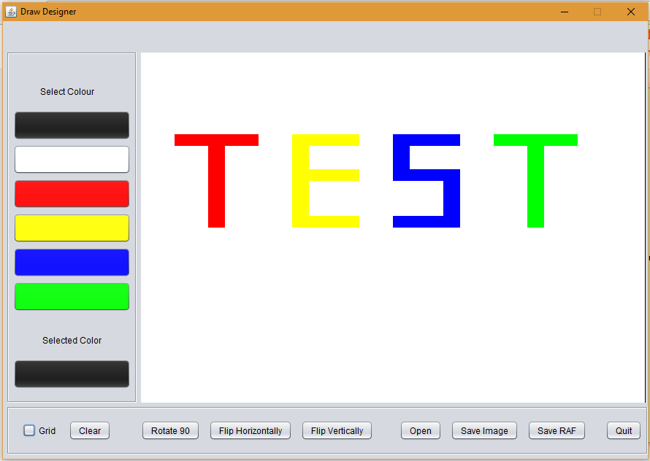 | Features by Component/Button  Screen opens: Initialize image to blank  Colours buttons: Set current colour correspondingly  Grid checkbox: Display and remove grid on image  Clear button: Clear image  Rotate 90 button:  Rotate the image 90 degreed clockwise  Flip Horizontally button:  Flip the image horizontally  Flip Vertically button:  Flip the image vertically  Open button: Load the image from a file  Save Image button:  Save the current image to a file (*.csv, *.txt or *.abc)  Save RAF button:  Save the current image to a file (*.raf)  Quit button: Close the program

How Do I?  Draw a picture  - Click one of the colour button except for the white one  - Click on the draw panel | How Do I?  Show/hide grid on draw panel  - Tick/untick Grid Checkbox
How Do I?  Open a saved image  - Click Open button  - Select the file | How Do I?  Save the image you draw  - Click Save Image button or Save RAF button  - Choose file type  - Locate the file

