Assignment 1 – Intro Java
(Birthdate Tracker)

Student: Zhiyi Zeng
Date: 16/04/2017
Unit: ICTPRG418
Teacher: Mark O’Reilly

IPO Chart

Input | Process | Output | Storage
- Properties file  - ‘Person’ (entries) from the data file:  - id  - name  - likes  - dislikes  - DOB | - Retrieve last open file path from properties file  - Retrieve the file stream  - Read all of the entries and save them to RAM memory | - Show all entries on screen | - CSV file contains all entries  - Entry list in RAM memory
- New button  - Input info  - name  - likes  - dislikes  - DOB  - Save button | - Pop up a message tell user input valid data  - Clear the text boxes for new data to be entered  - Retrieve Information entered  - Add the record to entry list | - New entry:  - id  - name  - likes  - dislikes  - DOB  - Show all entries on screen | - Update entry list in RAM  - Update CSV file
- Input info  - name  - likes  - dislikes  - DOB  - Update button | - Retrieve Information entered  - Change the properties of the entry in entry list | - Modified entry:  - id  - name  - likes  - dislikes  - DOB  - Show all entries on screen | - Update entry list in RAM  - Update CSV file
- Entry to be deleted selected  - Delete button | - Retrieve the entry was selected  - Delete the entry selected in entry list | - The remaining entries on screen | - Update entry list in RAM  - Update CSV file
- Search string  - Search all check box  - Search button | - Retrieve Search text and search all check box value  - Go through the entry list and find entries name which matches the search text | - Result entries of the search on screen | - Create a new entry list store search result
- Search string  - Search button | - Sort the entry list by name  - Retrieve Search text  - Go through the entry list and find entry which its name matches the search text | - Move the cursor to result
- Import button  - Open file dialog  - Data file selected | - Retrieve the file stream of the file was selected  - Read all of the entries and save them to RAM memory | - Show all entries on screen | - CSV file contains all entries  - Entry list in RAM memory
- Export button  - Save file dialog  - Data file selected | - Retrieve the file stream of the file was selected  - Read all of the entries and save them to RAM memory | - Export of all records to the file was selected | - CSV file contains all entries  - Entry list in RAM memory

TOE Chart
Task | Object | Event
Load last open csv file | Form | Open
Pop up new message box shows new entry entering rules | New button | Click
Save the current entry to data file and show all records | Save button | Click
Get back to main display mode | Back button | Click
Find the entry name contain the keyword | Search button | Click
Move cursor to entry name fully match the keyword | Binary Search button | Click
Update current entry details to data file | Update button | Click
Delete current entry in data file | Delete button | Click
Move cursor to the first entry | First (|<) button | Click
Move cursor to the previous entry | Previous (<) button | Click
Move cursor to the next entry | Next (>) button | Click
Move cursor to the last entry | Last (>|) button | Click
Close the program | Exit button | Click
Display entries which are in selected month | Month list item | Click
Pop up an open file dialog and load the data file selected | Import button | Click
Pop up a save file dialog and save the current entries to data file selected | Export button | Click

Stylised Data Flow
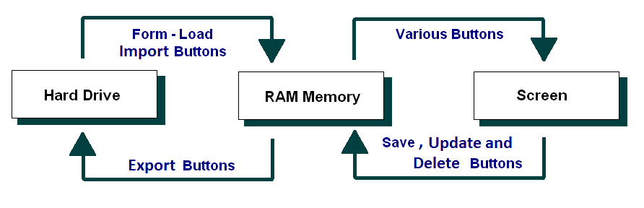

Selected Pseudo Code
DisplayRecord (CurrentRecord)

Copy the Name for the currentRecord to the Name text field
Copy the Like for the currentRecord to the Like text field
Copy the Dislike for the currentRecord to the Dislike text field
Copy the DOB for the currentRecord to the DOB text field

SaveRecord (CurrentRecord)

Copy the Name from the Name text field to the currentRecord of the Person list
Copy the Like from the Like text field to the currentRecord of the Person list
Copy the Dislike from the Dislike text field to the currentRecord of the Person list
Copy the DOB from the DOB text field to the currentRecord of the Person list

ReadFile

If there is an error, then go to the ErrorHandler

Open the data file ready for reading
Set counter = 0
While there is more data
Read in a line of data
Add the entry in Person list
End While
Close the data file

ErrorHandler:
Display the error message

WriteFile

Open the data file for writing data
For all entries in the list
Write a line of data into the data file
End For
Close the data file

First

Set the CurrentIndex = the first index (0 for Java) in the list
Call: DisplayRecord(CurrentRecord)

Last

Set the CurrentIndex = the last index of the list
Call: DisplayRecord(CurrentRecord)

Previous

If the CurrentIndex > first index (0 for Java), then:
Set the index = the index – 1
Else
set the CurrentIndex = first index (0 for Java)
Call: DisplayRecord(CurrentRecord)
End If

Next

If CurrentIndex < LenghOfRecords, then:
Set the CurrentIndex = the CurrentIndex + 1 in the list
Else
Set the CurrentIndex = the last index of the list
Call: DisplayRecord(CurrentRecord)
End If

New

Clear the text fields for the new record
Show Save and Back buttons

Save

Add the new record Person list
Shows original buttons again
DisplayRecord(CurrentRecord)

Exit

Write the Person list data to the data file
Quit the program

Delete

Delete remove item from list using CurrentIndex
DisplayRecord(CurrentRecord)

Search

For all entries in the list
If entry name contains key word
Add this entry to resultLsit
End if
End For
DisplayRecord(resultLsit)

Binary Search

Sort Person list
Using Binary Search to find the index of the entry which has a name equals to key word
DisplayRecord(list[index])

Import

Retrieve fileName using an OpenFileDialog
Call ReadFile method to load the file to RAM memory
DisplayRecord(list[index])

Export

Retrieve a fileName using a SaveFileDialog
Call WriteFile method to write the List<Person> from RAM memory to a file

Class diagram
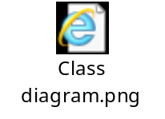

Debugging:
Check the Binary Search function:

Tracking the displayingPeople Array

Before click binary search button:
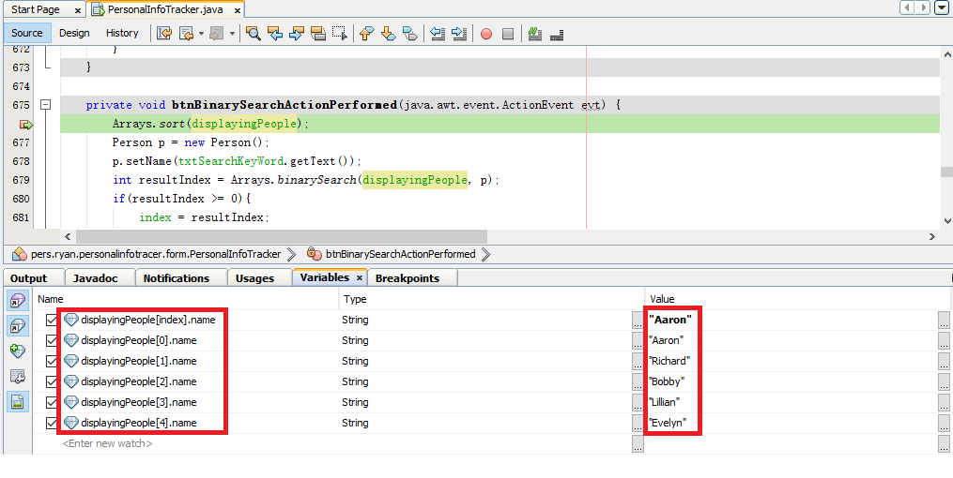

After click binary search button:
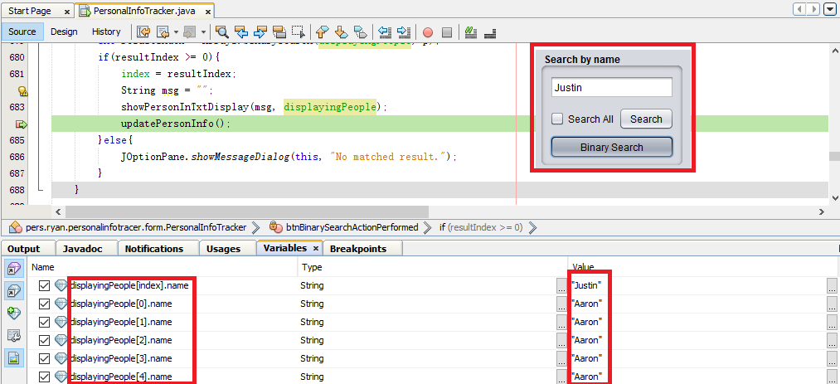

The array has been sorted and the result also matched the keyword.

Check the Find function:

Tracking the displaying entry

Before click Search button:
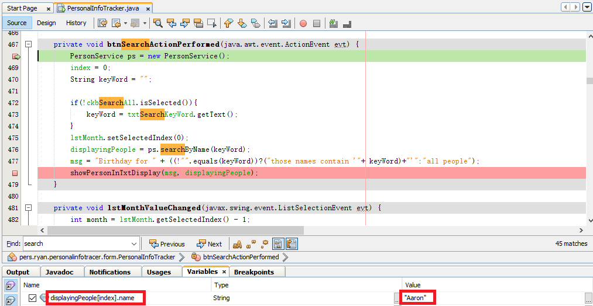

After click Search button:
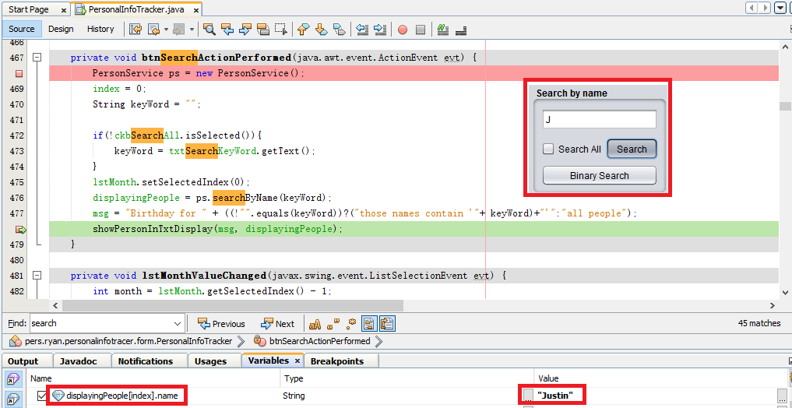

The entry displayed above matches the keyword typed in by user input.

Check the New function:

Tracking the displayingPeople Array and new entry.

Before click New button:

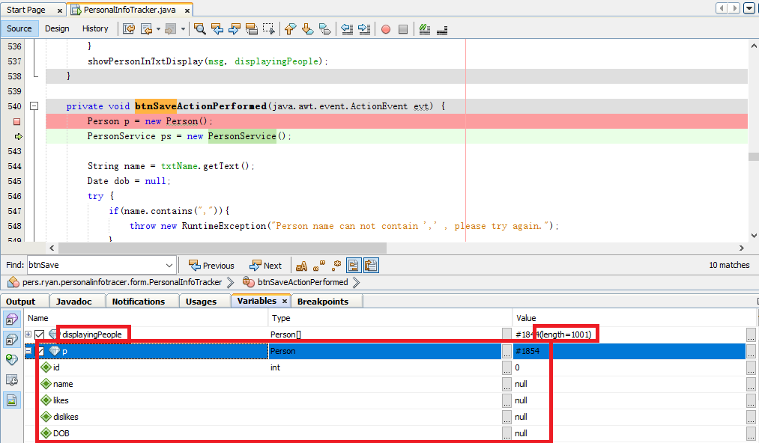

After click New button:
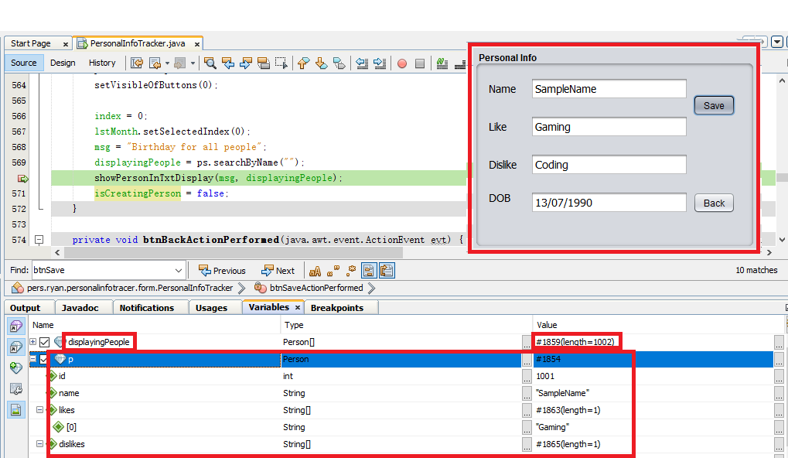

The new entry properties above match those texts typed in by user input.

Appendix B - Stylised Representation of the Flow of Data

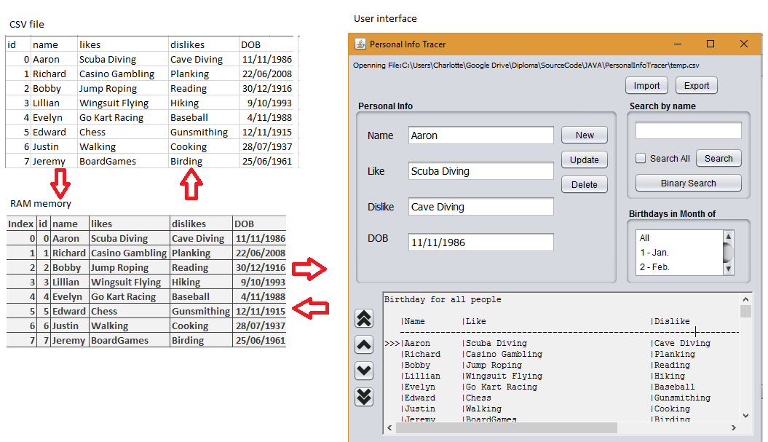

User Manual for: Personal Info Tracker
Prepared for: Sample Business/Organisation
Author: Zhiyi Zeng
Date Prepared: 16/04/2016

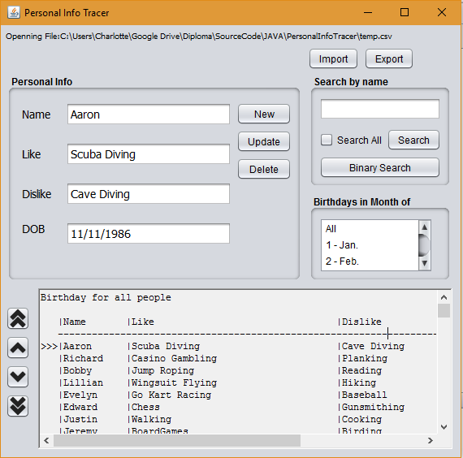 | Features by Component/Button  Screen opens: Load last open file records  New button: Clear screen ready for new entry  Save button: Save the current entry to current data file  Search button: Use in conjunction with the Search text box to find an existing entry name contains key word  Binary Search button:  Use in conjunction with the Search text box to find an existing entry name contains key word  Update button: Update current selected entry details in current data file  Delete button: Delete current selected entry in current data file  Month list: Display entries which are in selected month  Import button: Pop up an open file dialog and load the data file selected  Export button: Pop up a save file dialog and save the current entries to data file selected
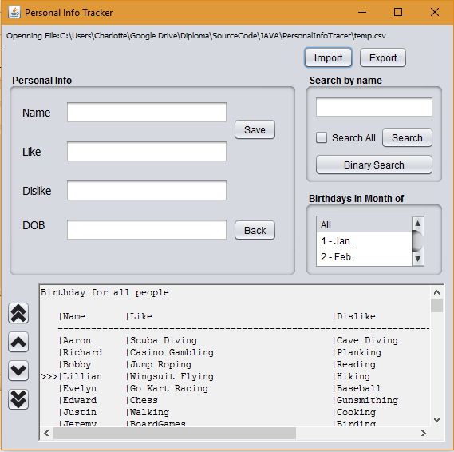 | How Do I?  Create a New Entry  - Click New button  - Type all new details  - Click Save button
How Do I?

Select an Existing Entry

- Type Person Name
- Click on the Search button
- Use navigation button to select the entry you want

How Do I?  Delete an Existing Entry  - Select an entry you want to update  - Click on the delete button to delete the entry | How Do I?  Update an Existing Entry  - Select an entry you want to update  - Edit the entry as required  - Click on the Update button to save the entry

