Assignment 2
– Quick Quiz by Network

Student: Zhiyi Zeng
Date: 06/10/2017
Unit: ICTPRG523
Teacher: Mark O’Reilly

IPO Chart

Input | Process | Output | Storage
Click on the question | Get the ID of the selected question  Find the selected question by ID from database  Pass selected question details to respective controls | Question detail shows on screen | A space is created in RAM memory to store the data of question details
Click on Submit button | Assemble json object with question id, student name and answer  Send json object to server  Compare the answer to correct answer  Show result pop up window | Result of answer | A space is created in RAM memory to store the window pop on the screen
Answers from clients | Convert the massage to json object  Get the answer  Compare the answer to correct answer to determine if the answer is correct  Increase the count of the question if the answer is incorrect | Linked list shows how many students answered incorrect answers | Linked list is updated
Click on Sort button | - Sort question list in RAM memory  - Show the question list in table again | Sorted question table | Question list is updated
Runs the program | Load database properties  Get connection  Send query to database to find all questions  Store questions in a list  Show them in question table | Questions show in question table | Question list is created in RAM memory
Click on Send button | Assemble json object by question detail  Send json object to clients  Show how many clients has been sent  Insert the sent question to linked list and binary list | Question detail shows on client’s interface | Update stringArray property in drawPanel in RAM memory

TOE Chart
Task | Object | Event
Initialize the interface and display questions in question table | Form | Open
Display question detail | Question row | Click
Submit answer, question id and student name to server and shows the result | Submit button | Click
Sort the question list | Sort button | Click
Linked list shows how many students answered incorrect answers | Form | Timer trigger
Send question to client | Send button | Click
Show binary tree in different orders | Display button | Click

Stylised Data Flow
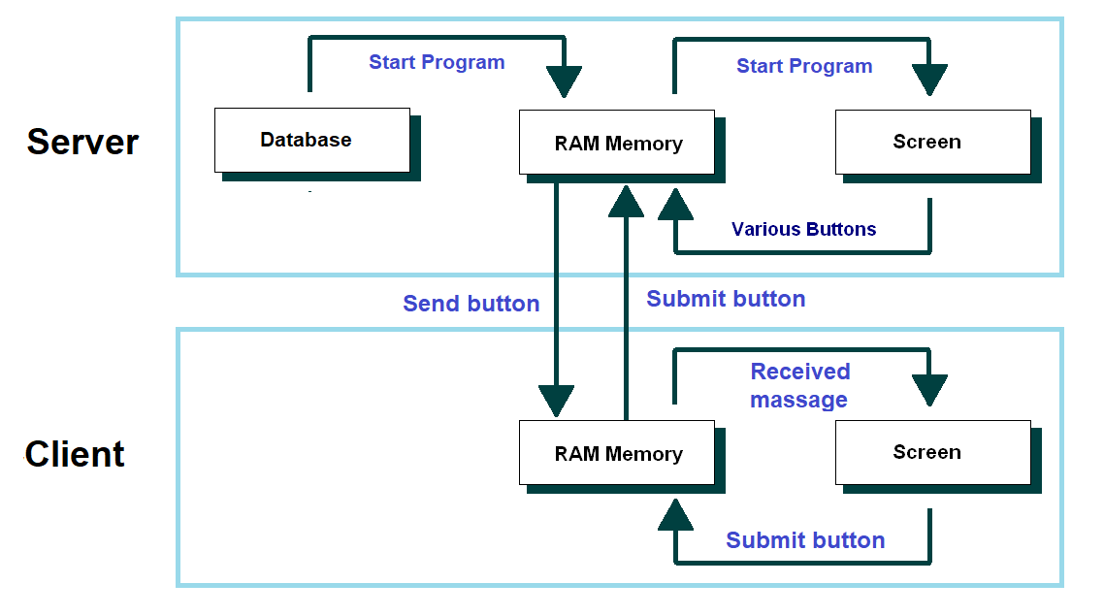

Selected Pseudo Code

Send Question
Get selectedQuestion
Convert selectedQuestion to selectedQuestionJson
For client in clients
Send selectedQuestionJson to client
End For
Submit Answer
Get selectedAnswer
Get studentName
Get questionID
Assemble AnswerJson with selectedAnswer, stuentName and questionID
send answerJson to server
Receive Answer
Get answerJson
Analyse answerJson and convert to selectedAnswer, stuentName and questionID
if selectedAnswer equals to correctAnswer then
incorrectCount ++
End if

Class diagram
Server | 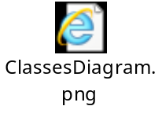
Client | 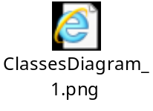

Debugging:
Track jsonString:

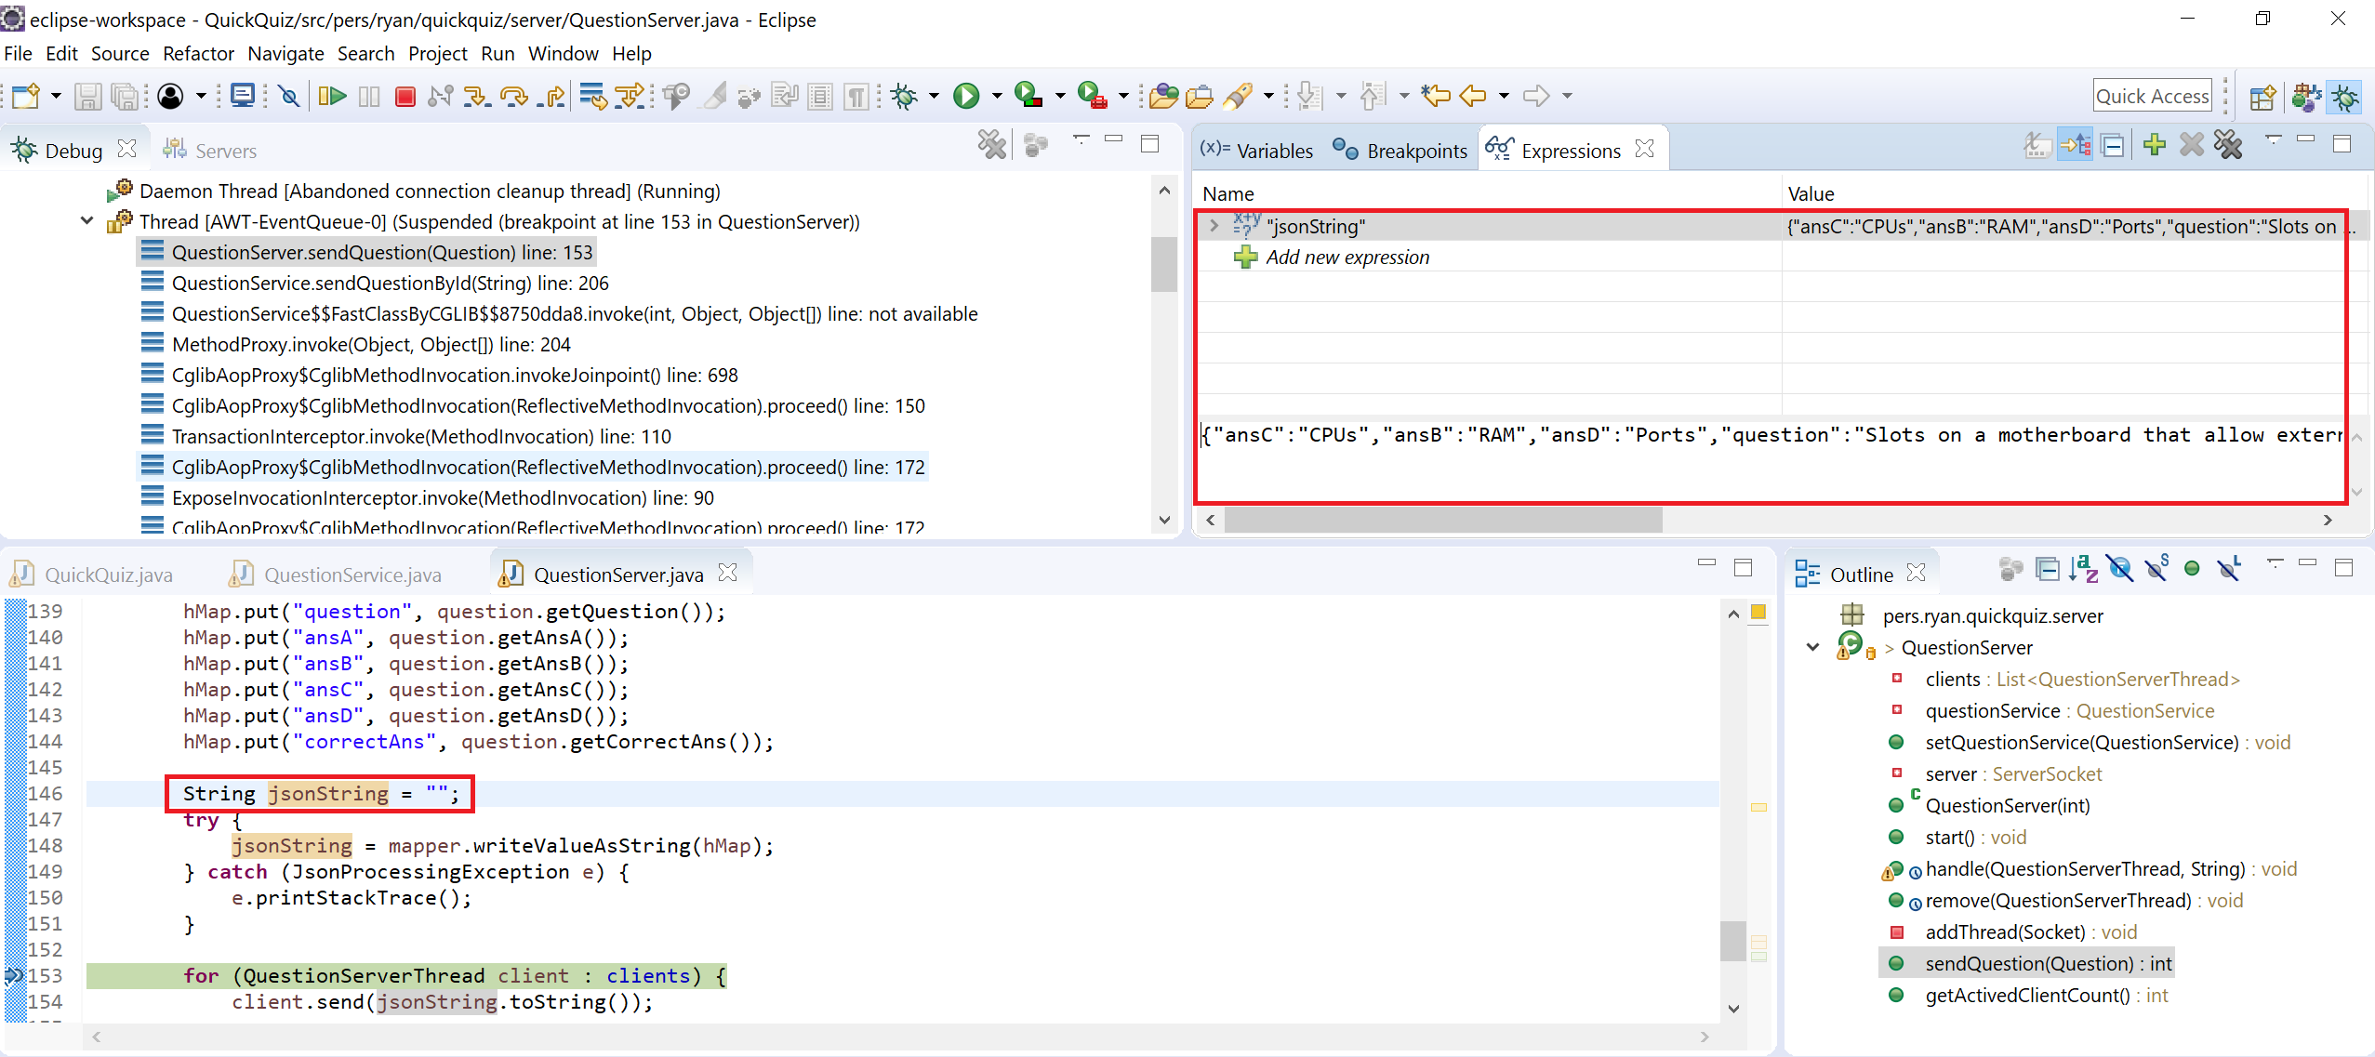

jsonString value:
{"ansC":"CPUs","ansB":"RAM","ansD":"Ports","question":"Slots on a motherboard that allow external devices to be connected are called:","ansA":"IP Addresses","topic":"Networking","ID":"a0c258c834304f38a0426ca307d62f7b","correctAns":"D"}

Value format is as expected.
Check questions list get from database:
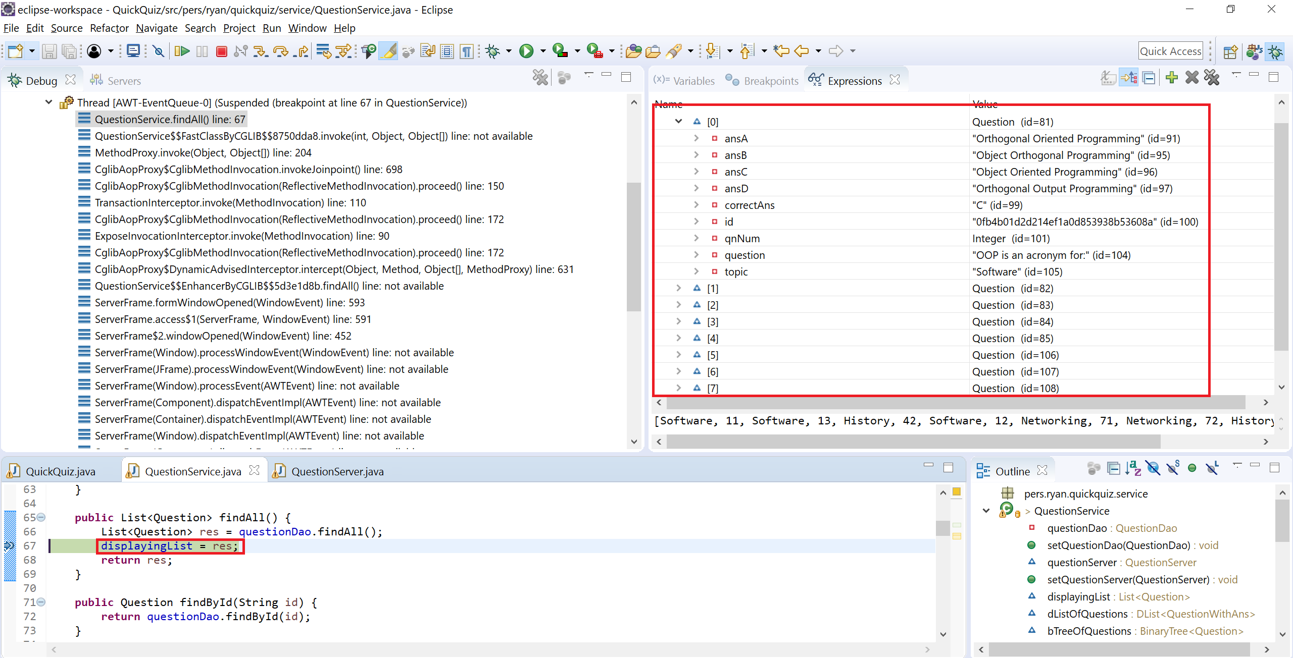

Got 8 questions from database and values are all as expected.
Check answer from client:
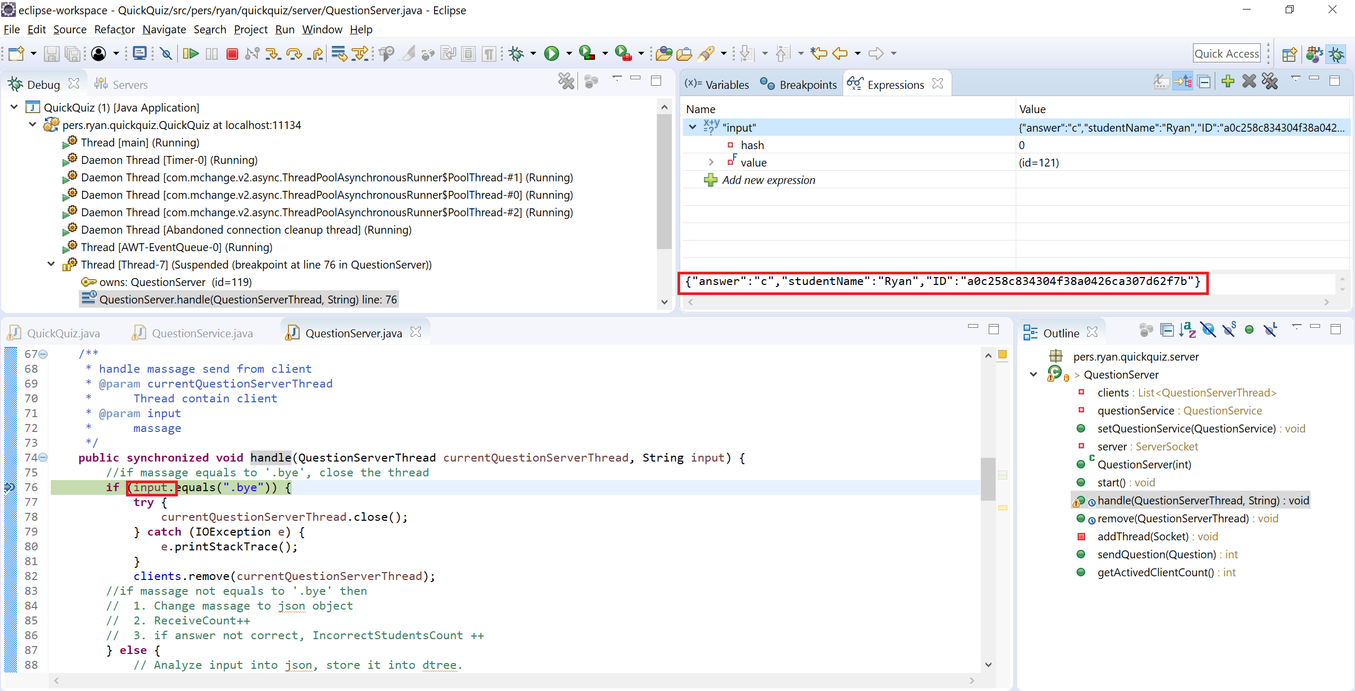

As expected, value contains answer, studentName and questionID.

Appendix B - Stylised Representation of the Flow of Data

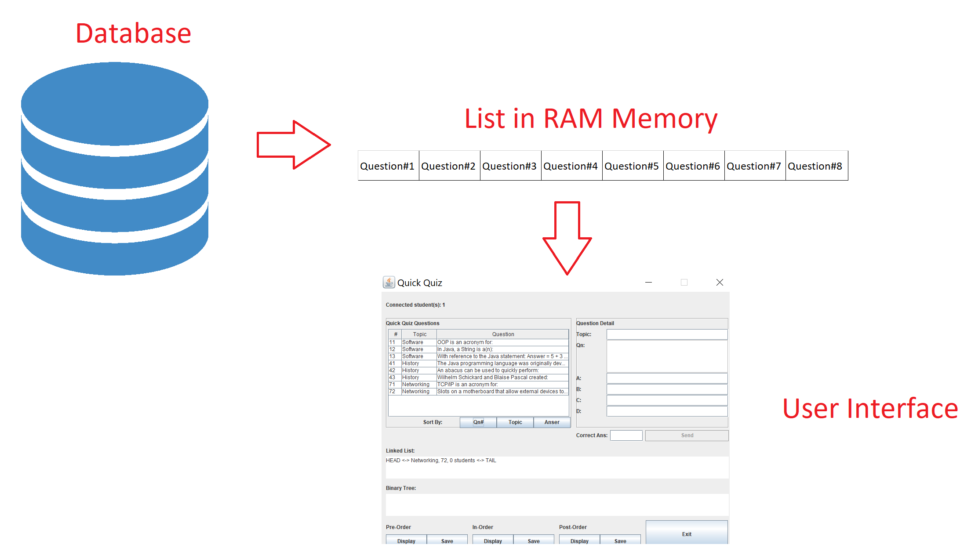

User Manual for: Draw Designer
Prepared for: Sample Business/Organisation
Author: Zhiyi ZENG
Date Prepared: 30/10/2017

Teacher-side
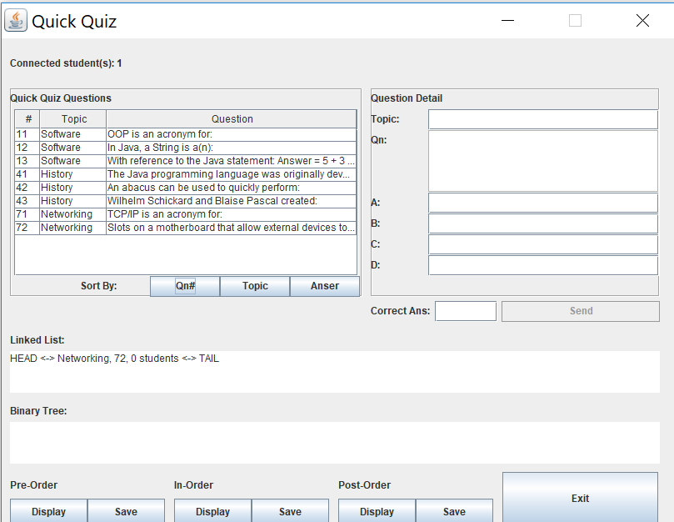 | Features by Component/Button  Sort buttons: Sort questions by question number, topic and answer.  Send button: Send selected question to all connected student-side.  Display buttons: Display binary tree in different traverse order.  Save buttons: Save binary tree into a file.  Exit button: Close the program

How Do I?  Send a question to all students:  - Click the question which you want to send out in table.  - Click send button | How Do I?  Check how many students submit a wrong answer  - Check values in linked list.
How Do I?

Save binary tree into a file

- Click one of those save buttons
- Select a path of the file you want to save

Student-side
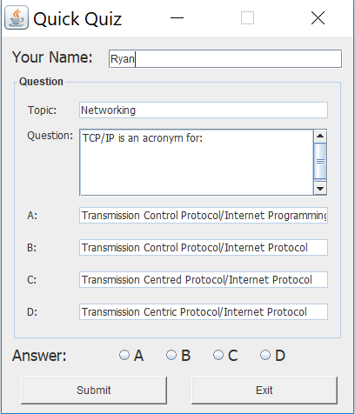 | Features by Component/Button  Answer radio buttons:  Choose your answer.  Submit buttons:  Submit your answer to teacher-side.  Exit button: Close the program

How Do I?  Receive a question:  - Nothing but wait until teacher send out a question. | How Do I?  Submit my answer:  - Fill in your name  - Choose your answer by click on radio buttons.  - Click Submit button.

