COMP-4478 – Game Programming Assignment 2

Ryan Vickers

Student #: 1111810

**Unity Version:** 2021.2.19f1

**GitHub:** <https://github.com/RyanVickers/COMP4478-Assignment-2>

**Programming:**The memory game is designed with a main image script and object that represents a single card. When the game is started, the game controller script generates a 4x4 grid of main image objects that have a front and back face. The images are randomized and there is a corresponding pair for each card to ensure a matching game. Users can click on each card object to reveal the image using the button script. The game then allows the user to flip another card and checks if it’s a pair. If the pair matches the score is updated, and the cards remain open. If the pair does not match the cards flip back over. Once all cards are flipped the game ends and a reset button scene is displayed.

**Initializing project**: Unity will install library and other necessary folders, make sure to click on main scene to start that scene.

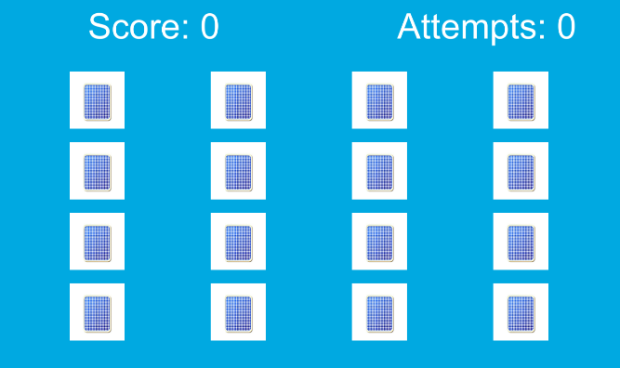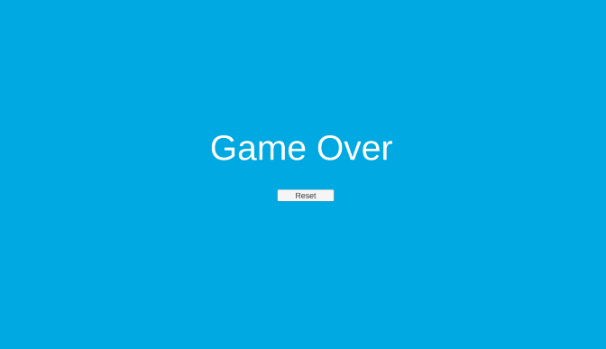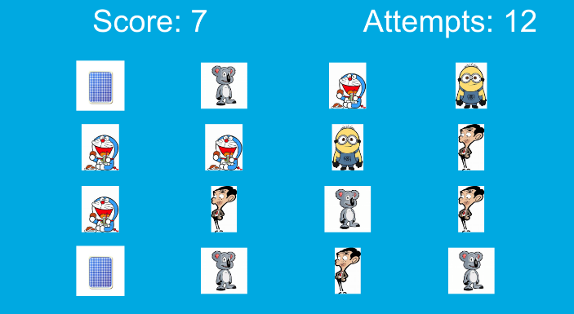

Figure 3 Game Over Scene

Figure 2 Gameplay with flipped over cards and score

Figure 1 Start of game with all card’s backs