Shaker Von Price Funkhouser

Gregory Gonzales

Ryan Westerhoff

CST363

Final Project: Private Eye Agency

Summary:

Our database is designed for use by a private investigation agency. This agency has many clients and employs many investigators, each of which can gather many pieces of evidence against many suspects for each case (see assumptions below). The SUS_LINE table allows our database to be in 3N: it reduces the many-to-many relationships that would exist among the case, suspect and evidence tables.

Practically speaking, the agency can use this database to log the evidence the investigator gathers for every case and to log the suspects that the investigator encounters. Based on the conclusivity of a piece of evidence that implicates a suspect, the agency has the capability to change the “status” of a suspect (by using the SQL update command on a particular suspect). If the evidence is overwhelmingly incriminating, the agency can change the suspect’s status to “guilty”; if the evidence overwhelmingly vindicates a suspect, the agency can change the suspect’s status to “innocent.”

If a client wishes to hire an investigator, the client must give their first name, last name, and phone number so that it can be documented in the database. The client must also give the first name, last name, and occupation of an initial suspect- an investigation must begin with a suspect (no null value can be supplied, and there is only one initial row in the SUS_LINE table), and through the course of an investigation, the investigator may need to add suspects and evidence to the case via SUS_LINE. To facilitate data entry, the receptionist interacting with this database will be **prompted** to supply all of this information (with an SQL prompt). As for **referential integrity**, every table in this database has a primary key that uniquely identifies each row; all attributes in these tables are functionally dependent on the primary key in each table; all foreign keys refer to the primary keys of other tables; there are no many-to-many relationships; there are no multi-valued attributes in any tables, which puts every table at least in 1NF; there are no partial dependencies in any tables, which puts every table in 2NF; there are no transitive dependencies in any tables, which puts every table in **3NF**.

**ER Diagram in 3NF (Click the picture for a link to expand):**

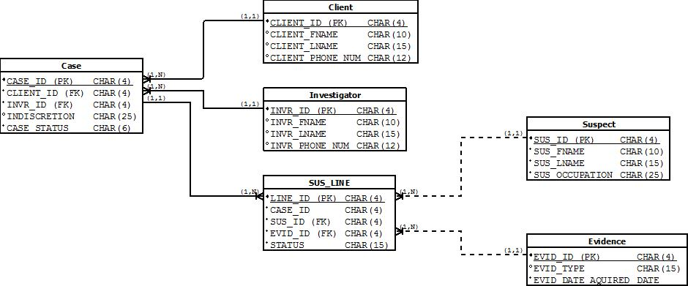

**Assumptions:**

1. A case cannot exist without a client and investigator.
2. A client cannot exist without a case.
3. A suspect cannot exist without evidence and a case.
4. Evidence cannot exist without a case and suspect.
5. One case may only have only one investigator, and one client.
6. One investigator can be assigned to many cases.
7. One client can have many cases.
8. One suspect may be involved with many cases.
9. One piece of evidence may be involved with many cases.
10. One piece of evidence may be involved with many suspects.

**File Descriptions:**

**createTables.sql:** Drops any pre-existing tables for the database, sets up all database entities, drops any pre-existing sequences for the database, and initializes all sequences for the database.

**Init.sql:** Populates entities with default values.

**addInvestigator.sql:** Allows the user to enter a new investigator.

**addClient.sql:** Allows the user to enter a new client, add their case, and assign an investigator.

**addCase.sql:** Allows the user to enter a new case for an existing client.

**addSuspect.sql:** Allows the user to enter a new suspect and evidence for a case.

**addEvidence.sql:** Allows the user to enter new evidence for an existing suspect and case.

**assignSuspect.sql:** Allows the user to assign an existing suspect to a new case, and enter the evidence.

**updateCase:** Allows the user to update a case’s status (i.e. from open to closed).

**updateClient:** Allows the user to update a client’s record.

**updateInvestigator**: Allows the user to update an investigator’s record.

**updateSusLine:** Allows the user to update a suspect’s status (i.e. from investigating to convicted).

**updateSuspect:** Allows the user update a suspect’s record.

**testPI.sql:** Runs all the above scripts to test the database, and sets all column formatting.