Test report

MathWorks

Test report:
by MathWorks
Published 30-Jan-2013 05:10:35

Table of Contents
1. Model information 1
2. Test cases: Test Case 1 2
Result : Pass 6

Chapter 1. Model information
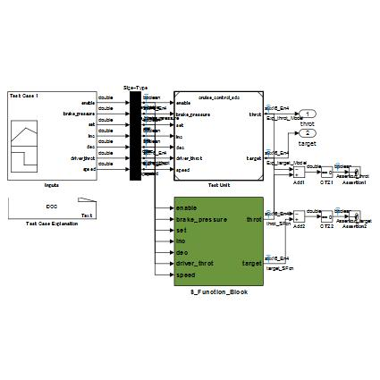

Chapter 2. Test cases: Test Case 1
Input Signals
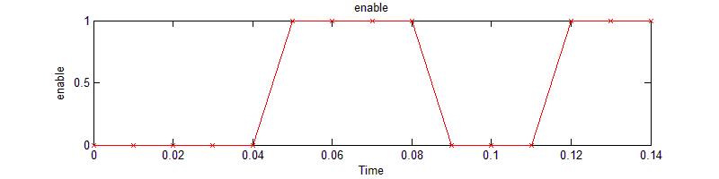

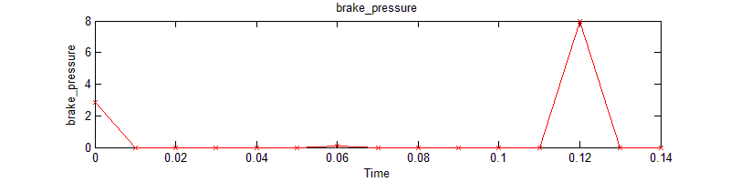

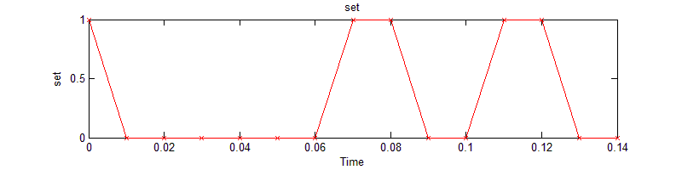

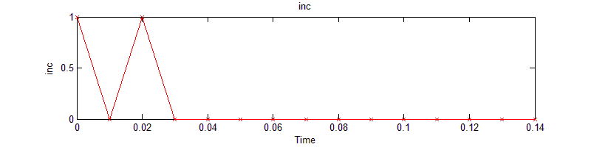

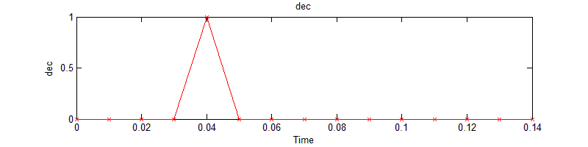

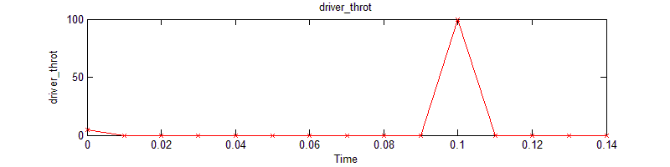

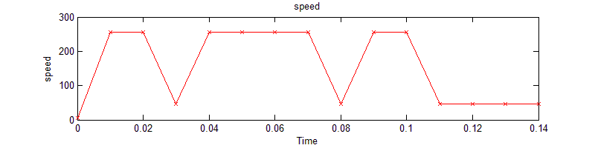
Output Signals
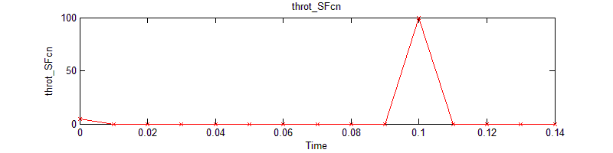

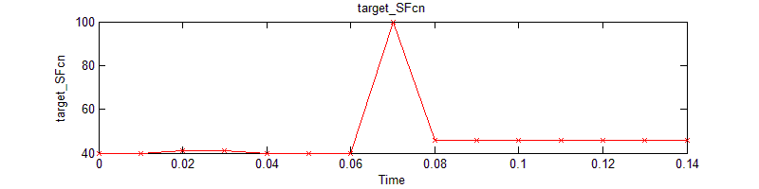
Expected output Signals
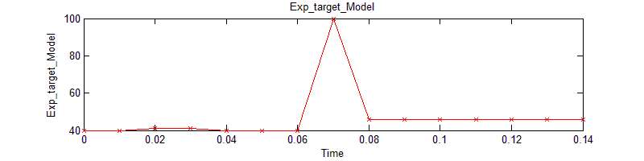

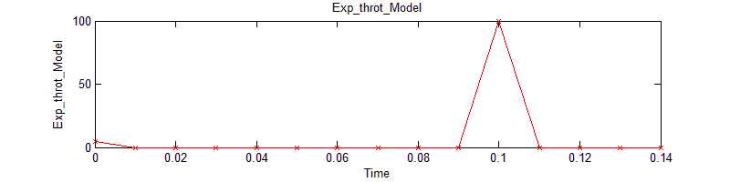

Assertion Signals
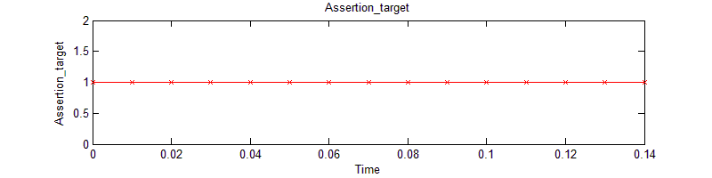
Results of comparizon with expected outputs: Pass
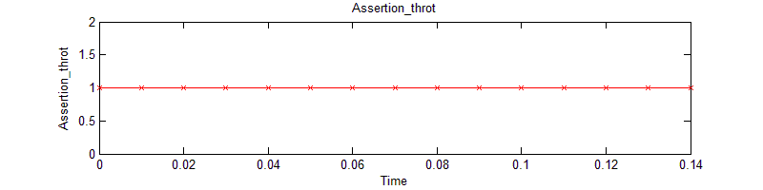
Results of comparizon with expected outputs: Pass

Result : Pass
Results Pass

