Contents

Setup 2

Running the Model 2

Abbreviations 3

## Setup

* Open the Simulink Project in by double clicking it. This will setup the paths and environment variables.
* Open the model *Models > Step0_CompleteModel > DisplayModel.slx*

## Running the Model

* Select APU Master button in Start Switches Panel
* Select APU Start button in Start Switches Panel
* Select Engine Master button in Start Switches Panel
* Select Engine Start button in Start Switches Panel
* Select other buttons on EFIS panel to see page changes (page title changes) and additional information on the Navigation Display
* Select other buttons on ECAM panel to see page changes (page title changes) on the System Display
* Select checkboxes in the Faults section to inject faults into the system and see the warnings change on the Engine Display along with page changes on the System Display

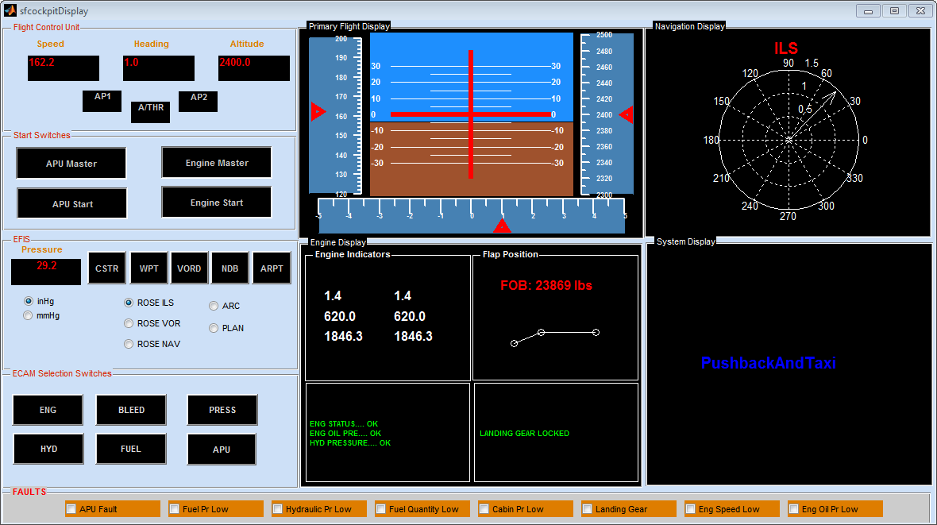

## Abbreviations

APU: Auxiliary Power Unit

CSTR: Constraints

WPT: Waypoints

VORD: VHF Omnidirectional Range navigation system

NDB: Non-directional beacon

ARPT: Airports

ENG: Engine

BLEED: Air bleed

PRESS: Pressure

HYD: Hydraulics

ILS: Instrument Landing System

NAV: Navigation

FOB: Fuel on-board