# Section 7 - Comparison of Results for Nonsense Sentences: Mistral vs. Qwen2

## Reasoning Comparison

**Sentence:** "After the rain, Sarah fnpe her umbrella before leaving the office."

* **Mistral Output:**
  + Focuses on Sarah's use of an umbrella for protection from rain and the sequence of her actions.
  + Emphasizes practicality: Sarah takes the umbrella because it rained, ensuring she's prepared for wet conditions.
* **Qwen2 Output:**
  + Highlights common practices and Sarah’s awareness of weather conditions.
  + Provides broader reasoning, including potential scenarios and the practicality of carrying an umbrella even after the rain stops.

**Comparison:**

* Both models reason similarly about the necessity of the umbrella after rain.
* Qwen2 explores additional hypothetical scenarios, while Mistral remains concise and context specific.

**Sentence:** "Kzak the rain, Sarah grabbed her wxluik before leaving the office."

* **Mistral Output:**
  + Assumes "kzak" refers to rain and "wxluik" as protective gear.
  + Focuses on Sarah’s response to the rainy condition and her.
* **Qwen2 Output:**
  + Adds linguistic reasoning by interpreting "kzak" as an action linked to rain.
  + Includes insights into Sarah’s proactive planning based on expected rain​.

**Comparison:**

* Both models infer "wxluik" as rain gear, but Qwen2 delves deeper into the linguistic interpretation of nonsense words.

**Sentence:** "After the rain, Sarah ntaltk her umbrella before gkiweh the office."

* **Mistral Output:**
  + Interprets "ntaltk" as leaving the umbrella behind.
  + Suggests a logical sequence: Sarah uses the umbrella during the rain, then stores it safely.
* **Qwen2 Output:**
  + Links Sarah’s action to a habit of preparation for future rain.
  + Suggests strategic thinking about the weather and her commute.

**Comparison:**

* Mistral keeps reasoning within immediate context, while Qwen2 incorporates forward-looking scenarios and habitual patterns.

**Sentence:** "After the onmxba, wyesm ocuoug her xqbnx before tvegke the office."

* **Mistral Output:**
  + Struggles with nonsensical terms but attempts to reverse phrases and deduce their meaning​.
* **Qwen2 Output:**
  + Focuses on temporal relationships and sequence determination, attempting to interpret the nonsensical terms based on context​.

**Comparison:**

* Both models encounter difficulty due to high ambiguity. Qwen2 provides a more structured sequence analysis, while Mistral attempts novel approaches like reversing terms.

**Sentence:** "After the rain, Sarah grabbed her umbrella mmrac jkfv the office."

* **Mistral Output:**
  + Focuses on the practical reasoning: Sarah grabs her umbrella for protection against wet conditions​.
* **Qwen2 Output:**
  + Adds layers of habitual behaviour and environmental cues, interpreting Sarah’s actions as reflexive based on past experiences with rain​.

**Comparison:**

* Both models align on the core reasoning but diverge in depth. Qwen2 includes speculative reasoning about habits, while Mistral sticks to immediate context.

## Observations

1. **Handling of Nonsense Words:**
   * Both models reasonably infer meaning when nonsense words replace known terms.
   * Qwen2 often includes speculative reasoning and attempts linguistic interpretation.
2. **Reasoning Depth:**
   * Mistral is concise and context specific.
   * Qwen2 tends to explore broader scenarios, incorporating hypothetical or habitual considerations.
3. **Sentence Complexity:**
   * Both models handle simpler nonsensical sentences well but struggle with highly ambiguous sentences (e.g., "onmxba, wyesm ocuoug").

## Preferred Model:

* For direct, concise reasoning: Use Mistral.
* For speculative insights or linguistic interpretation: Use Qwen2.

# Section 8 – Handling Ambiguity

## Propose Prompts to Understand the Meaning a Language Model Selects

**General Prompt:**

* "What does the sentence 'The chicken is ready to eat' mean?"

**Disambiguating Prompts:**

1. "Does the sentence 'The chicken is ready to eat' mean the chicken is a meal or that it is about to eat something?"
2. "Explain the possible meanings of the sentence 'The chicken is ready to eat.' Which one is most likely?"

## Apply the Prompts, Compare and Explain the Results

### Comparison of Results

**Prompt:** "What does the sentence 'The chicken is ready to eat' mean?"

1. **Mistral Output:**
   * Interprets the sentence as the chicken being fully cooked and suitable for consumption.
   * Notes that the preparation stage is complete, but there’s no specific mention of who is consuming the chicken​.
2. **Qwen2 Output:**
   * Similar interpretation: the chicken is cooked and ready for eating.
   * Explores additional nuances, like instructions to others (e.g., “You can now serve the chicken”) or implying readiness to start eating​.

**Comparison:**

* Both models prioritize the literal interpretation (prepared food).
* Qwen2 provides more detail about contexts where the phrase might be used, such as serving instructions or responding to readiness questions.

**Prompt:** "Does the sentence 'The chicken is ready to eat' mean the chicken is a meal or that it is about to eat something?"

1. **Mistral Output:**
   * Acknowledges two possible interpretations:
     1. The chicken has been cooked and is a meal.
     2. The chicken (as an animal) is ready to eat something.
   * Suggests ambiguity can be avoided with clearer phrasing like “The chicken is ready to be eaten” or “The chicken is about to eat”​.
2. **Qwen2 Output:**
   * Strongly emphasizes the interpretation that the chicken is a prepared meal.
   * Dismisses the alternative interpretation (live chicken eating) as unlikely without metaphorical context, citing the difference in how humans and chickens consume food​.

**Comparison:**

* Mistral provides a balanced view, presenting both interpretations as valid depending on context.
* Qwen2 dismisses the live chicken interpretation as less plausible, focusing on the food-related meaning.

**Prompt:** "Explain the possible meanings of the sentence 'The chicken is ready to eat.' Which one is most likely?"

1. **Mistral Output:**
   * Identifies two interpretations:
     1. Literal: The chicken is cooked and ready to eat.
     2. Figurative: Someone or something is metaphorically “ready to eat” (e.g., facing a challenge).
   * Concludes that the literal meaning is more common and likely​.
2. **Qwen2 Output:**
   * Provides four possible meanings:
     1. Cooked chicken is ready to eat.
     2. A live chicken is biologically mature for certain purposes.
     3. Chicken in a retail context is available for purchase.
     4. The chicken has been seasoned and is ready for further cooking.
   * Concludes the most likely interpretation is the cooked chicken is ready for eating​.

**Comparison:**

* Mistral keeps the analysis simple, focusing on literal vs. figurative meanings.
* Qwen2 expands the scope to include biological, retail, and culinary preparation contexts, offering a broader range of possibilities.

## Observations

1. **Ambiguity Recognition:**
   * Mistral acknowledges ambiguity in its responses, often suggesting clearer phrasing to resolve it.
   * Qwen2 is more confident in its preferred interpretation but provides a broader range of possible meanings when prompted.
2. **Context Sensitivity:**
   * Both models rely heavily on the literal interpretation of the sentence unless explicitly asked to consider alternative meanings.
   * Qwen2’s broader scope shows a slight advantage in flexibility, offering interpretations beyond the immediate food context.
3. **Depth of Reasoning**:
   * Mistral is concise and focused on the most probable meanings.
   * Qwen2 provides more detailed and context-rich explanations, sometimes at the cost of brevity.

## Propose Another Ambiguity

**The Sentence:**

“She saw the man with a telescope”

**Overview of Ambiguity:**

The sentence “She saw the man with a telescope” can be interpreted in two ways:

* + 1. She used a telescope to see the man.
    2. The man had a telescope.

**General Prompt:**

* "What does the sentence 'She saw the man with a telescope' mean?"

**Disambiguating Prompts:**

* "Who has the telescope in the sentence 'She saw the man with a telescope'?"
* "Does 'with a telescope' describe how she saw the man or describe the man?"

### Model Comparisons

1. **Mistral**:
   * Suggests the telescope belongs to the man when interpreting the general meaning.
   * Acknowledges ambiguity and provides cautious interpretations.
   * Agrees that "with a telescope" describes the method of observation when directly asked.
2. **Qwen2**:
   * Attributes the telescope to the woman in most interpretations.
   * Provides detailed grammatical analysis, favouring the instrumental use of "with a telescope."
   * Consistently interprets the telescope as a tool used by the woman for observation.

### Conclusion

* Mistral highlights ambiguity but leans toward attributing the telescope to the man.
* Qwen2 provides a more definitive interpretation, consistently linking the telescope to the woman's method of seeing.

## Proposed Algorithmic Solution for Ambiguity

1. **Contextual Querying:**
   * Use additional clarifying prompts to guide the model:
     + "Is the chicken a cooked dish, or is it alive and ready to eat something?"
     + "What scenario would clarify this sentence?"
2. **Semantic Disambiguation:**
   * Leverage external information (e.g., sentence context or a knowledge graph) to infer the intended meaning.
3. **Follow-Up Questions:**
   * Prompt the model with:
     + "Who or what is eating in this sentence?"
     + "Is the chicken ready to eat, or is it ready to be eaten?"
4. **Prompt Refinement:**
   * Rewrite ambiguous sentences in communication to avoid misinterpretation.

# Section 9 – Knowledge Graphs

## How Knowledge Graphs Improve Reasoning

Knowledge graphs improve reasoning by explicitly mapping entities and their relationships, making implicit connections clear and logical. They help reduce ambiguity, provide contextual understanding, and ensure a structured flow of reasoning. By visually representing information, they make it easier to identify dependencies, infer new insights, and analyze cause-effect relationships. This structured approach enhances both human comprehension and automated reasoning, particularly in complex scenarios.

For this task we used the qwen2 model and prompted it to give us the relationships in the sentences for a knowledge graph. We can see in the results that it does not do a perfect job providing the relationships, but it still handles the task well. We used the output from qwen2 model to visualize the graphs for 3 random sentences.

**1. Sentence:** "The coffee was too hot to drink, so I added an ice cube."

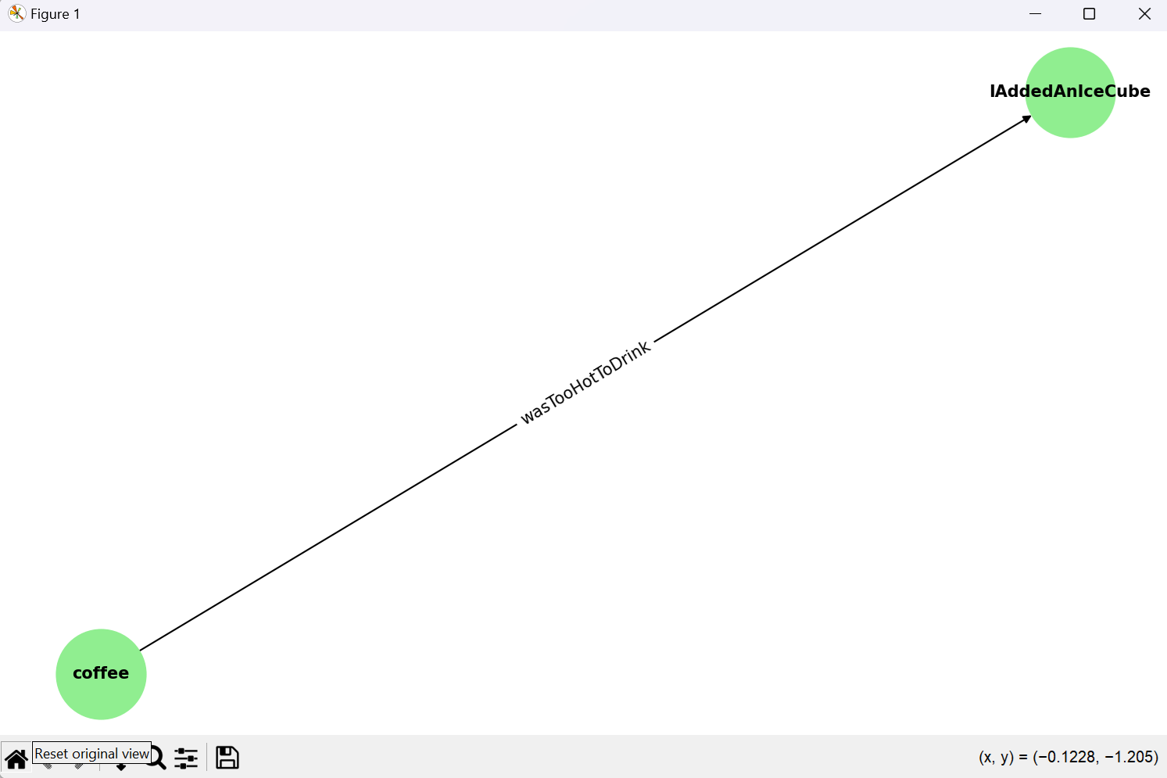

**Knowledge Graph Summary:**

* **Nodes**:
  + coffee
  + IAddedAnIceCube
* **Edges**:
  + coffee → IAddedAnIceCube (wasTooHotToDrink)

**Reasoning Without the Graph:**

* The sentence implies:
  + The coffee was too hot, and the speaker solved the problem by adding an ice cube.
  + The connection between "coffee temperature" and "adding an ice cube" is not explicitly stated.

**Enhancement With Knowledge Graph:**

* The graph explicitly represents:
  + The **cause-and-effect relationship** between the coffee being too hot and the addition of the ice cube.
  + The **action of adding the ice cube** directly solves the problem.

**Improved Insights:**

* The graph makes the reasoning clear by linking:
  1. The condition of the coffee (too hot to drink).
  2. The action (added an ice cube) as the response to this condition

**2. Sentence:** "She put the groceries away before the ice cream melted."

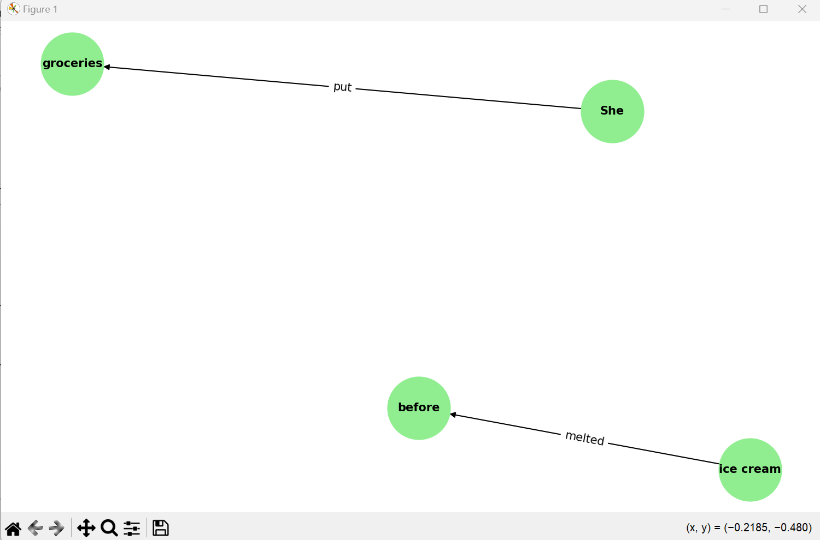

**Knowledge Graph Summary:**

* **Nodes**:
  + She
  + groceries
  + ice cream
  + before
* **Edges**:
  + She → groceries (put)
  + ice cream → before (melted)

**Reasoning Without the Graph:**

* The sentence implies:
  + She prioritized putting the groceries away quickly to prevent the ice cream from melting.
  + The relationship between "putting groceries away" and "ice cream melting" is indirectly understood but not explicitly linked.

**Enhancement With Knowledge Graph:**

* The graph explicitly represents:
  + The sequence of events:
    - Action (put groceries away) occurs before the condition (ice cream melted).
  + The dependency between actions: The graph suggests that putting the groceries away first was motivated by the condition of the ice cream.

**Improved Insights:**

* The graph clarifies the dependency between the action and its motivation, highlighting:
  1. The priority (before ice cream melted).
  2. The logical sequence in the reasoning process.

**3. Sentence:** "The plant died because Jenny forgot to open the curtains for a week."

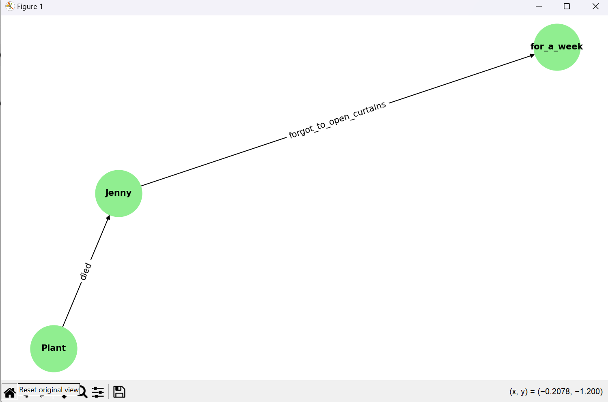

**Knowledge Graph Summary:**

* **Nodes**:
  + Plant
  + Jenny
  + for_a_week
* **Edges**:
  + Plant → Jenny (died)
  + Jenny → for_a_week (forgot_to_open_curtains)

**Reasoning Without the Graph:**

* The sentence implies:
  + The plant died due to lack of light because Jenny didn’t open the curtains.
  + The cause-and-effect chain is inferred but not explicitly mapped.

**Enhancement With Knowledge Graph:**

* The graph explicitly represents:
  + The **cause of death** for the plant (Jenny forgot to open the curtains).
  + The **duration of neglect** (for a week).

**Improved Insights:**

* The graph shows a **direct causal chain**, connecting:
  1. Jenny’s action (forgot to open curtains).
  2. The resulting consequence (plant died).

.