buildingcare
  - BUILDING 1 · COMPETITION PROJECT DOSSIER

基于构件级建筑模型与因果知识图谱的可解释维修决策平台
Explainable maintenance decisions with component-level building models and causal knowledge graphs
项目介绍、技术方案、创新贡献与真实运行案例
Project introduction, technical design, contributions and live case study
NUS · BPS5231 AI Application in the Built Environment
Version 3.0 · 27 September 2026
运行原型；演示假设已披露；不主张现场验证或专利授权。
Running prototype; demonstration assumptions disclosed; no claim of field validation or a granted patent.
  - 10,575 model entities / 1,433 KG nodes / 4 repair options

01 项目总览：从住户感知到可解释维修决策
Project overview: from occupant observations to explainable maintenance decisions
BuildingCare 是一个面向建筑住户与维护团队的构件级运维决策支持原型。住户通过手机上报房间、位置、问题描述及照片；维护人员在可交互三维模型中定位构件，查询因果知识图谱，逐项记录排查证据，再比较不同维修方案对建筑服务、房间使用和住户的影响。
BuildingCare is a component-level maintenance decision-support prototype for occupants and maintenance teams. Residents report a room, location, description and photographs from a phone. The team locates the component in an interactive 3D model, queries causal knowledge, records inspection evidence one hypothesis at a time, and compares interventions in terms of building services, room use and occupants.
项目聚焦“解释为什么检查这里，以及这样维修会影响谁”。它把住户报告、IFC 构件身份、知识图谱证据、人工检查与情景推演组织为可追溯闭环。当前为运行中的教学与参赛原型；缺少现场测量时仍能展示决策流程，同时清楚标明假设。
The central question is: why inspect this component, and who would be affected by this repair? Reports, IFC identities, graph evidence, human inspections and scenarios form a traceable workflow. The current system is a running teaching and competition prototype. It demonstrates the decision process while keeping assumptions explicit when field measurements are absent.
对象  Object | 当前交付  Current delivery
住户端  Resident interface | 移动报修、照片证据、构件建议、状态查询、双语临时指导  Mobile reporting, photo evidence, component suggestions, status and bilingual interim guidance
维护端  Maintenance interface | 构件定位、单假设排查、图查询可视化、方案与影响对比  Instance location, hypothesis inspection, visual queries, intervention and impact comparison
数据基础  Data foundation | 10,575 个模型实体；71 个可选房间；30 个 GLB 分块  10,575 model entities; 71 selectable rooms; 30 GLB chunks
知识基础  Knowledge foundation | Neo4j 中 1,433 个节点与 4,959 条去重关系  1,433 nodes and 4,959 deduplicated relationships in Neo4j

总体演示流程：上报 → 构件定位 → 候选根因 → 人工排查 → 方案选择 → 依赖传播动画 → 费用与住户影响图表 → 报告及住户查询。
Demonstration workflow: report → component location → candidate causes → human inspection → intervention selection → dependency animation → cost and occupant-impact charts → report and resident enquiry.

02 技术背景、问题与研究定位
Technical background, problem and research positioning
住户反馈描述的是“房间闷、风量弱、灯不亮”等现象，建筑模型记录的是构件和空间，专业知识表达的是设备类别、故障模式和候选原因。三种信息的粒度和身份不同。仅把模型与聊天窗口并排放置，仍不能说明某条图谱知识适用于哪个实际构件，也不能区分怀疑、确认和维修后假设。
Occupants describe symptoms such as stuffiness, weak airflow or failed lighting. Building models describe components and spaces, while domain knowledge describes equipment classes, failure modes and potential causes. These representations have different granularity and identities. A model beside a chat window does not by itself establish which knowledge applies to a physical component, or distinguish a hypothesis from confirmation and assumed recovery.
BIM 与建筑语义图的集成已有研究基础。Brick 区分设备间的供给关系与空间位置关系；BIM-to-BRICK 研究讨论 IFC、传感器/楼宇管理系统与空间语义互操作。本项目在这些既有方向上提出面向维修排查与住户影响解释的工作流实现，贡献不在于首次提出 BIM、知识图谱或 GraphRAG。[2][3]
Integration of BIM and building semantic graphs has an established research basis. Brick distinguishes service-flow relationships from spatial location. BIM-to-BRICK examines interoperability between IFC, sensor/BMS information and spatial semantics. This project builds a maintenance-inspection and occupant-impact workflow on these directions; it does not claim to invent BIM, knowledge graphs or GraphRAG. [2][3]
研究问题  Research question | 原型中的回答方式  Prototype response
居民说的位置对应哪个构件？  Which component matches the report? | 房间选择、稳定身份、文本建议、人工绑定及原始属性核对  Room selection, stable identities, text suggestions, explicit binding and source properties
为什么出现这个候选原因？  Why was a cause suggested? | 显示失败模式、根因、检查项、查询参数与证据行  Expose failure mode, cause, checks, query parameters and source-row evidence
维修的代价与影响如何比较？  How do intervention consequences compare? | 保存同一分析版本下的方案、资源输入、服务范围和指标  Save plans, resource inputs, service scope and indicators against one analysis version

研究目标是降低信息割裂和解释成本。当前验证的是流程可运行、身份一致性及规则计算正确性，尚未用真实故障样本证明诊断准确率提升或维修成本下降。
The research objective is to reduce fragmented information and the effort of explaining decisions. Current validation establishes executable workflows, identity consistency and rule-calculation correctness; it does not yet demonstrate improved diagnostic accuracy or reduced maintenance cost on real faults.

03 总体架构与数据闭环
Architecture and data lifecycle
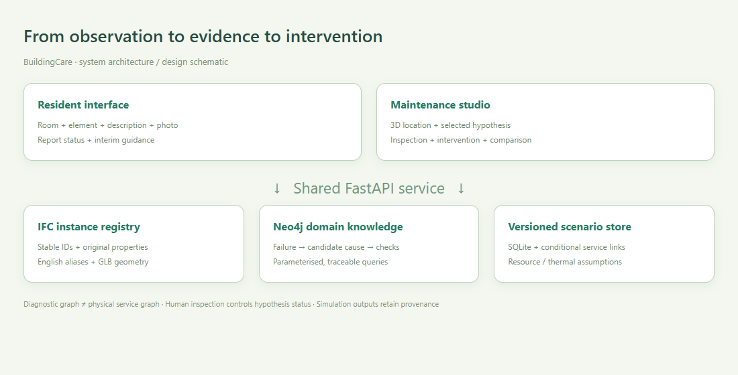
图 A：系统架构示意，非运行截图。图谱知识与物理服务关系有不同来源和语义。
Figure A. System architecture schematic, not a runtime screenshot. Domain knowledge and physical service links have distinct provenance and semantics.
前端由 React、TypeScript 和 Three.js 构成。维护工作台、Investigation Studio、移动报修及住户助手共用 FastAPI 服务。SQLite 保存工单、识别记录、分析版本、用户输入的拓扑与情景结果；照片和模型分块保存在本机。Neo4j 负责对导入数据集执行固定、参数化的 Cypher 查询。[1]
React, TypeScript and Three.js power the maintenance workspace, Investigation Studio, mobile reporting and resident assistant. They share a FastAPI service. SQLite persists reports, identification records, analysis versions, user-entered topology and scenario results; photographs and model chunks remain on the host. Neo4j executes fixed, parameterised Cypher queries against the imported dataset. [1]
每个分析保存工单位置快照、数据集哈希、图谱证据和拓扑快照。每个推演关联 analysisId，并保存所选 causeId、方法、全部输入、结果和依据。修改位置、构件绑定或排查结论会要求使用新的分析版本；旧结果仍保存在数据库中，但不能作为当前版本报告的结果。
An analysis stores a report-location snapshot, dataset hash, graph evidence and topology snapshot. A scenario records analysisId, causeId, intervention method, all inputs, outputs and sources. Changing location, binding or inspection state requires a new analysis version. Older results remain stored but cannot be used as the result of the current report version.
当前项目使用本机 Neo4j；后端连接方式也可用于配置好的远程 Neo4j 服务。浏览器不持有数据库密钥，也不会直接执行用户输入的 Cypher。当前没有部署公网服务，真实多用户发布还需要认证、授权、TLS、备份与日志管理。
The delivered instance uses local Neo4j; the backend connection boundary can also target a configured remote Neo4j service. Browsers do not receive database credentials or execute arbitrary user-entered Cypher. No public deployment has been completed. Production multi-user hosting still requires authentication, authorisation, TLS, backups and operational logging.

04 构件身份、英文命名与位置可信度
Component identity, English naming and location confidence
建筑统一命名为 Building 1。显示名按 IFC 类别、源系统用途、源系统标签、楼层和稳定短编号生成。例如：Supply air · Duct segment · T3 · B1-L02-05050D95。房间优先使用 Pset_SpaceCommon.Reference；Room AS-1.01 不擅自改称 Bedroom。原始名称、楼层键、IFC GlobalId、坐标、包围盒和原始属性均保留。
The display name is Building 1. Component names combine the IFC class, translated source service, original service tag, level and stable short identifier; for example, Supply air · Duct segment · T3 · B1-L02-05050D95. Rooms preferentially use Pset_SpaceCommon.Reference. Room AS-1.01 is not renamed Bedroom without evidence. Original names, floor keys, IFC GlobalIds, coordinates, bounds and properties are retained.
字段  Field | 用途与边界  Purpose and boundary
id / ifcGlobalId | 模型实体身份；网页对象、工单及分析的关联基础  Model identity joining browser objects, reports and analyses
name / originalName | 清晰英文别名 / 原始模型名称，支持溯源核对  Readable English alias / preserved original model name
floorId / floorName | 稳定数据键 02_Kerros / 显示名称 Level 02  Stable key 02_Kerros / display label Level 02
serviceTag | 源系统标签 T3 等；标签相同不证明连通或服务同一房间  Original tag such as T3; equal tags do not establish connectivity or room service
roomId / assetId | 用户所报位置；不等同于已确认的根因位置  Reported location, not a confirmed root-cause location

本轮命名核对覆盖 10,575 个实体，得到 10,575 个不重复显示名。自动核对确认 IFC 标识、坐标与源属性保持一致。完整对应表见 model-name-register.csv；核对结果见 naming-audit.json。这验证了显示变更未改变身份和位置，不代表模型的现场位置或系统连接已完成实地校核。
The naming audit covers 10,575 entities and 10,575 distinct display names. Automated comparisons confirm preserved IFC identifiers, coordinates and source properties. The full mapping is model-name-register.csv, with checks in naming-audit.json. This verifies that presentation changes did not alter identities or positions; it does not certify as-built locations or connectivity.
文本定位目前使用双语词汇、构件类别、源标签和空间距离给出建议；最终由用户或维护人员确认。照片上传和展示已可用，视觉识别接口已预留，但本次未配置视觉模型，不能声称已实现任意照片自动精确识别到某个管段。
Text-based location suggestions currently use bilingual terms, component classes, source tags and spatial distance, followed by human confirmation. Photo upload and display work, and a vision-service adapter exists. No vision model was configured in this run; arbitrary-photo localisation to an exact duct segment is not claimed.

05 根因图谱与查询推理的工作方式
How the causal graph and query-based reasoning work
用户提供的 Neo4j CSV 导出含 n、r、m 三列。导入审计得到 5,000 行、1,433 个节点、4,959 条去重关系；包含 Equipment、FailureMode、RootCause、DiagnosticCheck 等类型。当前 431 个故障模式缺少根因边，432 个缺少检查项边；恰好 5,000 行可能反映导出限制，需要无 LIMIT 的完整导出来核实覆盖范围。
The supplied Neo4j CSV export has n, r and m columns. Import auditing yields 5,000 rows, 1,433 nodes and 4,959 deduplicated relationships, including Equipment, FailureMode, RootCause and DiagnosticCheck. In this snapshot, 431 failure modes lack cause edges and 432 lack check edges. Exactly 5,000 rows may reflect an export limit; an unrestricted export is needed to establish coverage.
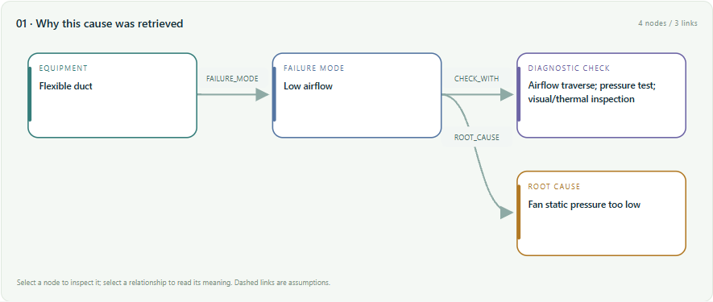
图 1：运行中的 Neo4j 查询结果子图，显示设备类别、故障模式、候选原因与检查项。
Figure 1. Runtime subgraph from Neo4j querying: equipment class, failure mode, candidate cause and diagnostic check.
流程为：双语症状匹配 → 按模型设备类别及源服务标签调整适用性 → 选择候选失败模式 → 参数化 Cypher 查询 HAS_ROOT_CAUSE 与 CHECK_WITH → 分别展示候选假设和证据。HAS_ROOT_CAUSE 的原始方向为“故障模式 → 候选根因”，是诊断查询方向，不能当作建筑中的物理故障传播方向。界面可展开实际查询文本、参数、返回行数和数据集哈希。
The pipeline matches bilingual symptoms, adjusts applicability using model classes and source service tags, selects failure modes, and queries HAS_ROOT_CAUSE and CHECK_WITH using parameterised Cypher. Candidates and evidence are shown separately. HAS_ROOT_CAUSE points from failure mode to candidate cause: a diagnostic lookup direction, not physical failure propagation. The interface exposes the actual query, parameters, returned row count and dataset hash.
本版采用图查询支持的诊断假设检索，而不是概率因果发现、自动证明或 Neo4j GDS 算法。词汇匹配分数表示适用性排序，不是故障概率。知识图中的设备类型还需要与实际 IFC 实例绑定；没有适当映射时保留未知，允许人员调整。
This version uses graph-query-supported diagnostic hypothesis retrieval, not probabilistic causal discovery, automatic proof or Neo4j GDS algorithms. Lexical scores rank applicability, not fault probabilities. Equipment classes in the KG still need association with actual IFC instances. Unmapped cases remain uncertain and can be corrected by a person.

06 单假设排查与图—模型联动
Hypothesis inspection and graph-to-model interaction
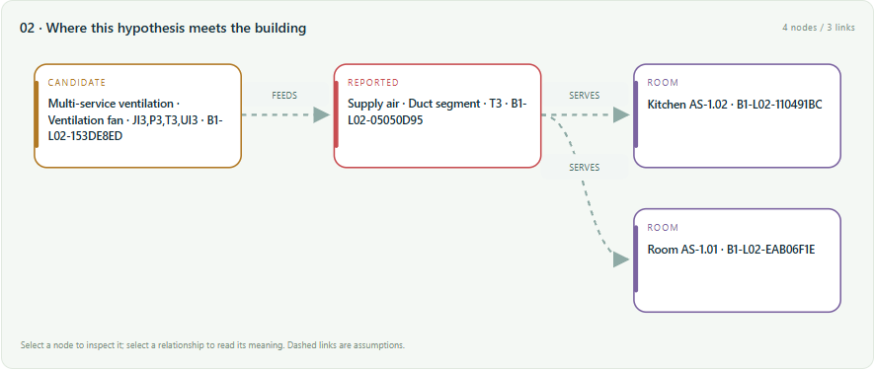
图 2：所选上游风机假设与报修风管、房间的实例路径；虚线表示演示假设。
Figure 2. Instance path from the selected upstream-fan hypothesis to the reported duct and rooms; dashed links denote demonstration assumptions.
系统把报修位置标红，把当前选中的候选位置标为琥珀色，并将情景影响标为紫色。恢复帧以绿色展示有条件恢复。一个假设对应一组当前可解释的证据和实例路径；切换假设会切换图与模型高亮，不把所有原因一次性涂成红色。点击节点可定位实际构件，点击边可查看关系、传播条件和证据说明。
Reported locations are red, the selected candidate location is amber, and scenario impacts are purple. The recovery frame shows conditional restoration in green. Each hypothesis has its own evidence and instance trace; changing it changes the graph and highlights rather than marking every possible cause red. Nodes locate components, and edges expose relationship meaning, propagation conditions and provenance.
排查状态为未检查、检查中、已排除与人员确认。保存时必须填写观察或证据引用；没有构件绑定不能记录确认。已排除假设禁止继续推演。改变构件绑定会撤销该构件原有确认状态。每次排查产生新的分析版本，当前比较结果清空并要求重算；历史记录保留。确认表示人员输入的结论，不代表系统已验证现场事实。
Inspection states are untested, investigating, ruled out and inspector-confirmed. Saving requires an observation or evidence reference, and confirmation requires a component association. Ruled-out hypotheses cannot be simulated. Changing a bound component resets its confirmation. Inspections create a new analysis version and require current comparisons to be recalculated, while retaining history. Confirmation records a human assertion, not automatic validation of a physical fact.
物理路径仅来自用户输入或本案例单独保存的服务边。距离近、位于同一楼层、属于同一设备类别，都不会自动创建 SERVES 或 FEEDS 关系。若候选位置与报修位置之间没有路径，界面直接显示缺失连接。
Physical paths come only from entered service links or links isolated within this case. Proximity, a shared floor or a common equipment class never creates SERVES or FEEDS automatically. Missing paths between a candidate and report are explicitly shown.

07 维修方案、资源与传播计算
Repair options, resources and propagation calculations
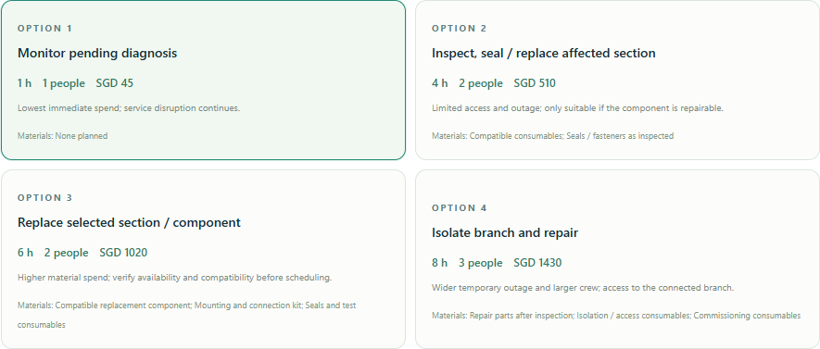
图 3：实际界面中的四类方案卡片。时间、人数、材料及费用均为可编辑假设。
Figure 3. Four intervention cards in the live interface. Time, crew, materials and cost are editable assumptions.
可比较继续观察、局部检修、替换构件和支路停运检修。方案包含步骤、预期成果、材料清单类别、代价与局限。材料是规划描述，尚未连接真实采购目录；不同原因会使用过滤器、密封修补等不同模板。界面所选时间、人数、工时费率、材料费、费用区间和停运节点全部保存在情景中。
The interface compares monitoring, local repair, component replacement and branch-isolation repair. Options include steps, intended outcomes, material categories and trade-offs. Materials are planning descriptions rather than a live procurement catalogue. Templates vary with the cause, such as filter work or sealing. Chosen duration, crew, hourly rate, material cost, cost range and isolation point are saved with the scenario.
费用 = 人数 × 作业小时 × 每人工时费率 + 材料费。费用区间使用用户输入的 ± 百分比，属于敏感性范围，不是统计置信区间。未包含税费、等待备件、营业损失和间接费用。观察方案的作业时间指巡视劳动，服务中断则持续整个规划时段。
Cost = crew × work hours × hourly rate + material cost. The entered ± percentage is a sensitivity range, not a statistical confidence interval. Taxes, parts lead times, lost business and overhead are excluded. For monitoring, work duration means inspection labour while service interruption lasts over the full planning horizon.
影响沿条件服务边传播。例如配电失电经 SUPPLIES_POWER 可变换为风机通风损失，再经 FEEDS 与 SERVES 传至风管和房间。遍历状态为（构件，服务状态），已访问状态不重复展开，避免循环无限运行。停运节点必须通过相同条件规则到达所选根因构件；未配置的连接保持未知。
Effects propagate through conditional service links. For example, power loss can become fan ventilation loss through SUPPLIES_POWER, then reach ducts and rooms through FEEDS and SERVES. Traversal state is the pair (entity, service state), and visited states are not expanded twice, preventing infinite cycles. An isolation node must reach the selected cause through those same conditions; unconfigured connections remain unknown.

08 住户与建筑性能指标的计算边界
Occupant and building-performance indicators
模拟强调方案之间的服务范围和资源差异。指标包括受影响房间与构件、假定受影响人数、住户服务中断小时、房间关闭小时、规划时段服务可用率，以及明确假设失去制冷后的空气温度与阈值超温积分。人数按每房间固定假设计算，不等于真实入住统计，也不等于劳动生产率下降或健康损失。
Simulation focuses on differences in service scope and resources. Indicators include affected rooms and elements, assumed occupants, occupant-hours of service loss, room-closure hours, service availability over the planning horizon, and air-temperature trajectories and degree-hours when loss of cooling is explicitly assumed. Occupancy is a fixed per-room assumption, not measured presence, productivity loss or health impact.
指标  Indicator | 计算与解释  Calculation and interpretation
住户服务中断小时  Occupant service-loss hours | affected rooms × assumed occupants/room × min(outage, horizon)
房间关闭小时  Room-closure hours | affected rooms × min(outage, horizon), only when closure is selected
服务可用率  Service availability | 100 × [1 − min(outage, horizon) / horizon]
温度模型  Thermal model | C dT/dt = UA(Tout − T) + Q
恢复模型  Recovery model | T = Tinitial + (Trepair − Tinitial) exp[−(t − trepair)/τrecovery]
超温积分  Temperature degree-hours | ∫ max(Tair − Tthreshold, 0) dt; per-room planning indicator

热模型采用单节点、常数室外温度与热增益，同一组输入用于每个受影响房间；没有房间间传热、湿度、风速、太阳辐射、设备控制或人员差异。它不是 EnergyPlus、CFD 或校准后的数字孪生。空气温度不等于操作温度或体感温度，本版不输出 PMV/PPD、舒适标准符合性、能耗节约或预测概率。通风故障也不会自动被当作制冷故障。
The thermal model is single-node with constant outdoor temperature and internal gains, using shared inputs for affected rooms. It omits inter-room transfer, humidity, airspeed, solar gains, detailed controls and occupant differences. It is not EnergyPlus, CFD or a calibrated digital twin. Air temperature is not operative or perceived temperature; PMV/PPD, comfort-standard compliance, energy savings and prediction probabilities are not output. Ventilation failure does not automatically imply cooling failure.
动画按服务依赖层级逐步显现构件和房间，随后显示有条件恢复。动画步数不是故障物理传播速度；维修小时与温度曲线在独立时间轴上表达。此设计使观众能理解路径，又不制造未经建模的物理精度。
Animation reveals elements and rooms by service-dependency hops, followed by conditional recovery. Animation steps do not represent physical propagation speed; repair duration and thermal evolution use their own time quantities. This makes the trace understandable without implying unsupported physical precision.

09 Demo case study：对象与场景设定
Demo case study: model objects and scenario
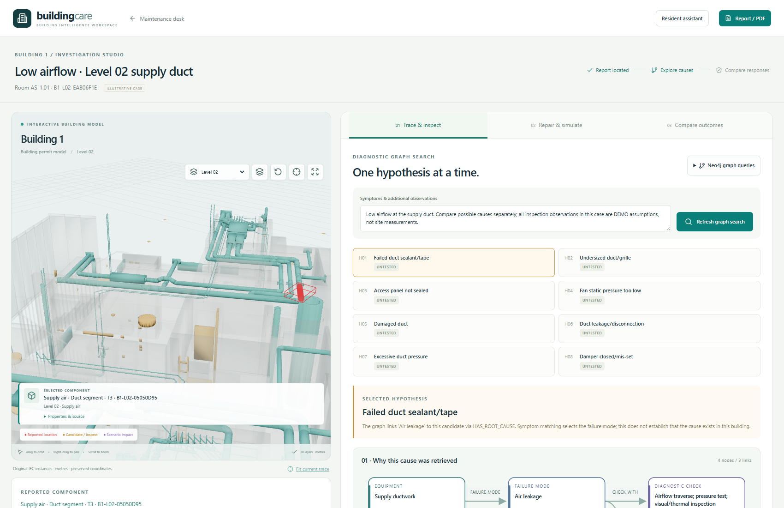
图 4：真实运行的 Building 1 工作区。报修对象为模型中的独立 T3 送风管段；故障描述为演示数据。
Figure 4. Live Building 1 workspace. The reported object is an individual T3 supply-air duct from the model; the defect report is demonstration data.
案例位于 Level 02。报修房间为 Room AS-1.01，选定管段为 asset_05050d9591661e63，风机为 asset_153de8eda3c22936，配电板为 asset_3313a248aec6c28f。三者均为源模型中的真实独立实体。假定该风机服务两条支路，第一条服务 Room AS-1.01 与 Kitchen AS-1.02，第二条服务 Room AS-1.06；Room AS-1.05 作为不连通的对照房间。
The case is on Level 02. Room AS-1.01 is reported, with duct asset_05050d9591661e63, fan asset_153de8eda3c22936 and board asset_3313a248aec6c28f. All are real independent entities in the source model. For demonstration, the fan is assumed to supply two branches: the first serves Room AS-1.01 and Kitchen AS-1.02; the second serves Room AS-1.06. Room AS-1.05 is an intentionally disconnected control.
这些服务边只保存在该案例工单中，不写入普通工单共用的服务拓扑。模型中的 T3 标签支持源系统身份识别，不能证明上述房间服务关系。案例检查、室温、入住人数及成本没有对应实测资料；所有展示均用于验证流程和计算。
These service links are stored only on this case report, not in the topology shared by ordinary reports. The T3 tag supports source-system identity but does not prove these room-service relationships. No field evidence underlies the case inspections, temperatures, occupancy or costs; the demonstration validates workflow and calculations.
运行记录与截图来自 2026-09-27T13:50:34.175188+00:00。完整工单、最新分析、四个方案输入输出与浏览器检查结果保存在 evidence/case-run.json，可据此复算。
The run and screenshots were captured at 2026-09-27T13:50:34.175188+00:00. The report, current analysis, all four scenario inputs/outputs and browser checks are preserved in evidence/case-run.json for reproduction.

10 案例步骤：从候选原因到排查结论
Case steps: from candidate causes to inspection outcome
步骤 1：在维护首页选择 Open case study，进入 Investigation Studio。症状为“选定送风管风量弱”。点击 Find possible causes 或 Refresh graph search，系统执行真实 Neo4j 查询并生成候选原因。步骤 2：选择 Fan static pressure too low，查看候选风机、报修管段与受服务房间之间的路径，并在图中核对虚线的假设属性。
Step 1: choose Open case study from the maintenance homepage and enter Investigation Studio. The symptom is low airflow at the selected supply duct. Find possible causes or Refresh graph search executes real Neo4j queries and produces candidates. Step 2: select Fan static pressure too low, inspect the path between fan, reported duct and rooms, and verify the assumption labels on dashed edges.
步骤 3：输入明确带 DEMO 标识的“假定风机输出检查正常”，将该原因标为 Ruled out。页面禁止按被排除原因继续推演。步骤 4：切换 Duct leakage/disconnection，输入“假定选定 T3 风管接头漏风”的 DEMO 检查记录，选择 Confirmed by inspector。系统保存新分析版本；这只表示模拟检查员结论，不意味着建筑真的漏风。
Step 3: enter a DEMO observation assuming normal fan output and mark that cause Ruled out. The interface prevents simulation of that excluded cause. Step 4: select Duct leakage/disconnection, enter a DEMO finding assuming a leaking joint on the chosen T3 duct, and choose Confirmed by inspector. A new analysis version is saved. This is a simulated inspection outcome, not proof of a real leak.
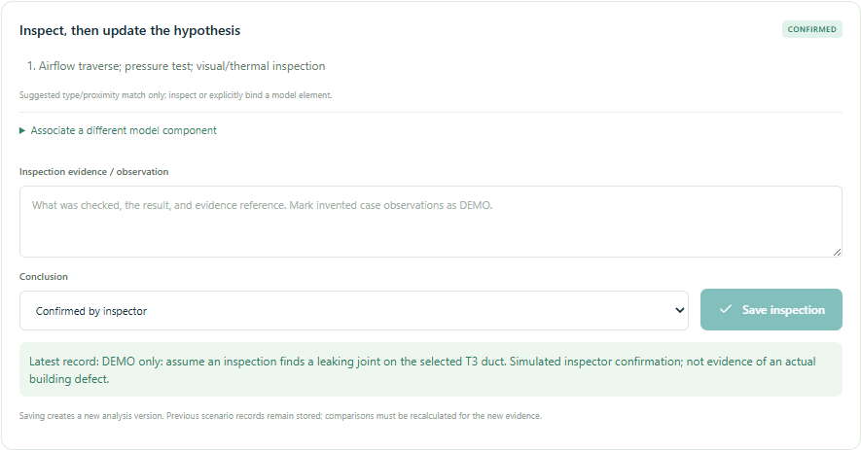
图 5：实际保存的排查状态与证据文字。演示确认被明确标为非现场检查。
Figure 5. Saved inspection status and evidence text. The confirmation is explicitly marked as a demonstration, not field inspection.
步骤 5：进入 Repair & simulate。分别选择四个方案，并明确勾选“假设受影响房间失去制冷”。支路方案选择上游风机作为停运范围。每次点击 Run selected scenario，平台保存结果；之后在 Compare outcomes 中进行同一分析版本的方案比较。
Step 5: enter Repair & simulate, select each of the four options, and explicitly assume cooling is unavailable in affected rooms. For branch isolation, choose the upstream fan. Each Run selected scenario saves an output, then Compare outcomes compares scenarios belonging to the same analysis version.

11 案例结果：范围、动画与维修图
Case results: scope, animation and repair graph
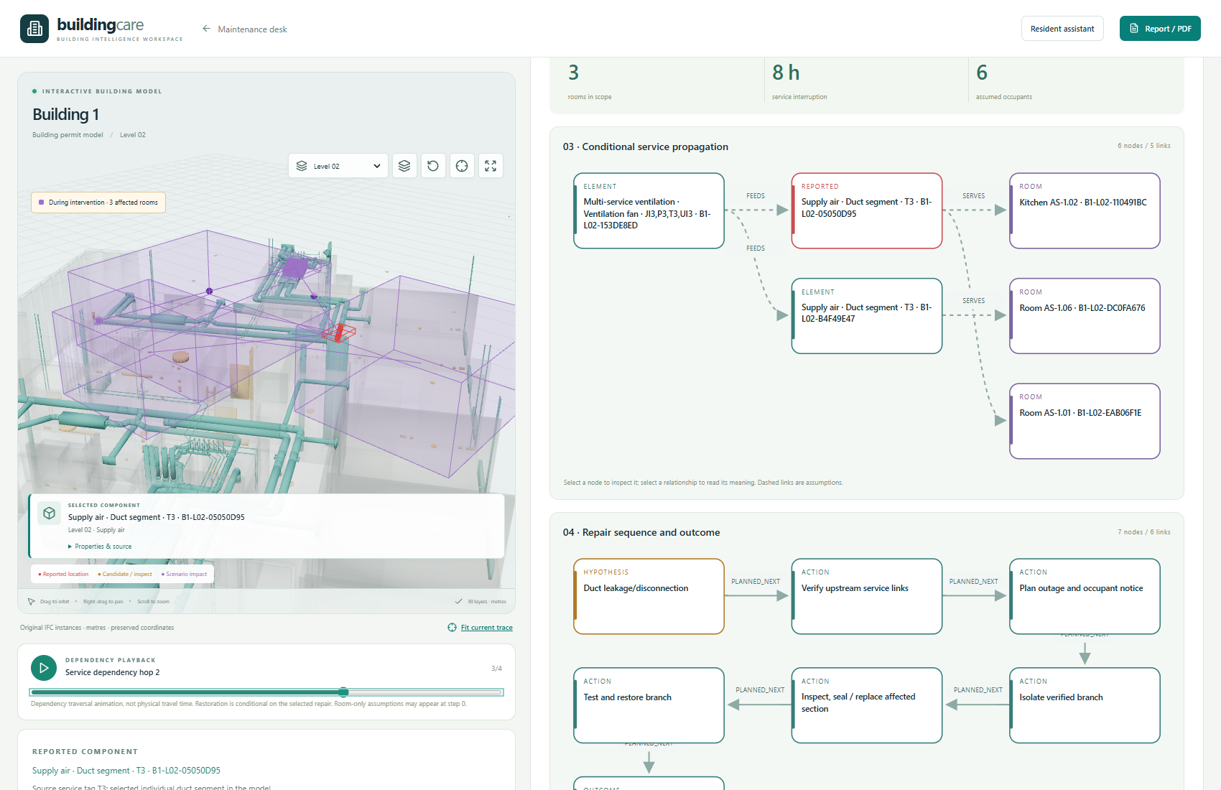
图 6：支路方案运行时的模型联动与依赖传播动画帧；不是预绘制效果图。
Figure 6. Live model and dependency-playback frame for branch isolation; not a pre-rendered mock-up.
局部维修和更换选择当前风管为故障/干预起点，因此影响两个假定服务房间；支路停运选择风机为起点，影响范围扩大到两条风管与三个房间。第四个房间没有服务边，因此不在结果中。规则只影响路径可达的对象，未将同楼层全部房间一并计入。
Local repair and replacement start at the selected duct and affect its two assumed served rooms. Branch isolation starts at the fan, expanding scope to two ducts and three rooms. The fourth room has no service edge and is excluded. The rule reaches only configured dependencies rather than marking the entire floor affected.
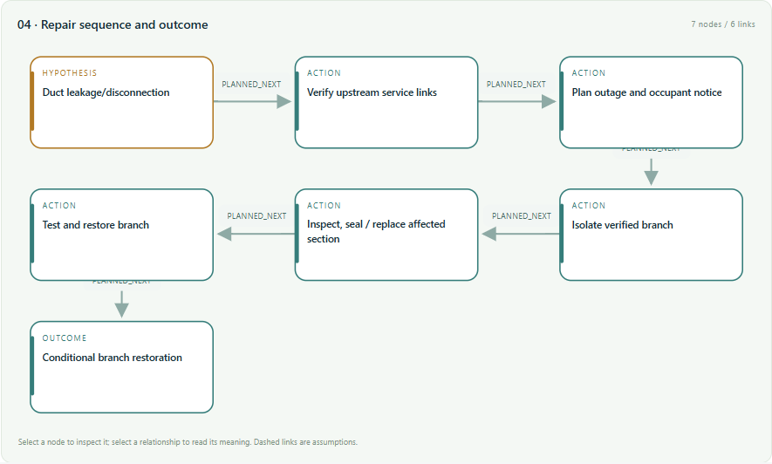
图 7：维修步骤至有条件恢复的方案图。零受影响房间的恢复帧依赖正确诊断、维修成功及复机测试。
Figure 7. Intervention sequence leading to conditional restoration. A zero-impact recovery frame assumes correct diagnosis, successful repair and recommissioning.

12 案例结果：成本、人员与住户影响比较
Case results: comparing cost, crew and occupant impact
方案  Option | SGD | 人数 / 作业h  Crew / work h | 房间  Rooms | 中断h  Outage h | 住户·h  Occupant·h | 峰值°C  Peak °C
继续观察  Monitor | 45.0 | 1 / 1 | 2 | 24 | 96.0 | 31.0
局部检修  Local repair | 510.0 | 2 / 4 | 2 | 4 | 16.0 | 25.8
替换构件  Replace component | 1020.0 | 2 / 6 | 2 | 6 | 24.0 | 26.6
支路停运检修  Branch isolation | 1430.0 | 3 / 8 | 3 | 8 | 48.0 | 27.3

共同热工输入：初始空气温度 24°C、室外 32°C、内部热增益 300W、UA = 150W/K、等效热容 3kWh/K、恢复时间常数 2h、规划时段 24h、用户阈值 28°C。每房间假定 2 人，工时费率 45 SGD/人·h，费用区间 ±25%。这是为演示设置的暖天气边界，不是源建筑气候、NUS 实测值或承包商报价。
Shared thermal inputs: initial air temperature 24°C, outdoor 32°C, internal gains 300 W, UA = 150 W/K, capacitance 3 kWh/K, recovery constant 2 h, horizon 24 h and user threshold 28°C. Two occupants per room, a labour rate of 45 SGD/person-hour and a ±25% cost range are assumed. These illustrative warm-weather boundaries are not the source building’s climate, NUS measurements or contractor quotations.
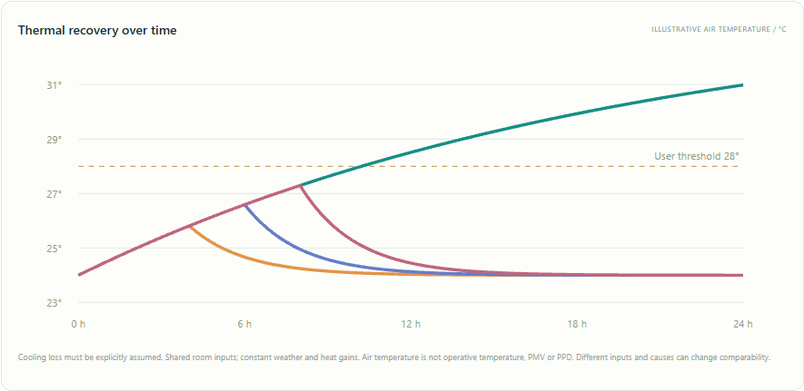
图 8：实际运行生成的温度比较图。维修方案在各自完工后进入假定恢复，观察方案的温升持续。
Figure 8. Temperature comparison generated by the live run. Repair options enter assumed recovery after their respective durations, while the monitoring trajectory continues warming.
这组输入下局部维修的估计支出和住户服务损失低于支路停运；但该比较不能证明局部维修在工程上可行，也不能替代诊断、隔离许可和现场施工条件核实。平台展示取舍，不自动给出未经验证的“最优方案”。替换方案的备件兼容性和交付时间仍需补充。
Under these inputs, local repair has lower estimated spending and occupant service loss than branch isolation. This does not establish its engineering feasibility or replace diagnosis, isolation authorisation and site checks. The platform exposes trade-offs without claiming an unverified optimal solution. Replacement compatibility and lead time still require evidence.

13 住户问答、临时指导与报告
Resident enquiry, interim guidance and reporting
住户可直接打开 Resident assistant，或在提交工单后进入同一入口。中英文问题会获得预设的临时指导；带工单链接时，可查询该工单状态和最新方案中的本房间通知草稿。例如“房间太闷怎么办”提示检查是否有物品挡住出风口、记录时间和现象、必要时转移至舒适区域，并由维护团队处理设备。不会指导住户拆卸风机、带电维修或反复合闸。
Residents can open Resident assistant directly or after submitting a report. English and Chinese questions receive preset interim guidance. A linked report adds its status and the latest scenario’s notice draft for that room. For stuffiness, guidance suggests checking whether belongings block vents, recording time and symptoms, moving to a more comfortable area when necessary, and leaving equipment work to maintenance. It does not instruct residents to dismantle fans, work on live equipment or repeatedly reset breakers.
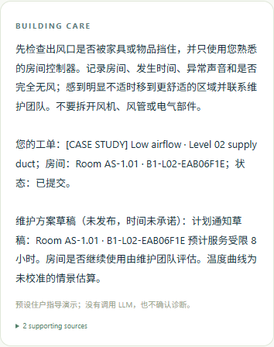
图 9：手机尺寸下的真实住户问答。界面注明预设指导、未调用 LLM，维修通知尚为草稿。
Figure 9. Real resident enquiry at a phone viewport. The interface labels preset guidance, no LLM call, and the draft status of the maintenance notice.
维护端原有 LLM 问答接口保留，但本次实际 LLM 与视觉服务均未配置。住户助手的可用演示由确定性规则和保存的工单数据完成，不能描述为经过真实 LLM 验证的智能对话。报告支持打印/PDF，引用图谱、排查和情景依据；本次另导出 evidence/live-maintenance-report.pdf。
The existing maintenance LLM interface remains available for configuration, but neither a real LLM nor a vision service was configured in this run. The usable resident demonstration is deterministic guidance plus saved report data, not validated live-LLM conversation. Reports support print/PDF and cite graph, inspection and scenario evidence; evidence/live-maintenance-report.pdf is exported from this run.

14 技术贡献与技术交底式说明
Technical contributions and disclosure-style description
技术领域：建筑设施运维、建筑信息模型、知识图谱检索与维修情景决策支持。拟解决的技术问题：异构报告、通用故障知识与建筑实例之间缺少可核对的对应，导致根因依据和维修影响难以统一解释。技术方案：将保留 IFC 身份的模型实例注册、带来源的候选根因检索、版本化人工排查、带状态转换的服务拓扑遍历及住户影响展示组合为一套方法与系统。
Technical field: building facilities maintenance, building information modelling, knowledge-graph retrieval and repair-scenario decision support. Technical problem: heterogeneous reports, generic failure knowledge and building instances lack auditable correspondence, making cause evidence and repair consequences difficult to explain together. Proposed solution: combine identity-preserving instance registration, provenance-aware cause retrieval, versioned human inspection, state-transforming service-topology traversal and occupant-impact presentation.
贡献主张  Contribution | 已实现的技术内容  Implemented technical content | 仍需验证  Further validation
身份保持的报告—模型对齐  Identity-preserving report/model alignment | 英文别名保留原始 IFC 身份，允许逐构件定位与人工核对  English aliases preserve IFC identity; individual location and human verification | 真实住户定位效率与错误率  Resident location time and error rate
诊断与物理传播的语义分离  Separate diagnosis from physical propagation | HAS_ROOT_CAUSE 查询与条件服务边独立保存、独立展示  Distinct storage and display for causal lookup and conditional service edges | 专业人员对图路径解释的理解效果  Expert comprehension of path explanations
证据版本约束的方案比较  Evidence-version-constrained comparison | 检查或位置变化使旧方案失去当前适用性；历史结果可追溯  Inspection/location changes invalidate current use of old scenarios while retaining history | 并发编辑、正式审批及审计可靠性  Concurrent editing, approval and audit robustness
面向住户的维修后果表达  Occupant-oriented repair consequences | 成本、材料、时间、范围、服务损失与温度曲线并列比较  Compare cost, materials, time, scope, service loss and thermal curves | 校准性能模型、住户实验及决策质量  Calibrated performance models, occupant studies and decision quality

可用于技术交底的流程表述：S1 建立构件注册与空间关联；S2 接收并确认报修实例；S3 查询故障模式到根因与检查项的路径；S4 保存人员排查状态并生成新分析版本；S5 按所选维修方案的隔离范围及条件服务图计算影响；S6 计算资源和住户指标，生成对应图表、动画与可追溯报告。
Disclosure-style process: S1 register components and spatial references; S2 receive and confirm a reported instance; S3 query paths from failure modes to causes and checks; S4 save inspection state and create a new analysis version; S5 calculate impact using the selected isolation scope and conditional service graph; S6 calculate resource and occupant indicators and produce corresponding charts, animation and a traceable report.
以上是项目技术组合和实现贡献的表述，不是“全球首次”、授权专利或专利性结论。本材料没有开展完整的新颖性检索。建议参赛时以可解释闭环、可复现实验与显式不确定性管理为核心价值主张。
These are claims about the project’s technical combination and implementation contributions, not world-first claims, a granted patent or a patentability conclusion. No comprehensive novelty search is included. The recommended competition positioning is an explainable workflow, reproducible experiments and explicit treatment of uncertainty.

15 验证、复现与下一阶段
Validation, reproduction and next stage
离线动画见 evidence/simulation-playback.gif，由真实浏览器帧构成；平台支持播放、暂停与滑块。
Offline animation: evidence/simulation-playback.gif, made from actual browser frames. The platform supports playback, pause and a step slider.
本次功能验证包括：Neo4j 数据集连接和真实查询、30 个模型分块加载、单假设切换、排除原因禁止推演、人员确认生成新版本、四个方案保存、局部与支路范围差异、动画及恢复帧、刷新页面后读取保存结果、手机问答、无页面横向溢出，以及维护报告 PDF。浏览器未记录页面错误或服务器 5xx。自动化测试另覆盖图循环、传播条件、位置变更、上传和持久化等。详见 VALIDATION_V3.md。
Validation includes real Neo4j dataset connectivity/querying, all 30 model chunks, individual hypotheses, blocking ruled-out causes, versioned inspector confirmation, four saved options, distinct local/branch scopes, animation and recovery, saved results after reload, mobile enquiry, no page overflow, and a report PDF. No page errors or server 5xx responses were recorded. Automated tests additionally cover cycles, propagation conditions, location changes, uploads and persistence. See VALIDATION_V3.md.
已运行  Running now | 尚未验证或实现  Not yet validated or implemented
构件级模型与英文注册表  Instance model and English registry | 现场构件定位及竣工拓扑全面核验  Complete field verification and as-built topology
Neo4j 查询与证据路径  Neo4j query and evidence paths | 图谱完整性、真实故障诊断准确率、概率推断  Full KG coverage, real-fault accuracy and probabilistic inference
依赖传播与资源估算  Dependency propagation and resource estimates | 工程气流/热湿模拟、真实工期与报价校准  Engineering airflow/thermal-moisture simulation; calibrated durations and quotes
确定性双语住户助手  Deterministic bilingual resident guidance | 已配置并验收的 LLM、视觉模型和生产权限控制  Configured and accepted LLM/vision services; production access controls

复现：在 maintenance-platform 文件夹运行 .\restart.ps1 -Build；访问 http://localhost:8000/，点击 Open case study。住户入口为 /report 和 /resident。Neo4j 本机浏览器在 http://127.0.0.1:17474/，登录信息留在本机 .env，不包含在提交材料中。照片、模型与数据库均在 data 文件夹。完整案例重放脚本为 tools/capture_case_v3.py。
Reproduce: run .\restart.ps1 -Build from maintenance-platform, open http://localhost:8000/ and choose Open case study. Resident routes are /report and /resident. The local Neo4j browser is http://127.0.0.1:17474/. Credentials remain in the local .env and are excluded from the dossier. Photographs, model data and database are in data. The complete case-replay script is tools/capture_case_v3.py.
下一阶段建议按证据积累推进：先完整导出并复核 KG 和实例服务拓扑，再引入真实工单与专家标注形成测试集；随后配置 LLM/视觉服务并测量定位与检索质量，最后接入温湿度、风量或 BMS 数据校准性能模型。可报告 Top-k 根因覆盖、定位正确率、错误传播范围、人员任务用时和预测误差；当前材料不填造这些尚未测量的结果。
Next, complete and review the KG and instance service topology, then collect real reports and expert labels as a test set. Configure LLM/vision services and evaluate localisation/retrieval before calibrating performance models with temperature, humidity, airflow or BMS data. Suitable measures include top-k cause coverage, localisation accuracy, false impact scope, task time and prediction error. No unmeasured values are filled in here.
参考依据：[1] Neo4j Python Driver Manual，Query the database（参数化查询）；[2] Brick Ontology，Relationships（位置与服务关系）；[3] BIM-to-BRICK: Using graph modeling for IoT/BMS and spatial semantic data interoperability within digital data models of buildings，arXiv:2307.13197。
References: [1] Neo4j Python Driver Manual, Query the database (parameterised queries); [2] Brick Ontology, Relationships (location and service relationships); [3] BIM-to-BRICK: Using graph modeling for IoT/BMS and spatial semantic data interoperability within digital data models of buildings, arXiv:2307.13197.
https://neo4j.com/docs/python-manual/current/query-simple/
https://docs.brickschema.org/brick/relationships.html
https://arxiv.org/abs/2307.13197

