EECS 452 Lab 2 Report
Video Capture, Color Thresholding, Timing, and Ball Localization
Name: Ryan Zhang
Platform: Raspberry Pi 4 + Picamera2 (imx219)
Code: LAB2_script/lab2_picamera2.py, timer.py
Note: Pre-Lab (Q1–Q7) submitted separately and omitted here.

In-Lab

2. Video Capture (Q8–Q12)

Q8. Benefits of a circular buffer vs capturing every loop
A circular buffer lets the camera continuously write frames in the background while the main loop only reads the most recent frame.
Compared with calling picam2.capture_image() every iteration, this approach:
- Reduces latency, because the loop does not block on a fresh full capture each time.
- Gives a more stable frame rate by decoupling capture from processing.
- Avoids backlog of stale frames when processing temporarily slows down.
- Works well with the H.264 encoder and CircularOutput running continuously behind the scenes.

Q9. Meaning of 1 in cv2.waitKey(1); can OpenCV wait less?
The argument to waitKey is the maximum wait time in milliseconds. waitKey(1) waits up to 1 ms for a keypress (and also lets OpenCV process GUI events).
OpenCV cannot wait for less than 1 ms in a meaningful way: the parameter is an integer number of milliseconds, so 1 is the smallest positive wait. waitKey(0) waits forever.

Q10. Why colors looked wrong; how we fixed it
OpenCV’s imshow interprets color images as BGR channel order, while Picamera2 is configured for RGB888-style color data. If the channel order is mismatched, red and blue are swapped, so an orange/yellow ball can look blue/cyan.
Fix: convert the frame to the order expected by the display/processing path (e.g., cv2.cvtColor(..., cv2.COLOR_RGB2BGR) when needed) so that Raw Image shows true object colors before thresholding.

Q11. Typical RGB pixel value for the ball
Using the ‘c’ key capture and hovering the mouse over the ball in pyplot, a typical RGB value measured on the ball surface was approximately:
RGB = (238, 183, 5)
(High R and G, very low B — consistent with a bright yellow/orange ball under lab lighting.)
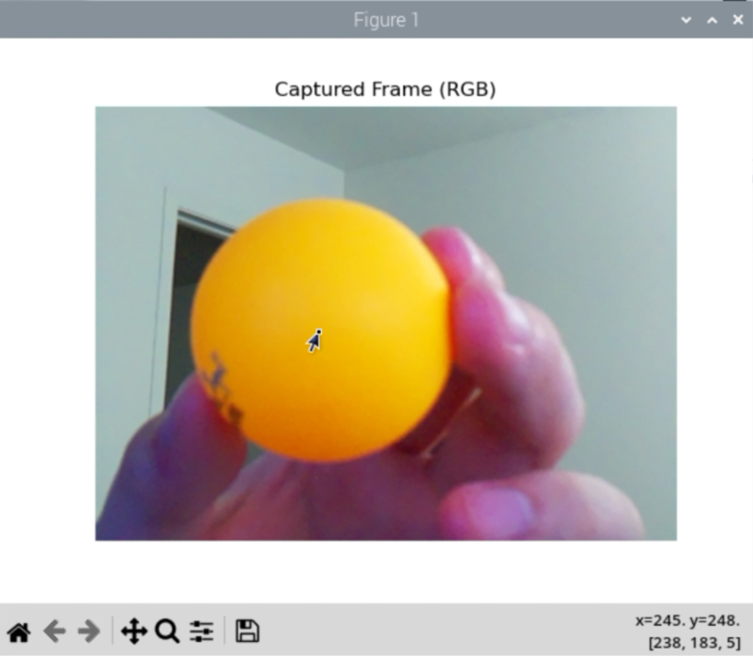
Figure: BallRGB_Q11.png

Q12. Screenshot of working video capture and image capture
The screenshot below shows the live OpenCV windows (Raw / Difference / Binary / Trackbars) together with the pyplot “Captured Frame (RGB)” window after pressing ‘c’.
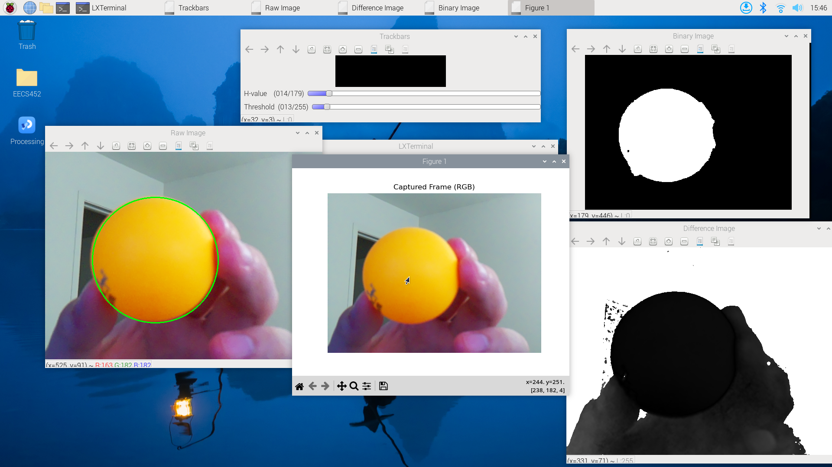
Figure: Q12_video_and_pyplot.png

3. Color Thresholding (Q13–Q19)

Q13. Chosen H-value
Initial / working H-value on the OpenCV 0–179 hue scale: H_val = 13 (also used after trackbar tuning; see Q18).

Q14. What color is the ball in the difference image?
The ball appears dark (low intensity) in the difference image. Pixels whose hue is close to H_val have a small absolute difference, while background hues produce larger differences and appear brighter.

Q15. Appropriate threshold type
cv2.THRESH_BINARY_INV
Pixels with difference below the threshold become white (255) — the ball — and pixels above the threshold become black (0) — the background.

Q16. Shape after boxFilter
The shape is unchanged from the input difference image: (480, 640) for our 640×480 capture. boxFilter with ddepth=-1 only smooths values; it does not resize the image.

Q17. Five arguments to createTrackbar
The five arguments are:
- trackbarName: name of the slider (e.g., "H-value")
- windowName: OpenCV window that owns the trackbar
- value: initial value
- count: maximum value on the slider
- onChange: callback invoked when the slider moves (can be a no-op such as nothing)

Q18. Tuned H-value and threshold
After tuning while watching the Binary Image window:
- H-value = 13
- Threshold = 13
These settings gave a clean white ball mask with minimal background noise.

Q19. Example binary image
Example Binary Image after tuning (H=13, Threshold=13):
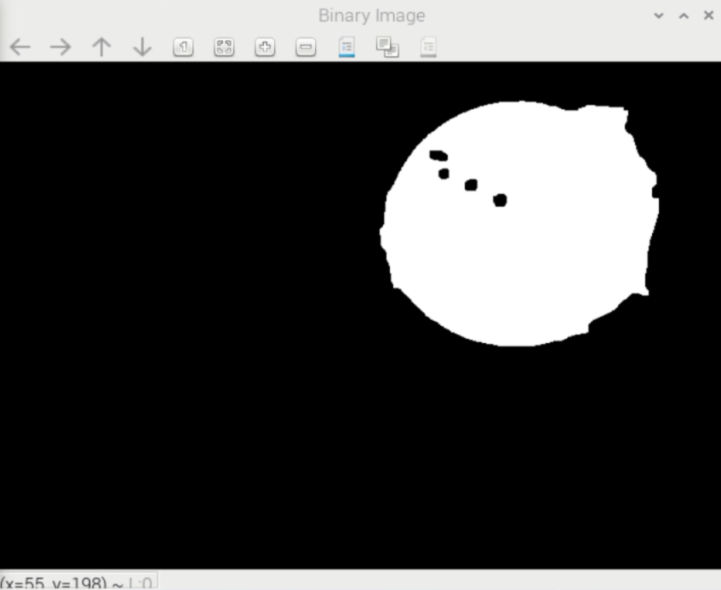
Figure: Binary_Q19.png

4. Timing (Q20–Q22)
All timings below are from Raspberry Pi 4, 640×480, with USE_IDX_IMG = True unless noted. Representative frame used for Q20–Q22 and Q24:
Frame processed in 0.0922 s (10.84 frames per second)

Q20. Execution times
Measured on a representative frame:
- Total color thresholding: 0.023132 s
- Display images: 0.001799 s
- Process one frame: 0.0922 s

Q21. Frames per second
About 10.84 FPS on the representative frame (typically about 9–12 FPS in index-image mode with three display windows).

Q22. Color-thresholding breakdown
Same representative frame:
- Difference image: 0.013107 s
- Box filter: 0.001741 s
- Threshold (including light morphological cleanup): 0.007897 s
Difference-image generation was the slowest of the three color-threshold substeps on our Pi.

5. Ball Localization (Q23–Q25)

Q23. Nested-loop localization timing
With USE_IDX_IMG = False (double nested Python loops), representative frame:
Frame processed in 2.5258 s (0.40 frames per second)
contours (localization): 2.377461 s
- Localization time: 2.377461 s
- Overall FPS: 0.40 FPS
Almost the entire frame time is spent in localization.

Q24. Index-image localization timing
With USE_IDX_IMG = True (NumPy index-image method), representative frame:
Frame processed in 0.0922 s (10.84 frames per second)
contours (localization): 0.010873 s
- Localization time: 0.010873 s
- Overall FPS: 10.84 FPS
Localization is roughly 200× faster than the nested-loop method (2.38 s → 0.011 s).

Q25. Demonstration that index-image localization works
With USE_IDX_IMG = True, the green circle on the Raw Image tracks the ball. The screenshot below shows the live Raw Image with the detected circle overlaid while the Binary Image isolates the ball.
Figure: Q25_index_image_tracking.png

6. Post-Lab (Q26–Q29)

Q26. Compare the two localization methods
The nested-loop heuristic is easy to understand and debug: it directly implements the centroid formulas by visiting every pixel in Python. On the Raspberry Pi it is far too slow for real-time tracking (~2.4 s per localization, ~0.4 FPS), so the green circle lags badly.
The index-image method uses the same mathematical formulas but evaluates them with NumPy vectorized operations (masking and summing index vectors). Accuracy is essentially the same when the binary mask is the same, but runtime drops to ~0.011 s and overall rate rises to ~11 FPS, which is usable for interactive tracking.
Conclusion: nested loops are useful for learning; real-time systems should use the index-image (or other vectorized/OpenCV) approach.

Q27. Python vs C++ language differences
A) Interpreted vs compiled:
Compiled languages (C++) translate source to machine code ahead of time and generally run faster, but require a compile/link step. Interpreted languages (Python) execute via an interpreter/bytecode VM, which is convenient for development but slower for tight loops. Python is primarily interpreted; C++ is compiled.
B) Dynamic vs static typing:
Statically typed languages (C++) check types at compile time, catching many errors early and enabling optimizations. Dynamically typed languages (Python) resolve types at runtime, which is flexible but adds overhead. Python is dynamically typed; C++ is statically typed.
C) Garbage collection:
GC automatically reclaims unreachable memory, reducing leaks and dangling-pointer bugs, but can introduce pauses and runtime overhead. Python has garbage collection (reference counting plus a cyclic GC). C++ does not provide a built-in GC by default; memory is managed manually or with RAII/smart pointers.

Q28. Using C++ OpenCV on Raspberry Pi
A) Import / include OpenCV in C++:
#include <opencv2/opencv.hpp>
(or module headers such as opencv2/core.hpp, imgproc.hpp, highgui.hpp)
B) Compile on Raspberry Pi OS:
Typical CMake flow:
mkdir build && cd build
cmake ..
make
./your_program
Or with g++ and pkg-config, for example:
g++ main.cpp -o app `pkg-config --cflags --libs opencv4`
Reference: OpenCV Linux GCC/CMake tutorial (docs.opencv.org).

Q29. OpenCV Python vs C++ performance
A) Why Python OpenCV can be slower:
Many OpenCV calls still run optimized C++ under the hood, but Python adds interpreter overhead, argument conversion, and GIL constraints. Pure Python loops over pixels (as in our nested-loop centroid) are especially slow compared with C++ or NumPy.
B) Why use Python anyway:
Faster prototyping, shorter code, easy integration with tools such as matplotlib and picamera2, and “good enough” speed when heavy work is done in NumPy/OpenCV vectorized functions. A common workflow is to prototype in Python and rewrite only hotspots in C++ if needed.

Appendix — Code & Deliverables
Primary code files submitted / used:
- LAB2_script/lab2_picamera2.py — main lab program
- LAB2_script/timer.py — Timer class using time.time()
Figures included in this report: BallRGB_Q11.png, Q12_video_and_pyplot.png, Binary_Q19.png, Q25_index_image_tracking.png.
Pre-Lab answers (Q1–Q7) are omitted as requested (submitted separately).

