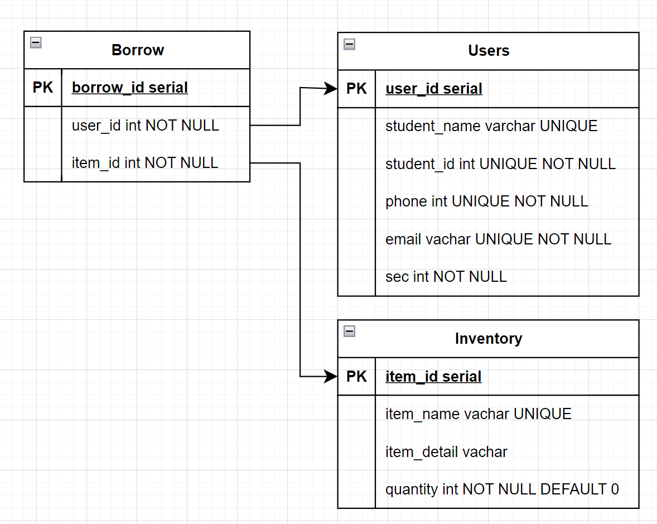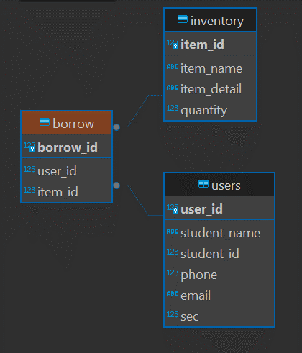

Users Table is collecting student information including phone, email and section in case we need to contact student when item is missing. Next, Inventory table keep item name, detail and quantity. When borrow we can identify exactly what item does the student borrow and after that, quantity in inventory will be decrease

I established relationships between tables using keys: The borrow_id in the ‘Borrow’ table connects to both the user_id in the ‘Users’ table and the item_id in the ‘Inventory’ table. This allows us to determine which user borrowed which item.