SINGAPORE POLYTECHNIC
SCHOOL OF ELECTRICAL & ELECTRONIC ENGINEERING

ET0706 Object Oriented Programming---PROJECT CONCEPT PAPER

Name (Adm)(Class): Chan Yan Hui Ryan p2124179 DCPE/FT/3A/21

Project Title: TuitionFinder – Connecting Students and Tutors through JavaFX

A. Problem Statement (10%)
(Defines the problem clearly and outline the resulting impact. Details the thought process of how you understand the problem.)

As the academic environment within schools become more competitive and rigorous, more and more parents are seeking for more ways to bolster the grades of their younglings through private tuition. However, few of them manage to successfully find the right teachers for their children, as they lack connections and knowledge of online resources to reach them.

The JavaFX application, TuitionFinder, is a one-stop center for both parents and private tutors to match up with each other and set students on the track towards academic success.

B. Special features/business logic/OOP design principles employed (20%)
(Evaluate the pros and cons of the solution proposed. Describe why you think users would find your application cool or useful)

Pros/cool factors:
- The application is split into two parts, via parent account login or tutor account login.
- A parent’s account can create tuition assignments for tutors to accept. They can create as many assignments as they need, in the situation of multiple subjects or multiple children.
- A tutor’s account is designed for tutors to browse our database of student assignments and select assignments that are relevant to their expertise and/or location. They also have a dashboard summarizing all their current students, their teaching calendar, as well as their total pay.
- Evidently, using this application as a parent is a simple way to list out the needs of each child and receive appropriate teaching resources, whereas using this application as a private tutor makes it easy for them to find and secure more commissions, resulting in a win-win for both parties involved.
Cons:
- Back-end logic will be more complex than the typical OOP JavaFX Mini project, which incurs challenges of time and resource management.
C. Wireframe design of JavaFX GUI and/or combined with Flow Chart (20%)
(GUI designs should NOT be hand-drawn. Instead use UI/UX Design Software e.g. Adobe XD)

Wireframe designs made in Figma: link to prototype

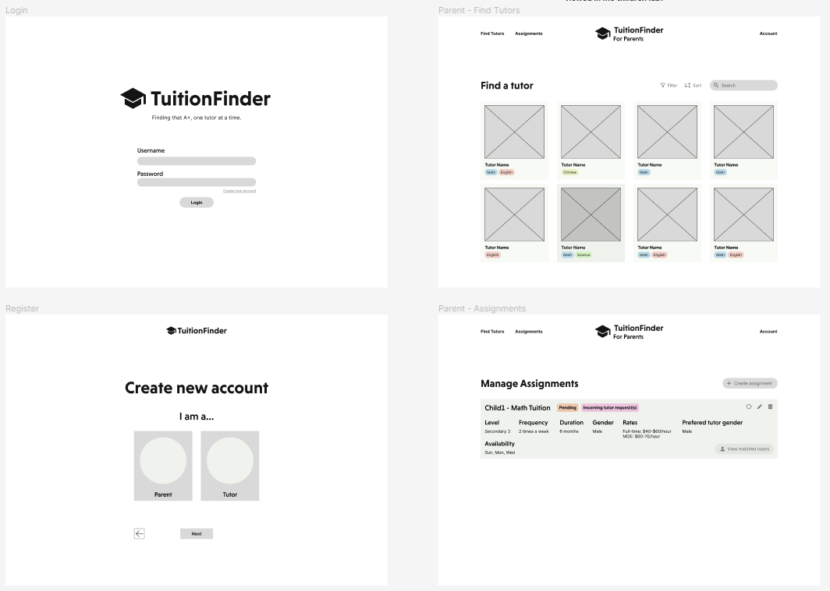

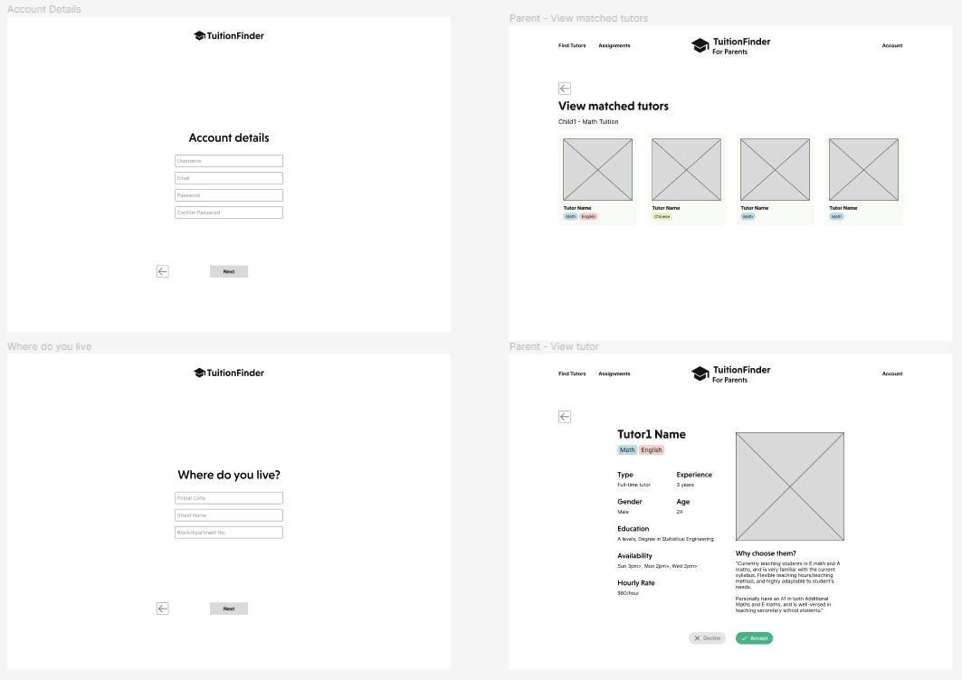

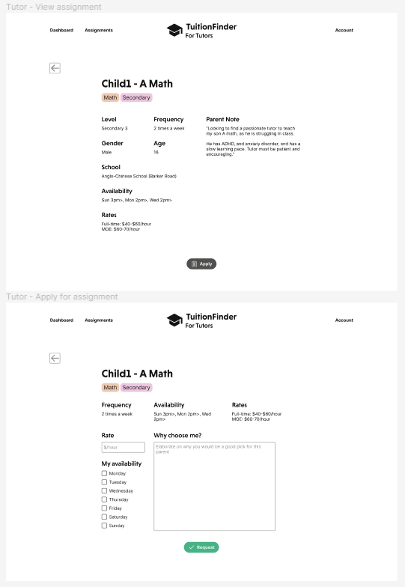

D. Class Design (20%)
(Illustrate UML of OOP Classes to be implemented.)

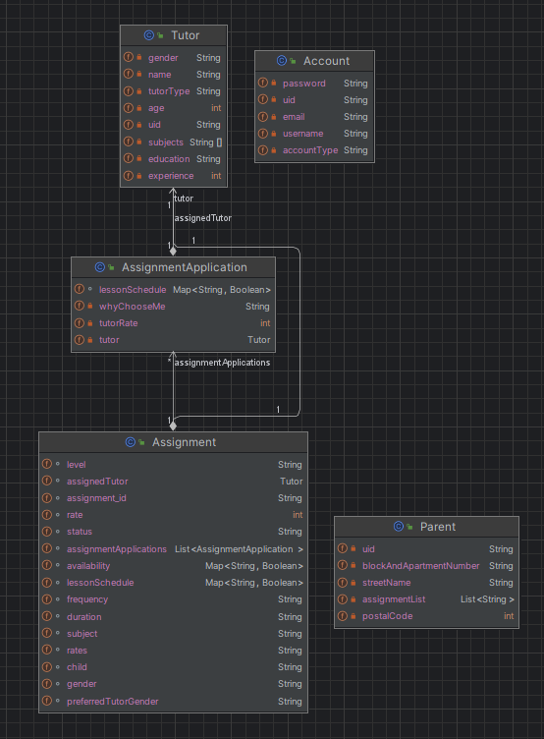

Notes:
- The account class contains basic login information like username, password and email address.
  - The way I’ve chosen to distinguish between a tutor account and a parent account is to link them via a UID (User ID) of the same value.
- Using this class structure the login process can proceed as such:
- Enter login details
- Lookup the accounts class database and find matching account.
- Get the accountType, as well as the UID of this account
- Depending on the accountType, go to the respective Parent/Tutor database and return the object with the same UID.
- A tuition assignment is created by a parent account, and multiple tutors can apply for it via individual assignment applications. A parent can then choose one tutor out of the many who’ve applied for and proceed with the lessons.
- The “assignment” class is a standalone document collection within MongoDB. Parents who create assignments do not store this class within them. Rather, they save a list of assignment IDs associated with them.

E. Database Design (20%)
(List the database tables clearly with columns for each table)

I’ve proposed to store my application’s data via MongoDB documents, as they support JSON structure with nesting.

{
"Accounts" : [
{
"uid": "1234133489",
"username": "RyanHuii",
"email": "abc@gmail.com",
"password": "1234",
"accountType": "Parent"
},
{
"uid": "9085390454",
"username": "seconduser",
"email": "defg@gmail.com",
"password": "0000",
"accountType": "Tutor"
}
],
"Parents" : [
{
"uid": "9085390454",
"postalCode": "142040",
"streetName": "123 Adam Drive",
"blockAndApartmentNumber" : "#09-99",
"assignmentList" : [
"123694d",
"3049587"
]
}
],
"Tutors": [
{
"uid": "9085390454",
"name": "Thomas Yeo",
"gender": "Male",
"age": 33,
"tutorType": "Part-Time",
"experience": 3,
"subjects": ["Math", "Science", "English"],
"education": "A levels, Bachelor in Science"
}
],
"Assignments": [
{
"assignment_id": "123694d",
"child": "Beth",
"subject": "English",
"status": "Pending",
"level": "Primary 4",
"frequency": "twice a week",
"duration": 6,
"gender": "Female",
"rates": "40/hr part-time, 50/h4 full-time",
"availability": [
{
"Monday": 0,
"Tuesday":0,
"Wednesday":0,
"Thursday":1,
"Friday":0,
"Saturday":0,
"Sunday":1
}
]
},
{
"assignment_id": "3049587",
"child": "Ryan",
"subject": "Mathematics",
"status": "Matched",
"level": "Secondary 5",
"frequency": "twice a week",
"duration": 6,
"gender": "Female",
"rates": "40/hr part-time, 50/hr full-time",
"availability": [
{
"Monday": 0,
"Tuesday":0,
"Wednesday":0,
"Thursday":1,
"Friday":0,
"Saturday":0,
"Sunday":1
}
]
}
]
}

F. SDL References (10%)
(List the YouTubes, web sites ChatGPT prompt query etc. referenced)

Learning how to switch scenes within a single window.
https://www.youtube.com/watch?v=hcM-R-YOKkQ&t=273s

SpringBoot MongoDB Atlas tutorial:
https://www.youtube.com/watch?v=qVNOw9TWwxo

Integrating JavaFX into a Spring Boot application
https://www.youtube.com/watch?v=u0dEf-QN-90
https://www.youtube.com/watch?v=01GTN2iXbd8

