Philadelphia Crime Analysis Bulletin
Aggravated Assault, Motor Vehicle Theft, Robbery and Theft from Vehicle, 2015–2025

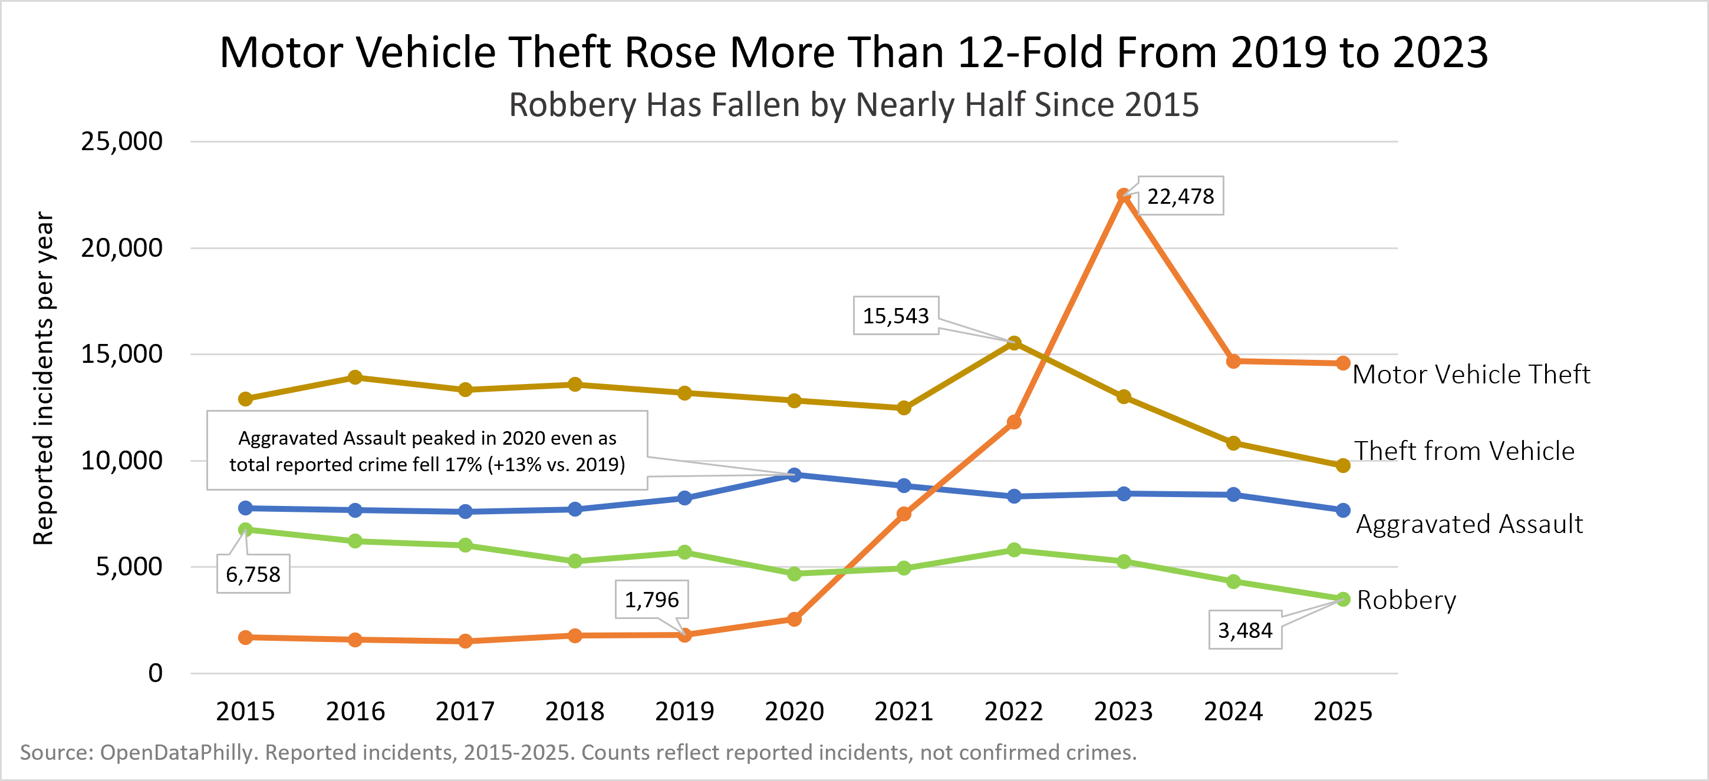  Reported incidents per year, 2015–2025, four focus offenses. | KEY FINDINGS  - Motor vehicle theft: 1,796 reports in 2019 to 22,478 in 2023. It fell to about 14,600 in 2025, still roughly 8x the 2019 level.  - Aggravated assault held at 7,600–8,500 a year. The one exception was 2020 (9,332) while citywide crime fell 17%.  - Robbery is down 48% since 2015 (6,758 to 3,484).  - Theft from vehicle peaked at 15,543 in 2022 after a gradual rise from May to October and was 9,770 in 2025.
Where: Mapped Patterns
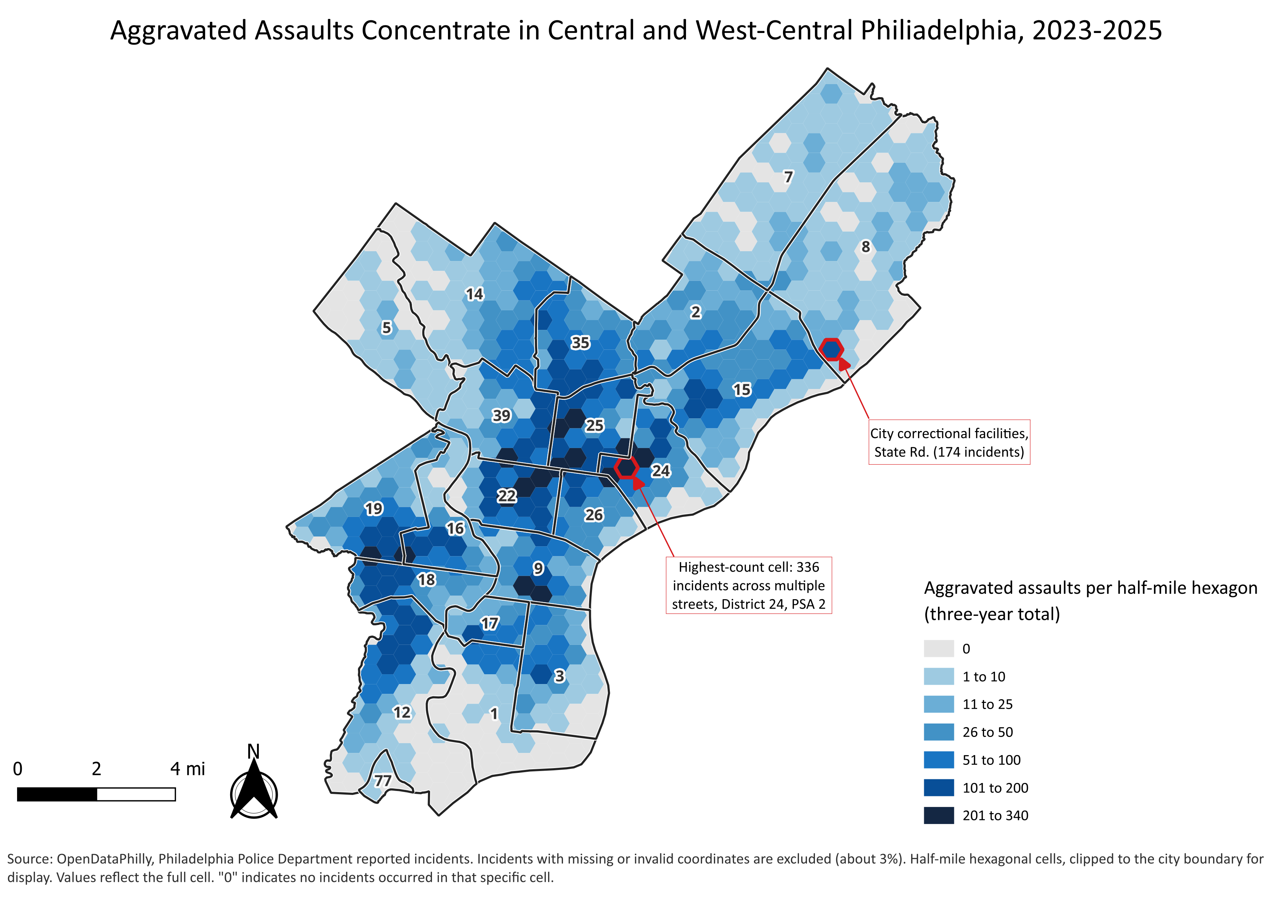  Aggravated assault hotspots, half-mile hexagons | 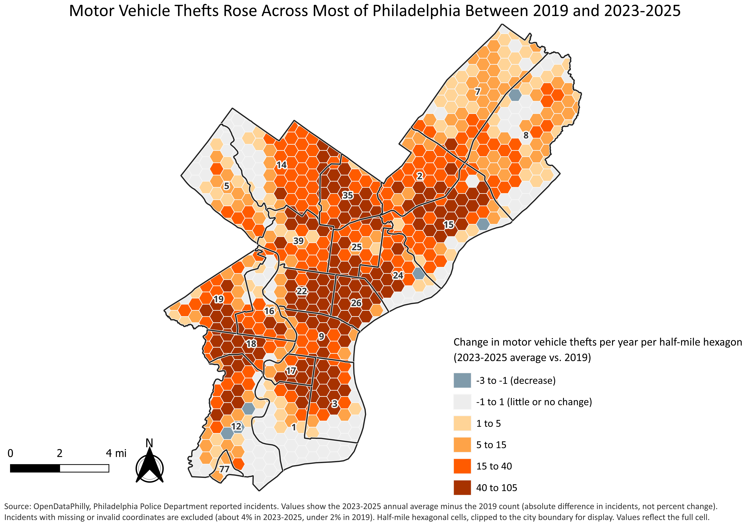  Change in motor vehicle theft, 2019 vs. 2023–2025 average
Aggravated assault clusters in a band across police districts 22, 24, 25 and 9, with secondary clusters in 16, 18 and 19. The densest cell logged 336 incidents at about 264 distinct locations across several adjacent streets, so the pattern is area-wide rather than one address. The State Road cell (174 incidents) reflects city correctional facilities. Motor vehicle theft spread across the city: the busiest half-mile cell averaged about 117 reports a year in 2023–2025, against a maximum of 14 in 2019. The citywide mapped average rose about ninefold (1,769 to 16,540 a year).
When: Time Patterns
Aggravated assault peaks 4–6 PM on weekdays and runs later on weekends; midnight to 4 AM on Saturday and Sunday is about 55% higher than on weekdays. Motor vehicle theft peaks around 8 AM on weekdays, and 7–9 AM accounts for about 25% of reports (13,064 of 51,744), compared with 11% from midnight to 6 AM. The hour is dispatch time, so the morning peak likely reflects when owners discover the loss, not when the theft happened.
Analyst Suggestions
- Aggravated Assault Recommendation: weekday late-afternoon assault patterns may support scheduling patrol or outreach resources around the 4–6 PM window in the darkest-band districts.
- Motor Vehicle Theft Recommendation: morning motor vehicle theft reports suggest overnight thefts, so overnight prevention (steering-wheel locks, lighting, camera coverage in lots) fits better than daytime enforcement.
Data Notes
Source: OpenDataPhilly incidents, 2015–2025. Counts are reported, not confirmed, incidents. Hour is dispatch time; 2023 blank hours were recovered from dispatch time (99.1% agreement). 71 records dated 2014 were excluded. Records without usable coordinates were left out of the maps (aggravated assault 3.4%, motor vehicle theft 4.1%, 2023–2025), along with one default placeholder coordinate and 30 State Plane-format records. Hexagon size (half mile) affects how hotspots look. Hexagons are clipped to the city boundary for display, but values reflect the full cell. District 6 merged into District 9 on May 1, 2024.

