February 18, 2026

Luke Gholston
JLL
1703 W 5th Street, Suite 850
Austin, TX 78703

RE: Lease Proposal to Maev for office space at Eastlake at Tillery

Dear Luke,

On behalf of Eastlake Tillery Owner, LP (“Landlord”), we are pleased to submit the following proposal to Maev (“Tenant”) to lease space at Eastlake at Tillery – Building 1 (the “Building”). The principal points of the transaction are as follow:

Tenant: Maev

Address: 3212 E Cesar Chavez Street
Austin, TX 78702

Project Size: Approximately 176,696 Rentable Square Feet (“RSF”) between two buildings.

Building Size: Building 1 is approximately 78,383 RSF.

Amenities: Eastlake at Tillery is located in East Austin within walking distance of dining options, such as Grizzelda’s, Jacoby’s and Dainty Dillo. Within two miles of Eastlake at Tillery there are approximately 2,100 multi-family units, 1,700 single-family homes, 190 hotel keys, 1.4 million square feet of existing or proposed office space, and over 60 restaurants, breweries, and entertainment options.

Project amenities include a fitness facility with showers and lockers, state of the art and first in our market mother’s suite, a bike locker room, a retrofitted airstream that is used for Tenant events or can be used by Tenants and abundant outdoor gathering space.

Media Gallery: Please take a moment to follow the below links and experience ELT from the comfort of your chair. Along with our project website, the below links provide information and video content to familiarize yourself with exciting elements of the project like our dynamic neighborhood and innovative and full-service mother’s suites:

Eastlake at Tillery

Why A Taste of Koko's Jane Ko Loves East Austin
The Clean Standard
Mother’s Suite

Premises: Spec Suite 1100 consisting of 5,900 rentable square feet (“RSF”) on the first (1st) floor of Building 1.

Add-on Factor: 18.25%

Commencement
Date: Earlier of, (i) Tenants occupancy for business purposes or, (ii) June 1, 2026.

Tenant shall have free early access to the Lease Premises three (3) weeks prior to the Commencement Date to prepare the Lease Premises for business operations, so long as early access does not interfere with construction.

Lease Term: Forty-eight (48) months.

Abatement: The first four (4) months of Gross Rent following the Commencement Date shall be abated.

Base Rent
Schedule: $38.00 per RSF NNN for months 1-12 with 3% annual escalations starting in month 13.

Operating

Expenses: In addition to the annual Base Rent, Tenant shall be responsible for paying its pro-rata share of the building’s actual Operating Expenses for each year of the lease term. 2026 Operating Expenses (“NNN”), inclusive of janitorial service to the Premises, are currently estimated to be $21.97 per RSF.

Phase-In: Tenant shall pay Base Rent and Operating Expenses based on the following RSF.

Months 1 – 12 | 3,300 RSF
Months 13 – 24 | 4,600 RSF
Months 25 – 48 | 5,900 RSF (Entire Premises)

Use: General office.

Tenant Allowance: Landlord shall provide Tenant with an allowance of up to $5.00 per RSF to use towards moving, cabling/data or FF&E.

Holdover: 150% of the Base Rent plus 150% of the OPEX on a daily basis.

Security Deposit/

Letter of Credit/

Guaranty: Subject to Landlords review of Tenants last 2 years and YTD financials.

Renewal: Tenant shall have one (1) option to renew the lease for three (3) years by giving Landlord at least nine (9) months but no more than twelve (12) months prior written notice. The Base Rent shall be equal to the fair market rate. To be further defined in the Lease.

Parking: Tenant shall have access to unreserved parking at a ratio of 3.3 licenses per 1000 RSF leased in the adjacent garage at no charge during the Primary Term of the Lease.

Signage: Tenant shall have the right to Building standard suite signage outside of its Premises.

Building Hours and
Access: Tenant shall have 24/7 access to the Premises 365 days of the year. Landlord shall furnish Tenant air conditioning and heating, from 7:00 a.m. to 7:00 p.m., Monday through Friday, and 8:00 a.m. to 1:00 p.m. Saturday, but not on Sundays and holidays. Automated overtime service for same may be requested on demand by Tenant who shall bear the cost thereof.

Sublease and
Assignment: Tenant shall have the right to sublease the Premises or assign the lease. Landlord and Tenant shall split profits 50/50 after deducting deal costs. Specific language to be addressed in lease.

Property
Management: The Project is professionally managed by AQUILA Management Services.

Green Certification: The Building has achieved 3 Star AEGB and LEED O&M certification.

Brokerage: Tenant has not dealt with any other broker or agent other than Landlord’s Representative, AQUILA Commercial, LLC and Tenant’s agent,
JLL. Tenant shall indemnify and hold Landlord harmless from any other broker claiming a commission or finder’s fee through Tenant.

This letter/proposal is intended solely as a preliminary expression of general intentions and is to be used for discussion purposes only. The parties intend that neither shall have any contractual obligations to the other with respect to the matters referred herein unless and until a definitive agreement has been fully executed and delivered by the parties. The parties agree that this letter/proposal is not intended to create any agreement or obligation by either party to negotiate a definitive lease agreement and imposes no duty whatsoever on either party to continue negotiations, including without limitation any obligation to negotiate in good faith or in any way other than at arm's length. Prior to delivery of a definitive executed agreement, and without any liability to the other party, either party may (1) propose different terms from those summarized herein, (2) enter into negotiations with other parties and/or (3) unilaterally terminate all negotiations with the other party hereto. Terms presented in this proposal are specifically contingent upon Landlord and its Lender’s review and approval. In the event that we have not received a response thirty (30) days following the date listed on the proposal, this proposal will be deemed null and void.

Sincerely,
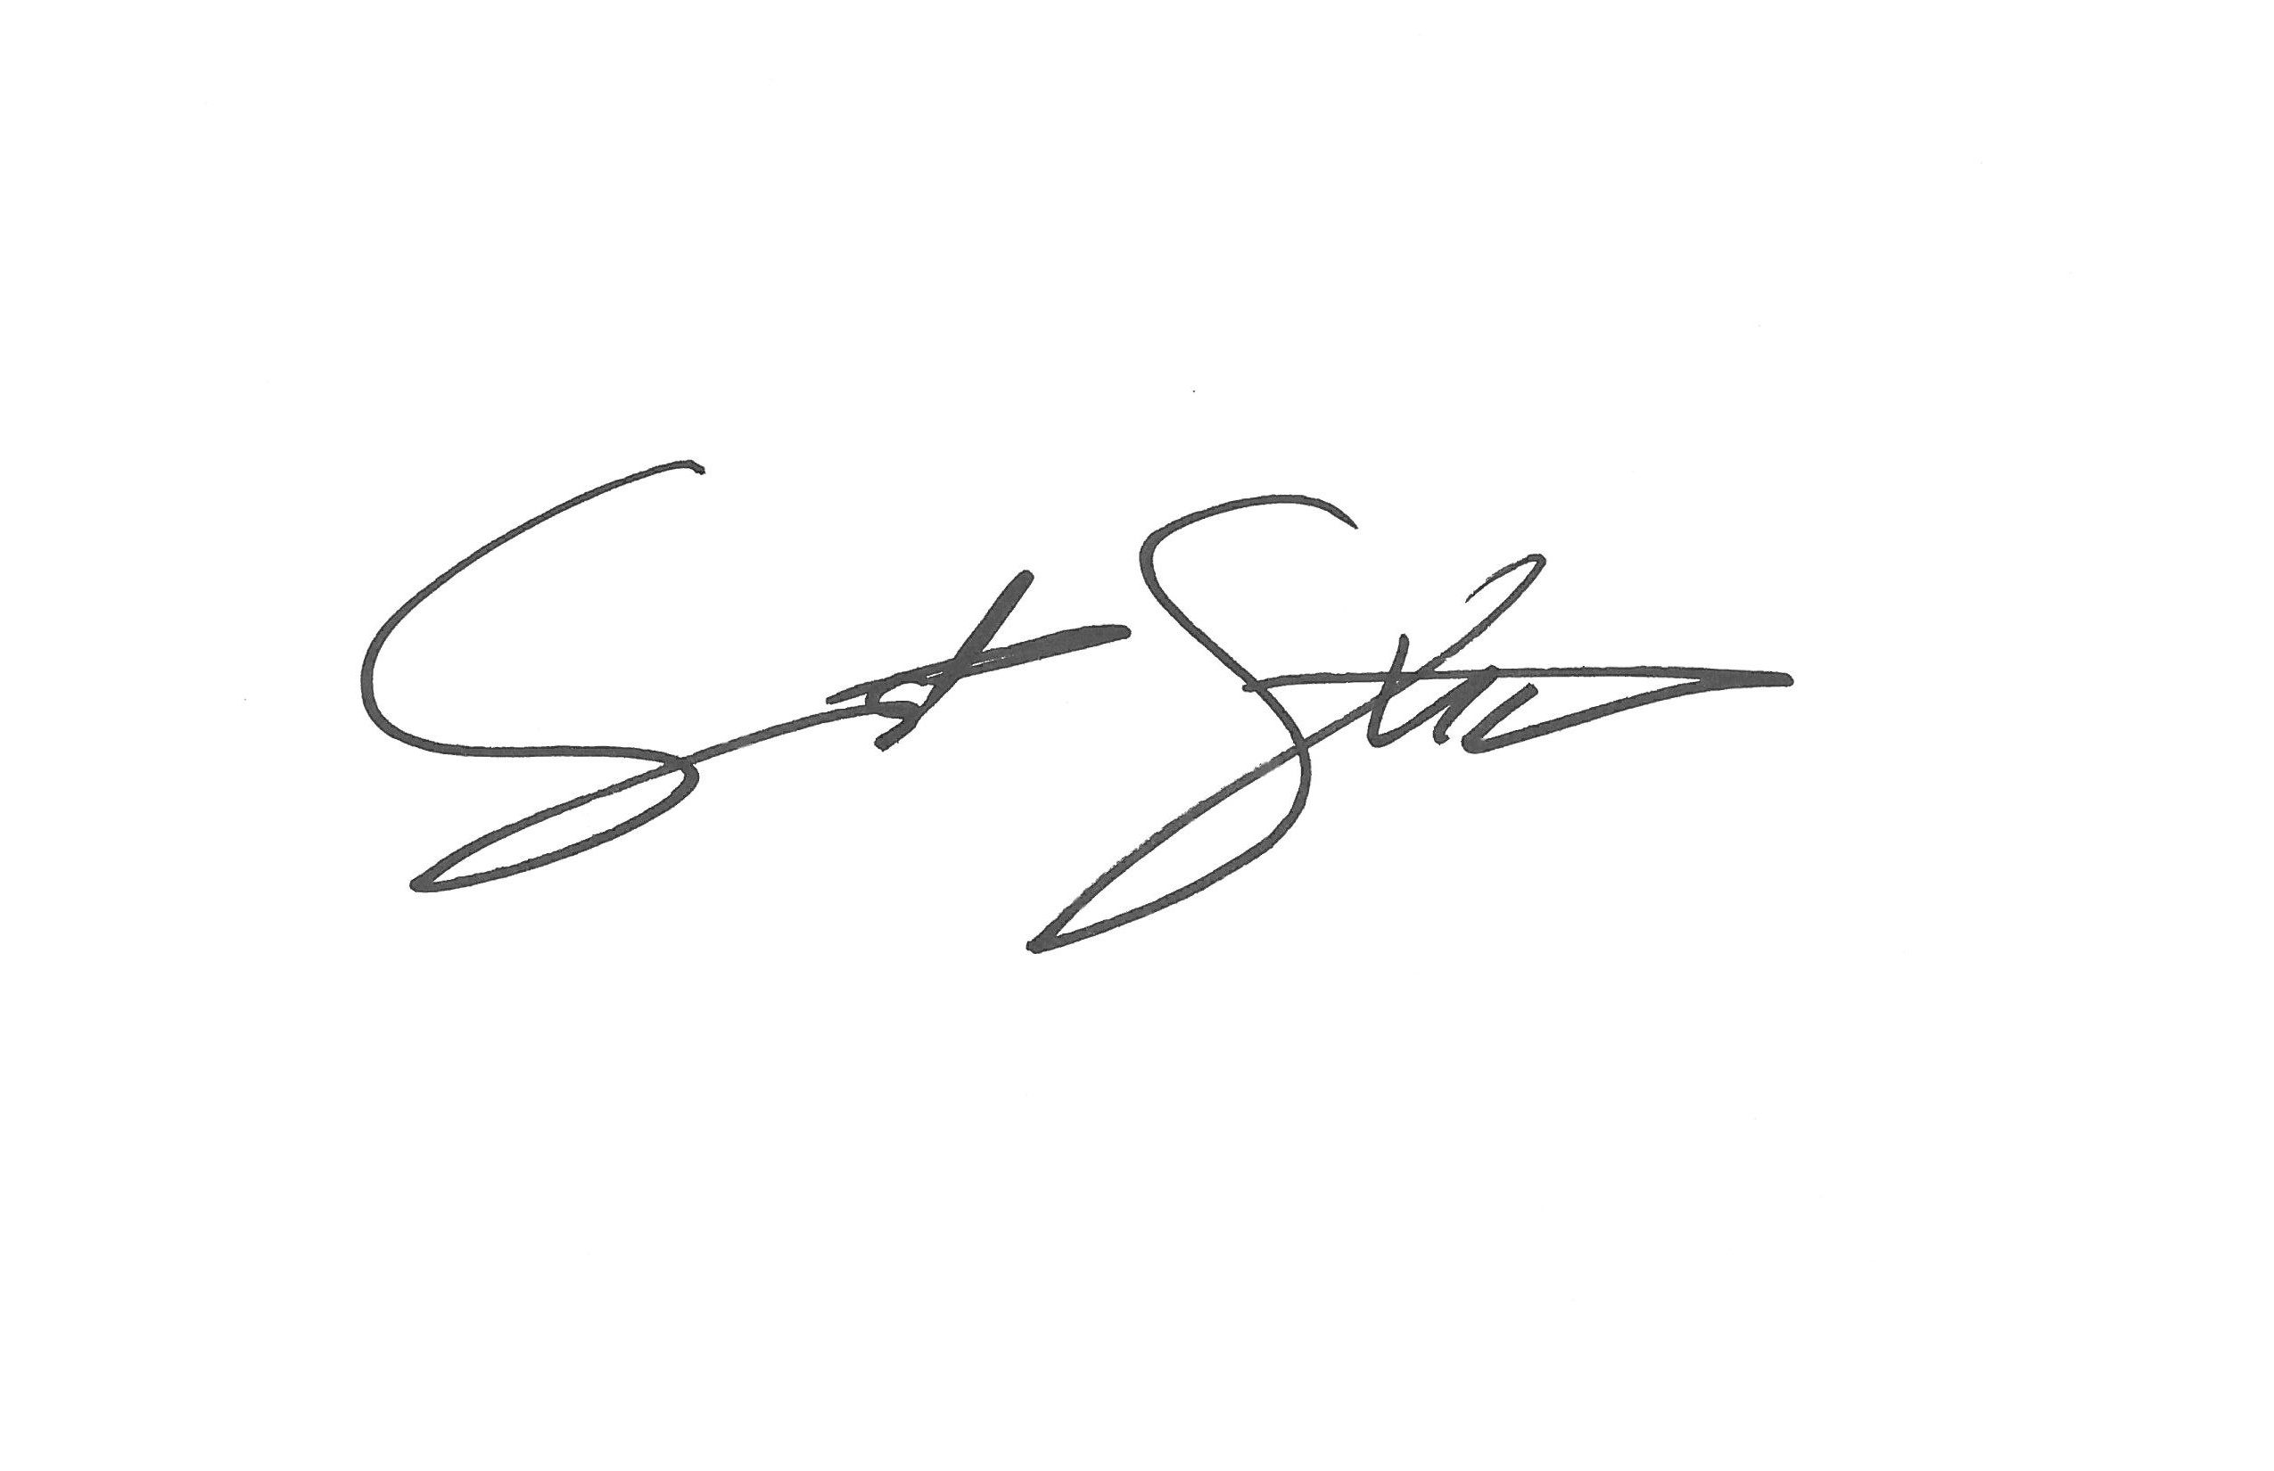
AQUILA Commercial, LLC

Ben Tolson Seth Stuart

AGREED AND ACCEPTED THIS ___ DAY OF _______________ 2026

By:

Its:

TREC
Before working with a real estate broker, you should know that the duties of a broker depend on whom the broker represents. If you are a prospective sell or landlord (owner) or a prospective buyer or tenant (buyer), you should know that the broker who lists the property for sale or lease is the owner’s agent. A broker who acts as a subagent represents the owner in cooperation with the listing broker. A broker who acts as a buyer’s agent represents the buyer. A broker may act as an intermediary between the parties if the parties consent in writing. A broker can assist you in locating a property, preparing a contract or lease, or obtaining financing without representing you. A broker is obligated by law to treat you honestly.

IF THE BROKER REPRESENTS THE OWNER: The broker becomes the owner’s agent by entering into an agreement with the owner, usually through a written listing agreement, or by agreeing to act as a subagent by accepting an offer of subagency from the listing broker. A subagent may work in a d different real estate office. A listing broker or subagent can assist the buyer but does not represent the buyer and must place the interests of the owner first. The buyer should not tell the owner’s agent anything the buyer would not want the owner to know because an owner’s agent must disclose to the owner any material information known to the agent.

IF THE BROKER REPRESENTS THE BUYER: The broker becomes the buyer’s agent by entering into an agreement to represent the buyer, usually through a written buyer representation agreement. A buyer’s agent can assist the owner but does not represent the owner and must place the interests of the buyer first. The owner should not tell a buyer’s agent anything the owner would not want the buyer to know, because a buyer’s agent must disclose to the buyer any material information known to the agent.

IF THE BROKER ACTS AS AN INTERMEDIARY: A broker may act as an intermediary between the parties if the broker complies with the Texas Real Estate License Act. The broker must obtain the written consent of each party to the transaction to act as an intermediary. The written consent must state who will pay the broker and, in conspicuous, bold, or underlined print, set forth the broker’s obligations as an intermediary. The broker is required to treat each party honestly and fairly and to comply with the Texas Real Estate License Act.

A broker who acts an intermediary in a transaction:
(1) shall treat all parties honestly;
(2) may not disclose that the owner will accept a price less than the asking price unless authorized in writing to do so by the owner;
(3) may not disclose that the buyer will pay a price greater that the price submitted in a written offer unless authorized in writing to do so by the buyer; and
(4) may not disclose any confidential information or any information that a party specifically instruct the broker in writing not to disclose unless authorized in writing to disclose the information or required to do so by the Texas Real Estate License Act or a court order or if the information materially relates to the condition of the property.

With the parties consent, a broker acting as an intermediary between the parties may appoint a person who is licensed under the Texas Real Estate License Act and associated with the broker to communicate with and carry out instruction of one party and another person who is licensed under that Act and associated with the broker to communicate with and carry out instruction of the other party.

If you choose to have a broker represent you, you should enter into a written agreement with the broker that clearly establishes the broker’s obligations and your obligations. The agreement should state how and by whom the broker will be paid. You have the right to choose the type of representation, if any, you wish to receive. Your payment of a fee to a broker does not necessarily establish that the broker represents you. If you have any questions regarding the duties and responsibilities of the broker, you should resolve those questions before proceeding.

TEXAS LAW REQUIRES THAT ALL REAL ESTATE LICENSEE’S PRESENT THIS INFORMATION TO PROSEPECTIVE SELLERS, LANDLORDS, BUYERS, OR TENANTS.

ACKNOWLEDGMENT: Please acknowledge your receipt of the information, for Broker’s records.

____________________________________________________________
Buyer (Tenant) or Authorized Representative.

____________________________________________________________
Date

