
LEASE PROPOSAL

PREPARED FOR

Maev

EASTBOUND

AND

LINCOLN PROPERTY COMPANY

February 18, 2026 – Landlord Response

Building: Eastbound - 3232 E. Cesar Chavez St. Austin, Texas 78702 – Building 2.

Premises: Option 1 - 3,226 RSF located in Suite 2-380

Lease Commencement: The Commencement Date shall be upon the substantial completion of the Leasehold Improvements in the Premises, estimated to be May 1, 2026.

Lease Term: Landlord is proposing a 52 month term

Base Rent: Landlord is proposing initial base rent of $42.00 /rsf, net of operating, with 3% annual increases.

Provided that Tenant is not in Default, The initial four (4) months of base rent only shall be abated after the commencement date.

Operating Expenses: In addition to base rent, Tenant will pay its pro-rata share of operating costs, grossed up to 95% occupancy. Estimated operating expenses for 2026 are $14.26. 2025 Operating expenses were $14.35.

All controllable operating expenses shall be capped not to exceed 5% per annum, on a cumulative compounded basis.

Tenant Improvements: Premises is part of Landlord’s spec suite program and will be provided in move in ready condition. Tenant shall be provided an allowance of $1.50 RSF for the installation of power to furniture in the open office space. Tenant shall be responsible for providing data/cabling for Tenant’s equipment, all appliances except a dishwasher and any access control desired for Premises. In lieu of the countertop in Suite 2-380, Landlord will deliver a kitchen island with an over-hang for chair height stools in accordance with Landlord’s current spec plan as further described in Exhibit A.

Signage: Building standard signage shall be provided at the entry to the Premises and on the Building directory at Landlord’s sole cost

Renewal Option: Provided no Event of Default per the lease exists and Tenant is occupying the entire Premises at the time of such election, Landlord will provide Tenant with 1 option to extend the lease for a period of 4 years at the then prevailing fair market value rental rate for renewal of space in the Building of equivalent size, quality, location with the length of the extended term and the credit standing of Tenant to be taken into account with not more than 12 months nor less than 12 months prior written notice to Landlord. Tenant’s right shall be personal to Tenant.

Parking: The Building will provide an overall parking ratio of 3:1000 RSF non-reserved parking spaces in the Building’s attached Parking Garage over the initial term. There shall be no cost for unreserved parking throughout the initial Lease Term.

Security Deposit: Last months’ rent and operating expense due as a security deposit and first month’s rent and operating expense due upon lease execution. Subject to review of Tenant’s financial statements, additional security may be required in the form of a letter of credit or guaranty.

Brokerage: Landlord and Tenant each warrant to the other that it has not dealt with any broker or agent in connection with the negotiation or execution of the Lease other than JLL and Lincoln Property Company, who shall be paid under separate agreement. Tenant and Landlord shall each indemnify each other against all costs, expenses, attorney’s fees and other liability for commission or other compensation claimed by any other broker or agent claiming the same by, through or under the indemnifying party.

The parties recognize the need for confidentiality with respect to the terms herein and the fact that discussions are taking place between the parties about the potential lease of space at the Building. The parties and their advisors shall not disclose to third parties (other than to Landlord’s or Tenant’s counsel who shall be instructed to keep this confidential): the existence of this proposal, the terms thereof and the fact that discussions are taking place regarding the potential leasing of space at the building.

EXHIBIT A

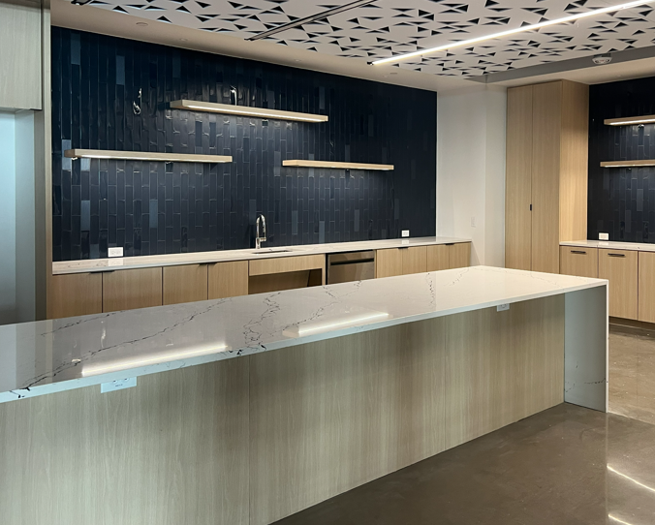

Figure 1 Proposed Premises
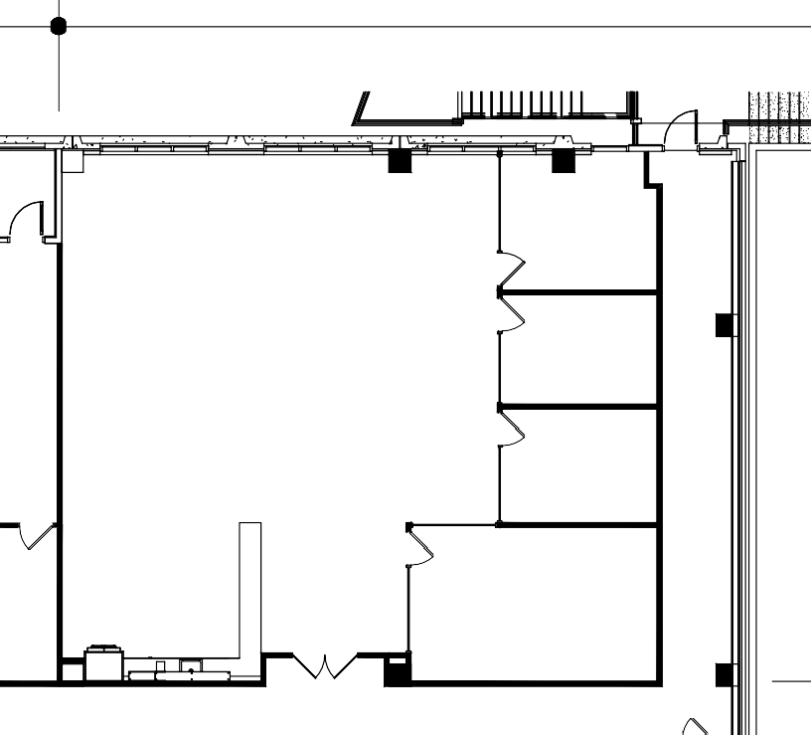
OFFICE
OFFICE
OFFICE
CONFERENCE

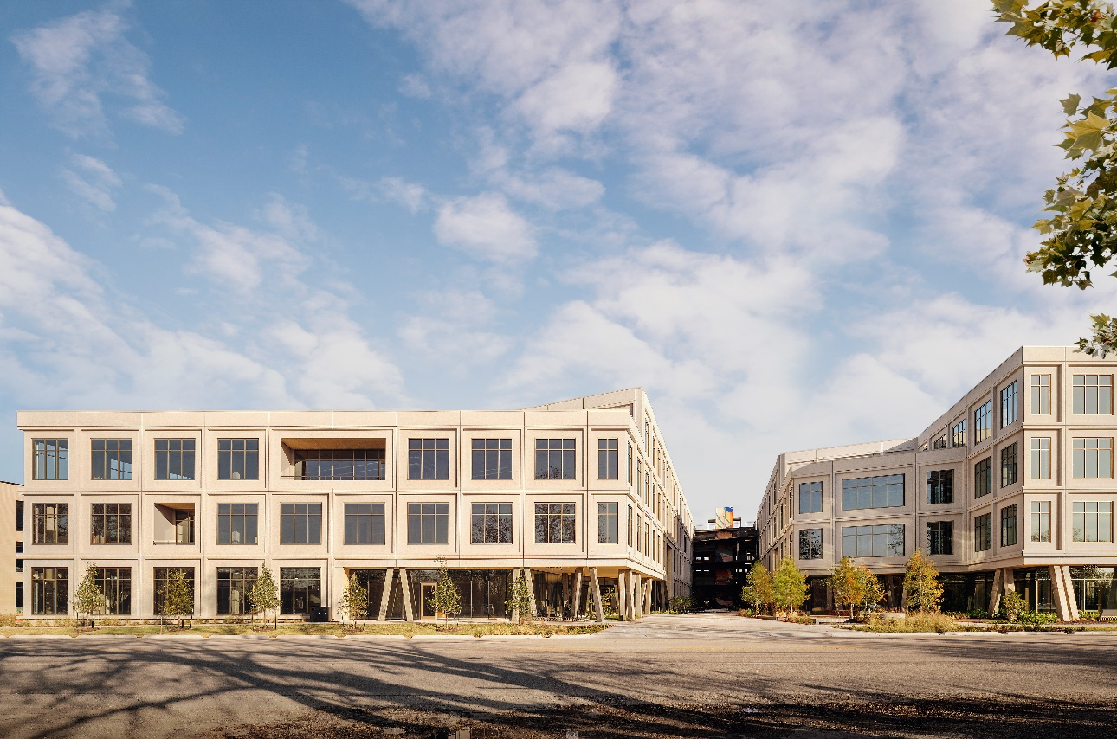
Building Amenities

