Fastpages automatically uses minima as its theme but you can change this to another theme in config.yml:



Here is the result:

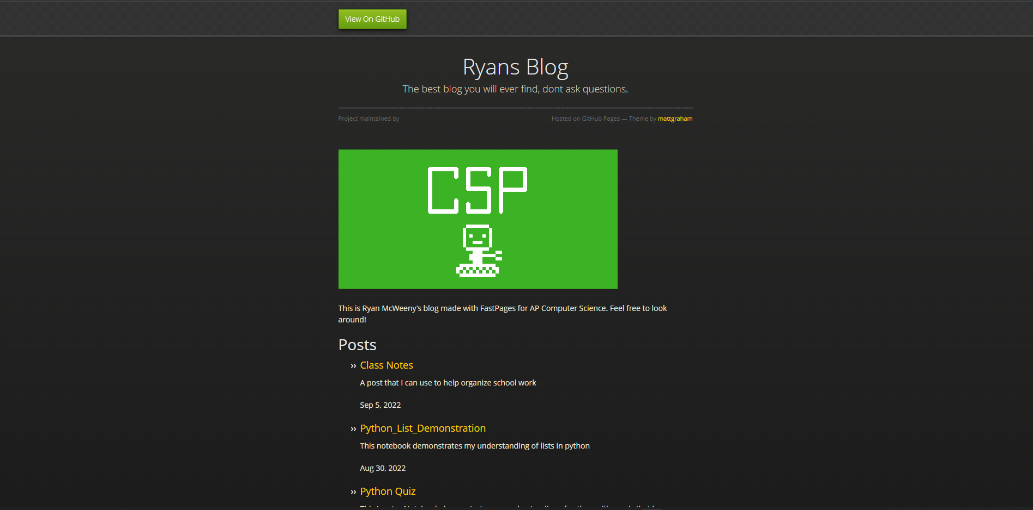

As you can see it is quite different and doesn’t work with all features of fastpages. For example the text colors are off and the “_pages” are not visible on the top bar.