Ryan Loi

5 December, 2018

Abstract

An analysis of the relationships between employee conflicts with managers, job satisfaction and the number of weeks they have worked at their job in 2008

Conflicts and Employee turnover

An essay for SOC3142: Applied Statistical Analysis

Table of Contents

Introduction 3

Literature Review 4

Data Set Descriptions and Univariate Analysis 6

**Data Set Descriptions** 6

Univariate Analysis of WLY_145: Number of weeks worked at the job – Past 12 Months 7

Univariate Analysis of JSR_02: Job Satisfaction 12

Univariate Analysis of SFC_07: Conflicts with Supervisor or Manager – Past 12 Months 15

Bivariate Analysis 18

Bivariate Analysis of JSR_02: Job Satisfaction by WLY_145: Number of Weeks Worked at Job – Past 12 Months 19

Cross Tabulation 19

Graphs 21

Inferential Test 22

Measures of Association 23

Summary 24

Bivariate Analysis of SFC_07: Conflicts with Supervisor or Manager – Past 12 Months by WLY_145: Number of Weeks Worked at Job – Past 12 Months 24

Cross Tabulation Table 25

Graphs 27

Inferential Tests 28

Measures of Association 30

Summary 31

Bivariate Analysis of SFC_07: Conflicts with Supervisor or Manager – Past 12 Months by JSR_02: Job Satisfaction 31

Cross Tabulation Table 31

Graphs 33

Inferential Test 35

Measures of Association 36

Summary 38

Discussion 39

Conclusion 41

References 43

Appendix 44

# Introduction

Employees are a vital part of any organizational structure and managers should try their best to retain as many of them as possible. Failure to maintain employees is problematic and disruptive to the productivity of the organization. In fact, the costs of losing an employee are expensive and detrimental to an organization’s wellbeing. The rate at which employees leave an organization and are replaced by a new employee is measured by an indicator called employee turnover. Human resources departments can measure the employee turnover rate to evaluate whether an organization is succeeding at retaining their employees and generate solutions to decrease the turnover rate and consequently, maintain existing employees. This essay aims to answer the following question: Do the frequency of conflicts between the respondent and their supervisor manager (SFC_07) and job satisfaction (JSR_02) affect the number of weeks worked at the respondent’s current job (WLY_145) of 8512 cases in Canada in 2008?

To answer this question, the variables mentioned in the research question will be analyzed in pairs. The variables which were chosen from the General Social Survey Cycle 30, which was published in 2008. Ordinal by interval-ratio measures were selected to analyze the independent-dependent variable pairs while ordinal by ordinal measures were selected to analyze the two independent variables as a pair. With these analyses, the research will be able to provide an answer to the question.

# Literature Review

Employment turnover is a subject that has been studied numerous times. As a result, there are more resources to refer to, it has become easier to understand this concept and to identify the causes of turnover as well as its effects. Although there is not much research available regarding the number of weeks worked when taking the job satisfaction and conflicts with management into account like what this essay will do, one way to investigate the relationship between the three variables is exploring the likeliness of an employee leaving a job. By exploring the causes of what would entice an employee to leave their job, it could be possible to quantify how many works an employee can work as a result of these causes. In 2010, Dr. Adnan Iqbal studied the causes of employment turnover in Saudi Arabian organizations. What he discovered was that ineffective communication was one of the factors that caused employees to leave their organization.

Small businesses are also worth examining as relationships between employers and employees can be more intimate than relationships in larger businesses. As these businesses are small, there are more frequent interactions between employees and the effects of any conflicts can magnify and resonate quickly (Heavey). This means that during conflicts, employees can easily become more dissatisfied with their relationships in the workplace and consequently, they are more likely to leave as a result of their discomfort.

Researchers Angela L. Heavey and Jacob A. Holwerda and John P. Hausknecht conducted a study on the causes and effects of employment turnover. They determined 6 hypotheses with one of them regarding the quality of work group and supervisory relations. Their hypothesis is, “Climate, cohesiveness, supervisory relations, and OCBs (Organizational citizenship behaviours) will be negatively related to collective turnover; age diversity and tenure diversity will be positively related to collective turnover.” (Heavey) In other words, they expected that positive climates, higher cohesiveness and better supervisory relations with employees has an inverse relationship with an employee’s likeness to leave a business and implicitly, reduce turnover.

Overall, the research obtained suggests that there are a variety of reasons that an employee could leave their employment, but there is some correlation between how satisfied an employee is, the relationship between the employee and the supervisor or manager and how many weeks the employee has worked at their employment at that time; in the case of this essay, this relationship should be negative; the higher the employee’s dissatisfaction at their employment, the fewer weeks the employee will work and the more often an employee has a conflict with their supervisor or manager, the fewer weeks the employee will work.

# Data Set Descriptions and Univariate Analysis

This section is divided into 2 parts: the dataset descriptions, which describe the characteristics of the variable being measured and the statistics of each variable.

## **Data Set Descriptions**

|  |  |  |  |
| --- | --- | --- | --- |
| Variable Name | **WLY_145** | **JSR_02** | **SFC_07** |
| Level of Measurement | Interval-Ratio | Ordinal | Ordinal |
| Variable Label | Number of weeks worked at the job | Job satisfaction | Conflicts with supervisor or manager within past 12 months |
| Variable Definition | How long a person has worked at their job within the year measured as the number of weeks | The respondent’s personal score of how satisfied they are with their employment | The respondent’s response to how often they get into a conflict with a supervisor or manager at their job described with an adjective |
| Variable coverage | Respondents who have responded that they have been employed that year. | Respondents who were currently employed that year | Respondents who were currently employed that year |
| Variable Unit of Analysis | Individuals who are employed | Individuals who are employed | Individuals who are employed |
| Variable Unit of Measurement | The number of weeks | The respondents rating | The respondents rating |
| Variable values (both valid and missing) | Weeks range from 1 to 52  Missing values:  96 = Valid Skip  97 = Don’t know  98 = Refusal  99 = Not stated | 1 = Very satisfied  2 = Satisfied  3 = Neither satisfied nor dissatisfied  4 = Dissatisfied  5 = Very dissatisfied | 1 = Always  2 = Often  3 = Sometimes  4 = Rarely  5 = Never  6 = Do not have supervisor or manager  96 = Valid Skip  97 = Don’t know  98 = Refusal  99 = Not stated |

### Univariate Analysis of WLY_145: Number of weeks worked at the job – Past 12 Months

|  |  |  |  |  |  |
| --- | --- | --- | --- | --- | --- |
| **Number of weeks worked at the job - Past 12 months** | | | | | |
|  | | Frequency | Percent | Valid Percent | Cumulative Percent |
| Valid | 1 | 94 | .5 | .8 | .8 |
| 2 | 95 | .5 | .8 | 1.5 |
| 3 | 85 | .4 | .7 | 2.2 |
| 4 | 159 | .8 | 1.3 | 3.6 |
| 5 | 70 | .4 | .6 | 4.1 |
| 6 | 117 | .6 | 1.0 | 5.1 |
| 7 | 56 | .3 | .5 | 5.5 |
| 8 | 190 | 1.0 | 1.6 | 7.1 |
| 9 | 59 | .3 | .5 | 7.6 |
| 10 | 118 | .6 | 1.0 | 8.6 |
| 11 | 38 | .2 | .3 | 8.9 |
| 12 | 312 | 1.6 | 2.6 | 11.4 |
| 13 | 42 | .2 | .3 | 11.8 |
| 14 | 71 | .4 | .6 | 12.3 |
| 15 | 59 | .3 | .5 | 12.8 |
| 16 | 206 | 1.1 | 1.7 | 14.5 |
| 17 | 30 | .2 | .2 | 14.8 |
| 18 | 45 | .2 | .4 | 15.1 |
| 19 | 25 | .1 | .2 | 15.3 |
| 20 | 185 | .9 | 1.5 | 16.9 |
| 21 | 25 | .1 | .2 | 17.1 |
| 22 | 47 | .2 | .4 | 17.4 |
| 23 | 15 | .1 | .1 | 17.6 |
| 24 | 147 | .7 | 1.2 | 18.8 |
| 25 | 60 | .3 | .5 | 19.3 |
| 26 | 206 | 1.1 | 1.7 | 21.0 |
| 27 | 25 | .1 | .2 | 21.2 |
| 28 | 114 | .6 | .9 | 22.1 |
| 29 | 12 | .1 | .1 | 22.2 |
| 30 | 123 | .6 | 1.0 | 23.2 |
| 31 | 12 | .1 | .1 | 23.3 |
| 32 | 142 | .7 | 1.2 | 24.5 |
| 33 | 15 | .1 | .1 | 24.6 |
| 34 | 32 | .2 | .3 | 24.9 |
| 35 | 48 | .2 | .4 | 25.2 |
| 36 | 138 | .7 | 1.1 | 26.4 |
| 37 | 10 | .1 | .1 | 26.5 |
| 38 | 36 | .2 | .3 | 26.8 |
| 39 | 24 | .1 | .2 | 27.0 |
| 40 | 283 | 1.4 | 2.3 | 29.3 |
| 41 | 21 | .1 | .2 | 29.4 |
| 42 | 80 | .4 | .7 | 30.1 |
| 43 | 32 | .2 | .3 | 30.4 |
| 44 | 148 | .8 | 1.2 | 31.6 |
| 45 | 78 | .4 | .6 | 32.2 |
| 46 | 91 | .5 | .7 | 33.0 |
| 47 | 91 | .5 | .7 | 33.7 |
| 48 | 374 | 1.9 | 3.1 | 36.8 |
| 49 | 149 | .8 | 1.2 | 38.0 |
| 50 | 278 | 1.4 | 2.3 | 40.3 |
| 51 | 91 | .5 | .7 | 41.0 |
| 52 | 7193 | 36.7 | 59.0 | 100.0 |
| Total | 12196 | 62.2 | 100.0 |  |
| Missing | Valid skip | 7215 | 36.8 |  |  |
| Don't know | 114 | .6 |  |  |
| Refusal | 11 | .1 |  |  |
| Not stated | 73 | .4 |  |  |
| Total | 7413 | 37.8 |  |  |
| Total | | 19609 | 100.0 |  |  |

|  |  |  |
| --- | --- | --- |
| **Statistics** | | |
| Number of weeks worked at the job - Past 12 months | | |
| N | Valid | 12196 |
| Missing | 7413 |
| Mean | | 41.86 |
| Median | | 52.00 |
| Mode | | 52 |
| Std. Deviation | | 16.013 |
| Variance | | 256.400 |
| Range | | 51 |
| Percentiles | 25 | 35.00 |
| 50 | 52.00 |
| 75 | 52.00 |
| Interquartile Range |  | 17.00 |

For this variable, 12196 cases were analyzed. From this table, the mean is 41.86 weeks while the median is 52 weeks. As the median is greater than the mean, the distribution is negatively skewed. The mode is 52 weeks which implies that most respondents have worked the entire year. The standard deviation is 16.013 weeks and the range are 51 weeks which suggests that the data is quite dispersed from the mean and the variance is 256.40. The interquartile range is 17 weeks.

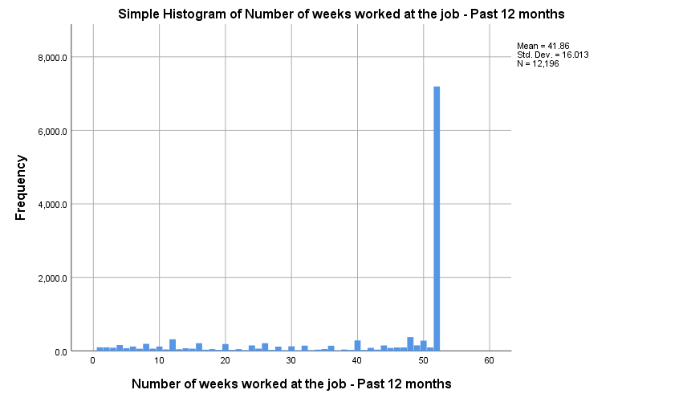

As shown in this bar chart, most respondents have worked 52 years in the year 2008, represented by the evidently long bar which negatively skews the distribution. Aside from that however, there are no significant differences in the number of responses for the other number of weeks.

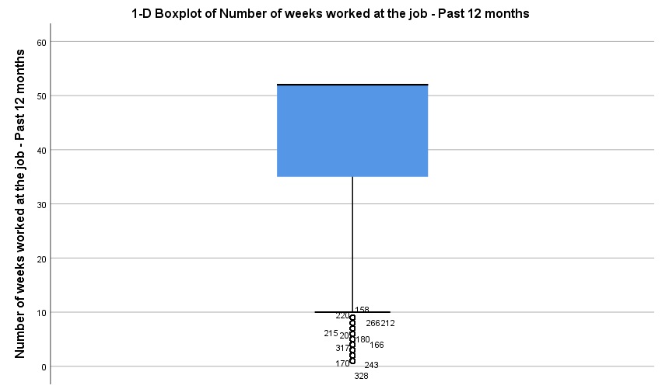

The median, represented by the thick black line, is at 52 and since it is at the upper end of the box, the data is heavily skewed to the right. The maximum number of weeks is at 52 and the minimum is at 10 with some outliers falling underneath it.

### Univariate Analysis of JSR_02: Job Satisfaction

|  |  |  |  |  |  |
| --- | --- | --- | --- | --- | --- |
| **Job satisfaction** | | | | | |
|  | | Frequency | Percent | Valid Percent | Cumulative Percent |
| Valid | Very satisfied | 3175 | 16.2 | 36.4 | 36.4 |
| Satisfied | 4315 | 22.0 | 49.5 | 85.8 |
| Neither satisfied nor dissatisfied | 765 | 3.9 | 8.8 | 94.6 |
| Dissatisfied | 351 | 1.8 | 4.0 | 98.6 |
| Very dissatisfied | 119 | .6 | 1.4 | 100.0 |
| Total | 8725 | 44.5 | 100.0 |  |
| Missing | Valid skip | 10789 | 55.0 |  |  |
| Don't know | 6 | .0 |  |  |
| Refusal | 2 | .0 |  |  |
| Not stated | 87 | .4 |  |  |
| Total | 10884 | 55.5 |  |  |
| Total | | 19609 | 100.0 |  |  |

|  |  |  |
| --- | --- | --- |
| **Statistics** | | |
| Job satisfaction | | |
| N | Valid | 8725 |
| Missing | 10884 |
| Median | | 2.00 |
| Mode | | 2 |
| Range | | 4 |
| Percentiles | 25 | 1.00 |
| 50 | 2.00 |
| 75 | 2.00 |

The median and mode are two meaning that most people responded that they were satisfied with their job. As the median and mode were equal, the distribution is not skewed at all.

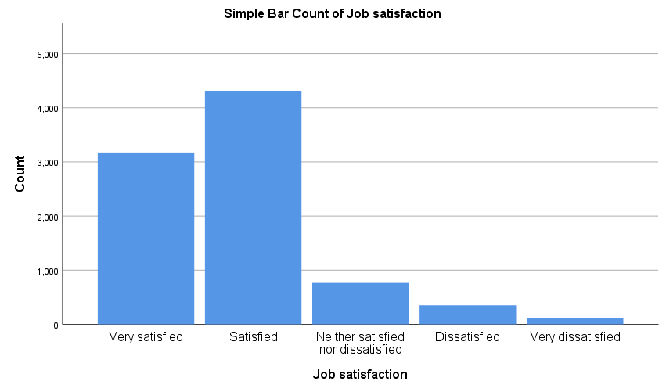

Most individuals reported that they were either very satisfied or satisfied with the rest of the respondents either reporting that they were neither satisfied or dissatisfied or worse and so the distribution is skewed positively.

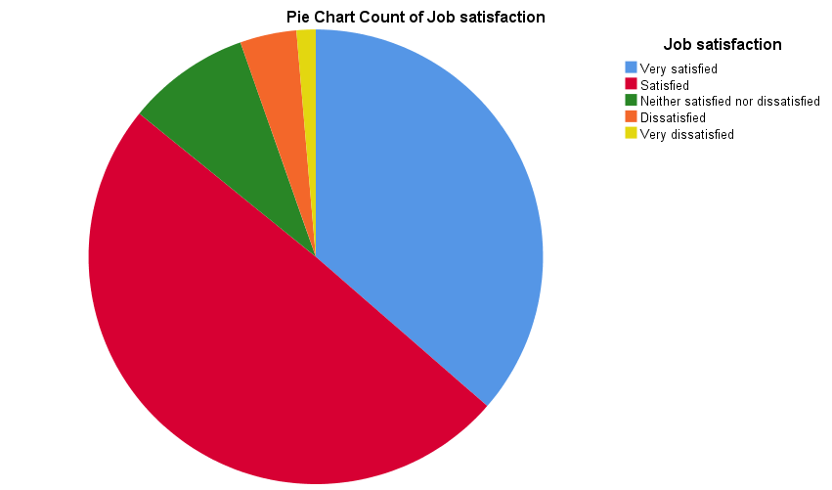

This is another way to show the breakdown of the responses where most of the responses were satisfied or dissatisfied with their job and the remainder of this pie chart is represented by the other responses.

### Univariate Analysis of SFC_07: Conflicts with Supervisor or Manager – Past 12 Months

|  |  |  |  |  |  |
| --- | --- | --- | --- | --- | --- |
| **Conflicts with managers or supervisors at work - Past 12 months** | | | | | |
|  | | Frequency | Percent | Valid Percent | Cumulative Percent |
| Valid | Always | 68 | .3 | .8 | .8 |
| Often | 277 | 1.4 | 3.2 | 4.0 |
| Sometimes | 1215 | 6.2 | 14.2 | 18.3 |
| Rarely | 2820 | 14.4 | 33.1 | 51.4 |
| Never | 4149 | 21.2 | 48.6 | 100.0 |
| Total | 8529 | 43.5 | 100.0 |  |
| Missing | Do not have a supervisor or manager | 185 | .9 |  |  |
| Valid skip | 10789 | 55.0 |  |  |
| Don't know | 13 | .1 |  |  |
| Refusal | 5 | .0 |  |  |
| Not stated | 88 | .4 |  |  |
| Total | 11080 | 56.5 |  |  |
| Total | | 19609 | 100.0 |  |  |

|  |  |  |
| --- | --- | --- |
| **Statistics** | | |
| Conflicts with managers or supervisors at work - Past 12 months | | |
| N | Valid | 8529 |
| Missing | 11080 |
| Median | | 4.00 |
| Mode | | 5 |
| Range | | 4 |
| Percentiles | 25 | 4.00 |
| 50 | 4.00 |
| 75 | 5.00 |

The median is 4 (rarely) and the mode is 5 (never). Most respondents responded that conflict either rarely occurs or never occurs at all. This suggests that the distribution is skewed to the right.

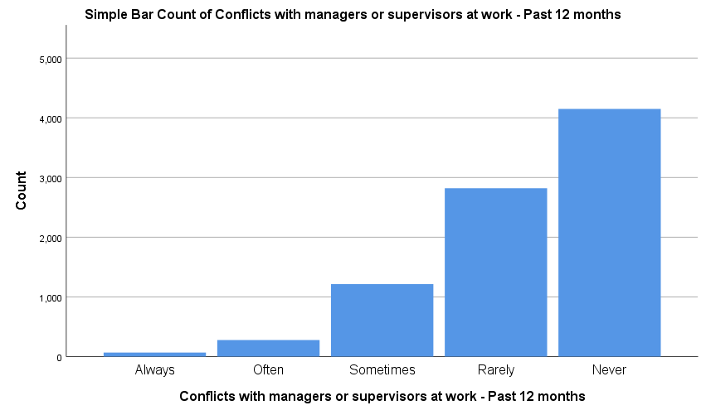

Most of the individuals reported that they rarely or never had a conflict with their supervisor or manager while some reported that they sometimes have a conflict and a very small number of respondents reported that they often or always had a conflict. The distribution is skewed to the right.

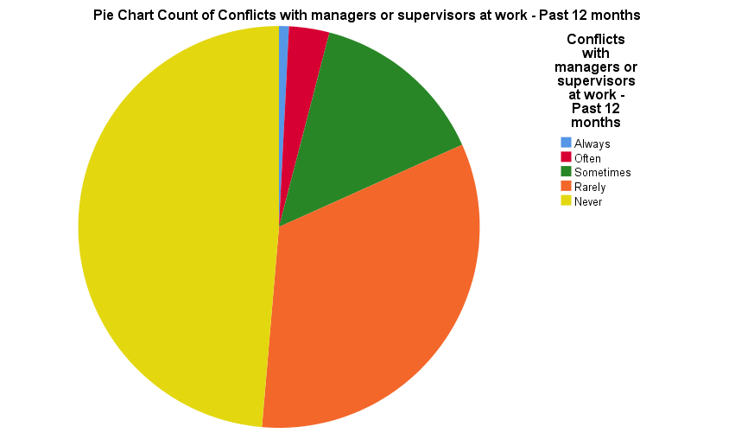

This pie chart again shows that most respondents answered that they never or rarely had a conflict with their supervisor or manage and the rest either reported that they sometimes had a conflict or had a conflict more frequently.

# Bivariate Analysis

The bivariate analysis section analyzes the pairs of these variables. The pairs analyzed are the independent by dependent variables and the independent by independent variables. Each analysis is divided into 5 sections: Cross Tabulation Table, Graphs, Inferential Test, Measures of Association and Summary.

## Bivariate Analysis of JSR_02: Job Satisfaction by WLY_145: Number of Weeks Worked at Job – Past 12 Months

### Cross Tabulation

|  |  |  |  |  |  |  |
| --- | --- | --- | --- | --- | --- | --- |
| **Case Processing Summary** | | | | | | |
|  | Cases | | | | | |
| Valid | | Missing | | Total | |
| N | Percent | N | Percent | N | Percent |
| Job satisfaction * Number of weeks worked at the job - Past 12 months | 8683 | 44.3% | 10926 | 55.7% | 19609 | 100.0% |

|  |  |  |  |  |  |  |  |
| --- | --- | --- | --- | --- | --- | --- | --- |
|  | | Job satisfaction | | | | | Total |
| Very satisfied | Satisfied | Neither satisfied nor dissatisfied | Dissatisfied | Very dissatisfied |
| Number of weeks worked at the job - Past 12 months | 1 | 7 | 14 | 4 | 2 | 0 | 27 |
| 2 | 8 | 17 | 2 | 1 | 0 | 28 |
| 3 | 10 | 14 | 3 | 0 | 1 | 28 |
| 4 | 19 | 22 | 3 | 1 | 1 | 46 |
| 5 | 9 | 13 | 5 | 0 | 1 | 28 |
| 6 | 16 | 15 | 4 | 3 | 3 | 41 |
| 7 | 5 | 10 | 1 | 0 | 0 | 16 |
| 8 | 39 | 28 | 6 | 5 | 0 | 78 |
| 9 | 12 | 8 | 5 | 2 | 0 | 27 |
| 10 | 20 | 25 | 8 | 3 | 1 | 57 |
| 11 | 7 | 8 | 3 | 0 | 0 | 18 |
| 12 | 57 | 73 | 21 | 6 | 3 | 160 |
| 13 | 8 | 11 | 1 | 1 | 0 | 21 |
| 14 | 12 | 17 | 3 | 2 | 0 | 34 |
| 15 | 8 | 15 | 4 | 0 | 0 | 27 |
| 16 | 35 | 40 | 10 | 3 | 3 | 91 |
| 17 | 5 | 13 | 0 | 0 | 0 | 18 |
| 18 | 9 | 9 | 4 | 1 | 0 | 23 |
| 19 | 4 | 4 | 2 | 0 | 0 | 10 |
| 20 | 24 | 47 | 5 | 1 | 1 | 78 |
| 21 | 5 | 5 | 1 | 1 | 0 | 12 |
| 22 | 6 | 13 | 3 | 1 | 0 | 23 |
| 23 | 2 | 5 | 1 | 0 | 0 | 8 |
| 24 | 28 | 46 | 8 | 2 | 0 | 84 |
| 25 | 11 | 14 | 1 | 1 | 0 | 27 |
| 26 | 40 | 64 | 11 | 5 | 0 | 120 |
| 27 | 5 | 8 | 3 | 1 | 0 | 17 |
| 28 | 18 | 38 | 8 | 0 | 1 | 65 |
| 29 | 5 | 3 | 1 | 0 | 0 | 9 |
| 30 | 24 | 29 | 5 | 4 | 0 | 62 |
| 31 | 2 | 4 | 0 | 0 | 0 | 6 |
| 32 | 26 | 39 | 9 | 2 | 2 | 78 |
| 33 | 4 | 5 | 2 | 0 | 0 | 11 |
| 34 | 6 | 9 | 2 | 3 | 1 | 21 |
| 35 | 12 | 14 | 1 | 0 | 0 | 27 |
| 36 | 28 | 37 | 9 | 5 | 3 | 82 |
| 37 | 2 | 2 | 2 | 0 | 0 | 6 |
| 38 | 6 | 12 | 3 | 0 | 0 | 21 |
| 39 | 6 | 6 | 2 | 0 | 0 | 14 |
| 40 | 56 | 85 | 16 | 8 | 0 | 165 |
| 41 | 3 | 5 | 2 | 3 | 0 | 13 |
| 42 | 19 | 37 | 6 | 2 | 0 | 64 |
| 43 | 8 | 8 | 0 | 2 | 0 | 18 |
| 44 | 47 | 51 | 3 | 4 | 1 | 106 |
| 45 | 14 | 29 | 4 | 5 | 1 | 53 |
| 46 | 24 | 22 | 5 | 2 | 0 | 53 |
| 47 | 23 | 43 | 9 | 1 | 1 | 77 |
| 48 | 97 | 136 | 29 | 8 | 2 | 272 |
| 49 | 38 | 66 | 7 | 5 | 0 | 116 |
| 50 | 68 | 107 | 13 | 10 | 2 | 200 |
| 51 | 24 | 32 | 5 | 4 | 1 | 66 |
| 52 | 2191 | 2916 | 495 | 240 | 89 | 5931 |
| Total | | 3162 | 4293 | 760 | 350 | 118 | 8683 |

*Table had to be transposed to fit data onto page

### Graphs

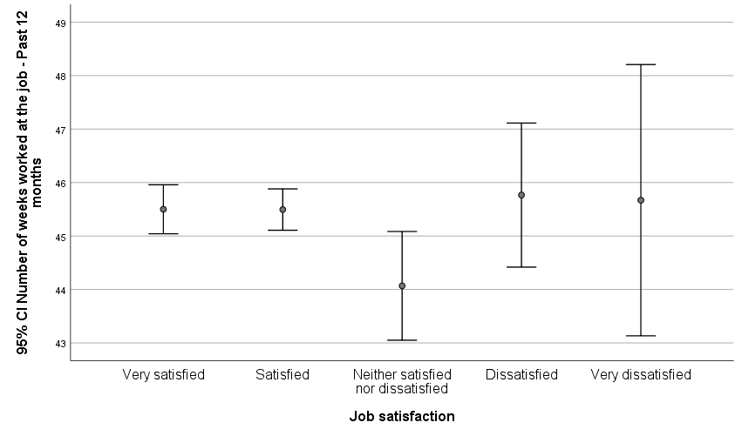

The response categories overlap each other either slightly or completely, meaning that there is no statistically significant difference between the two variables.

### Inferential Test

**Hypotheses**

The test we will need to use is the ANOVA test:

Null hypothesis - H0: μ Very Satisfied = μ Satisfied = μ Neither satisfied nor dissatisfied = μ dissatisfied = μ very dissatisfied  
Research hypothesis – H1: At least one of the means is different

|  |
| --- |
|  |

|  |  |  |  |  |  |
| --- | --- | --- | --- | --- | --- |
| **ANOVA** | | | | | |
| Number of weeks worked at the job - Past 12 months | | | | | |
|  | Sum of Squares | df | Mean Square | F | Sig. |
| Between Groups | 1473.819 | 4 | 368.455 | 2.134 | .074 |
| Within Groups | 1498462.108 | 8678 | 172.674 |  |  |
| Total | 1499935.928 | 8682 |  |  |  |

The F critical is 2.37 as dfw = (8683 – 5) = 8678 and dfb = 4.

The F obtained  is 2.134 at the 95% confidence level and its associated p-value is 0.074. With that, this value is greater than the preselected alpha value of 0.05 which means the Fcritical exceeds the Fobtained and therefore, we fail to reject the null hypothesis, indicating that the means of the response categories are equal and thus, there is no statistically significant difference between the two variables.

### Measures of Association

|  |  |  |  |
| --- | --- | --- | --- |
| **Directional Measures** | | | |
|  | | | Value |
| Nominal by Interval | Eta | Job satisfaction Dependent | .067 |
| Number of weeks worked at the job - Past 12 months Dependent | .031 |
|  | Eta Squared | Job Satisfaction Dependent | 0.4489 |
|  |  | Number of weeks worked at the job - Past 12 months Dependent | 0.0961 |

Taking the eta value of 0.067, squaring it evaluates to 0.0961, indicating a weak positive association between the two variables. About 9% of the change in the number of weeks worked can be explained by the change in the respondent’s job satisfaction.

|  |  |  |  |  |  |
| --- | --- | --- | --- | --- | --- |
| **Symmetric Measures** | | | | | |
|  | | Value | Asymptotic Standard Errora | Approximate Tb | Approximate Significance |
| Ordinal by Ordinal | Gamma | -.025 | .017 | -1.473 | .141 |
| N of Valid Cases | | 8683 |  |  |  |
| a. Not assuming the null hypothesis. | | | | | |
| b. Using the asymptotic standard error assuming the null hypothesis. | | | | | |

The gamma of these two variables is -0.025, indicating a very weak negative association between the two variables and is significant at 0.141.

### Summary

The results were obtained using the ANOVA inferential test, eta and eta squared and Kruskal’s gamma. Given the results generated above, the null hypothesis was not rejected and the associations between the two variables were weak. This means that the respondent’s rating on job satisfaction does not influence the number of weeks the respondent has worked at their job by much.

## Bivariate Analysis of SFC_07: Conflicts with Supervisor or Manager – Past 12 Months by WLY_145: Number of Weeks Worked at Job – Past 12 Months

### Cross Tabulation Table

|  |  |  |  |  |  |  |
| --- | --- | --- | --- | --- | --- | --- |
| **Case Processing Summary** | | | | | | |
|  | Cases | | | | | |
| Valid | | Missing | | Total | |
| N | Percent | N | Percent | N | Percent |
| Conflicts with managers or supervisors at work - Past 12 months * Number of weeks worked at the job - Past 12 months | 8489 | 43.3% | 11120 | 56.7% | 19609 | 100.0% |

|  |  |  |  |  |  |  |  |
| --- | --- | --- | --- | --- | --- | --- | --- |
|  | | Conflicts with managers or supervisors at work - Past 12 months | | | | | Total |
| Always | Often | Sometimes | Rarely | Never |
| Number of weeks worked at the job - Past 12 months | 1 | 0 | 4 | 2 | 5 | 16 | 27 |
| 2 | 0 | 2 | 3 | 7 | 14 | 26 |
| 3 | 1 | 1 | 3 | 3 | 20 | 28 |
| 4 | 0 | 1 | 10 | 3 | 30 | 44 |
| 5 | 0 | 1 | 5 | 6 | 16 | 28 |
| 6 | 0 | 1 | 4 | 8 | 28 | 41 |
| 7 | 0 | 0 | 1 | 3 | 12 | 16 |
| 8 | 0 | 0 | 4 | 13 | 58 | 75 |
| 9 | 0 | 0 | 2 | 7 | 17 | 26 |
| 10 | 0 | 1 | 7 | 13 | 36 | 57 |
| 11 | 0 | 0 | 2 | 4 | 11 | 17 |
| 12 | 1 | 5 | 17 | 42 | 91 | 156 |
| 13 | 0 | 0 | 3 | 1 | 17 | 21 |
| 14 | 0 | 1 | 0 | 7 | 25 | 33 |
| 15 | 0 | 0 | 4 | 6 | 16 | 26 |
| 16 | 2 | 2 | 12 | 23 | 52 | 91 |
| 17 | 0 | 0 | 2 | 6 | 10 | 18 |
| 18 | 0 | 1 | 2 | 6 | 11 | 20 |
| 19 | 1 | 0 | 2 | 1 | 6 | 10 |
| 20 | 0 | 2 | 7 | 20 | 47 | 76 |
| 21 | 0 | 1 | 3 | 2 | 5 | 11 |
| 22 | 0 | 0 | 3 | 7 | 12 | 22 |
| 23 | 0 | 0 | 2 | 3 | 3 | 8 |
| 24 | 1 | 2 | 6 | 21 | 52 | 82 |
| 25 | 0 | 2 | 2 | 6 | 16 | 26 |
| 26 | 2 | 4 | 17 | 28 | 68 | 119 |
| 27 | 0 | 0 | 1 | 4 | 12 | 17 |
| 28 | 0 | 4 | 2 | 23 | 35 | 64 |
| 29 | 0 | 0 | 2 | 3 | 4 | 9 |
| 30 | 1 | 1 | 5 | 16 | 34 | 57 |
| 31 | 0 | 0 | 1 | 3 | 2 | 6 |
| 32 | 0 | 0 | 11 | 20 | 45 | 76 |
| 33 | 0 | 0 | 1 | 6 | 4 | 11 |
| 34 | 2 | 2 | 2 | 6 | 9 | 21 |
| 35 | 0 | 1 | 3 | 8 | 15 | 27 |
| 36 | 1 | 2 | 8 | 23 | 47 | 81 |
| 37 | 0 | 0 | 1 | 1 | 4 | 6 |
| 38 | 0 | 0 | 1 | 8 | 12 | 21 |
| 39 | 0 | 0 | 3 | 2 | 9 | 14 |
| 40 | 0 | 7 | 23 | 63 | 72 | 165 |
| 41 | 0 | 0 | 1 | 6 | 5 | 12 |
| 42 | 0 | 5 | 11 | 16 | 30 | 62 |
| 43 | 0 | 1 | 0 | 5 | 12 | 18 |
| 44 | 0 | 3 | 11 | 28 | 63 | 105 |
| 45 | 1 | 1 | 8 | 24 | 17 | 51 |
| 46 | 1 | 2 | 3 | 19 | 27 | 52 |
| 47 | 0 | 3 | 13 | 28 | 31 | 75 |
| 48 | 0 | 10 | 45 | 85 | 127 | 267 |
| 49 | 0 | 3 | 21 | 37 | 52 | 113 |
| 50 | 0 | 4 | 22 | 61 | 108 | 195 |
| 51 | 1 | 4 | 7 | 16 | 35 | 63 |
| 52 | 51 | 192 | 879 | 2051 | 2624 | 5797 |
| Total | | 66 | 276 | 1210 | 2813 | 4124 | 8489 |

*Table has been transposed to fit the margins of the paper

### Graphs

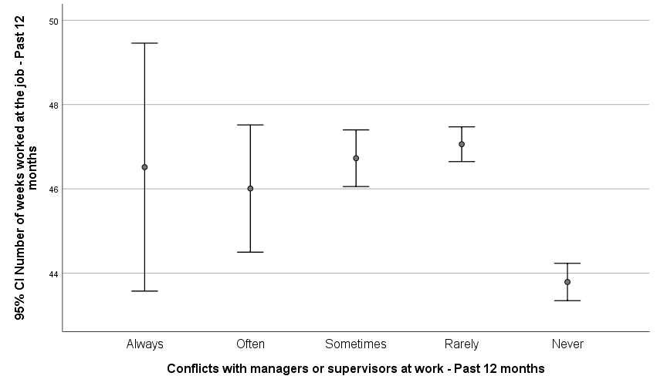

The error bars overlap with each other except for the “Never” response category who only overlaps with “Always”. The overlap between these error bars suggests that there is no statistically significant difference between the two variables.

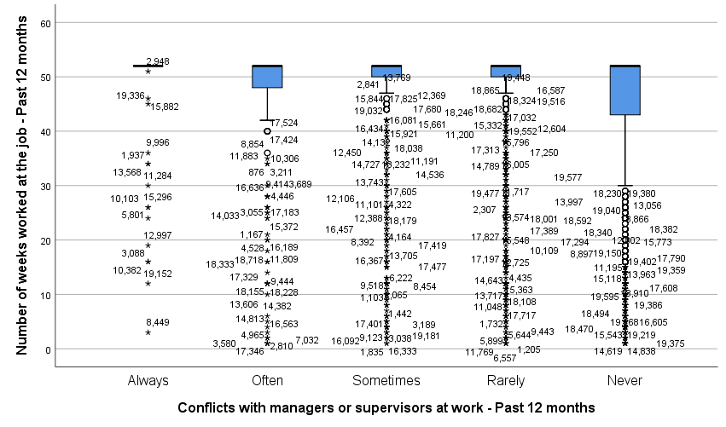

Most people responded that they never had a conflict with their supervisor or manager but with that, there seemed to be a wider range of responses for the amount of weeks which were worked. If there really was a relationship between the two, it would be expected to see the boxes for the “always” and “often” categories be placed lower which would mean that when there are more conflicts, individuals were more likely to work fewer weeks than those who were satisfied but in this graph here, the sizes of the boxes aren’t too different from each other although the range of responses might be.

### Inferential Tests

**Hypotheses**

The test we will use is the ANOVA test.

Null hypothesis - H0: μ Always= μ Often = μ Sometimes = μ Rarely = μ Never  
Research hypothesis – H1: At least one of the means is different

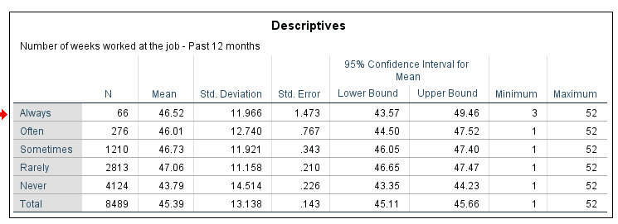

|  |  |  |  |  |  |
| --- | --- | --- | --- | --- | --- |
| **ANOVA** | | | | | |
| Number of weeks worked at the job - Past 12 months | | | | | |
|  | Sum of Squares | df | Mean Square | F | Sig. |
| Between Groups | 20736.338 | 4 | 5184.085 | 30.449 | .000 |
| Within Groups | 1444437.814 | 8484 | 170.254 |  |  |
| Total | 1465174.152 | 8488 |  |  |  |

The F critical is 2.37 as dfb = (16978 – 5) = 16973 and dfw = 5 – 1 = 4

The F Obtained is 30.449 with the p level at 0.000. As the p value is less than the preselected alpha level of 0.05 and because the F Obtained exceeds the F Critical, we reject the null hypothesis and can conclude that there is a statistically significant difference in the means of the independent variable.

### Measures of Association

|  |  |  |  |
| --- | --- | --- | --- |
| **Directional Measures** | | | |
|  | | | Value |
| Nominal by Interval | Eta | Conflicts with managers or supervisors at work - Past 12 months Dependent | .123 |
| Number of weeks worked at the job - Past 12 months Dependent | .119 |
|  | Eta Squared | Conflicts with managers or supervisors at work - Past 12 months Dependent | 0.015129 |
|  |  | Number of weeks worked at the job - Past 12 months Dependent | 0.014161 |

Taking the value of eta, squaring it equals 0.014161, which indicates a very weak positive association between the two variables.

|  |  |  |  |  |  |
| --- | --- | --- | --- | --- | --- |
| **Symmetric Measures** | | | | | |
|  | | Value | Asymptotic Standard Errora | Approximate Tb | Approximate Significance |
| Ordinal by Ordinal | Gamma | -.154 | .017 | -9.236 | .000 |
| N of Valid Cases | | 8489 |  |  |  |
| a. Not assuming the null hypothesis. | | | | | |
| b. Using the asymptotic standard error assuming the null hypothesis.  Gamma is -0.154, indicating a weak negative relationship between the two variables. | | | | | |

### Summary

The results were obtained using the ANOVA test, eta and eta squared and gamma. This time, the null hypothesis was rejected, suggesting that there is a correlation between the frequency of conflicts between the respondent and the supervisor or manager and the number of weeks worked during that year. With this, the measures of associations suggested that the correlation is weak and so the frequency of conflicts affects the number of weeks slightly.

## Bivariate Analysis of SFC_07: Conflicts with Supervisor or Manager – Past 12 Months by JSR_02: Job Satisfaction

### Cross Tabulation Table

|  |  |  |  |  |  |  |
| --- | --- | --- | --- | --- | --- | --- |
| **Case Processing Summary** | | | | | | |
|  | Cases | | | | | |
| Valid | | Missing | | Total | |
| N | Percent | N | Percent | N | Percent |
| Job satisfaction * Conflicts with managers or supervisors at work - Past 12 months | 8521 | 43.5% | 11088 | 56.5% | 19609 | 100.0% |

|  |
| --- |
| **Job Satisfaction * Conflict with Supervisor or Manager – Past 12 Months Cross Tabulation** |
|  |

### Graphs

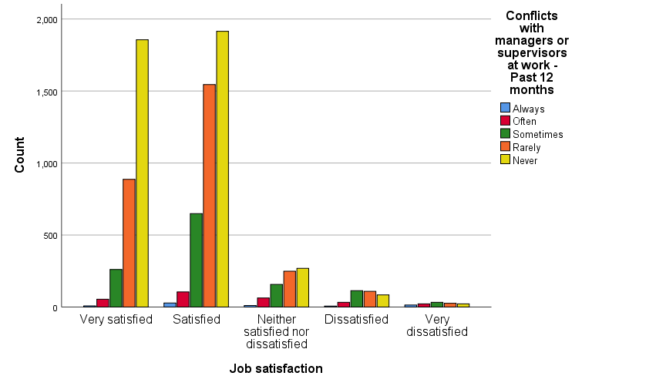

According to this clustered bar chart, most respondents who responded that they never had a conflict or rarely had a conflict with their manager were very satisfied or satisfied with their job. It does not appear however, that the people who reported that they had conflicts with their supervisor or manager often or always reported to be dissatisfied with their job. In fact, it seems that those responses were spread out in terms of their satisfaction with the job.

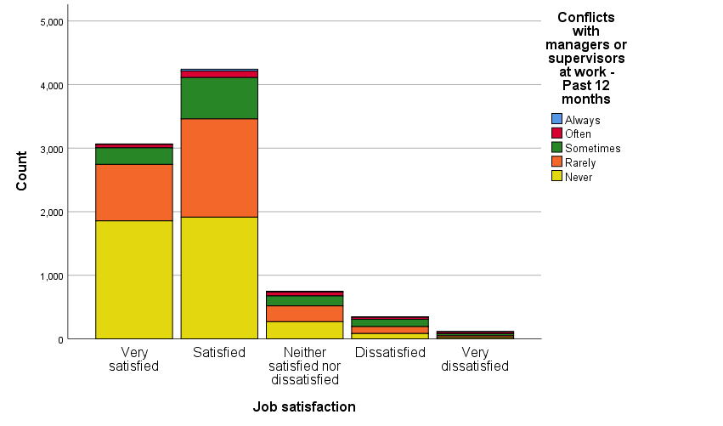

Like the above clustered bar chart, most respondents who never had or rarely had a conflict with their supervisor or manager reported that they were satisfied with their job or very satisfied with their job. Most of the respondents were in the satisfied category. Again, the sizes of the bars for the respondents who reported that they had conflicts with their supervisor or manager often or always had varying levels of satisfaction.

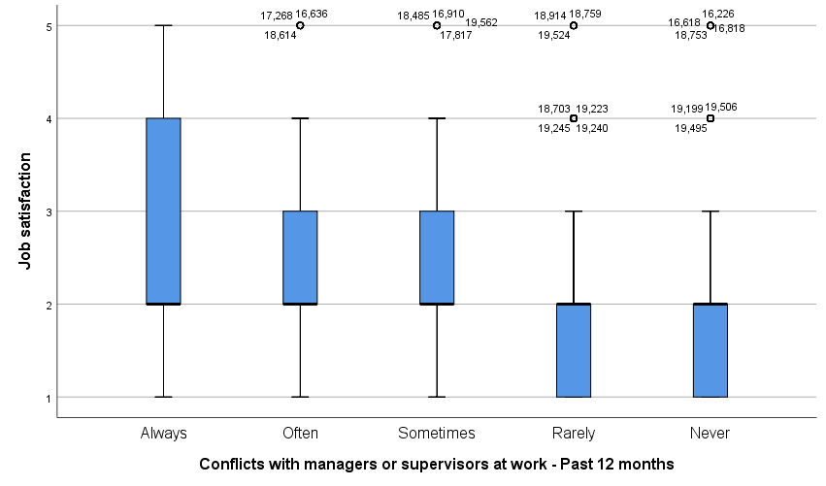

This parallel box plot suggests the same conclusions found in the bar charts above but it also provides a clearer view of the range of responses provided. It appears that most individuals who responded that they never had a conflict or rarely had a conflict with their supervisor or manager were usually satisfied or very satisfied with their job and at worst, most would be neither satisfied or dissatisfied. As for the individuals who reported that they had a conflict with their supervisor or manager sometimes or often, there appears to be a wider range of responses but most would not say that they were very dissatisfied with their job and again as for the individuals who said that they always had a conflict had a wide range of responses but most have answered that they were at most satisfied or at worst, dissatisfied.

### Inferential Test

**Hypotheses**

The test used is the chi-square test.

Null hypothesis H0: X2 = 0

Research hypothesis H1: X2 ≠ 0

|  |  |  |  |
| --- | --- | --- | --- |
| **Chi-Square Tests** | | | |
|  | Value | df | Asymptotic Significance (2-sided) |
| Pearson Chi-Square | 846.215a | 16 | .000 |
| Likelihood Ratio | 635.555 | 16 | .000 |
| Linear-by-Linear Association | 629.733 | 1 | .000 |
| N of Valid Cases | 8521 |  |  |
| a. 3 cells (12.0%) have expected count less than 5. The minimum expected count is .93. | | | |

The XCritical is26.30 as the degrees of freedom is 16 and the p value is 0.05. The XObtained = 846.215 and with that since the XObtained is greater than the Xcritical, the null hypothesis is rejected meaning that there is a possibility that the conflicts between the employee and their supervisor or manager could influence the respondent’s job satisfaction.

### Measures of Association

|  |  |  |  |  |  |
| --- | --- | --- | --- | --- | --- |
| **Symmetric Measures** | | | | | |
|  | | Value | Asymptotic Standard Errora | Approximate Tb | Approximate Significance |
| Ordinal by Ordinal | Kendall's tau-b | -.215 | .010 | -22.030 | .000 |
| Gamma | -.337 | .014 | -22.030 | .000 |
| N of Valid Cases | | 8521 |  |  |  |
| a. Not assuming the null hypothesis. | | | | | |
| b. Using the asymptotic standard error assuming the null hypothesis. | | | | | |

The Kendall’s tau-b measurement is -0.215, indicating a moderate negative association between the two variables. For gamma, the value is -0.337, indicating a strong negative relationship between the two variables.

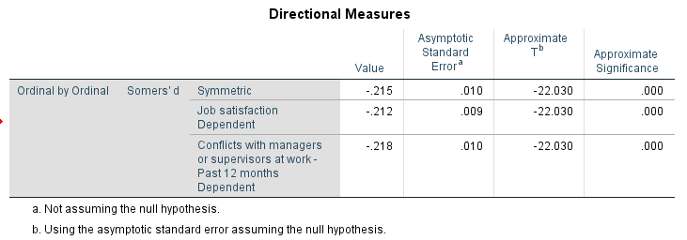

The somer’s d value is -0.212 and -0.218, suggesting a moderate negative relationship between the variables.

|  |  |  |  |  |
| --- | --- | --- | --- | --- |
| **Correlations** | | | | |
|  | | | Job satisfaction | Conflicts with managers or supervisors at work - Past 12 months |
| Spearman's rho | Job satisfaction | Correlation Coefficient | 1.000 | -.238** |
| Sig. (2-tailed) | . | .000 |
| N | 8725 | 8521 |
| Conflicts with managers or supervisors at work - Past 12 months | Correlation Coefficient | -.238** | 1.000 |
| Sig. (2-tailed) | .000 | . |
| N | 8521 | 8529 |
| Rho Squared | Job Satisfaction | Correlation Coefficient | 1 | -0.056644 |
|  |  | Sig(2-tailed) |  | 0.000 |
|  | Conflicts with managers or supervisors at work - Past 12 months | Correlation Coefficient | -0.056644 | 1 |
| **. Correlation is significant at the 0.01 level (2-tailed). | | | | |
|  | | | | |

Taking Spearman’s rho and squaring it, the result is -0.056644, indicating a weak negative relationship between the two variables.

### Summary

The results above were obtained by using chi-square tables, Kruskal’s Gamma, Somers d, Kendall’s tau-b, Spearman’s Rho and rho squared. The null hypothesis in this case has been rejected which suggests that the frequency of conflicts between the respondent and the supervisor or manager does influence the job satisfaction. However, the results generated by the measures of association seemed to be contradicting. The measures either indicated a weak, moderate or strong correlation. However, it can be said that the relationship is negative.

# Discussion

The univariate analyses showed that most respondents were satisfied with their jobs, never had a conflict with their supervisor or manager, and worked for all 52 weeks of the year. Although that is good to hear, this is obviously not enough to answer the research question. What this research is more interested in is determining the correlation between the three variables analyzed above by pairing each two of the three variables together. This is where bivariate analysis is useful.

Starting with the variable pair JSR_02 and WLY_145, it was found that there is no statistically significant difference between the two variables. As the null hypothesis was not rejected, it cannot be concluded that the two variables have a strong relationship with each other, if any and even with the measures of associations could not suggest such a relationship at all. With the variable pair SFC_07 and WLY_145, the null hypothesis was rejected indicating a possible relationship between the two variables but the correlation was weak suggesting that the influence of SFC_07 is not too great on WLY_145. Finally, with the independent variables being analyzed together, the null hypothesis was not rejected indicating a possible relationship, but the relationship’s strengths remained unclear as varying responses were discovered with each measure of association. However, it can be said that the relationship is negative; the more conflicts occur, the less satisfied the respondent is. The weak correlations seemed to make sense as there could be other causes that may result in a person leaving a job. For example, employees may leave when they get a better job offer or a family emergency has forced them to quit. With a variety of reasons that someone could quit a job, it could be surprising if one reason that a stronger influence than another.

The sources discussed in the literature review have approached this topic differently, but it appears that the conclusion reached by this essay and the conclusions reached by the other sources were similar. The findings of this essay were constrained by the fact that the data used was only from the GSS Cycle 30 released by Statistics Canada and even then, the data used was summarized; there was no breakdown of the variables that permitted further analysis. To better explore this topic, surveys could be designed to give allow the respondent to provide more answers pertaining to this topic. One suggestion that comes to mind is a question to ask individuals who have quit their job that year to indicate why they have quit or questions that would further ask about their satisfaction at the job. Multivariate analytical methods might also be beneficial to control and determine the influence of one cause of turnover on another cause of turnover.

As discussed before, employee turnover is a challenge that employers and human resources departments need to learn to control, especially those in the fast food and retail industry where turnover is higher than average. With poor management and no incentive to stay at the job, employees will leave and that can disrupt the work flow. To combat this, employers should try their best to Maintain strong relationships and make the work environment safe and accessible so that they can retain as many employees as possible.

# Conclusion

In conclusion, there isn’t much evidence to suggest a strong relationship between job satisfactions, conflicts with the supervisor or the manager and the number of weeks worked in the year.

# References

Iqbal, A. (2010). Employee Turnover: Causes, Consequences and Retention Strategies in Saudi Organizations. *The Business Review,* *16*(2), 275-281. Retrieved November 3, 2018, from <https://www.researchgate.net/publication/215912138_Employee_Turnover_Causes_Conseque> nces_and_Retention_Strategies_in_Saudi_Organizations.

Gialuisi, O., & Coetzer, A. (2013). An exploratory investigation into voluntary employee turnover and retention in small businesses. *Small Enterprise Research*, 20(1), 55-68. doi:10.5172/ser.2013.20.1.55

Heavey, A. L., Holwerda, J. A., & Hausknecht, J. P. (2013). Causes and consequences of collective turnover: A meta-analytic review. *Journal of Applied Psychology*, 98(3), 412-453. doi:10.1037/a0032380

Maertz, C. P., & Kmitta, K. R. (2012). Integrating turnover reasons and shocks with turnover decision processes*. Journal of Vocational Behavior*, 81(1), 26-38. doi:10.1016/j.jvb.2012.04.002

# Appendix

**Appendix A: Univariate Analysis**

|  |
| --- |
| DATASET ACTIVATE DataSet1.  FREQUENCIES VARIABLES=WLY_145  /ORDER=ANALYSIS.  DATASET ACTIVATE DataSet1.  FREQUENCIES VARIABLES=SFC_07  /ORDER=ANALYSIS.  DATASET ACTIVATE DataSet1.  FREQUENCIES VARIABLES=JSR_02  /ORDER=ANALYSIS.  FREQUENCIES VARIABLES=WLY_145  /FORMAT=NOTABLE  /NTILES=4  /STATISTICS=STDDEV VARIANCE RANGE MEAN MEDIAN MODE  /ORDER=ANALYSIS.  FREQUENCIES VARIABLES=JSR_02  /FORMAT=NOTABLE  /NTILES=4  /STATISTICS=MEDIAN MODE RANGE  /ORDER=ANALYSIS.  FREQUENCIES VARIABLES=SFC_07  /FORMAT=NOTABLE  /NTILES=4  /STATISTICS=MEDIAN MODE RANGE  /ORDER=ANALYSIS. |

**Appendix B: Bivariate Analysis**

|  |
| --- |
| * Encoding: UTF-8.  CROSSTABS  /TABLES=JSR_02 BY SFC_07  /FORMAT=AVALUE TABLES  /STATISTICS=CHISQ  /CELLS=COUNT ROW COLUMN  /COUNT ROUND CELL.  NONPAR CORR  /VARIABLES=JSR_02 SFC_07  /PRINT=SPEARMAN TWOTAIL NOSIG  /MISSING=PAIRWISE.  ONEWAY WLY_145 BY JSR_02  /STATISTICS DESCRIPTIVES  /MISSING ANALYSIS.  * Encoding: UTF-8.  CROSSTABS  /TABLES=JSR_02 BY WLY_145  /FORMAT=AVALUE TABLES  /STATISTICS=ETA GAMMA  /CELLS=COUNT  /COUNT ROUND CELL.  ONEWAY WLY_145 BY JSR_02  /MISSING ANALYSIS.  ONEWAY WLY_145 BY JSR_02  /STATISTICS DESCRIPTIVES  /MISSING ANALYSIS.  * Encoding: UTF-8.  CROSSTABS  /TABLES=SFC_07 BY WLY_145  /FORMAT=AVALUE TABLES  /STATISTICS=ETA GAMMA  /CELLS=COUNT  /COUNT ROUND CELL.  ONEWAY WLY_145 BY SFC_07  /MISSING ANALYSIS. |