| **模型名** | **AlexNet** | **VGG** | **GoogLeNet** | **ResNet** |
| --- | --- | --- | --- | --- |
| 初入江湖 | 2012 | 2014 | 2014 | 2015 |
| 层数 | 8 | 19 | 22 | 152 |
| Top-5错误 | 16.4% | 7.3% | 6.7% | 3.57% |
| Data Augmentation | + | + | + | + |
| Inception(NIN) | – | – | + | – |
| 卷积层数 | 5 | 16 | 21 | 151 |
| 卷积核大小 | 11,5,3 | 3 | 7,1,3,5 | 7,1,3,5 |
| 全连接层数 | 3 | 3 | 1 | 1 |
| 全连接层大小 | 4096,4096,1000 | 4096,4096,1000 | 1000 | 1000 |
| Dropout | + | + | + | + |
| Local Response Normalization | + | – | + | – |
| Batch Normalization | – | – | – | + |

AlexNet 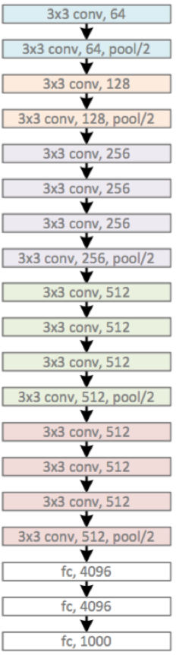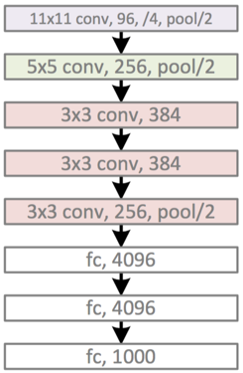 VGG

Googlenet的inception结构V1

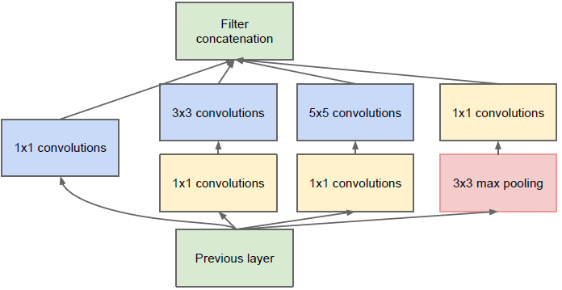

V2

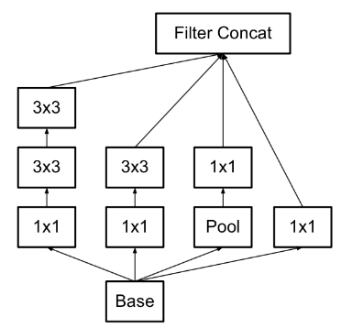

V3

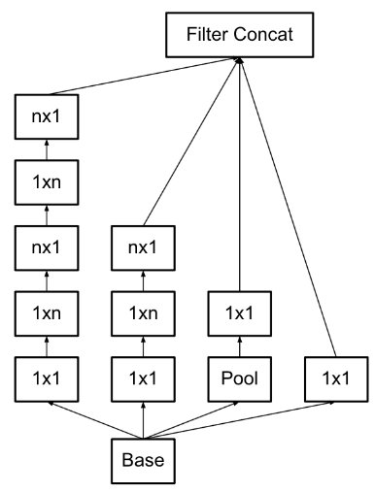

V4

加入了残差网络