**Project Proposal: Flight Delay Prediction Using Machine Learning**

**1. Business Problem**

Flight delays present a persistent challenge in the aviation industry, causing significant financial losses and operational inefficiencies. Airlines incur costs related to crew overtime, increased fuel consumption, and disrupted scheduling, while airports face congestion and gate allocation issues. Passengers are negatively impacted through missed connections, lost productivity, and reduced satisfaction. A predictive model that anticipates flight delays in advance offers the potential to reduce these costs, optimize operations, and improve the overall travel experience.

**2. Stakeholders**

The solution will directly benefit several key stakeholders:

* **Airlines**: Optimize scheduling, reduce costs, and improve on-time performance.
* **Airports**: Allocate gates, runways, and staff more efficiently.
* **Passengers**: Gain access to more accurate and timely travel information.
* **Regulatory Bodies (e.g., FAA)**: Use predictive insights for air traffic management.
* **Travel Services (e.g., booking platforms, tour operators)**: Provide more reliable information to customers.

**3. Project Goals**

The primary goals of this project are to:

* **Improve operational efficiency** by enabling airlines and airports to anticipate and mitigate delays.
* **Enhance customer satisfaction** by providing passengers with more reliable flight information.
* **Reduce costs** associated with inefficient scheduling, fuel waste, and staffing disruptions.
* **Support strategic planning** through insights into recurring patterns in delays.

**4. Why Machine Learning?**

Flight delays are influenced by a complex interplay of factors, including weather conditions, carrier performance, air traffic congestion, and seasonal patterns. Traditional rule-based systems are insufficient for capturing these dynamic relationships. Machine learning, however, excels at identifying patterns in large datasets, adapting to new information, and generating probabilistic predictions. This approach is well-suited to the complexity of the aviation environment, allowing for accurate, scalable, and data-driven forecasting.

**5. Dataset Overview**

The dataset chosen for this project is the U.S. Flight Delay Dataset, sourced from the Bureau of Transportation Statistics (BTS) and available on Kaggle as “Airline Delay Causes.” It includes millions of U.S. domestic flight records, with variables such as:

* Flight date and time
* Airline carrier
* Origin and destination airports
* Scheduled and actual departure/arrival times
* Delay causes (weather, carrier, security, late aircraft, NAS delays)

This dataset is both comprehensive and large-scale, providing the necessary depth to train robust machine learning models.

**6. Dataset Relevance**

The dataset is directly relevant to the business problem because it captures the operational variables most closely tied to flight delays. Historical patterns in weather, airline performance, airport congestion, and seasonal trends can be used to train predictive models. These insights enable stakeholders to anticipate potential disruptions and take proactive measures, such as adjusting schedules, reallocating resources, or providing passengers with early updates.

**7. Measuring Success**

Success will be assessed from both technical and business perspectives:

* **Technical Success**:
  + Evaluate models using metrics such as accuracy, precision, recall, F1-score, and ROC-AUC.
  + Emphasize recall to ensure true delay cases are effectively captured.
* **Business Success**:
  + Demonstrated reduction in operational costs through improved scheduling and staffing efficiency.
  + Measurable improvements in on-time performance rates.
  + Increased customer satisfaction and loyalty due to more reliable travel information.

Even modest improvements in predictive accuracy can translate into significant business value, given the scale and costs associated with flight delays.

**Flight Delay Prediction: Problem-Solving Process**

**1. Data Acquisition and Understanding**

**Data Source**  
The dataset will be obtained from the Bureau of Transportation Statistics (BTS) and Kaggle’s *Airline Delay Causes* dataset, which contains millions of U.S. domestic flight records.

**Exploration Approach**

* Load the dataset using Pandas for initial inspection (row/column counts, data types, missing values).
* Perform summary statistics (mean, median, distributions) to identify data patterns.
* Check categorical variable balance (e.g., airline, airports, seasons).

**Data Quality Assessment Plan**

* Identify and handle missing or inconsistent values (e.g., null departure times, negative delays).
* Detect and assess outliers (e.g., extreme delays of 24+ hours).
* Evaluate class imbalance (delays vs. on-time flights).

**Preliminary Visualization Strategy**

* Use Matplotlib/Seaborn to create exploratory visuals:
  + Distribution of delays by airline and airport.
  + Delay patterns by time of day, day of week, season.
  + Correlations between weather and delay outcomes.

**2. Data Preparation and Feature Engineering**

**Data Cleaning Approach**

* Drop irrelevant columns (e.g., flight number, tail number).
* Handle missing data with imputation or removal.
* Standardize time variables (convert to hour-of-day, weekday, season).
* Normalize/scale numerical variables (e.g., distance).

**Feature Selection/Engineering Methodology**

* Encode categorical variables (airline, airport) using one-hot encoding or target encoding.
* Engineer features such as:
  + Peak vs. off-peak hours.
  + Route popularity (# of flights per day on that route).
  + Weather indicators (storm, precipitation, temperature).
* Evaluate multicollinearity using correlation matrices.

**Implementation Plan for scikit-learn Pipeline**

* Build a scikit-learn Pipeline with steps:
  1. Preprocessing (encoding, scaling).
  2. Feature selection (e.g., SelectKBest).
  3. Model training (Logistic Regression, Random Forest, XGBoost).
* Add a ColumnTransformer to handle categorical and numerical preprocessing in parallel.

**3. Modeling Strategy**

**Algorithms to Evaluate (at least 3)**

1. Logistic Regression → interpretable baseline model.
2. Random Forest → handles non-linear relationships, good for feature importance.
3. XGBoost or LightGBM → strong performance on tabular data.
4. (Optional) Neural Networks (MLP) for deeper experimentation.

**Cross-Validation Strategy**

* Use Stratified K-Fold Cross-Validation (k=5) to maintain class balance and robust performance estimation.

**Hyperparameter Tuning Approach**

* Start with GridSearchCV for small parameter sets.
* Scale to RandomizedSearchCV or Bayesian optimization for larger search spaces.
* Optimize for recall to prioritize catching delayed flights.

**Evaluation Metrics Selection and Justification**

* Accuracy: Overall model performance.
* Precision & Recall: Ensure balance between false alarms and missed delays.
* F1-score: Harmonic mean to balance precision and recall.
* ROC-AUC: Evaluate probability calibration and discrimination ability.

**4. Results Interpretation and Communication**

**Translating Model Results to Business Insights**

* Show which factors (e.g., weather, specific routes, certain times) contribute most to delays.
* Quantify how prediction accuracy translates into cost savings (e.g., reduced crew overtime).
* Provide operational recommendations, such as rescheduling flights during high-risk times.

**Visualization Plans**

* Model performance: Confusion matrix, ROC curves, precision-recall plots.
* Feature importance: Bar plots, SHAP value visualizations for interpretability.
* Operational dashboards: Delay probabilities by route/airline/season (Tableau or Power BI).

**Communication Strategy**

* For technical teams: detailed metrics, model interpretability, feature engineering rationale.
* For non-technical stakeholders: simplified visualizations (charts, dashboards), cost-saving scenarios, plain-language explanations of predictions.

**5. Conceptual Framework**

**Flowchart of Proposed Solution Pipeline**

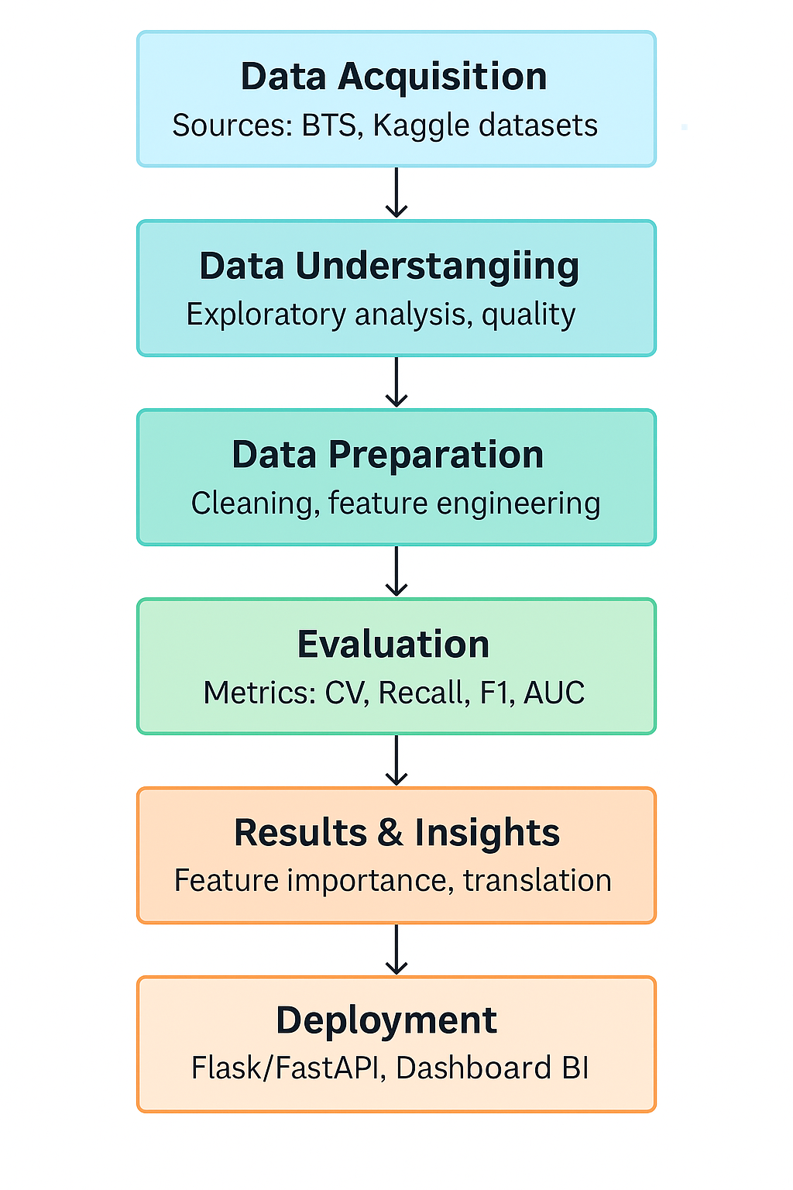

**Dependencies Between Stages**

* Data Acquisition → Data Preparation: Clean, structured data is required before modeling.
* Feature Engineering → Modeling: Engineered variables directly affect model performance.
* Modeling → Evaluation: Hyperparameter tuning depends on feedback from evaluation metrics.
* Results Interpretation → Deployment: Business insights guide how the model will be integrated into decision-making systems.

**Proposed Timeline**

**Day 1: Dataset Finalization and Problem Formulation**

* Finalize dataset choice (BTS/Kaggle flight delays).
* Clearly define the classification target (e.g., ≥15 min delay).
* Set up GitHub/Repo with README.
* Refine business problem statement and success criteria.

**Day 2: Exploratory Data Analysis (EDA)**

* Acquire and load dataset.
* Perform data profiling (missing values, distributions, imbalance).
* Statistical analysis (correlation of delays with airline, airport, time, weather).
* Create informative visualizations (delay trends by day/hour/season).
* Document key insights.

**Day 3: Data Preprocessing**

* Implement cleaning (handle nulls, outliers, duplicates).
* Encode categorical features (airline, airport).
* Engineer new features (hour of day, route frequency, peak hours).
* Build scikit-learn pipeline with ColumnTransformer.
* Split dataset into train/validation/test.

**Day 4-5: Model Development**

* Build baseline models (Logistic Regression, Decision Tree).
* Train advanced models (Random Forest, XGBoost).
* Run cross-validation for robustness.
* Perform hyperparameter tuning (GridSearch/RandomizedSearch).

**Day 6-7: Model Evaluation and Refinement**

* Evaluate models on the test set.
* Compute business metrics (recall for delay capture, precision for false alarms).
* Select final model and interpret results (confusion matrix, ROC, SHAP).
* Draft business insights.

**Day 8-9: Documentation and Reporting**

* Clean up code and ensure reproducibility.
* Write technical report (EDA findings, methodology, results).
* Create executive summary/presentation (visual storytelling).

**Day 10: Final Review and Submission**

* Conduct quality assurance (peer/self-review).
* Record video walkthrough.
* Finalize submission package.

Leaves plenty of buffer time for tasks that take longer than expected.

**Potential Challenges / Areas for Extra Learning**

* Class imbalance: Flight delay datasets are often skewed toward “on-time”; may need resampling (SMOTE/undersampling) or class weighting.
* Feature engineering: Incorporating external weather data or airport capacity may require additional data sources.