Name: Ryan Taylor

Question 1: List the first and last names of customers with credit limits of $1,000 or more.

Answer:

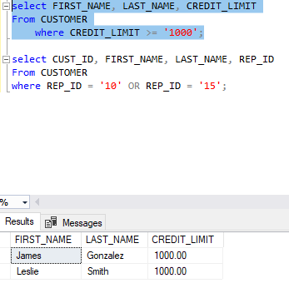

Question 2: List the number and name of each customer represented by sales rep 10 or sales rep 15.

Answer:

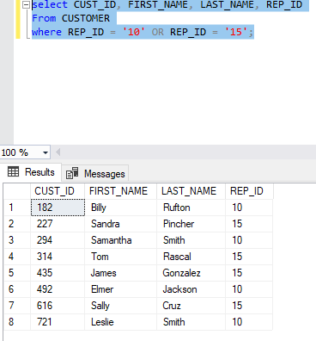

Question 3: Use the IN operator to list the item ID and description of each item in category FSH or BRD.

Answer:

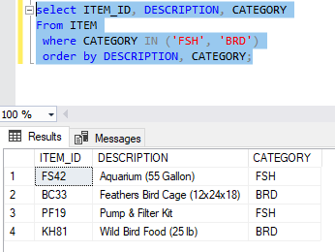

Question 4: Find the ID, first name, and last name of each customer whose first name begins with the letter “S.”

Answer:

