Wireframes:
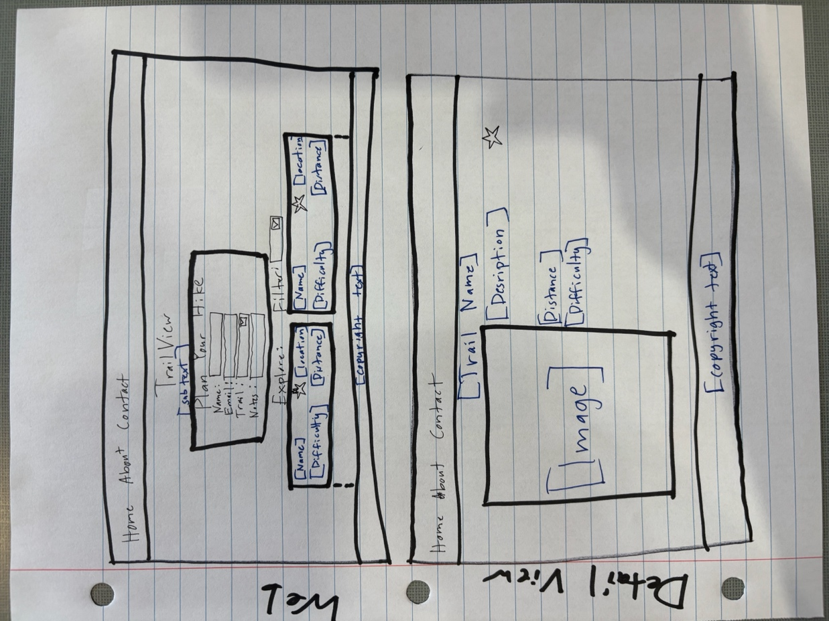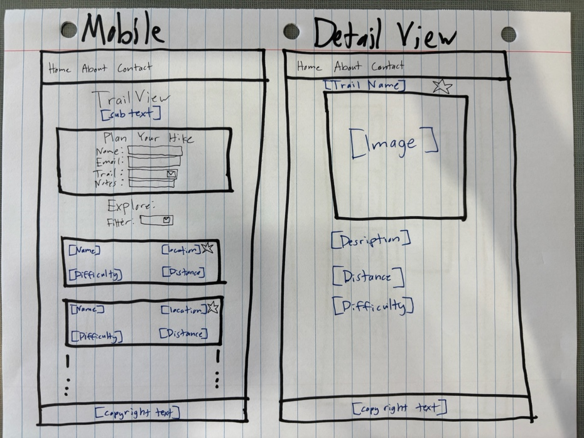
Typography:
Headers: Verdana
Paragraphs: Montserrat

Colors:
Light grey: dad7cd
Brown: 99582a
Olive green: a3b18a
Green: 588157
Forest green: 3a5a40

Pages:
Homepage
Detail view page

JavaScript Modules:
main.js
- Brain of the JS. Main listens for what’s happening on the page and calls on functions in other modules.
data.js
- Holds functions needed for getting and organizing data for display.
render.js
- Responsible for all displayed data and information.
favorites.js
- Manages what is stored in local storage on the page.

Data Structure:
{
"id": "trail01",
"name": "Table Rock Trail",
"location": "Boise, ID",
"distance": 3.7,
"difficulty": "Moderate",
"description": "A popular trail with great views of the city.",
"image": "images/tablerock.jpg"
}

Local Storage
Users will be able to save trails as favorite. Favorite trails will be stored in local storage, and will be used to show them when the “Favorites” filter is selected.

