REMALJ CAREWELL INSPIRATIONAL SCHOOL
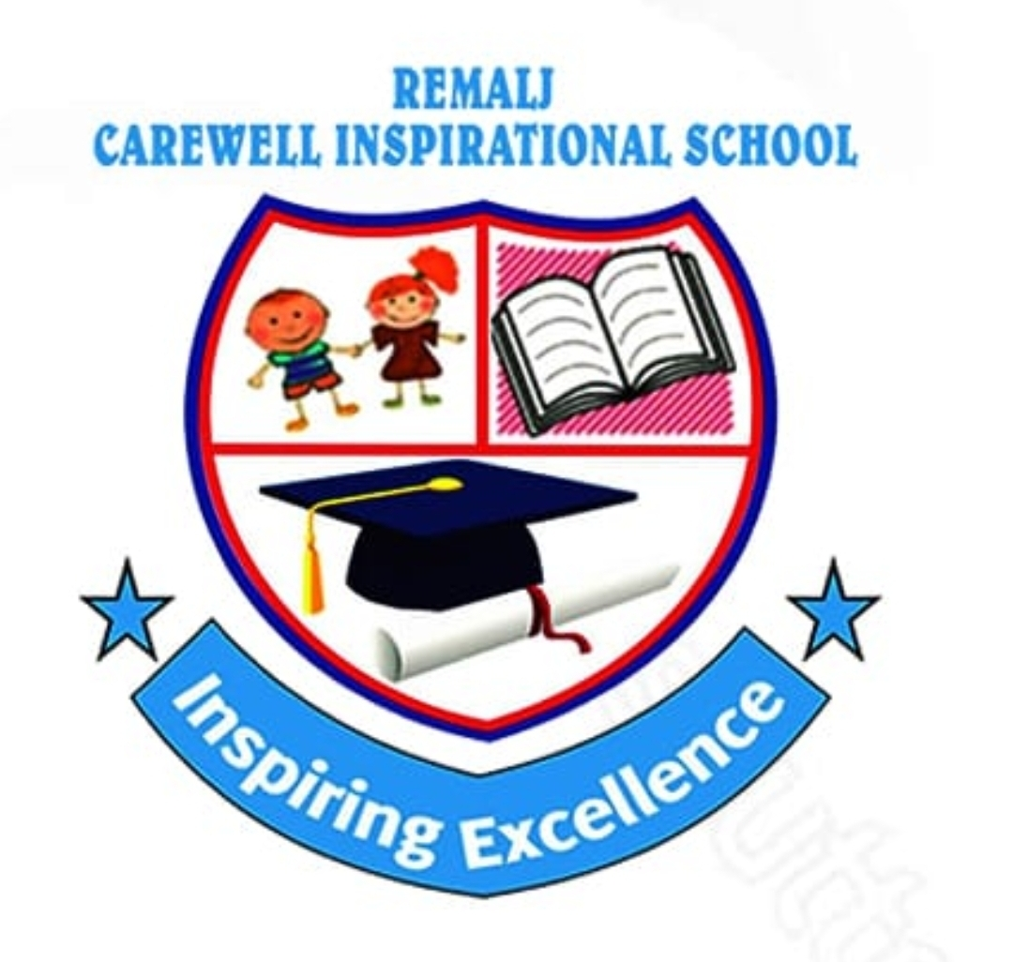
SCHOOL PORTAL
DOCUMENTATION
Functional Reference and Implementation Roadmap

Documentation purpose
This document records the current REMALJ Carewell school portal prototype and translates the attached RCIS Terms of Reference into a practical implementation roadmap. It distinguishes what is demonstrable in the present front-end from capability that still requires production services, policy design, and acceptance testing.
Project motto: One School. One System. One Source of Truth.
DOCUMENT | STATUS
School Portal Documentation | Prototype reference - implementation roadmap included
Prepared for | REMALJ Carewell Inspirational School
Version | 1.0 | 20 August 2026

1. BACKGROUND
REMALJ Carewell Inspirational School requires a coherent digital environment for teaching, learning, parent engagement, student information, communication and school transport. The existing portal provides a visual, role-based starting point across Teacher, Parent and Student experiences. It is a Vite and React single-page prototype with locally managed sample data and no live back-end services.
2. PURPOSE OF THE DOCUMENTATION
The documentation is intended to guide stakeholders, developers and future implementation partners. It describes the visible portal behaviour, identifies boundaries of the current prototype, and sets minimum production requirements aligned to the structure and institutional-control principles of the reference ToR.
3. CURRENT SOLUTION ARCHITECTURE
The current solution is a front-end application. Users switch among Teacher, Parent and Student portals through a shared top bar. Teacher and Parent experiences display a sign-in screen before portal access; Student access is configured as open for demonstration. State is held in the browser session and shared portal data is provided through a React context.
LAYER | CURRENT IMPLEMENTATION | PRODUCTION DIRECTION
Presentation | React 18 portal views, responsive CSS, Lucide icons and branded assets. | Maintain responsive role-based web interface and accessibility controls.
Application state | React useState and PortalStore context with representative data. | Replace with authenticated API services and server-side business rules.
Authentication | Demo email/password and school-card interface; browser camera scan support where available. | Identity provider, role-based access, secure sessions, audit logging and recovery controls.
Data and reporting | In-browser sample records; report-download helper can create a CSV-style file. | Institution-owned database, controlled imports/exports, backups and governed reporting.

4. PORTAL ACCESS AND ROLES
ROLE | CURRENT ACCESS | PRIMARY FUNCTIONS
Teacher | Login screen then teacher dashboard. | Class summary, student ledger, activity feed, subject performance, messages and live transport view.
Parent / Guardian | Login screen then parent dashboard. | Child selector, academic results, attendance, fees summary, events, teacher updates, contacts, reports and bus tracking.
Student | Open demonstration portal. | Dashboard, weekly schedule, assignments, deadlines, achievements, quick resources and read-only bus status.
Administrator | Not yet implemented as a portal role. | Required for production configuration, enrolment, fees, user administration, safeguarding, reports and operational control.

5. FUNCTIONAL SCOPE
The following capabilities are visible in the prototype or represented as navigation. A page labelled “Coming Soon” is a planned area and must not be treated as implemented functionality.
MODULE | CURRENT STATE | NOTES
Authentication and school card | Demonstration interface | Email/password and card-ID routes; optional camera scan uses browser BarcodeDetector when supported. No credential verification or secure persistence.
Academic management | Partially represented | Teacher and parent dashboards show example grades, performance and schedules. No grade-entry workflow or academic database.
Assignments and learning | Partially represented | Student assignment status and submission action are visual only; no file submission or teacher marking workflow.
Parent communication | Partially represented | Teacher updates, messages, directory and public pages are presented in the interface; delivery and consent controls require a back end.
Transport and fleet | Interactive prototype | Teacher, parent and student views surface bus route/status information. GPS integration, route management and notifications are required for production.
Reports | Prototype download | Published-report helper downloads sample CSV data. Formal report generation and permissions remain to be implemented.
Fees, contacts, settings | Navigation / representative cards | Portal surfaces and some components exist; payment, directory governance and configuration services are not integrated.

6. REQUIRED PRODUCTION MODULES
Following the reference ToR, a production Digital Campus Management Ecosystem should be delivered in phased, testable modules. The present portal can become the user-facing layer for the modules below.
- Student information and admissions: applicant, learner, guardian, class, attendance, transfers, graduation, documents and alumni records.
- Academic management: curriculum, subjects, timetables, lesson planning, assessment, examinations, report cards, progress tracking and approved parent access.
- Finance and administration: fee structures, invoicing, receipting, balances, scholarships, payment integration, cash controls and financial reporting.
- Human resources and payroll: staff records, recruitment, contracts, attendance, leave, payroll, statutory deductions and appraisal records.
- Boarding, dining, library, STEM, studio, clubs, facilities and asset management: operational records connected to a single learner/staff identity.
- Health, welfare and safeguarding: restricted-access case management, first-aid records, emergency contacts, escalation and anonymised management analytics.
- Management command centre: authorised dashboards for enrolment, attendance, academic outcomes, fees, transport, safeguarding, assets and service performance.
7. DATA OWNERSHIP, SECURITY AND SAFEGUARDING
All institutional data must remain under REMALJ Carewell control. Any implementation partner must provide exportable data, documented interfaces and administration credentials. Production design must enforce least-privilege role-based access, multi-factor authentication for privileged accounts, encryption in transit and at rest, audit trails, controlled backups, patch management, monitoring and tested incident-response arrangements.
Health, welfare, safeguarding and pickup information require heightened controls. Access must be limited to authorised personnel, information sharing must follow institutional policy and applicable law, and all actions must be auditable.
8. IMPLEMENTATION APPROACH
PHASE | OUTCOME | ACCEPTANCE EVIDENCE
I - Foundation | Institution-owned hosting, central data model, identity, admissions, core academic records and portal authentication. | Approved architecture, data model, access matrix, core workflows and migrated/validated pilot data.
II - Campus operations | Transport, fees, communications, boarding/dining, HR, facilities and operational dashboards. | Role tests, integration tests, training records and operational reports.
III - Future-ready learning | Digital learning, library, STEM, studio, portfolios and co-curricular management. | Configured modules, user guides and stakeholder acceptance.
IV - Intelligence and optimisation | Executive analytics, automated alerts, resilience improvements and performance monitoring. | Dashboard validation, backup/recovery exercise and support handover.

9. TESTING, DOCUMENTATION AND TRAINING
Installation alone shall not constitute acceptance. Before commissioning, the implementation must complete functional, role/access, integration, data-migration, reporting, performance, security and backup/recovery testing. User acceptance testing shall include teachers, parents/guardians, students, school management, finance, boarding/dining, transport, safeguarding and administrators as appropriate.
The final delivery set shall include system architecture, installation and configuration records, administrator and user manuals, API/integration references, database documentation, backup/recovery guide, cybersecurity configuration, troubleshooting guide, change log, training materials and a commissioning report.
10. KNOWN PROTOTYPE LIMITATIONS
- No live server, database, identity provider, payment gateway, GPS provider or external API is connected.
- Displayed people, academic scores, bus locations, dates, fees and messages are representative demonstration data.
- Teacher and Parent sign-in is a front-end state change, not real authentication; Student access is open in the current application configuration.
- Several navigation destinations intentionally show a “Coming Soon” view and do not provide complete workflows.
- The camera/card scan experience depends on browser support and does not currently verify a scanned card against an institutional registry.
11. SUCCESS CRITERIA
The programme will be successful when REMALJ Carewell operates a secure, integrated, documented, maintainable and scalable digital campus environment that it can control without permanent dependency on an implementing vendor. The deployed system must provide trusted records, appropriate access controls, practical training, verified recovery capability and measurable support for teaching, learning, administration, safeguarding and campus operations.

