Coulomb’s Law Lab

**Name :**

This activity consists of two Parts

Part one: Electic force versus distance.

Part two: Electric forces versus charge.

To be familiar with the electrostatic force magnitude direction and the parameters affect this force using Phet simulation open the following link and play with it.

<https://phet.colorado.edu/sims/html/coulombs-law/latest/coulombs-law_en.html>

**Objectives:**

1. Satisfy Coulomb’s law experimentally
2. Study the parameters that affect the electric force. (distance and charge

3- Find experimentally the electric constant k

**Theoretical Background:**

Coulomb’s Law: “The magnitude of the electric force that a particle exerts on another is directly proportional to the product of their charges and inversely proportional to the square of the distance between them.” Mathematically, the magnitude of this electrostatic force FE acting on two charged particles (q1, q2) is expressed as:

FE = k $\frac{q_{1}q_{2}}{r^{2}}$

Where r is the separation distance between the charged objects and k is a constant of proportionality, called the Coulomb constant, k = 9.0 × 109 Nm2/C2.

**Part one:**

To satisfy the objectives do the following steps.

1. Click on the following link and fix the charge q1 and q2 write their values in the table 1.

<https://phet.colorado.edu/sims/html/coulombs-law/latest/coulombs-law_en.html>

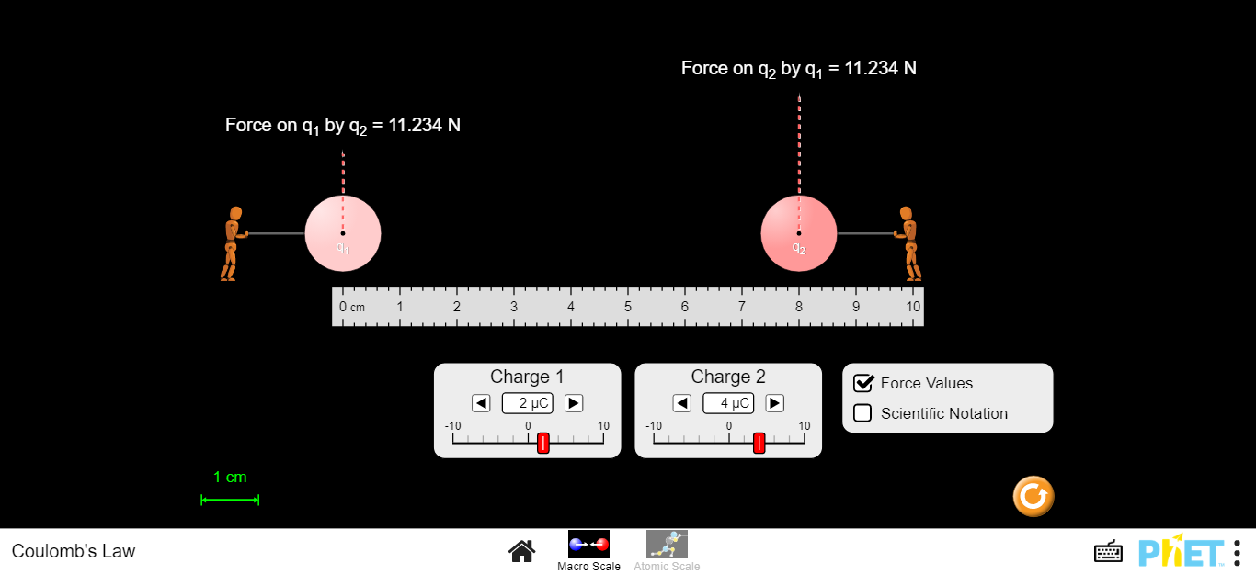

1. Change the distance between the two charges as shown in the table 1.
2. Record the force value for each distance.
3. Fill table 1 by finding r2 and 1/r2.

Table 1

|  |  |  |  |
| --- | --- | --- | --- |
| **q1=………….** | | **q2=………….** | |
| **r (cm)** | **r2 (m2)** | **1/r2 (1/m2)** | **FE (N)** |
| 10 |  |  |  |
| 9 |  |  |  |
| 8 |  |  |  |
| 7 |  |  |  |
| 6 |  |  |  |
| 5 |  |  |  |
| 4 |  |  |  |
| 3 |  |  |  |

**Part two:**

To satisfy the objectives do the following steps.

1. Click on the following link and fix the charge q1 and the distance r, write their values in the table 1.

<https://phet.colorado.edu/sims/html/coulombs-law/latest/coulombs-law_en.html>

1. Control q1 and fix it at 5μc and fix the distance between the two objects at 6 cm, record them in table 2.
2. Change the charge of object 2 as shown in the table 2 and for each q2 record the electric force between the two objects in table 2.

Table 2

|  |  |
| --- | --- |
| **q1 = 5 μC** | **r=6 cm** |
| **q2 (μC)** | **FE (N)** |
| 10 |  |
| 9 |  |
| 8 |  |
| 7 |  |
| 6 |  |
| 5 |  |
| 4 |  |
| 3 |  |

**Data Analysis**

**Part one:**

1. Uses excel software and plot a graph relates FE and r. comments on the graph.
2. Uses excel and plot one more graph relates FE and 1/r2. Use the graph to find the electric constant k.

………………………………………………………………………………………………

………………………………………………………………………………………………

………………………………………………………………………………………………

1. Calculate the percentage error in k (kknown=9.0 × 109 Nm2/C2)

………………………………………………………………………………………………

………………………………………………………………………………………………

………………………………………………………………………………………………

*Note: Attach the graphs to your sheet*

**Part two:**

1. Uses excel software and plot a graph relates FE and q2. comments on the graph.
2. Use the graph to find the electric constant k.

………………………………………………………………………………………………

………………………………………………………………………………………………

………………………………………………………………………………………………

1. Calculate the percentage error in k (kknown=9.0 × 109 Nm2/C2)

………………………………………………………………………………………………

………………………………………………………………………………………………

………………………………………………………………………………………………

*Note: Attach the graphs to your sheet*

This laboratory developed by faculty at **Dep. Of Applied Physics and Astronomy University of Sharjah.**